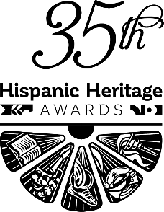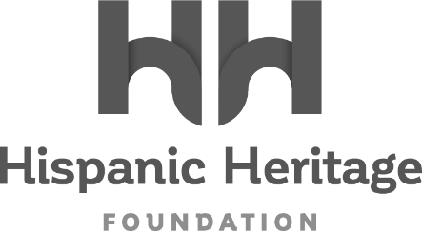

FIRST LATINA MILITARY PILOT OLGA CUSTODIO TO RECEIVE 2022 HISPANIC HERITAGE STEM AWARD

A Pioneer in the Military and Commercial Aviation and STEM Advocate, Olga Custodio Joins Marvel Studios’ Victoria Alonso, Band Los Lobos, and
Reggaeton Legend Daddy Yankee for
35th HISPANIC HERITAGE AWARDS’ September 30th Broadcast on PBS

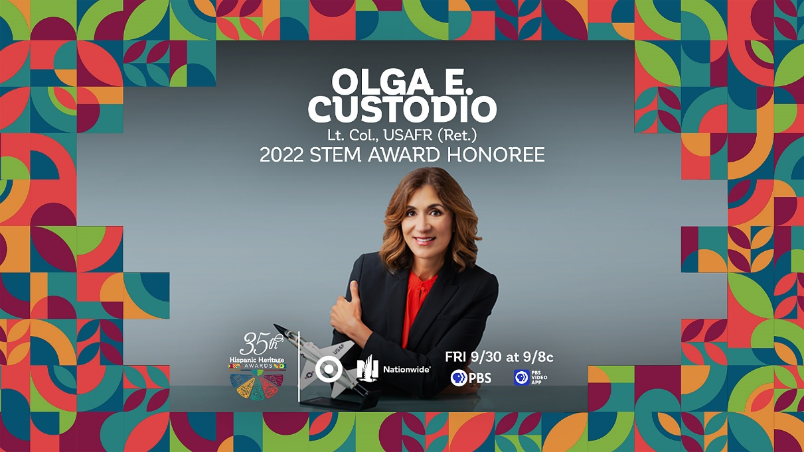

WASHINGTON, DC – August 18, 2022 – The Hispanic Heritage Foundation (HHF) announced today that Olga Custodio, the first Latina military pilot fighter qualified, a trailblazer in military and commercial aviation, will receive the 2022 STEM Award (Science, Technology, Engineering & Math) Award during the 35th Annual Hispanic Heritage Awards. The historic program, which was created by the White House to commemorate the establishment of Hispanic Heritage Month in America, is among the highest honors by Latinos for Latinos and supported by 40 national Hispanic-serving institutions. Presented by TARGET with Official Broadcast Sponsorship by Nationwide, and hosted by Google, the 35th Annual Hispanic Heritage Awards will air Friday, September 30th on PBS stations and stream on pbs.org and the PBS Video app. Custodio will be recognized alongside recently announced Honorees Daddy Yankee, Los Lobos, and Marvel Studios’ Victoria Alonso, with additional Latino artists and visionaries to be announced shortly.

“The Hispanic Heritage Foundation is honored to recognize the trailblazing achievements of Olga Custodio and present what is possible to our youth especially to young Latinas,” said Jose Antonio Tijerino, president and CEO, HHF. “Her representation in the military and aviation is a powerful statement on the value the Latino community provides our country and beyond. We are thrilled to tell her story through our partnership with PBS, sponsors and co-hoss and celebrate our community’s accomplishment, cultural pride, and great promise.”

Olga Custodio is a Latina military and commercial airline pioneer with over 40 years in aviation. As the first Latina to complete U.S. Air Force Undergraduate Pilot Training and graduate in the top 5% of her class, Olga went on to fly numerous types of military aircraft and become an instructor pilot. After transitioning from active duty to the US Air Force Reserves, Olga continued to break barriers by becoming the first American Airlines Latina commercial pilot reaching the airline rank of Captain with a 20-year career. She retired from the US Air Force Reserves with the advanced officer rank of Lt Colonel.

Despite the early impediment of being refused the opportunity to participate in the University of Puerto Rico’s ROTC program as a female student, Olga Custodio went on to log over 11,000 flight hours to her name. She continues to fly and serves as a highly respected STEM advocate, speaker, and community leader. Of the many highlights of her work in this area, Olga is proud to be on the board of several nonprofit organizations including the Latino Pilots Association, and Women in Aviation International – San Antonio Chapter, moderating multiple female aviation panels and acting as a constant advocate and inspiration empowering young women and all students in underserved communities to pursue careers in aviation and aerospace. Most recently, Olga co-authored the “Latinas in Aviation” anthology and is included as one of the 30 inspiring Latinas/Latinos who have shaped the United States in “Nuestra América”, published by the Smithsonian Institution.

Olga Custodio now joins the ranks of previous HHA winners across the last 35 years, that includes Justice Sonia Sotomayor; Dolores Huerta; Fania All-Stars; Celia Cruz; Linda Ronstadt; Carlos Santana; Gael Garcia Bernal; Salma Hayek; Pedro Martinez; John Leguizamo; Dr. Ellen Ochoa; and right up to the continued relevancy of recent winners such as NASA Engineers Christina Hernández, Clara O’Farrell, and Diana Trujillo; Carlos Santana, Linda Ronstadt, Bad Bunny, Ivy Queen, Zoe Saldana, Residente, Selena Gomez and more inspiring figures.

About the Hispanic Heritage Foundation
The Hispanic Heritage Awards serve as a launch of HHF’s year-round mission focused on education, the workforce, and social impact through the lens of leadership and culture. HHF is a 501(c)(3) nonprofit organization. For more information, visit www.hispanicheritage.org and follow the Hispanic Heritage Foundation on Instagram, Facebook, Twitter, and TikTok.

For more information on the 35th Hispanic Heritage Awards,
please contact John Reilly at (jreilly@jrprmusic.com)

For Sponsorship Opportunities,
please contact Jessica Herrera (Jessica@HispanicHeritage.org).

###

