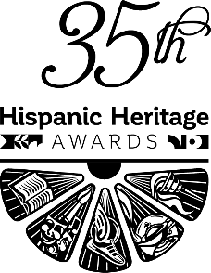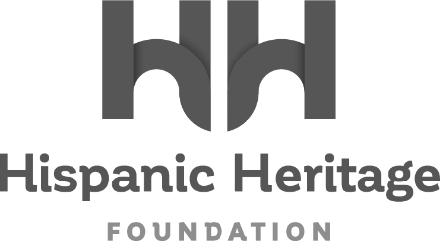

ALEJANDRO VELEZ AND NIKHIL ARORA OF
BACK TO THE ROOTS TO RECEIVE THE
2022 HISPANIC HERITAGE ENTREPRENEURSHIP AWARD

Immigrant Co-Founders of Thriving Organic Gardening Company to Join Marvel Studios’ Victoria Alonso, Reggaeton Legend Daddy Yankee
and Band Los Lobos, and Aviation Pioneer Olga Custodio as Honorees For
The 35th HISPANIC HERITAGE AWARDS’ September 30th Broadcast on PBS

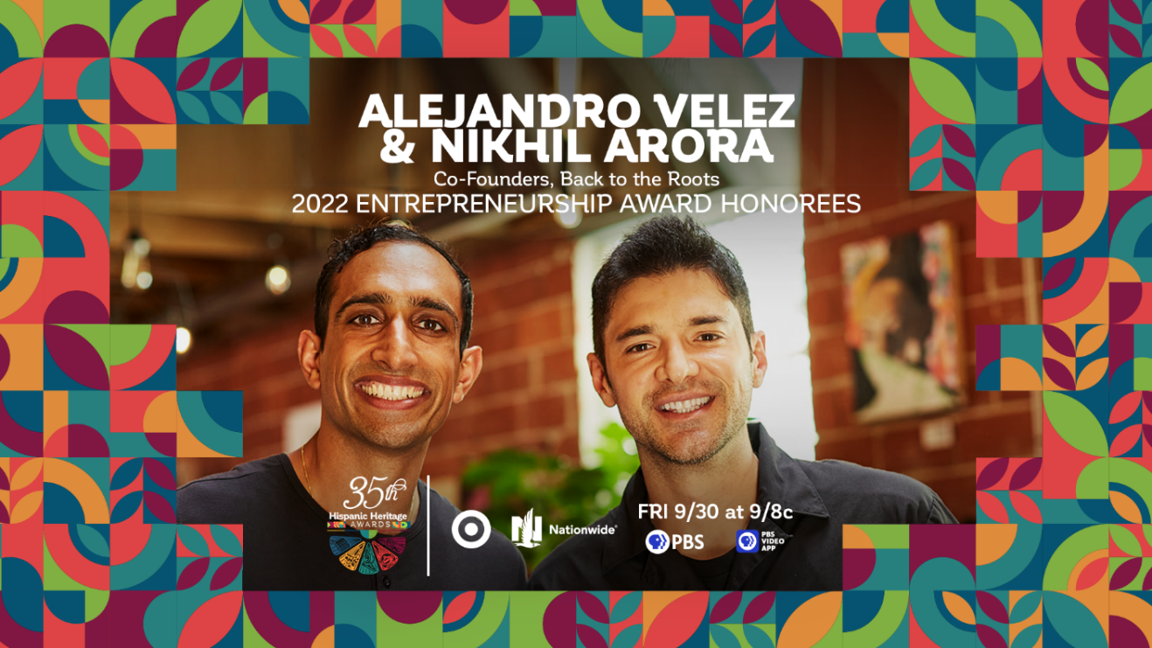
Facebook - Instagram - Twitter - TikTok - LinkedIn

WASHINGTON, DC – August 23, 2022 – The Hispanic Heritage Foundation (HHF) announced today that Nikhil Arora and Alejandro Velez, immigrant co-founders of the innovative, organic farming company Back to the Roots, and now globally recognized voices on sustainability, will receive the 2022 ENTREPRENEURSHIP AWARD during the 35th Annual Hispanic Heritage Awards. The historic program, which was created by the White House to commemorate the establishment of Hispanic Heritage Month in America, is among the highest honors by Latinos for Latinos and supported by 40 national Hispanic-serving institutions. Presented by TARGET with Official Broadcast Sponsorship by Nationwide, and hosted by Google, the 35th Annual Hispanic Heritage Awards will air Friday, September 30th on PBS stations and stream on pbs.org and the PBS Video app. Back to the Roots visionaries will be recognized alongside recently announced honorees Daddy Yankee, Los Lobos, Marvel Studios’ Victoria Alonso, and aviation pioneer Olga Custodio - with additional Latino artists and visionaries to be announced shortly.
“Honoring Alejandro and Nikhil of Back to the Roots is even more special because we have seen them grow from experimenting college students trying to grow food and plants in a sustainable way to brilliant business leaders with a conscious making great impact on their industry,” said Jose Antonio Tijerino, president and CEO, Hispanic Heritage Foundation. “Theirs is an American story of making a vision a reality through hard work which is what we contribute to America as entrepreneurs. We are thrilled to tell their story through our partnership with PBS, our dedicated sponsors and co-hots as we celebrate our community’s accomplishment, cultural pride, and great promise.”
Nikhil Arora and Alejandro Velez co-founded Back to the Roots in college after discovering how to grow gourmet mushrooms on recycled coffee grounds. Since then, the organic gardening company has evolved from an urban mushroom farm in Oakland, California, to a thriving national brand and the fastest-growing organic gardening company in the country. With a mission to reconnect everyone back to where food comes from, Nikhil and Alejandro are transforming the gardening industry by making it easy for anyone, anywhere to grow their own food – no green thumb needed.
Their award-winning line of organic gardening kits, soils, seeds, and plant food is currently distributed in over 10,000 stores. The duo have been recognized globally for their efforts in sustainability, innovation, and entrepreneurship, appearing on lists including Fast Company’s “Most Innovative Companies”, BusinessWeek’s “Top 25 Entrepreneurs Under 25”, Inc.’s “30 Under 30”, Inc. 500, Forbes’ “30 Under 30”, CNN’s “10 Next Entrepreneurs to Watch”, BBC’s Top Global Social Entrepreneurs, Forbes 40 Under 40, EY Entrepreneur of the Year and President Obama’s Champions of Change. They have delivered multiple TEDx Talks, UC Berkeley’s Business School commencement address, and have been featured on major press outlets such as CNBC Mad Money, Bloomberg, NPRs How I Built This, CNN, Fox News, ABC News, NBC News, Forbes, WSJ, Huffington Post and the NY Times.
Nikhil Arora and Alejandro Velez now join the ranks of previous HHA winners across the last 35 years, that includes Rita Moreno, Celia Cruz, Tito Puente, Gloria Estefan, Justice Sonia Sotomayor, Martin Sheen, Ricky Martin, Rubén Blades, Fania All-Stars, José Feliciano, Los Tigres Del Norte, Anthony Quinn, Juanes, Diego Luna, Juan Luis Guerra, and right up to the continued relevancy of recent winners such as Carlos Santana, Linda Ronstadt, Bad Bunny, Ivy Queen, Zoe Saldana, Residente, Selena Gomez and more inspiring figures ranging from essential farmworkers to pioneering NASA engineers.

About the Hispanic Heritage Foundation
The Hispanic Heritage Awards serve as a launch of HHF’s year-round mission focused on education, the workforce, and social impact through the lens of leadership and culture. HHF is a 501(c)(3) nonprofit organization. For more information, visit www.hispanicheritage.org and follow the Hispanic Heritage Foundation on Instagram, Facebook, Twitter, and TikTok.

For more information on the 35th Hispanic Heritage Awards, please contact John Reilly at (jreilly@jrprmusic.com)
For Sponsorship Opportunities, please contact Jessica Herrera (Jessica@HispanicHeritage.org).

###

