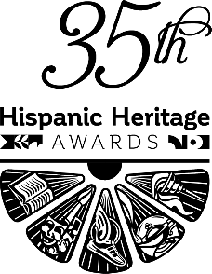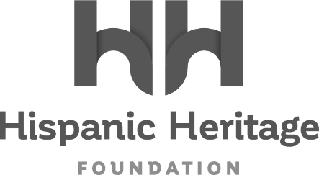

HOST & PERFORMERS ANNOUNCED FOR
THE 35th HISPANIC HERITAGE AWARDS.
Complete Talent Lineup Now Set For The
Friday, September 30th Broadcast On PBS
(Facebook - Instagram - Twitter - TikTok - LinkedIn)

Actress Stephanie Beatriz (Encanto / Brooklyn 911) To Host

Music Performances By: Carlos Vives, Julieta Venegas,
Aymée Nuviola, Boza, Robi and
Hector Tellez Jr. (with Peter Buck, Barret Martin & Dune Butler)

The Already Announced 2022 Honorees Are:
DADDY YANKEE – Legend Award
VICTORIA ALONSO – Vision Award
ARIANA DEBOSE – Inspira Award
LOS LOBOS – Arts Award
OLGA CUSTODIO – STEM Award
ALEJANDRO VELEZ & NIKHIL ARORA- Entrepreneurship Award

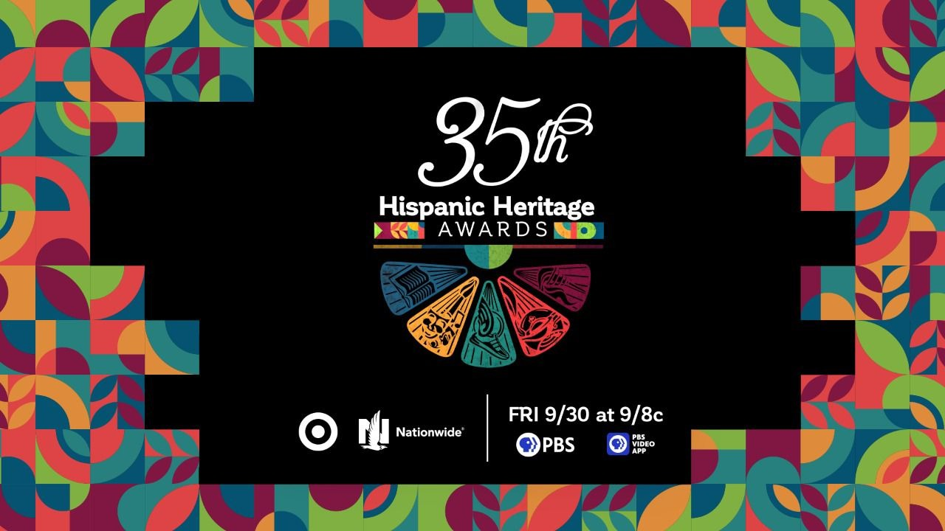

WASHINGTON, DC – September 13 2022 – The Hispanic Heritage Foundation (HHF) today announces this year’s host, and performers for the 35th^{th} Annual Hispanic Heritage Awards - to be broadcast Friday, September 30th, on PBS Stations. The historic program, which was created by the White House to commemorate the establishment of Hispanic Heritage Month in America, is among the highest honors by Latinos for Latinos and supported by 40 national Hispanic-serving institutions. (An announcement about HHF’s in-person Hispanic heritage celebration in Washington, DC, is forthcoming.)

Modeled on the same format which set new ratings records for the broadcast across the last two years, this year’s presentation will once again feature intimately filmed segments captured on location across the United States and Latin America. In addition to the exclusive honoree profiles (detailed again below), the show will be hosted by actress Stephanie Beatriz – widely known for voicing the character of Mirabel Madrigal in Disney’s Oscar-winning 2021 film Encanto, as well as her portrayal of Carla in the motion picture adaption of In The Heights, and as Detective Rosa Diaz in the action-comedy tv series Brooklyn Nine-Nine.

Continuing the Hispanic Heritage Awards’ long-running tradition of also celebrating the richness and stylistic diversity of Hispanic music and culture, the 35th anniversary broadcast will once again spotlight special musical guests spanning from established superstars to the introduction of essential new voices that will carry the communities’ music well into the future. This year, that collection features multi-GRAMMY and/or LATIN GRAMMY winners such as Colombian Vallenato champion and previous Hispanic Heritage Award honoree Carlos Vives, beloved Mexican singer-songwriter Julieta Venegas, and one of Cuba’s leading Timba/tropical music ambassadors Aymée Nuviola. Standouts of a new generation are also represented by already Platinum certified Panamanian Urban singer-songwriter Boza,, Interscope signed rising Puerto Rican star Robi (who will perform a heartfelt tribute to LEGEND honoree Daddy Yankee), and the first national TV performance of Cuban raised, and now Nashville based captivating rock guitarist and singer Hector Tellez Jr, - whose prowess already finds him backed by Rock and Roll Hall of Fame member Peter Buck, and Seattle Rock Scene veterans Barrett Martin (producer & drums) and bassist Dune Butler.

“We are thrilled to honor yet another inspirational class of Hispanic Heritage Awardees, and to pay tribute to them through these amazing performers and entertainers on the PBS broadcast,” said Jose Antonio Tijerino, president and CEO of HHF. “Thanks to PBS and our corporate partners we will be able to share our celebration of cultural pride, accomplishment, and vision with all of America during Hispanic Heritage Month and year-round. Stay tuned for our announcement for the in-person celebration.”

Presented by TARGET with Official Broadcast Sponsorship by Nationwide, and hosted by Google, the 35th Annual Hispanic Heritage Awards will air Friday, September 30th on PBS stations and stream on pbs.org and the PBS Video app. This year’s deserving honorees spotlighted throughout the broadcast and announced over the past two months are trailblazing Reggaeton superstar Daddy Yankee, Marvel Studios executive producer Victoria Alonso, Oscar Winner Ariana Debose, multiple GRAMMY winners Los Lobos, aviation pioneer Olga Custodio and ‘Back To The Roots’ co-founders Alejandro Velez & Nikhil Arora. They join the ranks of HHA winners across the last 35 years, that includes Rita Moreno, Celia Cruz, Tito Puente, Gloria Estefan, Justice Sonia Sotomayor, Martin Sheen, Ricky Martin, Rubén Blades, Fania All-Stars, José Feliciano, Los Tigres Del Norte, Anthony Quinn, Juanes, Diego Luna, Juan Luis Guerra, and right up to the continued relevancy of recent winners such as Carlos Santana, Linda Ronstadt, Bad Bunny, Ivy Queen, Zoe Saldana, Residente, Selena Gomez and more inspiring figures ranging from essential farmworkers to pioneering NASA engineers.

About the Hispanic Heritage Foundation
The Hispanic Heritage Awards serve as a launch of HHF’s year-round mission focused on education, workforce, social impact and culture through the lens of leadership. HHF is a 501(c)(3) nonprofit organization. For more information, visit www.hispanicheritage.org and follow the Hispanic Heritage Foundation on Instagram, Facebook, Twitter, and TikTok.

For more information on the 35th Hispanic Heritage Awards, please contact John Reilly at (jreilly@jrprmusic.com)
For Sponsorship Opportunities, please contact Jessica Herrera (Jessica@HispanicHeritage.org)

# # #

