Two New Documentaries Directed by Oscar® Nominee
Stanley Nelson and Nicole London Offer Fresh Perspectives on Iconic Historical Figures

HARRIET TUBMAN: VISIONS OF FREEDOM
Premieres Tuesday, October 4, 2022
BECOMING FREDERICK DOUGLASS
Premieres Tuesday, October 11, 2022
on PBS and Streaming on the PBS Video App and PBS.org

Oscar-Nominated and Emmy® Award-Winning Actor Alfre Woodard Narrates HARRIET TUBMAN: VISIONS OF FREEDOM and Acclaimed Actor Wendell Pierce Is the Voice of Frederick Douglass in Both Films

ARLINGTON, VA —Two original documentaries that shed new light on the lives of a pair of towering figures in the struggle to end slavery—Harriet Tubman and Frederick Douglass—premiere on PBS in October 2022. Co-productions of Firelight Films and Maryland Public Television (MPT), the films are directed by Oscar-nominated filmmaker Stanley Nelson (Attica, Freedom Riders, The Black Panthers: Vanguard of the Revolution) and Nicole London. HARRIET TUBMAN: VISIONS OF FREEDOM premieres Tuesday, October 4, 2022, 10:00-11:00 p.m. ET, and BECOMING FREDERICK DOUGLASS premieres Tuesday, October 11, 2022, 10:00-11:00 p.m. ET (check local listings) on PBS. Both films will stream on PBS.org and the PBS Video App.
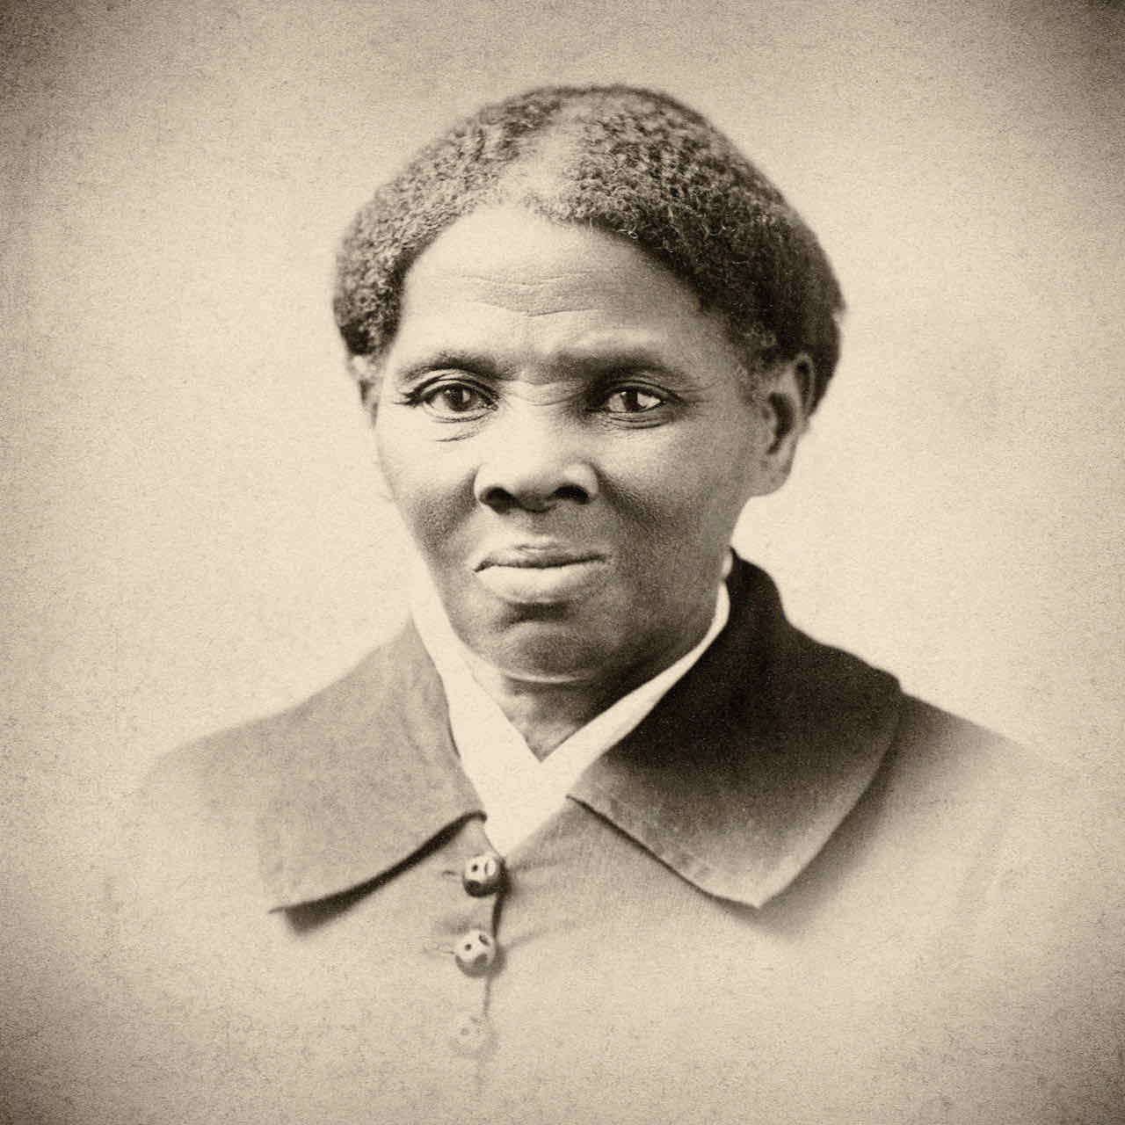
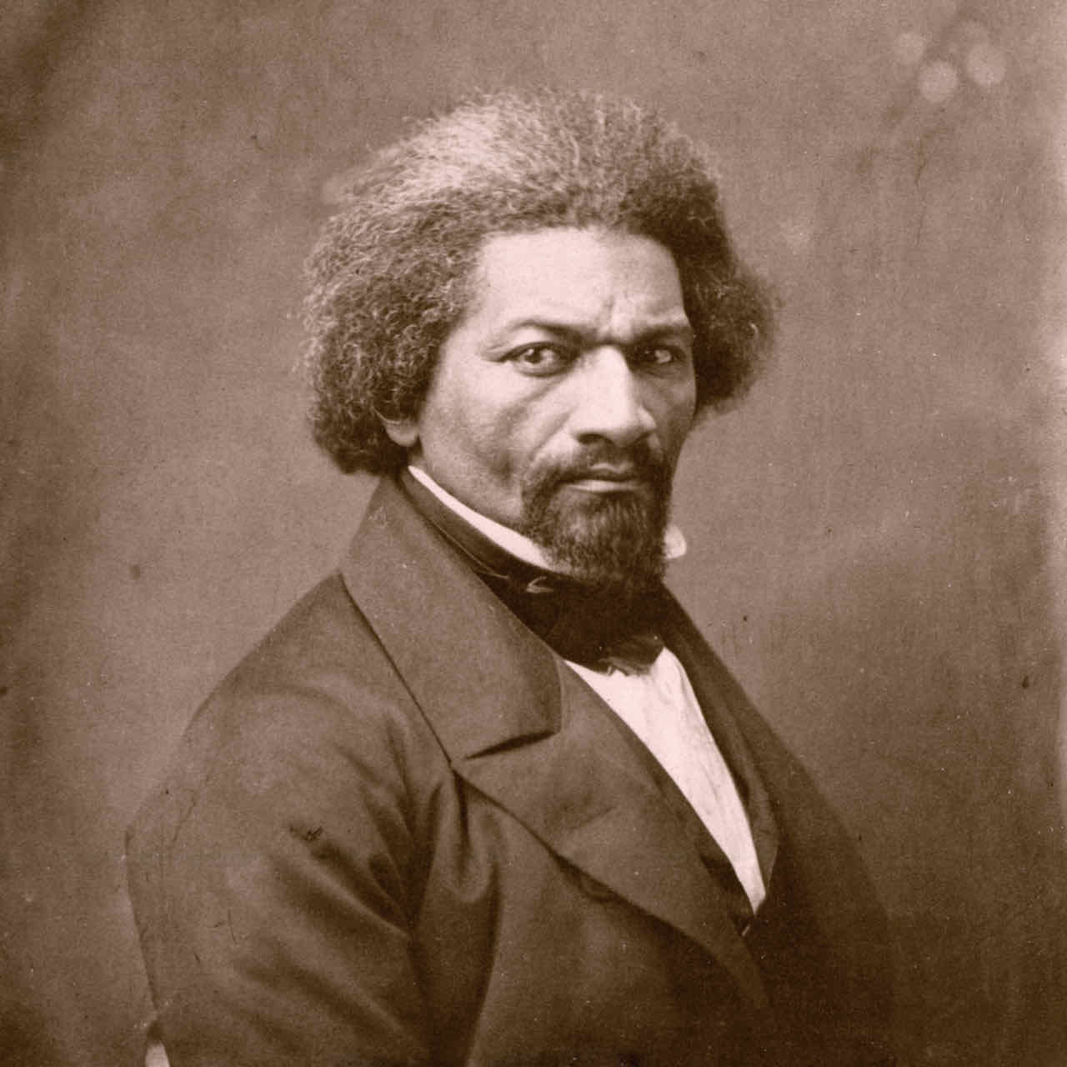
Credits: (Tubman) Alamy; (Douglass) © New York Historical Society / Bridgeman Images

HARRIET TUBMAN: Visions of Freedom is a rich and nuanced portrait of the woman known as a conductor of the Underground Railroad, who repeatedly risked her own life and freedom to liberate others from slavery. Born in Dorchester County, Maryland—2022 marks her bicentennial celebration—Tubman escaped north to Philadelphia in 1849, covering more than 100 miles alone. Once there, she became involved in the abolitionist movement and, through the Underground Railroad, guided an estimated 70 enslaved people to freedom. She would go on to serve as a Civil War scout, nurse and spy, never wavering in her pursuit of equality. Featuring more than 20 historians and experts and grounded in the most recent scholarship, the film goes beyond the standard narrative to explore what motivated Tubman, including divine inspiration, to become one of the greatest freedom fighters in our nation’s history.

“With this film, our aim was to go beyond what is covered in history books to create a real, three-dimensional portrait of who Harriet Tubman actually was,” Nelson said. “We wanted to examine what motivated her to pursue a revolutionary and often dangerous journey, particularly through her fierce religiosity and metaphysical connection to the divine. This film also has such a distinct sonic layer thanks to powerful narration by the great Alfre Woodard.”

BECOMING FREDERICK DOUGLASS is the inspiring story of how a man born into slavery became one of the most prominent statesmen and influential voices for democracy in American history. Born in 1818 on Maryland’s Eastern Shore, he escaped from slavery in 1838 and went on to become the most well-known leader of the abolitionist movement. A gifted writer and powerful, charismatic orator, it is estimated that more Americans heard Douglass speak than any other 19th-century figure, Black or white. The documentary explores how Douglass controlled his own image and narrative, embracing photography as a tool for social justice, and the role he played in securing the right to freedom and complete equality for African Americans.

“Given that Frederick Douglass was one of the most prolific and powerful orators of his time, we were interested in exploring how he created and controlled his image, and ultimately how he used it to shift public opinion around abolition,” said Nelson. “It was such a gift to have the inimitable Wendell Pierce provide the voice of Douglass to bring his words to life. Wendell’s dynamic performance, coupled with the many stunning photographs taken throughout Douglass’s lifetime, show how Douglass evolved to become one of the most influential and enduring social justice activists in American history.”

HARRIET TUBMAN: VISIONS OF FREEDOM and BECOMING FREDERICK DOUGLASS will stream simultaneously with broadcast and be available on all station-branded PBS platforms, including PBS.org and the PBS Video app, available on iOS, Android, Roku, Apple TV, Amazon Fire TV, Android TV, Samsung Smart TV, Chromecast and VIZIO.

Additional information and resources about the films are available at tubmandouglassfilms.com.
Executive producers for HARRIET TUBMAN: VISIONS OF FREEDOM and BECOMING FREDERICK DOUGLASS are Stanley Nelson and Lynne Robinson. The films are produced and directed by Stanley Nelson and Nicole London. Keith M. Brown and Michael English are the executives in charge of production. HARRIET TUBMAN: VISIONS OF FREEDOM was written by Paul Taylor, Nicole London and Marcia Smith.
BECOMING FREDERICK DOUGLASS was written by Anne Seidlitz.

Oscar-nominated and Emmy Award-winning actor Alfre Woodard is the narrator of HARRIET TUBMAN: VISIONS OF FREEDOM and acclaimed actor Wendell Pierce is the voice of Frederick Douglass in both films.

HARRIET TUBMAN: VISIONS OF FREEDOM and BECOMING FREDERICK DOUGLASS are co-productions of Firelight Films and Maryland Public Television with an appropriation from the State of Maryland. These programs are also made possible by Bowie State University, DIRECTV and Pfizer, Inc. Bowie State is the oldest Historically Black College and University (HBCU) in Maryland and the first HBCU to become a premier sponsor of a national PBS film.
About Maryland Public Television
Launched in 1969, Maryland Public Television (MPT) is a state-licensed public television network and member of the Public Broadcasting Service (PBS). MPT is among the leading producers and distributors of national public television programming in the United States. As a major content supplier to PBS stations, MPT boasts a five-decade legacy of groundbreaking and innovative contributions to public TV schedules nationwide. MPT is also one of the most prolific producers of regional programming in the public television system, serving a six-state area in the Mid-Atlantic region. MPT’s Emmy Award-winning content catalog includes news, public affairs, documentary, performance and lifestyle programming. For more information, visit mpt.org.
About Firelight Films
Founded by award-winning filmmaker Stanley Nelson, Firelight Films produces documentaries by and about communities of color. Firelight Films productions have garnered multiple Primetime Emmy, Peabody, IDA, and Sundance awards. Among them are the feature films Attica, which was recently nominated for an Academy Award and premiered on Showtime; Tulsa Burning: The 1921 Race Massacre; Crack: Cocaine, Corruption & Conspiracy; Miles Davis: Birth of the Cool; The Black Panthers: Vanguard of the Revolution; Freedom Summer; Freedom Riders; The Murder of Emmett Till; and The Black Press: Soldiers Without Swords. Firelight Films has also produced notable short films including “The Story of Access,” which was commissioned by Starbucks in 2017 for a mandatory anti-bias employee training program, and “Commemorate and Celebrate Freedom,” commissioned by the Smithsonian’s National Museum of African American History and Culture for its opening night in 2015. Upcoming Firelight Films productions include Creating the New World: The Transatlantic Slave Trade, a four-part documentary series for PBS.
About PBS
PBS, with more than 330 member stations, offers all Americans the opportunity to explore new ideas and new worlds through television and digital content. Each month, PBS reaches over 120 million people through television and 26 million people online, inviting them to experience the worlds of science, history, nature and public affairs; to hear diverse viewpoints; and to take front row seats to world-class drama and performances. PBS’ broad array of programs has been consistently honored by the industry’s most coveted award competitions. Teachers of children from pre-K through 12th grade turn to PBS for digital content and services that help bring classroom lessons to life. Decades of research confirms that PBS’ premier children’s media service, PBS KIDS, helps children build critical literacy, math and social-emotional skills, enabling them to find success in school and life. Delivered through member stations, PBS KIDS offers high-quality educational content on TV—including a 24/7 channel, online at pbskids.org, via an array of mobile apps and in communities across America. More information about PBS is available at www.pbs.org, one of the leading dot-org websites on the internet, or by following PBS on Twitter, Facebook or through our apps for mobile and connected devices. Specific program information and updates for press are available at pbs.org/pressroom or by following PBS Communications on Twitter.

– PBS –

CONTACTS:

MPT
Tom Williams, MPT, tomwilliams@mpt.org

Cara White / Mary Lugo, CaraMar, Inc.
cara.white@mac.com; lugo@negia.net

For images and additional up-to-date information on this and other PBS programs, visit PBS PressRoom at pbs.org/pressroom.

