HAPPY HOLIDAYS WITH BING & FRANK
Premieres on PBS Stations Beginning October 29

Legendary Duo Featured in an Early Color Television Special
Directed by Frank Sinatra

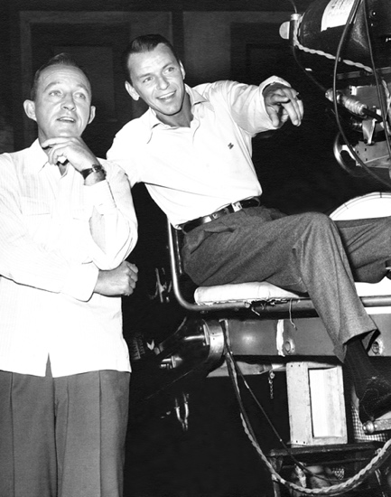
Credit: Frank Sinatra Enterprises, LLC

Originally aired on December 20, 1957, HAPPY HOLIDAYS WITH BING & FRANK is a timeless Christmas favorite, featuring the magical combination of Frank Sinatra and Bing Crosby in an early color television special. The two legends swap Christmas carols, songs, and stories, pay a musical visit to Victorian England, and duet on Christmas classics. The show finishes in inimitable fashion with “The Christmas Song” and “White Christmas” for pure festive perfection. Directed by Sinatra, with music conducted by Nelson Riddle, the program also features the Ralph Brewster Singers. HAPPY HOLIDAYS WITH BING & FRANK is part of special programming premiering on PBS stations beginning Friday, October 29, 2021 (check local listings).

Songs include: “Mistletoe And Holly,” “Jingle Bells,” “Deck The Halls,” “God Rest Ye Merry Gentlemen,” “Hark The Herald Angels Sing,” “O Come All Ye Faithful,” “The First Noel,” “It Came Upon A Midnight Clear,” “Away In A Manger,” “O Little Town of Bethlehem,” “Rudolph The Red Nosed Reindeer,” “Santa Claus Is Coming To Town,” “The Christmas Song” and “White Christmas.”

PBS special programming invites viewers to experience the worlds of science, history, nature and public affairs; hear diverse viewpoints; and take front-row seats to world-class drama and performances. Viewer contributions are an important source of funding, making PBS programs possible. PBS and public television stations offer all Americans from every walk of life the opportunity to explore new ideas and new worlds through television and online content.

Underwriters: Public Television Viewers and PBS
Production Company: Mercury Studios

- PBS –

CONTACT: Cara White, CaraMar, Inc., cara.white@mac.com

For images and additional up-to-date information on this and other PBS programs, visit PBS PressRoom at pbs.org/pressroom.

