THE GREEN PLANET,
Hosted by Sir David Attenborough,
Premieres Wednesdays, July 6-August 3, 2022 on PBS

New Five-Part Series Uses the Latest Technology to Reveal the Secret,
Incredible World of Plants

ARLINGTON, VA – Hosted by Sir David Attenborough, THE GREEN PLANET is a new five-part documentary series about Earth’s biodiversity told through the fascinating story of plants. As Attenborough explains: “Every mouthful of food that we eat, every lungful of air that we breathe, depends on plants.” Using pioneering new filmmaking technology and the latest science, THE GREEN PLANET takes viewers from the deepest jungles to the harshest deserts, revealing the strange and wonderful world of plants as never before. Living secret, unseen lives, plants are often overlooked. Yet they are as aggressive, competitive and dramatic as animals — locked in life-and-death struggles for food and light, taking part in fierce battles for territory and desperately trying to reproduce and scatter their young. Produced in partnership with the BBC Studios’ Natural History Unit, THE GREEN PLANET premieres Wednesdays, July 6-August 3, 2022, 8:00-9:00 p.m. ET (check local listings) on PBS, PBS.org and the PBS Video app.
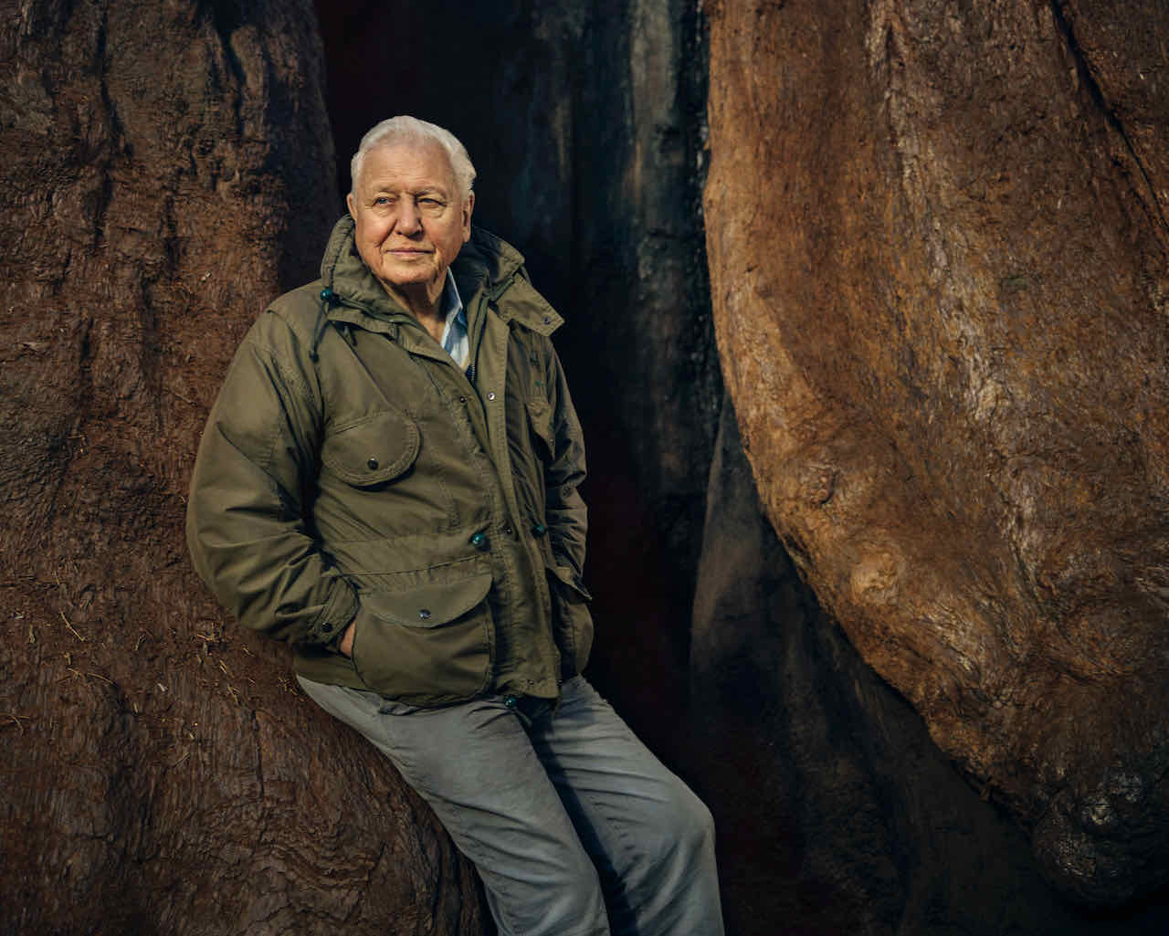

In the series, Sir David travels the globe, from deserts to mountains, from rainforests to the frozen north, to present a fresh understanding of how plants live their lives. He meets the largest living things that have ever existed, trees that care for each other, plants that hunt animals and plants that breed so fast they could cover the planet in a matter of months. He finds time travelers — seeds that can outlive civilizations and plants that remain unchanged for decades. By examining our relationship with plants past, present and future, THE GREEN PLANET reveals how all animal life, including ours, is totally dependent on plants.

Using pioneering motion-control robotics systems, THE GREEN PLANET takes viewers on a magical journey, going beyond the power of the human eye to make visible the amazing, hidden life of plants. Thermal cameras, macro frame-stacking, ultra-high-speed cameras and the latest developments in microscopy reveal the lives of plants and their incredible beauty. Surprisingly social, they communicate with each other, care for their young and help the weak and injured. They can plan, they can count — and they can remember.

Sir David believes we are living at the perfect time for a reexamination of the plant world. “There has been a revolution worldwide in attitudes towards the natural world in my lifetime — an awakening and an awareness of how important the natural world is to us all,” he said. “An awareness that we would starve without plants, we wouldn't be able to breathe without plants. Yet people's understanding about plants, except in a very kind of narrow way, has not kept up with that. I think this series will bring it home.”

The complete schedule with episode descriptions is below:

Episode 1: “Tropical Worlds”
Wednesday July 6; 8-9pm
More kinds of plants are crammed together in the tropical rainforests than anywhere else on earth. The result is astonishing beauty and intense competition — a plant battleground. From fast-growing trees to flowers that mimic dead animals, from life and death battles to reach the light to the secret behind every raindrop, take a journey into a magical world that operates on a different timescale to our own.

Episode 2: “Water Worlds”
Wednesday July 13, 8-9pm
Water plants create some of the most beautiful, bizarre and important habitats on earth. Some are armed with killer spikes to use as weapons, while others use nature’s super-glue to hold on. Yet others escape their enemies by forming spheres and rolling away. Plants turn into animal hunters where nutrients are washed away, laying traps and even counting to ensure their success. Brilliantly-colored flowers smother lakes, and in one magical river in Brazil, the water bubbles like champagne as plants create the atmosphere itself.

Episode 3: “Seasonal Worlds”
Wednesday July 20
Between the tropics and the frozen poles lies a region dominated by relentless change from the four seasons. Each presents plants with enormous challenges — from ice and snow to raging fires, from intense competition to surprising enemies, both animals and plants. To survive in this world of astonishing variety and vibrant color, plants must use strategy, deception and remarkable feats of engineering. Most importantly, they must get their timing right.

Episode 4: “Desert Worlds”
Wednesday July 27
Deserts are hostile. Temperatures soar and water is rare. Yet plants find extraordinary ways to survive. They may grow imperceptibly slowly or travel the landscape looking for water. Others wait decades in suspended animation for rain to power an explosion of color across the dunes. Desert plants protect their water stores from animals and each other, using camouflage, vicious spines or forging surprising alliances with animals. Plants have invaded the most dangerous deserts on earth, overcoming salt, fire and toxic bird droppings to bring life and color to these harsh landscapes.

Episode 5: “Human Worlds”
Wednesday August 3
We rely on plants for almost everything, including the air we breathe and the food we eat. Two in five wild plants are threatened with extinction, but people are finding new ways to help them, from projects in Africa to re-seed the landscape to rebuilding a tropical forest in Brazil, tree by tree. In David Attenborough’s words: ‘We can all work with plants to help make our world a little wilder. Our future will be safer and healthier, and, in my experience at least, we will also be happier. Plants are our most ancient allies.”

THE GREEN PLANET will stream simultaneously with broadcast and be available on all station-branded PBS platforms, including PBS.org and the PBS Video app, available on iOS, Android, Roku, Apple TV, Amazon Fire TV, Android TV, Samsung Smart TV, Chromecast and VIZIO.

THE GREEN PLANET is a BBC Studios’ Natural History Unit production for BBC and PBS, and co-produced by the Open University, bilibili, ZDF German Television, France Télévisions and NHK. The presenter and narrator is David Attenborough. The executive producer is Michael Gunton. The series producer is Rupert Barrington. Executive in charge for PBS is Bill Gardner.
ABOUT PBS
PBS, with more than 330 member stations, offers all Americans the opportunity to explore new ideas and new worlds through television and digital content. Each month, PBS reaches over 120 million people through television and 26 million people online, inviting them to experience the worlds of science, history, nature and public affairs; to hear diverse viewpoints; and to take front row seats to world-class drama and performances. PBS’ broad array of programs has been consistently honored by the industry’s most coveted award competitions. Teachers of children from pre-K through 12th grade turn to PBS for digital content and services that help bring classroom lessons to life. Decades of research confirms that PBS’ premier children’s media service, PBS KIDS, helps children build critical literacy, math and social-emotional skills, enabling them to find success in school and life. Delivered through member stations, PBS KIDS offers high-quality educational content on TV – including a 24/7 channel, online at pbskids.org, via an array of mobile apps and in communities across America. More information about PBS is available at www.pbs.org, one of the leading dot-org websites on the internet, or by following PBS on Twitter, Facebook or through our apps for mobile and connected devices. Specific program information and updates for press are available at pbs.org/pressroom or by following PBS Communications on Twitter.

– PBS –

CONTACTS:

Atiya Frederick, PBS, anfrederick@pbs.org

Cara White / Mary Lugo, CaraMar, Inc.
cara.white@mac.com; lugo@negia.net

For images and additional up-to-date information on this and other PBS programs, visit PBS PressRoom at pbs.org/pressroom.

