THE GREAT MUSLIM AMERICAN ROAD TRIP
PREMIERES SUMMER 2022
Airing on PBS, PBS.org and the PBS Video App

A three-part documentary series, THE GREAT MUSLIM AMERICAN ROAD TRIP follows a millennial Muslim American couple on a cross-country journey along historic Route 66 as they explore Islam’s deep roots in America. Making more than a dozen stops between Chicago and Los Angeles, rapper Mona Haydar and her husband Sebastian Robins meet with authors, entrepreneurs, medical students, performers and others to better understand the centuries-long Muslim experience in the United States. This series highlights the diversity of Muslims across the nation and their contributions to history and culture, weaving a colorful story of what it means to be a Muslim in America today.

BIOGRAPHIES

Mona Haydar and Sebastian Robins, series hosts

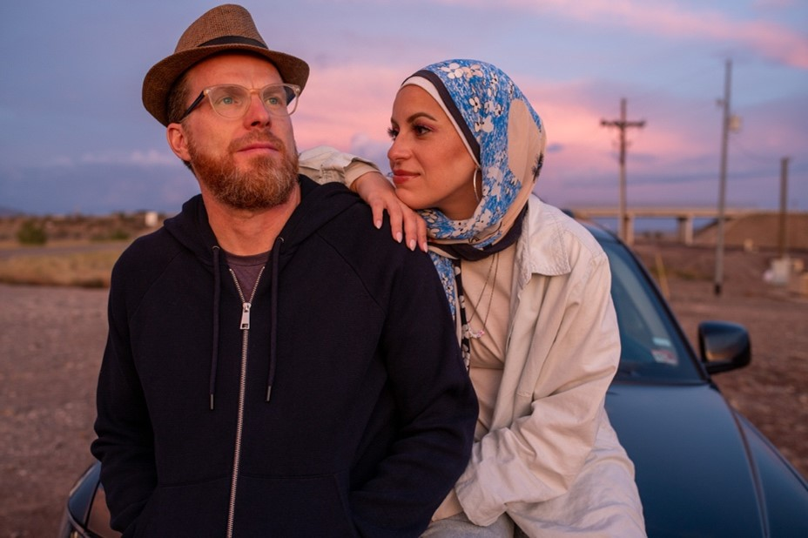
Mona Haydar and Sebastian Robins met at the top of a scenic mountain in northern New Mexico. It was the summer of 2011, and Mona had just arrived at the Lama Foundation, an inter-spiritual retreat center, where she was to start an internship. The first person she met there was Sebastian and, as the story goes, they fell in love that very day, marrying the following summer.

In 2015, Mona and Sebastian gained international attention for their “Ask a Muslim” project— a booth offering free donuts in exchange for dialogue and questions in the wake of the Paris and San Bernardino extremist attacks. Mona, a Muslim, is Syrian American, and Sebastian converted to Islam after meeting Mona. A few years later, Mona, who has a master’s degree in Christian Ethics and is a fierce advocate for civil rights and inclusivity, turned to music. The video for her hip-hop anthem, “Hijabi (Wrap My Hijab),” went viral in 2017, gaining over 8 million views on YouTube, and Billboard named it one of the “20 Best Protest Songs” of the year.

Before meeting Mona, Sebastian worked at the Lama Foundation, where he served as a coordinator and CEO. He has also worked in the education field as an elementary school teacher, assistant professor and vice principal. An advocate for sustainable farming, Sebastian has helped establish and maintain several farms across the country, while also continuing to work closely with his wife.

Together, the couple have been featured on NPR, CNN, The New York Times, BBC, People Magazine, BuzzFeed, HuffPost, Mic, Marie Claire, Glamour, Refinery 29 and many other publications. They both appeared in the Emmy-nominated series “The Secret Lives of Muslims” in 2017.

Hossam Aboul-Magd, director of photography

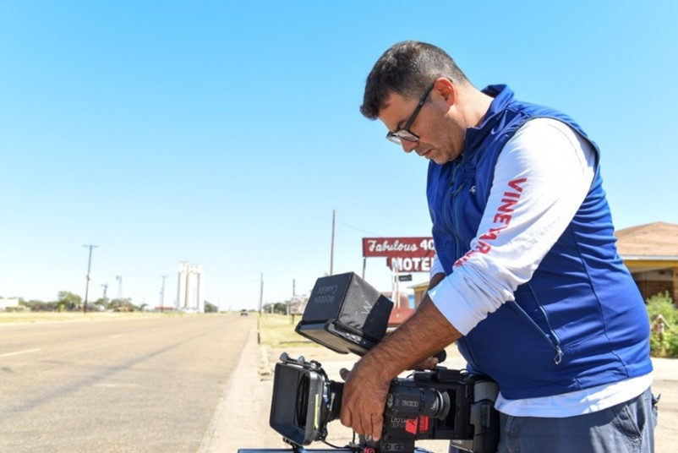
Hossam Aboul-Magd is an award-winning Egyptian American filmmaker, director and director of photography based in Washington, DC. Hossam has been in the business for more than 25 years, making films for PBS, National Geographic, Discovery, History, BBC, CNN and many other prestigious networks and corporate firms. He has filmed in more than 60 countries on four continents. Hossam's love of meaningful storytelling, combined with beautiful shots, has been his message throughout his career.

Alex Kronemer, series director and producer

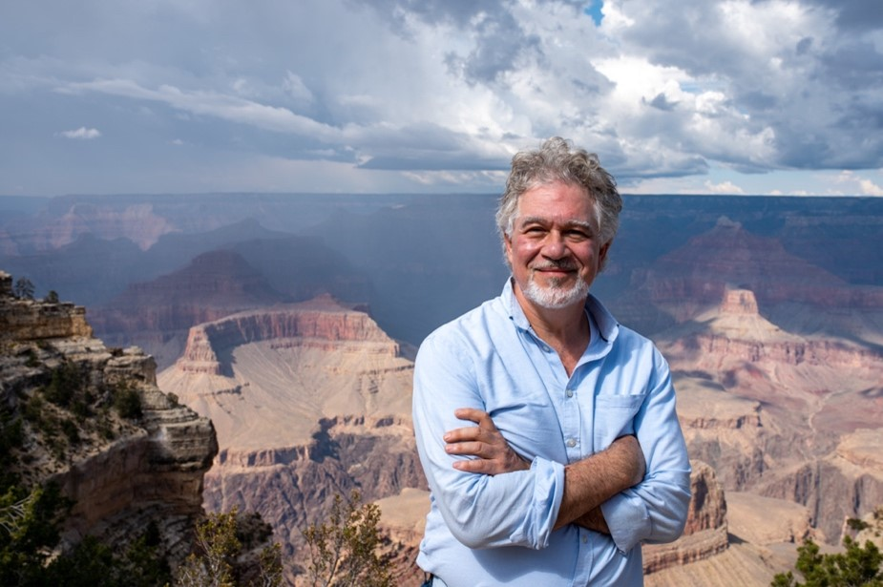
Alex Kronemer has been working for peace and interfaith understanding for most of his adult life. He was a member of the lobbying group that successfully lobbied Congress for the establishment of the current U.S. Institute of Peace in Washington, DC. Shortly after, Alex attended Harvard Divinity School, where he studied comparative religion on his way to receiving a Master of Theological Studies. Upon graduation, he worked for two years at a refugee resettlement agency in Boston, helping refugees from Vietnam, Cambodia and Eastern Europe find jobs and homes in the U.S.

Alex became a prolific writer, publishing articles in numerous newspapers magazines and appearing as a commentator on Islam and religion on CNN and other networks. In the late 1990s, he was the Middle East desk officer in the U.S. State Department Office of Human Rights and Democracy, helping to staff the newly formed Religious Freedom Office.

In 2000, he cofounded Unity Productions Foundation, a media and educational nonprofit dedicated to creating peace and understanding about Muslims and other religions in the world. Unity Production Foundation has gone on to produce 12 documentaries for national broadcast and theatrical release and received numerous prestigious film accolades, including an Emmy nomination for the PBS special THE SULTAN AND THE SAINT. His most recent production, an animated film about a Syrian refugee girl called “Lamya’s Poem,” has been officially selected in six major film festivals and counting since its debut in June 2021 and is expected in theaters in 2022. In addition, his organization has launched dozens of interfaith and peacemaking projects in the U.S. and abroad.

–PBS –

MEDIA CONTACTS:

PJ Feinstein, PBS
pjfeinstein@pbs.org; 571-481-8035

Brandii M. Toby-Leon, Bullseye Communications
brandii.leon@bullseyecomm.com; 865-963-2418

Heather Marohn, Bullseye Communications
heather.marohn@bullseyecomm.com; 908-268-3770

For images and additional up-to-date information on THE GREAT MUSLIM AMERICAN ROAD TRIP, visit PBS PressRoom at pbs.org/pressroom.

