PBS Announces Premiere Date for THE GREAT MUSLIM AMERICAN ROAD TRIP, A New Documentary Exploring
The Muslim Experience Throughout America’s History

Three-Part Series, Airing Tuesdays, July 5-19, Follows Millennial Muslim American Couple on a Journey of Self-Discovery Across Route 66

Images and Road Trip Stops Available on PBS PressRoom

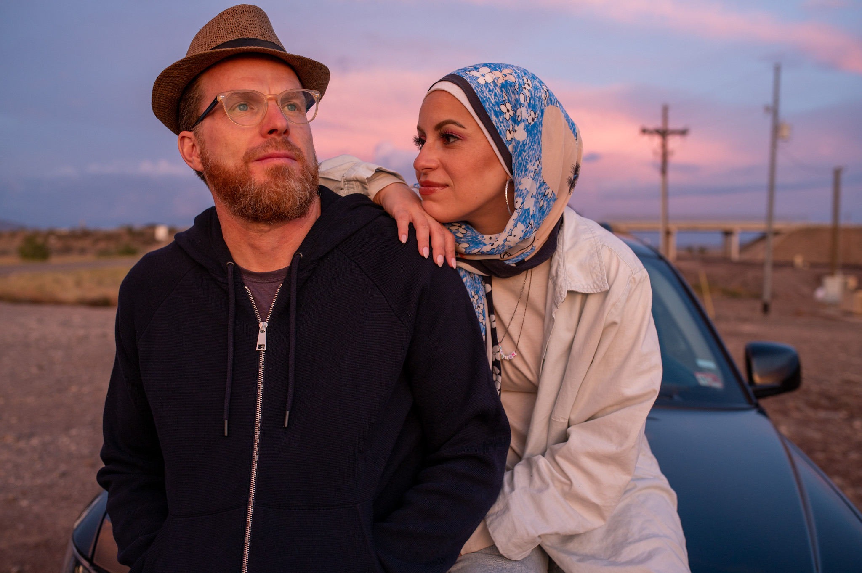
Sebastian Robins and Mona Haydar in THE GREAT MUSLIM AMERICAN ROAD TRIP (Credit: Adam McCall)
ARLINGTON, VA; MARCH 21, 2022 -- PBS invites viewers to buckle up for a cross-country journey along historic Route 66 in THE GREAT MUSLIM AMERICAN ROAD TRIP, premiering Tuesday, July 5, 10:00-11:00 p.m. ET (check local listings) on PBS, PBS.org and the PBS Video app. The new three-part documentary series follows a young Muslim American couple — rapper Mona Haydar and her husband Sebastian Robins — as they explore America’s “Mother Road” and its surrounding Muslim communities on a 2,500-mile drive from Chicago to Los Angeles.

Although they are practicing Muslims — Mona is Syrian American and Sebastian converted after meeting Mona — the couple, like most Americans, are unfamiliar with Islam’s deeps roots in America. This road trip is an opportunity for them not only to experience the breathtaking panoramas and iconic roadside attractions that have made Route 66 famous, but also to learn more about the history of their faith and what it means to be Muslim in America today.

“PBS is excited to share Mona and Sebastian’s journey along iconic Route 66, highlighting the diversity of Muslims in the United States,” said Bill Gardner, Vice President of Multiplatform Programming & Head of Development at PBS. “Muslim culture has always been a part of American history, a fact that THE GREAT MUSLIM AMERICAN ROAD TRIP explores throughout the heartland and its vibrant Muslim communities.”

Making more than a dozen stops, Mona and Sebastian meet authors, entrepreneurs, students and others, including Muhammad Ali’s daughter Maryam Ali in Chicago; Bosnian immigrants and restaurant owners Sulejman and Emmina Grbic in St. Louis; jazz musician Leon Rollerson in Tulsa; and award-winning actor and writer Amir Abdullah in Pasadena. Their conversations uncover the deep roots and impact of Islam and Muslims in American history and culture. By the time they reach the West Coast, the couple have a better understanding of themselves, their relationship and the centuries-long Muslim experience in America.

“Who knew that one of the first non-indigenous people to set foot in North America was a Moroccan explorer or that a Syrian camel driver helped survey the very road that has provided millions of American tourists their kicks on Route 66?” said Alex Kronemer, director and producer of THE GREAT MUSLIM AMERICAN ROAD TRIP. “It was an amazing and always-surprising experience to join hip-hop sensation Mona Hayder and her husband Sebastian Robins as they explored both their Muslim roots and Route 66. People will never view Muslim Americans the same way again."

THE GREAT MUSLIM AMERICAN ROAD TRIP series and episode details:

Series Description:
A three-part documentary series, THE GREAT MUSLIM AMERICAN ROAD TRIP follows a millennial Muslim American couple on a cross-country journey along historic Route 66 as they explore Islam’s deep roots in America. Making more than a dozen stops between Chicago and Los Angeles, rapper Mona Haydar and her husband Sebastian Robins meet with authors, entrepreneurs, medical students, performers and others to better understand the centuries-long Muslim experience in the United States. This series highlights the diversity of Muslims across the nation and their contributions to history and culture, weaving a colorful story of what it means to be a Muslim in America today.

Episode 1: “Life is a Highway: Chicago to Joplin, Missouri (w.t.)”
Premieres Tuesday, July 5, 10:00 p.m. ET
Description: On the first leg of their big adventure, Mona and Sebastian discover Muslim stories from America’s heartland, a history dating back to the 1800s. Along the way, however, their relationship hits a few bumps in the road. Will this be the second honeymoon the couple is hoping for?

Episode 2: “A Bridge Over Troubled Waters: Tulsa to Albuquerque, New Mexico (w.t.)”
Premieres Tuesday, July 12, 10:00 p.m. ET
Description: Mona and Sebastian learn why so many African Americans converted to Islam in the early 20th century, how Muslims contributed to modern jazz and why Catholics and Muslims share an affinity for the Virgin Mary. Later, they meet young Muslim robotics students aiming to solve big challenges with technology. Mona and Sebastian celebrate their anniversary on the mountaintop where they met, but as the road takes its toll, stress breeds trouble.

Episode 3: “Back on the Road Again: Arizona, Nevada, California (w.t.)”
Premieres Tuesday, July 19, 10:00 p.m. ET
Description: As their three-week journey winds down, Mona and Sebastian visit the grave of a famous Syrian-born camel driver, find traces of America’s first Muslim explorer from the 1500s and stumble upon an unexpected community of Muslims living in Las Vegas. The Grand Canyon helps heal relationship rifts that have been growing over the past 2,000 miles.

For more information on THE GREAT MUSLIM AMERICAN ROAD TRIP visit www.pbs.org. Viewers are also encouraged to engage in online conversation about the series by tagging @PBS and using #MuslimRoadTripPBS on Facebook, Twitter and Instagram.

Produced by Unity Productions Foundation, THE GREAT MUSLIM AMERICAN ROAD TRIP is directed by Alex Kronemer (THE SULTAN AND THE SAINT). Hossam Aboul-Magd is the director of photography. Bill Gardner is the executive in charge for PBS.

About Mona Haydar and Sebastian Robins
Mona Haydar and Sebastian Robins first gained national and international attention for their 2015 “Ask a Muslim” project—a booth offering free donuts in exchange for dialogue and questions in the wake of the Paris and San Bernardino extremist attacks. A few years later, the video for Mona’s hip-hop anthem, “Hijabi (Wrap My Hijab),” went viral, gaining over 8 million views on YouTube, and was named one of the “20 Best Protest Songs of 2017” by Billboard. Together, the couple have been featured on NPR, CNN, The New York Times, BBC, People Magazine, BuzzFeed, Marie Claire, Glamour, Refinery 29 and many other publications. Sebastian has a background in education and a passion for sustainable farming. Mona has a master’s degree in Christian ethics and is a fierce advocate for civil rights and inclusivity.

About Unity Productions Foundation
Unity Productions Foundation (UPF) is a nonprofit 501(c)3 filmmaking organization that specializes in creating films and outreach programs designed to educate Americans about diverse Muslim experiences and to promote dialogue and understanding across cultures. UPF has produced nine documentary films for PBS, including MUHAMMAD: LEGACY OF A PROPHET (2002), American Black Film Festival Best Documentary winner PRINCE AMONG SLAVES (2008) and Emmy-nominated THE SULTAN AND THE SAINT (2016).

About PBS
PBS, with more than 330 member stations, offers all Americans the opportunity to explore new ideas and new worlds through television and digital content. Each month, PBS reaches over 120 million people through television and 26 million people online, inviting them to experience the worlds of science, history, nature and public affairs; to hear diverse viewpoints; and to take front row seats to world-class drama and performances. PBS’ broad array of programs has been consistently honored by the industry’s most coveted award competitions. Teachers of children from pre-K through 12th grade turn to PBS for digital content and services that help bring classroom lessons to life. Decades of research confirms that PBS’ premier children’s media service, PBS KIDS, helps children build critical literacy, math and social-emotional skills, enabling them to find success in school and life. Delivered through member stations, PBS KIDS offers high-quality educational content on TV – including a 24/7 channel, online at pbskids.org, via an array of mobile apps and in communities across America. More information about PBS is available at www.pbs.org, one of the leading dot-org websites on the internet, or by following PBS on Twitter, Facebook or through our apps for mobile and connected devices. Specific program information and updates for press are available at pbs.org/pressroom or by following PBS Communications on Twitter.

– PBS –

MEDIA CONTACTS:

PJ Feinstein, PBS
pjfeinstein@pbs.org; 571-481-8035

Brandii M. Toby-Leon, Bullseye Communications
brandii.leon@bullseyecomm.com; 865-963-2418

Heather Marohn, Bullseye Communications
heather.marohn@bullseyecomm.com; 908-268-3770

For images and additional up-to-date information on THE GREAT MUSLIM AMERICAN ROADTRIP and other PBS programs, visit PBS PressRoom at pbs.org/pressroom.

