From Alaska to Massachusetts, Meet the Home Cooks Competing in Season 3 of THE GREAT AMERICAN RECIPE

New Season Premieres Mondays, June 17-August 12 on PBS and Streaming on PBS.org and the PBS App

New Judges Tim Hollingsworth and Frances Lam Join
Judge Tiffany Derry and Host Alejandra Ramos

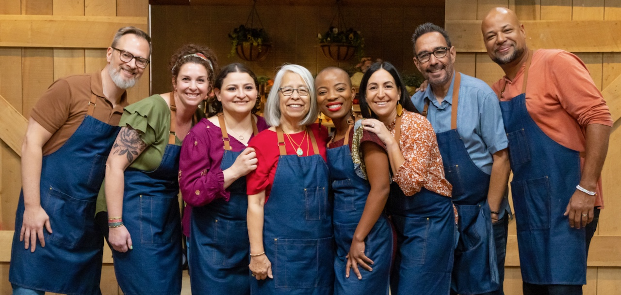

ARLINGTON, VA; May 7, 2024 – Today, PBS announced the eight home cooks from across America who will showcase their culinary talents in Season 3 of THE GREAT AMERICAN RECIPE, the upbeat cooking competition that celebrates the multiculturalism that makes American food so vibrant and delicious. With a wide-ranging variety of cooking styles influenced by their varied backgrounds — from Alaskan to African, Chinese to Sicilian, Southern, German, Mexican and more, Season 3’s contestants represent the unique diversity of American home cooking.

Hosted by Alejandra Ramos, Season 3 of THE GREAT AMERICAN RECIPE features two new judges and a new location. Tim Hollingsworth, award-winning chef and Los Angeles restaurateur, and Francis Lam, host of public radio's "The Splendid Table," join returning host Alejandra Ramos and judge Tiffany Derry in Nashville, Tennessee. Each week, after two challenges, the judges will determine which home cook has the winning dish and, in the final week, the top three will compete for a chance to win this year’s competition. The eight-episode series premieres Mondays, June 17 through August 12, 2024, 9:00-10:00 p.m. ET (check local listings) on PBS, PBS.org and the PBS App.

Meet the Contestants

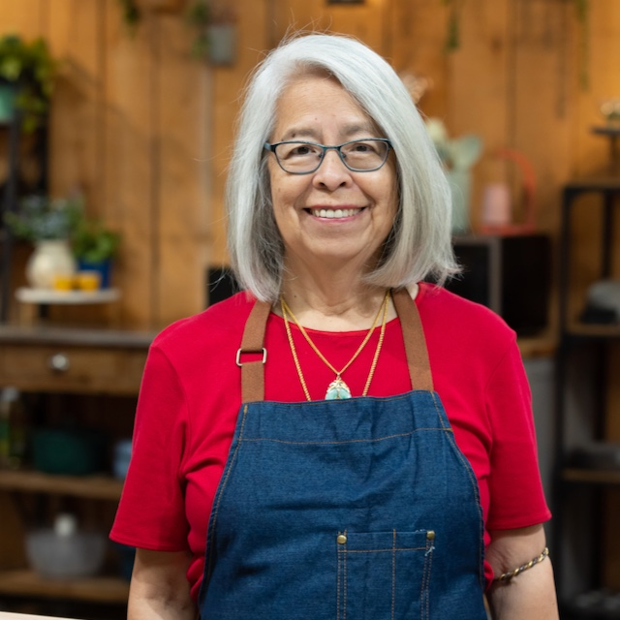
Mae Chandran (Malibu, California) was born in Guangzhou (Canton) in Southern China. At the age of three, she and her mother left China for Hong Kong. When she was eight, Mae left Hong Kong for Fall River, Massachusetts, to join her family, who lived above the Chinese-American restaurant they operated. Although Mae was immersed in the world of cooking (specifically Cantonese cuisine) from a young age, it wasn’t until she met and married her Sri Lankan husband that she began exploring the use of more spices and more "heat" in her recipes. Now with two grown children, Mae and her husband are enjoying retirement while she keeps busy working on their garden, which has been featured in The Malibu Times, making her international award-winning marmalade, and working on her memoirs. Mae’s signature dish is her Cantonese BBQ Chicken made with chicken thighs, Chinese brown bean sauce, hoisin sauce, and sriracha sauce.

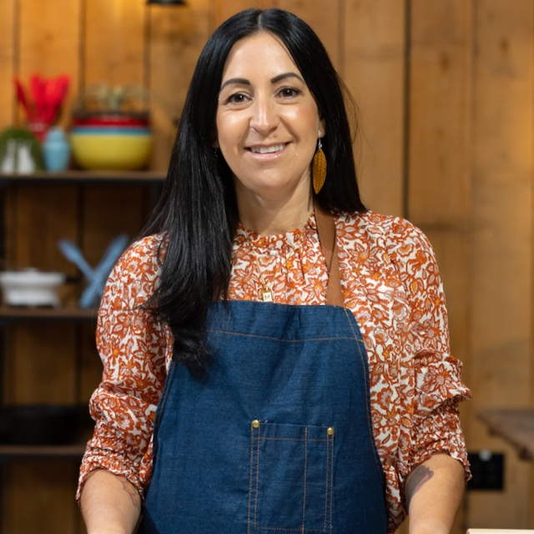
Marcella DiChiara (Franklin, Massachusetts) is a first-generation American whose passion for her Sicilian roots comes through in every dish she prepares. Her mother came to the United States with her family at age ten, and her dad immigrated to the United States in his late twenties. Growing up in Connecticut, Marcella spent every summer with her family, including her three siblings, back in Sicily. These experiences informed how she viewed cooking and the importance of family and community gathering around the table. Marcella works as an E-Commerce executive but never misses an opportunity to get in the kitchen and prepare a meal for her husband and two children. She prides herself on cooking traditional Sicilian dishes based on her mother’s recipes while using fresh, Mediterranean-inspired local produce. Marcella’s signature dish is Arancini al Ragu (Risotto Balls with Meat Sauce).

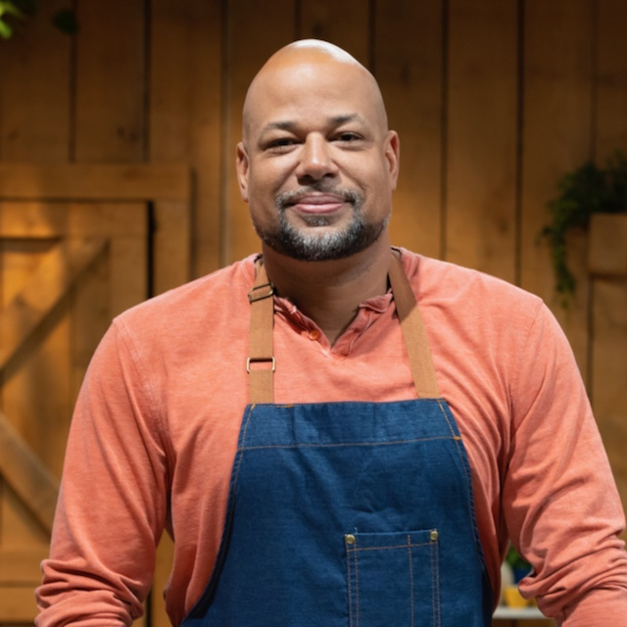
Tim Harris (Fort Mill, South Carolina) grew up living all over the world as a “military brat” until his father retired from a 27-year career in the US Air Force, and the family settled back in the Carolinas when Tim was 12. Influenced by his Dutch mother, as well as his paternal Southern Grandmama’s cooking, Tim developed an appreciation and a taste for many different types of cuisines at an early age. Now married with two children and a career in insurance, Tim uses his cooking to bring people together and spread community and positivity through his dishes. Creative and willing to try anything in the kitchen, he loves to grill, smoke meat, and feature fresh seafood from the Carolinas’ coastal waters along with bold flavors. Tim’s signature dish is his Lowcountry-Style Shrimp and Cheesy Grits.

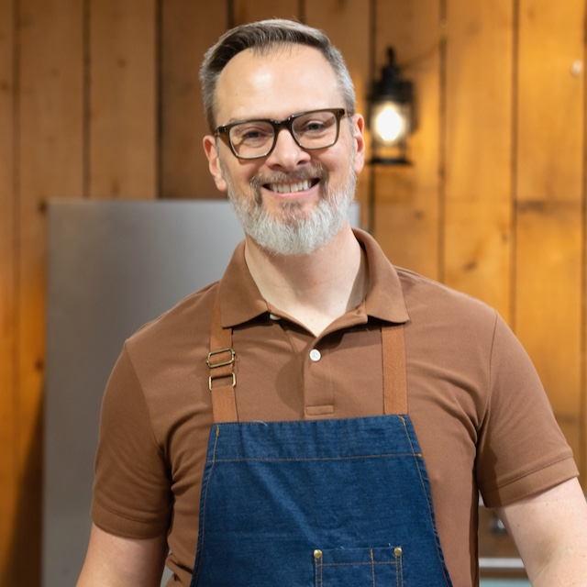
Doug Heilman (Pittsburgh, Pennsylvania) is a training consultant who grew up on a farm in western Pennsylvania. With German roots from both of his grandfathers, Doug fondly remembers his maternal grandmother cooking what she referred to as “peasant food,” taking their traditional German recipes and making them with the produce and other ingredients they farmed. In his cooking, Doug draws inspiration from his German heritage (often utilizing his family’s handwritten recipe cards), the thriving and eclectic Pittsburgh food scene, and his husband’s Italian roots. He’s a frequent guest on local news, where he does monthly cooking segments and loves to host delectable dinner parties with his husband for friends and family. Doug’s signature recipe is Pickle-Brined Chicken Schnitzel.

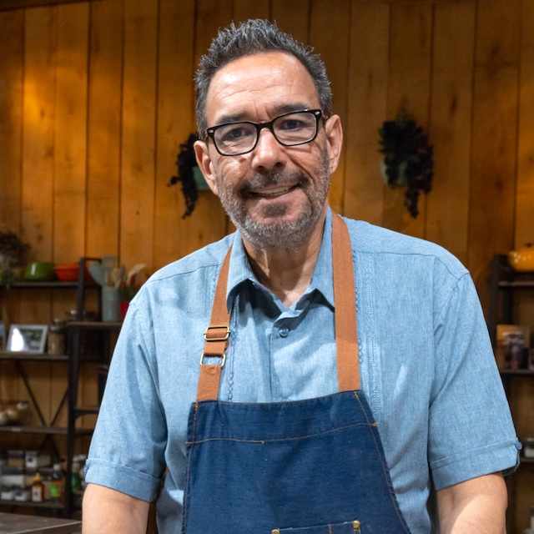
Jon Hinojosa (San Antonio, Texas) was born and raised in El Paso, Texas, to proud Mexican parents. Tragically, both of Jon’s parents passed away when he was young, so learning to cook began out of necessity. It quickly blossomed into a passion as he worked in local restaurants – starting as a dishwasher and eventually serving as manager. Now with a family of his own and a proud dad of three adult daughters, he feels it’s more important than ever to celebrate their roots and fully embrace what it means to be Mexican-American. He extended his nurturing role to the work he did as Founding Director of a San Antonio-based youth organization that advocates for marginalized communities through a series of arts and culture programs. As he looks forward to his next adventures, his focus and work will always center on the arts, culture, and community. Jon’s signature dish is Green Chicken Enchiladas served with Spanish Rice.
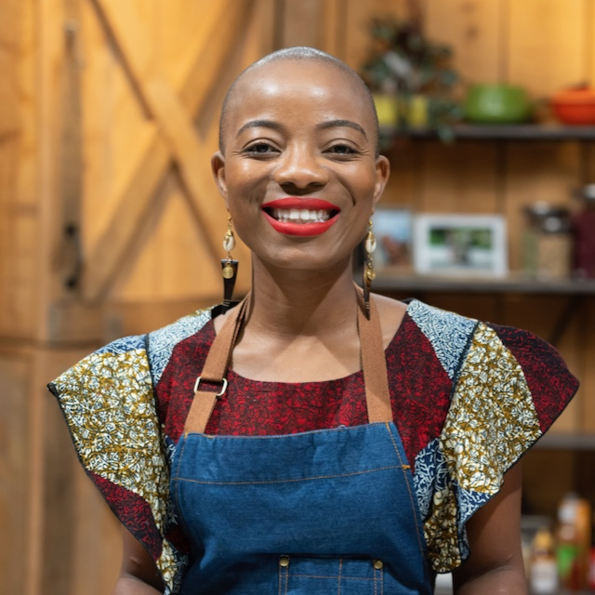
Adjo Honsou (St. Louis, Missouri), originally from Togo, West Africa, combines her heritage with her passion for food. She immigrated to the United States at the age of 14 and, introduced to the art of cooking traditional West African dishes by her grandmother, Adjo's culinary skills flourished. However, sourcing authentic African ingredients in Missouri proved to be a formidable task. Undeterred, she embarked on a journey of exploration and experimentation, tirelessly researching and discovering local substitutes to recreate the flavors of her homeland. Today, Adjo proudly shares her love for West African cuisine with the St. Louis community and beyond. A scientist and single mother of two, she balances her professional responsibilities and familial duties while nurturing her entrepreneurial spirit. Two years ago, she started her food truck showcasing Togolese specialties at local events and festivals. Among her signature dishes is Oxtail Palm Nut Stew, a tantalizing fusion of oxtail, aromatic curry sauce, palm nut puree, and fiery habanero peppers.
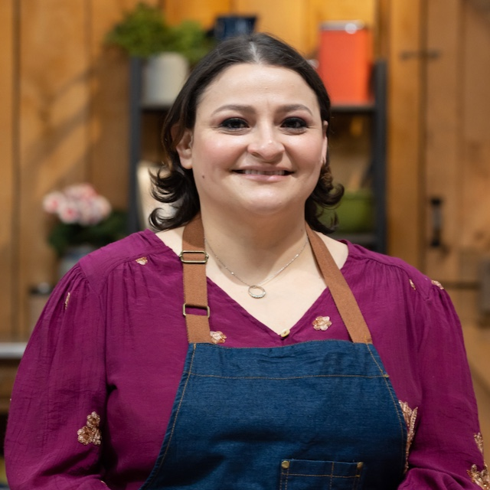
Ingrid Portillo (Charlotte, North Carolina) was born in El Salvador in the mid-1980s. Her father was a farmer and rancher whose dream was for his children to continue that tradition, but Ingrid and her family were forced to flee to the United States to escape the Salvadoran Civil War. Ingrid credits her grandmother as her cooking inspiration, and she keeps her memory and legacy alive through her own cooking. Ingrid considers herself a lifelong PBS fan, having learned English and many cooking skills by watching PBS programs. After meeting her husband and having two kids, they relocated to North Carolina, outside of Charlotte. It is incredibly important for Ingrid that her children embrace their Salvadoran roots and honor the memory of their ancestors, especially those who didn't survive the war. Ingrid's signature dish is Pupusas with Curtido and Salsa Maíz — corn tortillas stuffed with braised meat and served with pickled cabbage and salsa.

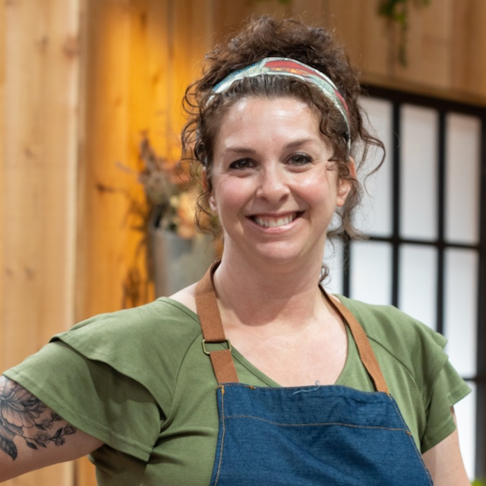
Kim Sherry (Anchorage, Alaska) is an artist who grew up in the small town of King Salmon as a fourth-generation Alaskan. Coming from a family of subsistence hunters and fishers, Kim is an avid gardener who has always had an appreciation for the outdoors and a reverence for the wildlife that sustained their community. Kim has two teen daughters and credits her husband, Bruce, for expanding her culinary repertoire and introducing her to the global flavors that influence much of her cooking. While comfort food is her go-to, Kim is also a skilled baker and frequently uses a sourdough starter that’s been in her family for more than one hundred years! Kim’s signature dish is a Salmon Banh Mi.

Season 3 of THE GREAT AMERICAN RECIPE was filmed at GREEN DOOR GOURMET, a 350-acre farm, on-farm market, and agritourism destination in Nashville, Tennessee. THE GREAT AMERICAN RECIPE is co-produced for PBS by VPM and Objective Media Group America. Steve Humble is the Executive in Charge for VPM. Zara Frankel is the Executive in Charge for PBS. At Objective Media Group America, an All3Media company, Alyssa Hastrich is Showrunner, Layla Smith and Jilly Pearce are Executive Producers and Erin Flynn is Senior Vice President of Current Series.

About VPM
As Virginia’s home for public media, VPM connects nearly 2 million people across Central Virginia and the Shenandoah Valley to insightful programming in arts and culture, history, science, news, and education. VPM operates public television stations VPM PBS, VPM Plus, VPM PBS KIDS, lifestyle channel VPM Create and international program channel VPM WORLD, as well as Richmond NPR station VPM News (88.9 FM) and VPM Music (107.3 FM, 93.1 FM and 88.9-HD2). In the Northern Neck (89.1 FM) and Southside Virginia (90.1 FM), listeners receive a combination of news and music. Audiences can access VPM online at VPM.org and on Facebook, Twitter, Instagram and YouTube.

About OBJECTIVE MEDIA GROUP AMERICA
Objective Media Group America is the U.S. arm of Objective Media Group. An LA-based All3Media America company, OMG America is led by President Jilly Pearce in creating and producing original entertainment and reality formats, including “Elf on the Shelf: Sweet Showdown (The Food Network) “Lingo” (returning for season 2 on CBS), “The Cube” (TBS), “12 Dates of Christmas” (HBO Max), “Worst Cooks in America” (The Food Network) and more. Objective Media Group, an All3Media company, is headquartered in London and headed up by CEO Layla Smith.

About PBS
PBS, with more than 330 member stations, offers all Americans the opportunity to explore new ideas and new worlds through television and digital content. Each month, PBS reaches over 42 million adults on linear primetime television, more than 15 million users on PBS-owned streaming platforms, and 56 million people view PBS content on social media, inviting them to experience the worlds of science, history, nature, and public affairs; to hear diverse viewpoints; and to take front-row seats to world-class drama and performances. PBS’s broad array of programs has been consistently honored by the industry’s most coveted award competitions. Teachers of children from pre-K through 12th grade turn to PBS LearningMedia for digital content and services that help bring classroom lessons to life. As the number one educational media brand, PBS KIDS helps children 2-8 build critical skills, enabling them to find success in school and life. Delivered through member stations, PBS KIDS offers high-quality content on TV — including a PBS KIDS channel — and streaming free on pbskids.org and the PBS KIDS Video app, games on the PBS KIDS Games app, and in communities across America. More information about PBS is available at PBS.org, one of the leading dot-org websites on the internet, Facebook, Instagram, or through our apps for mobile and connected devices. Specific program information and updates for press are available at pbs.org/pressroom or by following PBS Communications on X (formerly Twitter).

– PBS –
CONTACTS:

Atiya Frederick, PBS, anfrederick@pbs.org

Cara White / Mary Lugo, CaraMar, Inc.
cara.white@mac.com; lugo@negia.net

For screeners, images and additional information visit PBS PressRoom at pbs.org/pressroom.

