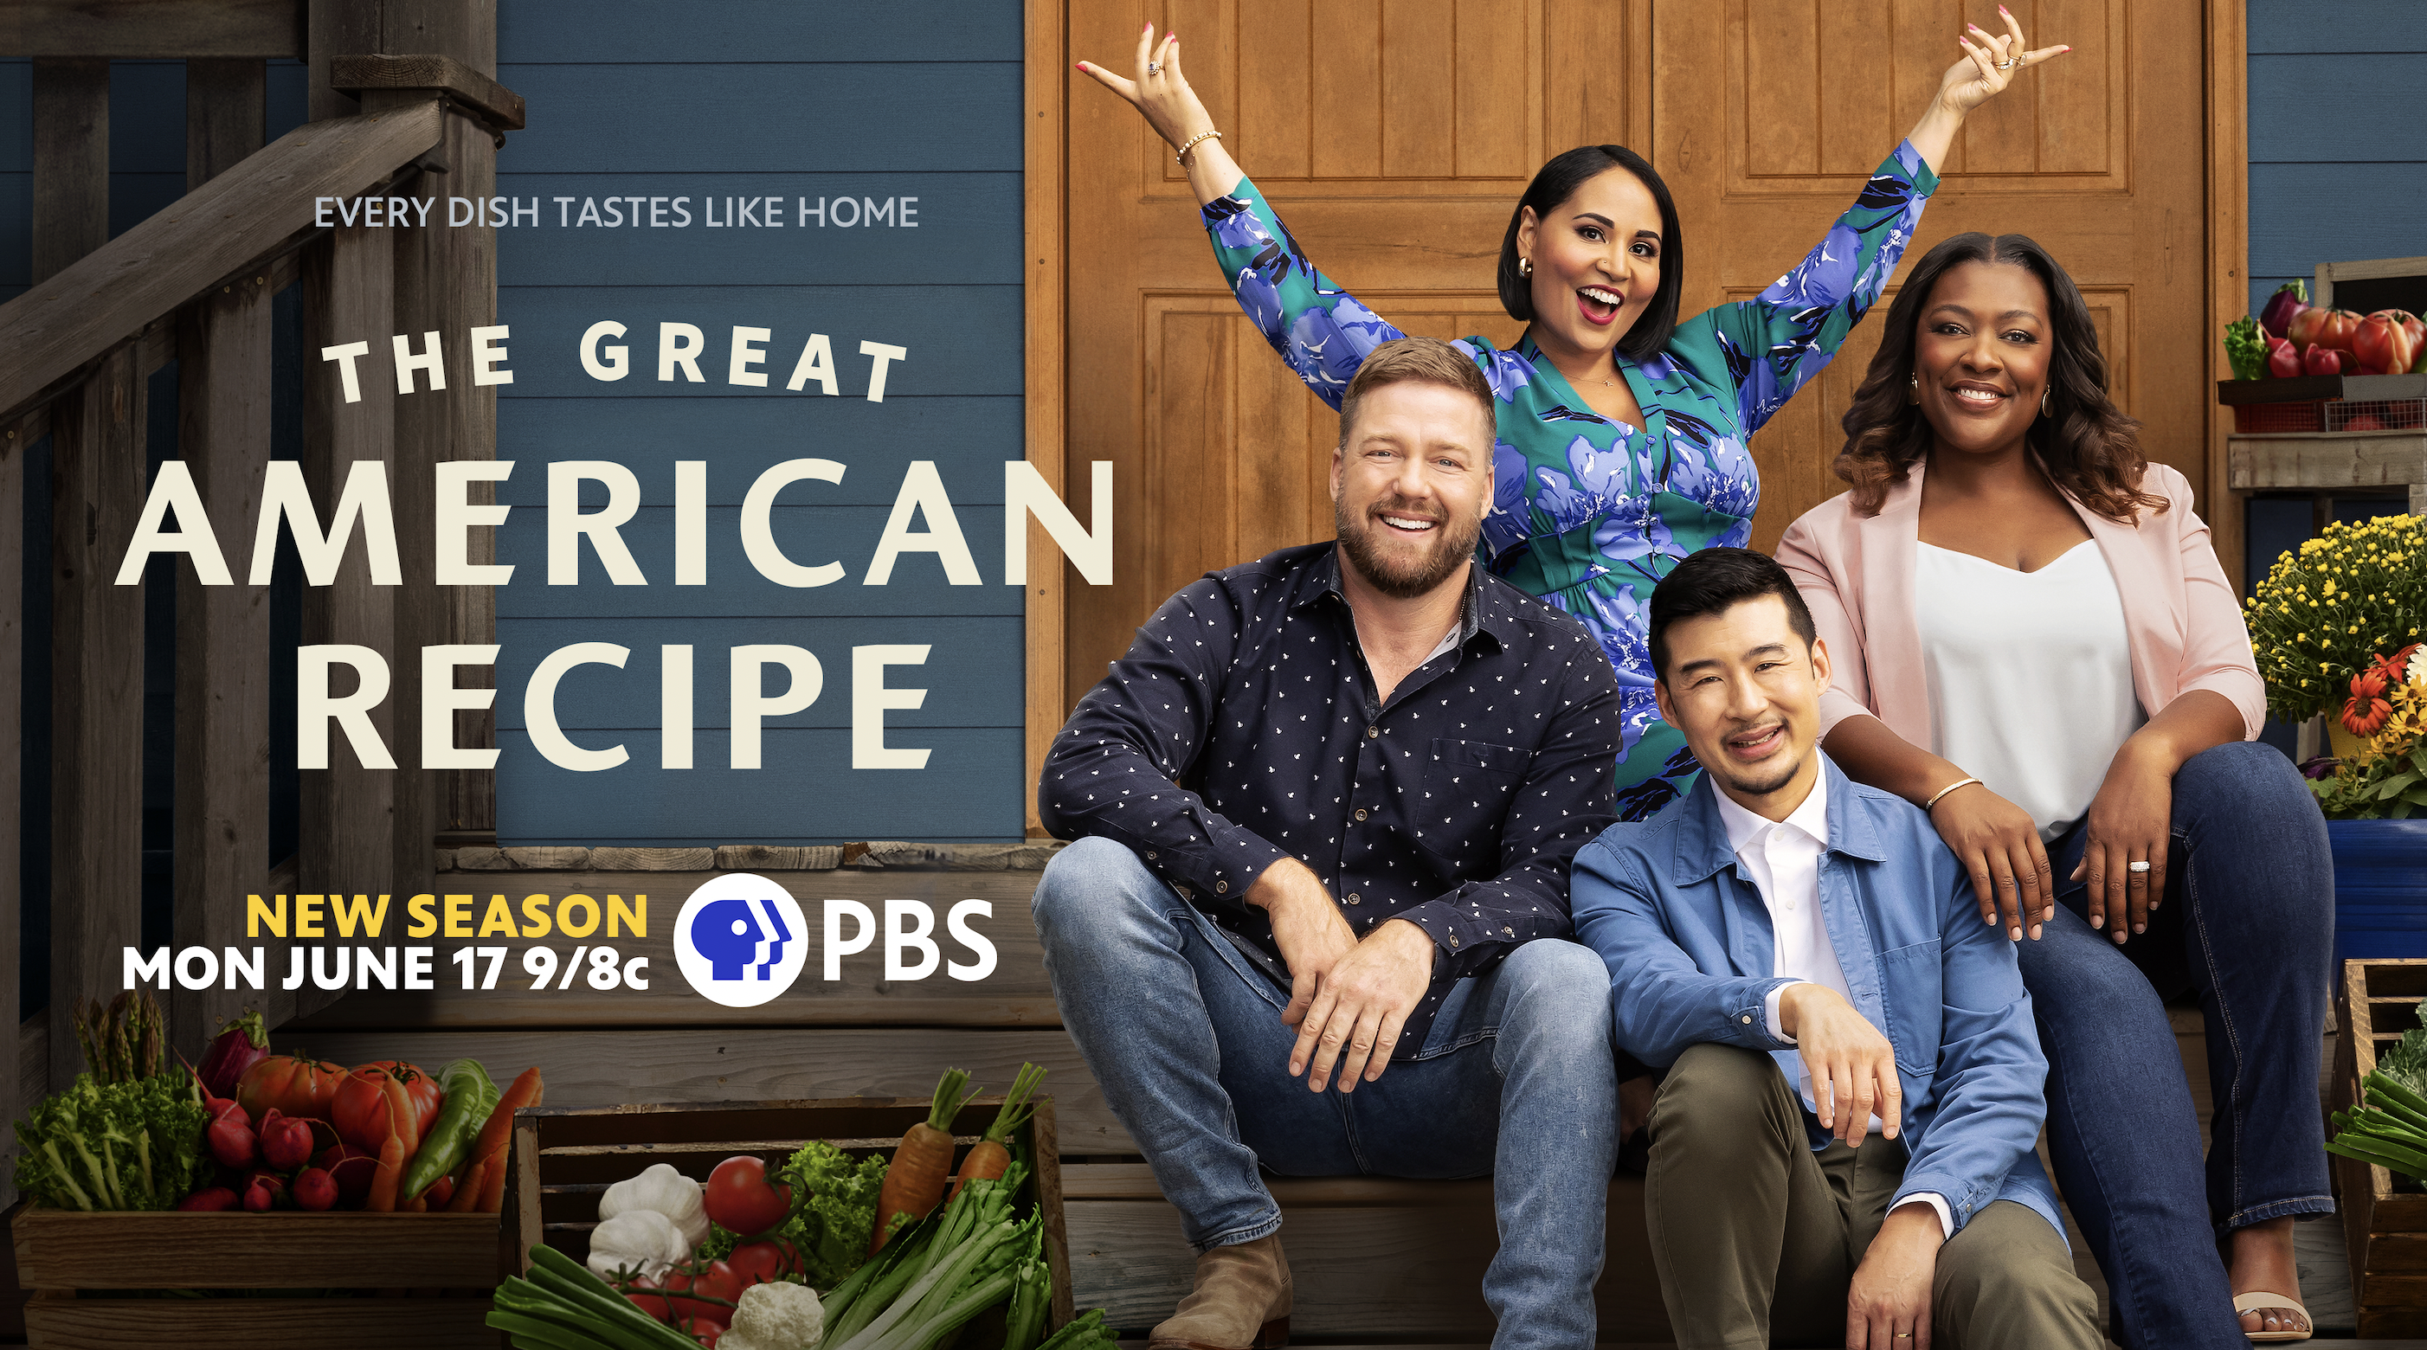

Season 3 of THE GREAT AMERICAN RECIPE Premieres Mondays, June 17-August 12 on PBS and Streaming on PBS.org and the PBS App

New Judges Tim Hollingsworth and Francis Lam Join
Judge Tiffany Derry and Host Alejandra Ramos

ARLINGTON, VA; Feb. 28, 2024 – Season 3 of PBS’s popular cooking competition series THE GREAT AMERICAN RECIPE premieres Monday, June 17 with eight new home cooks, two new judges and one new location. Award-winning chef and Los Angeles restaurateur Tim Hollingsworth and Francis Lam, host of public radio’s “The Splendid Table,” are new judges for Season 3, joining returning host Alejandra Ramos and judge Tiffany Derry at a new filming location in Nashville, Tennessee. The eight-episode series premieres Mondays, June 17 through August 12, 2024, 9:00-10:00 p.m. ET (check local listings) on PBS, PBS.org and the PBS App.

An upbeat cooking competition that spotlights the amazing variety of tastes and traditions found across the country, THE GREAT AMERICAN RECIPE celebrates the roots of America’s diverse cuisine. Season 3 will feature eight new talented home cooks preparing their most beloved recipes. Each week the judges will determine which home cook has the winning dish and, in the final week, the top three will compete for a chance to win this year’s competition.

"Season 3 of THE GREAT AMERICAN RECIPE will introduce audiences to several new faces and provide some fun, unexpected twists,” said VPM Chief Content Officer Steve Humble. “With community, tradition and culinary diversity at the heart of the show, the new season remains faithful to these ideas while highlighting new cuisines and experiences.”

“We are thrilled for the return of THE GREAT AMERICAN RECIPE, featuring new faces and a fresh location for Season 3,” said Zara Frankel, Senior Director of Programming and Development, General Audience Programming at PBS. “Since its start, this friendly competition series has proven itself to be a delicious hit, resonating with audiences across the country. We are excited to welcome Tim and Francis to the family and look forward to meeting a whole new group of home cooks this season.”

Season 3 of THE GREAT AMERICAN RECIPE was filmed at GREEN DOOR GOURMET, a 350-acre farm, on-farm market, and agritourism destination in Nashville, Tennessee. THE GREAT AMERICAN RECIPE is co-produced for PBS by VPM and Objective Media Group America. Steve Humble is the Executive in Charge for VPM. Zara Frankel is the Executive in Charge for PBS. At Objective Media Group America, an All3Media company, Alyssa Hastrich is Showrunner, Layla Smith and Jilly Pearce are Executive Producers and Erin Flynn is Senior Vice President of Current Series.

About the Host and Judges

Alejandra Ramos (Host) is a television host, TODAY Show contributor, and writer. Known for her vibrant, playful culinary point of view, and passion for style both in and out of the kitchen, Alejandra’s ability to inspire in a way that is fun and approachable has made her a favorite with audiences nationwide. In addition to her broadcast work, Alejandra hosts digital cooking series and holiday specials on NBC’s streaming app Peacock. As a writer, Alejandra contributes original recipes and essays to a number of publications; her work has appeared on NBCNews.com, Cosmopolitan, The Kitchen, Real Simple, O Magazine, and Saveur. A native New Yorker of Puerto Rican descent, her Latina heritage proudly informs her work, providing a fresh and authentic perspective across platforms. In recognition of her work, Alejandra was named a “Rising Latina Food Star” by NBC News, “One to Watch” by Latina Magazine, and one of HOLA! USA’s Top 100 Latina Powerhouses in 2021.

Tiffany Derry (Judge) is the founder of Tiffany Derry Concepts and co-founder of T2D Concepts, the Texas-based purpose-driven hospitality group behind Roots Chicken Shak, Roots Southern Table, Radici and ‘Shef Tiffany spice and apparel line. Tiffany stepped into the spotlight when she appeared on Bravo’s Top Chef Season 7, earning the title of “fan favorite” and finishing in the top four. Derry has also appeared on Top Chef: All-Stars, where she was again a finalist, and was a series host on Spike TV’s Hungry Investors and Bar Rescue alongside Jon Taffer.. In addition to The Great American Recipe, you can find Tiffany on Bobby’s Triple Threat and Worst Cooks in America on The Food Network.

Tiffany’s authentic approach to Southern cooking landed her on the 2022 James Beard Award finalist list in two categories – Best Chef: Texas and Best New Restaurant for Roots Southern Table. Outside of her restaurants, Tiffany is a fierce advocate for social justice and equity across gender, race and food access. She serves as a member of Les Dames d’Escoffier and is a spokesperson for the James Beard Foundation’s sustainability efforts, an ambassador for diabetes organization Novo Nordisk, and sits on the Board of Directors for Food Policy Action.

Tim Hollingsworth (Judge) is an award-winning chef and restaurateur in Los Angeles.
In 2015, he opened Otium, a contemporary American restaurant featuring a sophisticated yet accessible menu with eclectic, vibrant flavors inspired by the wood fire and global influences. He is currently working on expanding the Otium brand in other major cities. He is also the co-founder of a concept called Chain with B.J. Novak, which reimagines familiar chain restaurant favorites.

In 2001, Hollingsworth began as a commis chef at The French Laundry in Napa Valley, where he learned from former chefs de cuisine Eric Ziebold and Corey Lee. In 2004, Thomas Keller selected Hollingsworth as part of a team that trained for the opening of his New York restaurant Per Se. After returning to The French Laundry, Hollingsworth was promoted to sous chef in 2005 and in 2009, to chef de cuisine. Hollingsworth has won multiple awards, including the 2010 James Beard Foundation Rising Chef of the Year Award, the 2010 San Francisco Chronicle Rising Star Chef, and the 2009 Bocuse d'Or, where he placed sixth. In 2018, he competed and won Netflix’s The Final Table, a global culinary competition series.

Born in Houston, Texas, his family moved to Placerville, California, in 1980. Raised as a Southern Baptist in Texas, religion and family dinners were a large part of his upbringing. He currently lives in Los Angeles with his wife and four kids.

Francis Lam (Judge) is the host of public radio’s The Splendid Table, produced by American Public Media. Lam is the former “Eat” columnist for The New York Times Magazine and is Vice President and Editor in-Chief at Clarkson Potter, a division within Penguin Random House that is a leader in cookbook publishing. For two seasons, Lam was a regular judge on Bravo’s hit show, Top Chef Masters.
Lam was born to Chinese immigrant parents living in New Jersey and working in Manhattan's Chinatown, where they operated a small garment factory. Lam remembers trying to hide his "stinky lunches" from schoolmates and that he "wanted to eat what white people ate.”
Lam attended the University of Michigan and then graduated first in his class from The Culinary Institute of America (CIA) in 2003. While at CIA, he wrote emails to friends describing his experiences. After the emails began to circulate, he was contacted by an editor at Financial Times who asked him to write for the publication. In 2004, he met Gourmet editor Ruth Reichl and began freelancing for them. He went on to write for Food & Wine, Salon and Bon Appétit. Lam lives with his wife and daughter in New York City.

About VPM
As Virginia’s home for public media, VPM connects nearly 2 million people across Central Virginia and the Shenandoah Valley to insightful programming in arts and culture, history, science, news, and education. VPM operates public television stations VPM PBS, VPM Plus, VPM PBS KIDS, lifestyle channel VPM Create and international program channel VPM WORLD, as well as Richmond NPR station VPM News (88.9 FM) and VPM Music (107.3 FM, 93.1 FM and 88.9-HD2). In the Northern Neck (89.1 FM) and Southside Virginia (90.1 FM), listeners receive a combination of news and music. Audiences can access VPM online at VPM.org and on Facebook, Twitter, Instagram and YouTube.

About OBJECTIVE MEDIA GROUP AMERICA
Objective Media Group America is the U.S. arm of Objective Media Group. An LA-based All3Media America company, OMG America is led by President Jilly Pearce in creating and producing original entertainment and reality formats, including “Elf on the Shelf: Sweet Showdown (The Food Network) “Lingo” (returning for season 2 on CBS), “The Cube” (TBS), “12 Dates of Christmas” (HBO Max), “Worst Cooks in America” (The Food Network) and more. Objective Media Group, an All3Media company, is headquartered in London and headed up by CEO Layla Smith.

About PBS
PBS, with more than 330 member stations, offers all Americans the opportunity to explore new ideas and new worlds through television and digital content. Each month, PBS reaches over 42 million adults on linear primetime television, more than 15 million users on PBS-owned streaming platforms, and 56 million people view PBS content on social media, inviting them to experience the worlds of science, history, nature, and public affairs; to hear diverse viewpoints; and to take front-row seats to world-class drama and performances. PBS’s broad array of programs has been consistently honored by the industry’s most coveted award competitions. Teachers of children from pre-K through 12th grade turn to PBS LearningMedia for digital content and services that help bring classroom lessons to life. As the number one educational media brand, PBS KIDS helps children 2-8 build critical skills, enabling them to find success in school and life. Delivered through member stations, PBS KIDS offers high-quality content on TV — including a PBS KIDS channel — and streaming free on pbskids.org and the PBS KIDS Video app, games on the PBS KIDS Games app, and in communities across America. More information about PBS is available at PBS.org, one of the leading dot-org websites on the internet, Facebook, Instagram, or through our apps for mobile and connected devices. Specific program information and updates for press are available at pbs.org/pressroom or by following PBS Communications on X (formerly Twitter).

– PBS –

CONTACTS:

Atiya Frederick, PBS, anfrederick@pbs.org

Cara White / Mary Lugo, CaraMar, Inc.
cara.white@mac.com; lugo@negia.net

For images and additional up-to-date information on this and other PBS programs, visit PBS PressRoom at pbs.org/pressroom.

