Home Cook Brad Mahlof Wins Season 2 of
THE GREAT AMERICAN RECIPE

PBS Announces Season 3 to Premiere in Summer 2024

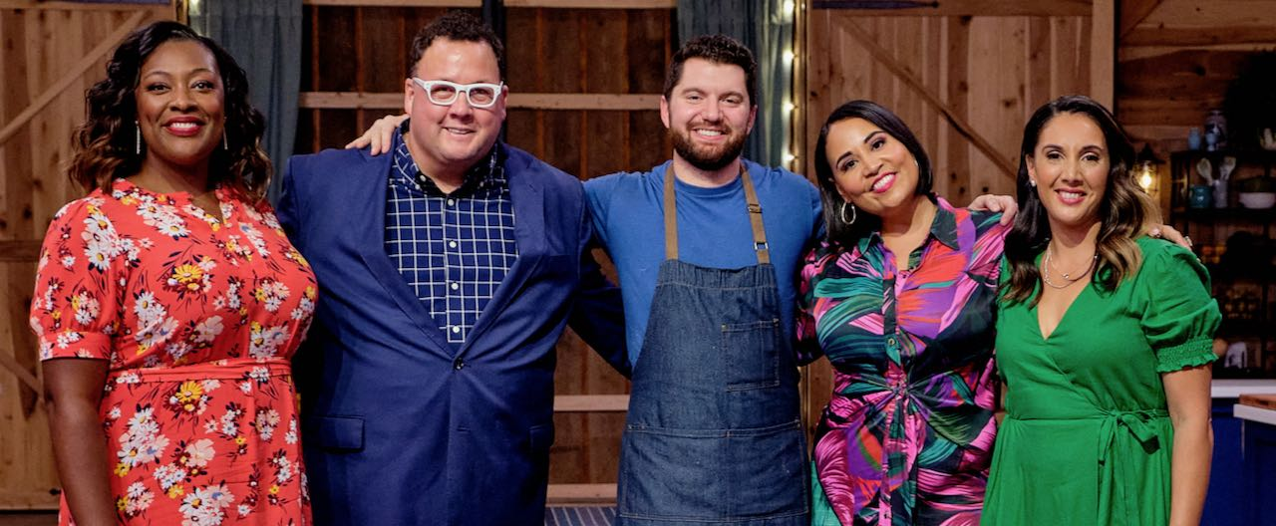
Left to right: Judges Tiffany Derry and Graham Elliot, winning contestant Brad Mahlof, host Alejandra Ramos, and Judge Leah Cohen. Credit: Courtesy of PBS

ARLINGTON, VA; August 8, 2023 – Brad Mahlof, a home cook from New York City whose cooking style honors both his Sephardic and Ashkenazi Jewish roots, is the winner of THE GREAT AMERICAN RECIPE Season 2, as revealed in the season finale, which premiered Monday, August 7. Brad’s father’s family is from Libya, while his mother’s family, originally from Europe, have been New Yorkers for generations. Brad’s mixed background gives him a well-rounded Jewish experience that heartily influences his food. His recipes, showcasing his Libyan, Israeli and Ashkenazi roots, won over host Alejandra Ramos and judges Leah Cohen, Tiffany Derry and Graham Elliot, frequently taking the top place. All episodes of Season 2 of THE GREAT AMERICAN RECIPE are currently streaming on PBS.org and the PBS app.

In addition, PBS today also announced that THE GREAT AMERICAN RECIPE has been renewed for an additional season. The third season, which will give a fresh crop of diverse home cooks from around the country the opportunity to showcase their beloved signature dishes, is set to premiere in Summer 2024. Production for Season 3 of the show, which is co-produced for PBS by VPM and Objective Media Group America, is scheduled to begin in Fall 2023.

“Last year audiences fell in love with this friendly competition series that celebrated diversity through the lens of food and story, and this year they came back for seconds, in increasing numbers,” said Zara Frankel, Senior Director of Programming and Development, General Audience Programming. “To date, over three million people have viewed each episode of THE GREAT AMERICAN RECIPE and Season 2 has garnered more than 600K full episode streams on PBS’s owned platforms and YouTube.* A big congratulations to Brad Mahlof for winning the second season of the series. We are thrilled that this show has resonated with so many and can’t wait for Season 3!”

“What makes this series special is the way it lifts up and embraces America's wonderful melting pot of cuisine,” said VPM Chief Content Officer Steve Humble. “We are thrilled that PBS is bringing THE GREAT AMERICAN RECIPE back for a third season and can't wait to share more heartfelt family stories that connect us through cooking.”

We are excited to be partnering again with PBS and VPM for Season 3 of THE GREAT AMERICAN RECIPE,” said Jilly Pearce, President, Objective Media Group America. “We’ll meet a new cast of talented home cooks from across the country, celebrating the diversity of American cuisine, and sharing their personal food stories that span generations and continents.”

The Great American Recipe Cookbook Season 2, the official series companion book, features Mahlof’s recipe for Mafrum and Salatim on the cover. The crown jewel of Libyan Jewish cuisine, the dish consists of meat-stuffed vegetables with salads and sides. Mafrum is traditionally made with potatoes, but Mahlof gives the dish his own unique twist by using eggplant. The cookbook includes more than 100 recipes from the cast, host and judges, along with personal stories, stills from the series and color photographs throughout. The cookbook is now available at Shop PBS, The VPM store and wherever books are sold.

THE GREAT AMERICAN RECIPE is an uplifting cooking competition that blends food, family and fun, highlighting the amazing variety of tastes and traditions found across the U.S., while capturing the roots of America’s diverse cuisine. Season 2 will be available for catch-up streaming through the end of 2023 on all station-branded PBS platforms, including PBS.org and the PBS app, available on iOS, Android, Roku, Apple TV, Amazon Fire TV, Android TV, Samsung Smart TV, Chromecast and VIZIO. Beginning in January 2024, all episodes will be available via PBS Passport. For more information about PBS Passport, visit the PBS Passport FAQ website.

THE GREAT AMERICAN RECIPE is co-produced for PBS by VPM and Objective Media Group America, an All3Media America company. Steve Humble is the Executive in Charge for VPM. Zara Frankel is the Executive in Charge for PBS. At Objective Media Group America, Alyssa Hastrich is Showrunner, Layla Smith and Jilly Pearce are Executive Producers.

Funding for THE GREAT AMERICAN RECIPE is provided by VPM, the Corporation for Public Broadcasting (CPB) and Plow & Hearth.
About VPM
As Virginia’s home for public media, VPM connects nearly 2 million people across Central Virginia and the Shenandoah Valley to insightful programming in arts and culture, history, science, news, and education. VPM operates public television stations VPM PBS, VPM Plus, VPM PBS KIDS, lifestyle channel VPM Create and international program channel VPM WORLD, as well as Richmond NPR station VPM News (88.9 FM) and VPM Music (107.3 FM, 93.1 FM and 88.9-HD2). In the Northern Neck (89.1 FM) and Southside Virginia (90.1 FM), listeners receive a combination of news and music. Audiences can access VPM online at VPM.org and on Facebook, Twitter, Instagram and YouTube.

About OBJECTIVE MEDIA GROUP AMERICA
Objective Media Group America is the U.S. arm of Objective Media Group. An LA-based All3Media America company, OMG America is led by President Jilly Pearce in creating and producing original entertainment and reality formats, including “Lingo” (CBS), “The Cube” (returning for season 2 on TBS), “Phrogger: Hider in My House” (Lifetime), “12 Dates of Christmas” (HBO Max), “Worst Cooks in America” (The Food Network), “Spring Baking Championship: Easter” (The Food Network) and more. Objective Media Group is headquartered in London and headed up by CEO Layla Smith.

About CPB
The Corporation for Public Broadcasting, a private, nonprofit corporation authorized by Congress in 1967, is the steward of the federal government’s investment in public broadcasting. It helps support the operations of more than 1,500 locally managed and operated public television and radio stations nationwide. CPB is also the largest single source of funding for research, technology and program development for public radio, television, and related online services. For more information, visit cpb.org, follow us on Facebook and LinkedIn and subscribe for email updates.

About PBS
PBS, with more than 330 member stations, offers all Americans the opportunity to explore new ideas and new worlds through television and digital content. Each month, PBS reaches over 42 million adults on linear primetime television, more than 15 million users on PBS-owned streaming platforms, and 56 million people view PBS content on social media, inviting them to experience the worlds of science, history, nature, and public affairs; to hear diverse viewpoints; and to take front-row seats to world-class drama and performances. PBS’s broad array of programs has been consistently honored by the industry’s most coveted award competitions. Teachers of children from pre-K through 12th grade turn to PBS LearningMedia for digital content and services that help bring classroom lessons to life. As the number one educational media brand, PBS KIDS helps children 2-8 build critical skills, enabling them to find success in school and life. Delivered through member stations, PBS KIDS offers high-quality content on TV — including a PBS KIDS channel — and streaming free on pbskids.org and the PBS KIDS Video app, games on the PBS KIDS Games app, and in communities across America. More information about PBS is available at PBS.org, one of the leading dot-org websites on the internet, Facebook, Instagram, or through our apps for mobile and connected devices. Specific program information and updates for press are available at pbs.org/pressroom or by following PBS Communications on Twitter.

– PBS –

CONTACTS:

Atiya Frederick, PBS, anfrederick@pbs.org

Cara White / Mary Lugo, CaraMar, Inc.
cara.white@mac.com; lugo@negia.net

For images and additional up-to-date information on this and other PBS programs, visit PBS PressRoom at pbs.org/pressroom.

* Source: Nielsen NPOWER, L+7, Reach & Frequency Program report, 1-minute qualifier; Google Analytics Media Starts for PBS owned platform streams; YouTube Creator Studio for YouTube views.

