THE GREAT AMERICAN RECIPE Returns With a New Season of Creative Home Cooks From Across the Country

Eight-Part Cooking Competition Series Premieres
Mondays, June 19-August 7, 2023

Host Alejandra Ramos and Judges Leah Cohen, Tiffany Derry
and Graham Elliot are Back for a Second Helping

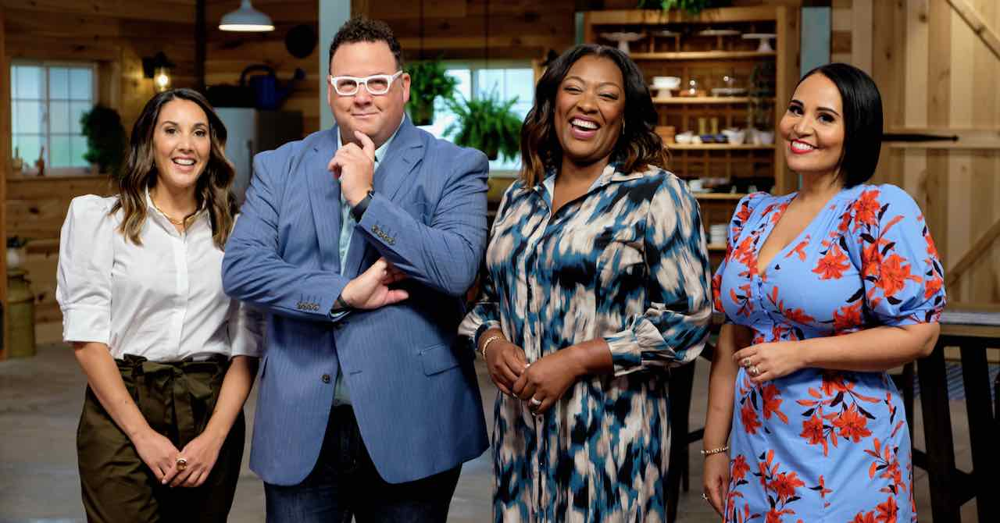
Left to right: Leah Cohen, Graham Elliot, Tiffany Derry and Alejandra Ramos.
Credit: Courtesy of PBS/VPM

Pasadena, CA; January 16, 2023 – Today at the Television Critics Association Winter Press Tour, PBS announced that Season 2 of the popular series THE GREAT AMERICAN RECIPE premieres Mondays, June 19-August 7, 9:00-10:00 p.m. ET (check local listings) on PBS, PBS.org and the PBS app. A fun and uplifting eight-part cooking competition that celebrates the multiculturalism that makes American food unique and iconic, Season 2 will introduce viewers to a new group of inventive home cooks who compete to wow the judges with their beloved signature dishes. Alejandra Ramos returns as host and renowned chefs Leah Cohen, Tiffany Derry and Graham Elliot are back as judges and mentors for Season 2.

“The first season of THE GREAT AMERICAN RECIPE was a multiplatform success, attracting younger and more diverse audiences to PBS,” said Zara Frankel, Senior Director of Programming and Development, General Audience Programming at PBS. “Viewers rooted for and connected with our wonderful home cooks from around the country, and we are delighted to launch a new season of this fan favorite with fresh faces, new recipes and heartwarming stories.”

“We couldn’t be more excited to launch the second season of THE GREAT AMERICAN RECIPE in June,” said Steve Humble, Chief Content Officer at VPM, co-producer of the series. “The team and cast had another great experience filming the show right here in Virginia. Being able to share the participants' touching personal stories through food is something we can all relate to. We found another batch of amazing home cooks from around the country, and we can’t wait to share another amazing array of dishes and family recipes with our audience.”

“We are excited to be partnering again with PBS and VPM for this celebration of everything that makes American cuisine so distinctive and diverse.” said Jilly Pearce, President, Objective Media Group America. “In Season 1, we experienced the culinary legacies of home cooks from the Midwest to Mexico. This season, our cooks traveled from all over the country to share their stories and most treasured recipes, from Native American bison short ribs, to Hawaiian loco moco, to Guyanese chicken curry.”

THE GREAT AMERICAN RECIPE blends food, family and fun, highlighting the amazing variety of tastes and traditions from across the U.S. while capturing the roots of America’s diverse cuisine. From family favorites passed down through generations to internationally influenced recipes that are becoming mainstays of American cuisine, the series mixes camaraderie with competition, revealing rich personal stories and the inspiration behind the contestants’ favorite recipes. As with the first season, one of the winner’s dishes will grace the cover of The Great American Recipe Cookbook Season 2, an official series cookbook, which will feature recipes from the contestants, the host and the judges.

THE GREAT AMERICAN RECIPE Season 2 will be available to stream on all station-branded PBS platforms, including PBS.org and the PBS app, available on iOS, Android, Roku, Apple TV, Amazon Fire TV, Android TV, Samsung Smart TV, Chromecast and VIZIO.

THE GREAT AMERICAN RECIPE is co-produced for PBS by VPM and Objective Media Group America. Steve Humble is the Executive in Charge for VPM. Zara Frankel is the Executive in Charge for PBS. At Objective Media Group America, Megan Bidner is Showrunner, Layla Smith and Jilly Pearce are Executive Producers and Alyssa Hastrich is Senior Vice President of Current Series.
Funding for THE GREAT AMERICAN RECIPE is provided by VPM and the Corporation for Public Broadcasting (CPB).

About VPM
As Virginia’s home for public media, VPM connects nearly 2 million people across Central Virginia and the Shenandoah Valley to insightful programming in arts and culture, history, science, news and education. VPM operates public television stations VPM PBS, VPM Plus, VPM PBS KIDS, lifestyle channel VPM Create and international program channel VPM WORLD, as well as Richmond NPR station VPM News (88.9 FM) and VPM Music (107.3 FM, 93.1 FM and 88.9-HD2). In the Northern Neck (89.1 FM) and Southside Virginia (90.1 FM), listeners receive a combination of news and music. Audiences can access VPM online at VPM.org and on Facebook, Twitter, Instagram and YouTube.

About OBJECTIVE MEDIA GROUP AMERICA
Objective Media Group America is the U.S. arm of Objective Media Group. An LA-based All3Media America company, OMG America is led by President, Jilly Pearce in creating and producing original entertainment and reality formats, including “Lingo” (CBS), “The Cube” (returning for season 2 on TBS), “Phrogger: Hider in My House” (Lifetime), “12 Dates of Christmas” (HBO Max), “Worst Cooks in America” (The Food Network), “Spring Baking Championship: Easter” (The Food Network) and more. Objective Media Group is headquartered in London and headed up by CEO Layla Smith.

About CPB
The Corporation for Public Broadcasting, a private, nonprofit corporation authorized by Congress in 1967, is the steward of the federal government’s investment in public broadcasting. It helps support the operations of more than 1,500 locally managed and operated public television and radio stations nationwide. CPB is also the largest single source of funding for research, technology and program development for public radio, television, and related online services. For more information, visit cpb.org, follow us on Twitter @CPBmedia, Facebook and LinkedIn and subscribe for email updates.

About PBS
PBS, with more than 330 member stations, offers all Americans the opportunity to explore new ideas and new worlds through television and digital content. Each month, PBS reaches over 120 million people through television and 26 million people online, inviting them to experience the worlds of science, history, nature, and public affairs; to hear diverse viewpoints; and to take front row seats to world-class drama and performances. PBS’s broad array of programs has been consistently honored by the industry’s most coveted award competitions. Teachers of children from pre-K through 12th grade turn to PBS for digital content and services that help bring classroom lessons to life. Decades of research confirms that PBS’s premier children’s media service, PBS KIDS, helps children build critical literacy, math, and social-emotional skills, enabling them to find success in school and life. Delivered through member stations, PBS KIDS offers high-quality educational content on TV — including a 24/7 channel — online at pbskids.org, via an array of mobile apps and in communities across America. More information about PBS is available at pbs.org, one of the leading dot-org websites on the internet, or by following PBS on Twitter, Facebook or through our apps for mobile and connected devices. Specific program information and updates for press are available at pbs.org/pressroom or by following PBS Communications on Twitter.

– PBS –

CONTACTS:

Atiya Frederick, PBS, anfrederick@pbs.org

Cara White / Mary Lugo, CaraMar, Inc.
cara.white@mac.com; lugo@negia.net

For images and additional up-to-date information on this and other PBS programs, visit PBS PressRoom at pbs.org/pressroom.

