Meet the Home Cooks From Across the USA in Season 2 of THE GREAT AMERICAN RECIPE

Eight-Part Cooking Competition Series Premieres
Mondays, June 19-August 7, 2023

Host Alejandra Ramos and Judges Leah Cohen, Tiffany Derry
and Graham Elliot Are Back for a Second Helping

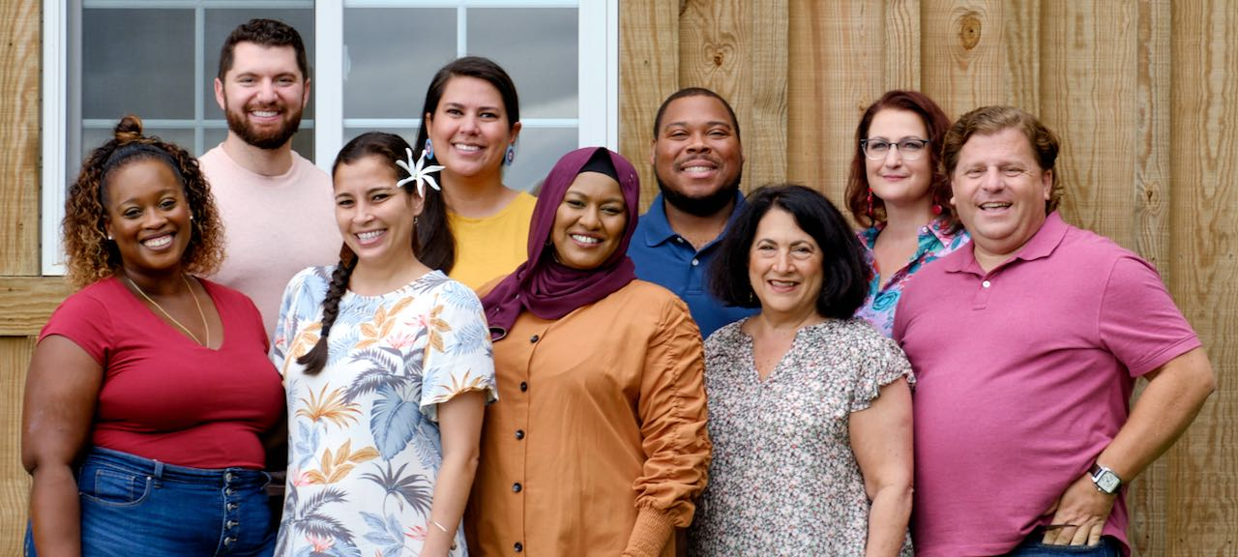

ARLINGTON, VA; May 10, 2023– PBS today announced the nine talented home cooks who will be showcasing their culinary expertise in Season 2 of THE GREAT AMERICAN RECIPE, the uplifting competition that celebrates the multiculturalism that makes American food so vibrant and unique. With a wide diversity of cooking styles influenced by their varied backgrounds — from Guyanese to Greek, Libyan to Lithuanian, Caribbean to Native American, Midwestern to Traditional Hawaiian, the contestants in Season 2 represent the delicious diversity of American home cooking.

Hosted by Alejandra Ramos, each episode challenges the cooks to showcase two of their beloved signature dishes as they compete to win the national search for “The Great American Recipe.” Judges Leah Cohen, Tiffany Derry, and Graham Elliot bring their professional insights and deep culinary knowledge to encourage and support the contestants along the way. THE GREAT AMERICAN RECIPE premieres Mondays, June 19-August 7, 9:00-10:00 pm ET (check local listings) on PBS, PBS.org and the PBS App.

About the Contestants

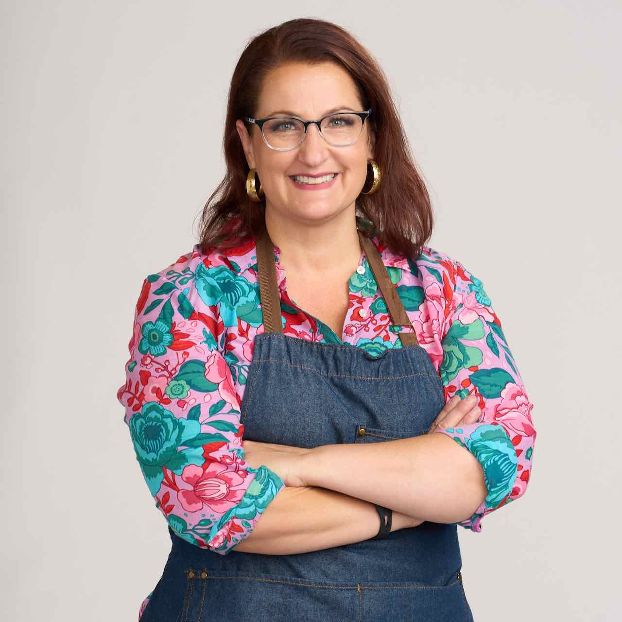
Khela Brewer (Overland Park, Kansas) inherited her love of fresh vegetables by spending summers in North Carolina with her garden-growing maternal grandmother. She loves experimenting in the kitchen and is an active member of several cooking groups — feeding people is not just her hobby, it’s her lifestyle. Khela always loved to cook, but her life pivoted when she joined a local Facebook foodie group. She met others who shared her passion for food and cocktails, made friends who changed her life, and was soon participating in cooking competitions. She had long struggled with her weight, but in 2018 drastically changed her cooking style, which led to new, healthier ways of preparing food, focusing on vegetables and creative salads. Khela is proud to represent Midwestern cuisine and wants to show the world that Kansas City offers more than BBQ. Her signature recipe is Stuffed Pork Tenderloin with risotto drizzled in drunken mushroom gravy with a seasonal veggie salad.

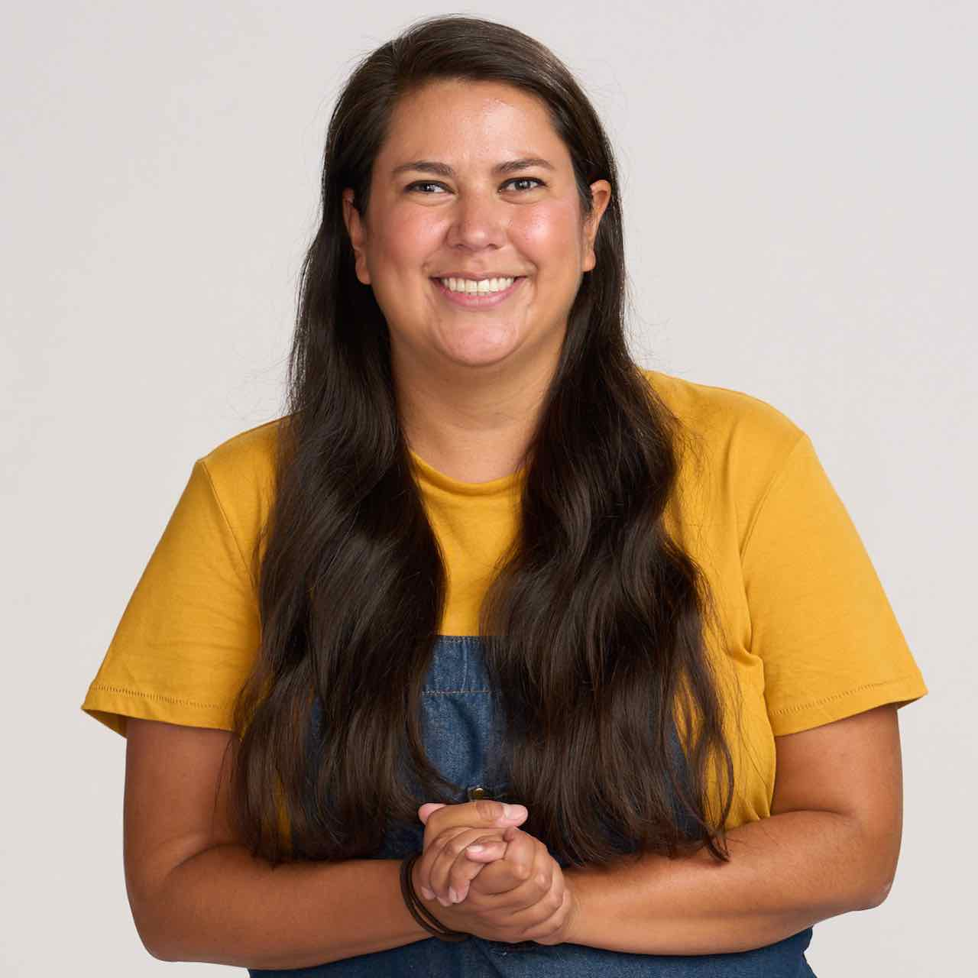
Maria Givens (Seattle, Washington) is a member of the Coeur d’Alene tribe in Idaho and grew up in her ancestral homelands on Lake Coeur d’Alene. She first learned about the importance of food in her community through her father’s work as a lawyer fighting for the ownership of the Coeur d’Alene lake as a means of food production for the entire reservation. When Maria wasn’t accompanying her father to court, she would go fishing and berry picking with her mother in the Idaho mountains. In college, Maria pursued degrees in both political science and American Indian studies. She has worked in the U.S. Senate, the National Congress of American Indians, and the Native American Agriculture Fund. There she helped pass legislation supporting food sovereignty for the Columbia River tribes, bringing her community closer to their ancestral food sources through federal policy. For Maria, food is vital in uniting her community and as a means of continuing to practice her culture. Maria’s signature recipe is Wood-Fired Salmon with Huckleberry Sauce cooked Coeur d’Alene style over bedsprings and an open fire.

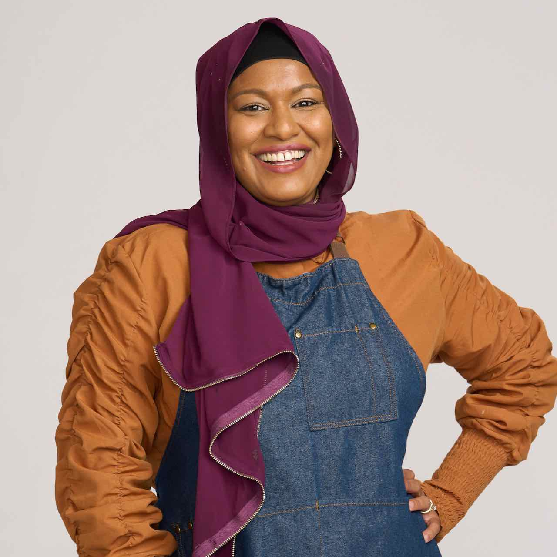
Salmah Hack (Orlando, Florida) was born and raised in Richmond Hill, New York, a Queens neighborhood known as Little Guyana. Salmah, whose parents emigrated in the 1980s, inherited a huge part of her family’s culture through food. A former British colony built on indentured servitude, Guyana and its cuisine reflect the influences of African, Indian, British, Portuguese, Chinese, Amerindian, and Dutch cultures. Salmah says that to understand Guyanese cuisine is to remember its history. Like her mother, Salmah has refined her culinary instincts so that she can cook without measuring or referencing a recipe. Guyanese cuisine is not widely known, and Salmah is proud to share it. Her signature recipe is Guyanese Chicken Curry, made with chicken, potatoes, and spices, including cardamom, dried Guyana thyme, garam masala, cumin and Wiri Wiri pepper.

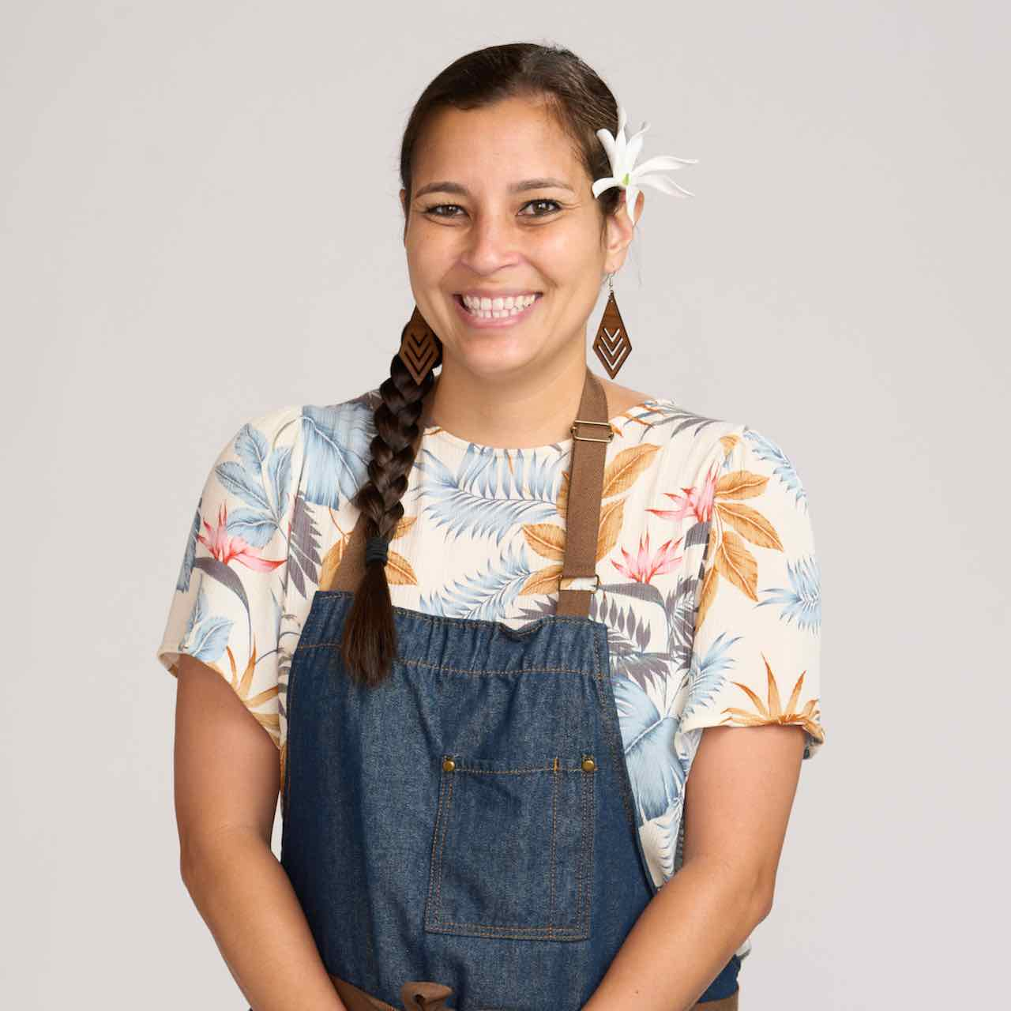
Relle Lum (Maui, Hawaii) is a Native Hawaiian. Born and raised in Maui, she grew up in a single-parent home. Traditional Hawaiian food is a staple in her everyday recipes and the foundation for her inventive fusion dishes. Relle has a vast knowledge of the many different cuisines that influence Hawaiian food and uses local, fresh island produce in her recipes. Relle says that food is life in Hawaii and hopes to preserve Hawaiian culture and cuisine for future generations. Her signature recipe is Loco Moco, a hamburger patty on a bed of white rice smothered with brown gravy and topped with an over-easy egg, which can be eaten for breakfast, lunch, or dinner.

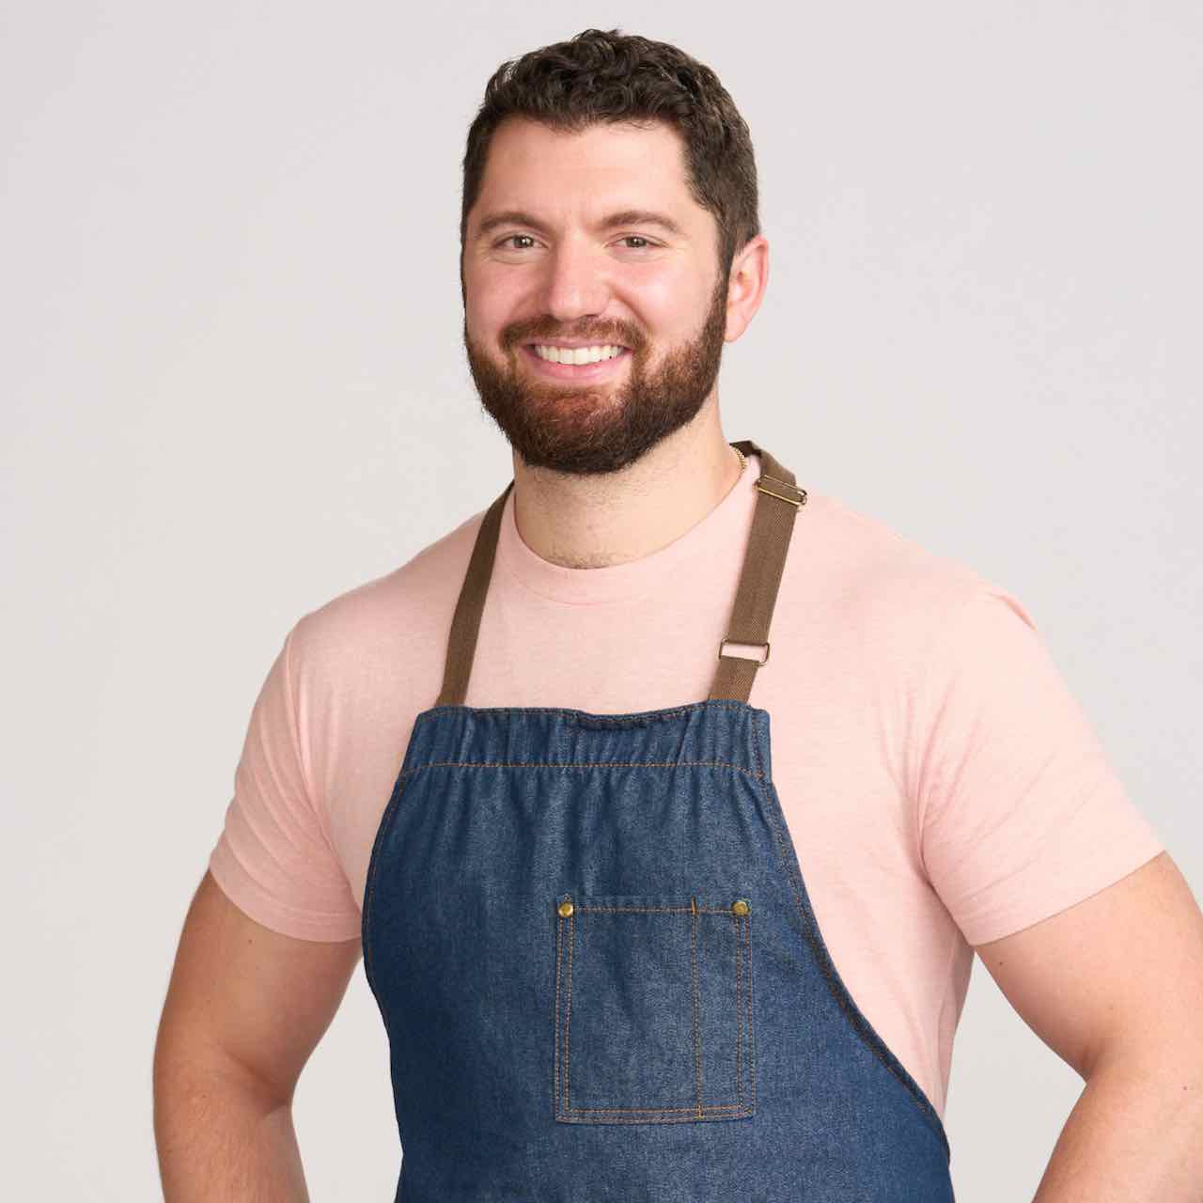
Brad Mahlof (New York, New York) developed a cooking style that honors both his Sephardic and Ashkenazi Jewish roots. Brad’s father’s family is from Libya, while his mother’s family, originally from Europe, have been New Yorkers for generations. Brad’s mixed background has given him a well-rounded Jewish experience that heartily influences his food. Brad learned to cook by watching his mom and aunts in the kitchen as a child and has fond memories of cooking from a young age. Now Brad hosts epic Shabbat dinners every Friday night for his friends and family that showcase his Libyan, Israeli and Ashkenazi roots as well as other global culinary influences inspired by his love of travel. Rather than strictly following recipes, Brad cooks by intuition, using roughly outlined recipes passed down to him. His cooking style emphasizes the importance of sourcing quality, seasonal, and local ingredients. Brad is passionate about representing his heritage through food to help preserve and honor the rich and beautiful history of these Jewish communities. Brad’s signature dish is T’becha, a Libyan short rib stew, served over hand-rolled couscous. He has been eating it for Shabbat dinner since he began to chew. There isn’t another dish that makes him feel more connected with his family and Jewish heritage.

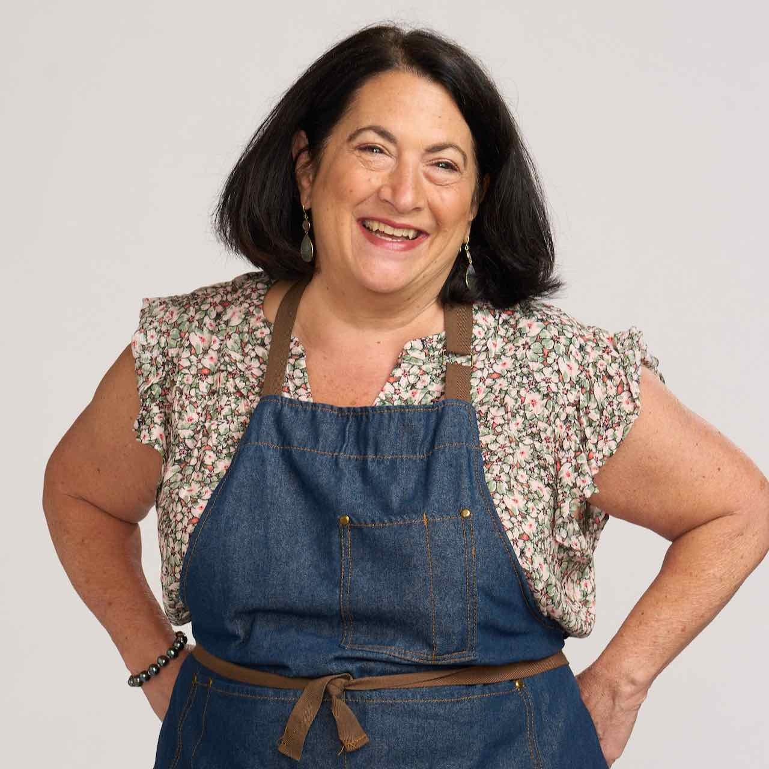
Abbe Odenwalder (Denver, Colorado) is a first-generation American and the author of a cooking blog. Her grandfather left Lithuania in 1938, with his family, which included Abbe’s six-year-old father, one year before the Nazis invaded. Her family settled in Kankakee, Illinois, where her grandfather was a janitor before opening a small grocery/butcher shop. Abbe taught herself to cook when she attended college in Colorado, quickly realizing that food was a way to bring people together. As an avid recipe and cookbook collector, she was inspired by her heritage and many of her grandmother’s old cookbooks. When her kids left for college, her daughter suggested she start a blog to keep track of all the recipes she’s cooked over the years. It’s there that family stories are shared along with other favorites Abbe has discovered over time. It is her wish that one day her children will read these stories, add to them, and continue the cooking journey that she began. Her signature recipe is Noodle Kugel, made of egg pasta, cream cheese, raisins, and cornflakes.

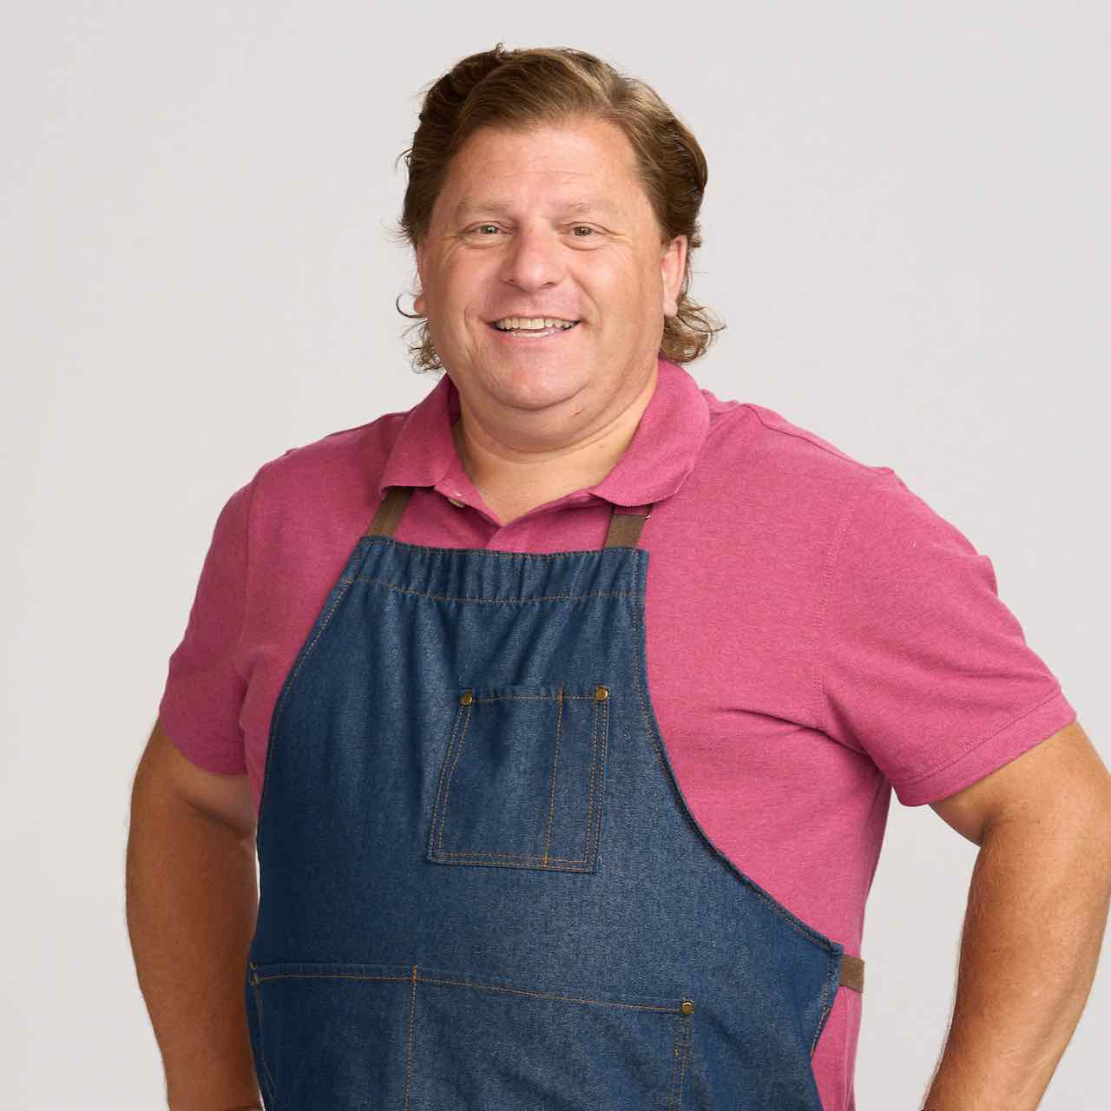
Ted Pappas (Western Springs, Illinois) is a semi-retired architect. He grew up in a traditional Greek American household headed by immigrants: a first-generation father and third-generation mother. His grandfather owned a supper club in Chicago in the 1960s, where Ted’s mother worked. She passed down happy memories of entertaining at the club, instilling in her son a love of social gatherings centered around food. Celebrated for their cooking and active in their community in Chicago, Ted’s parents raised him with an appreciation of all things Greek. His mother made sure he knew not only the best ingredients for a recipe, but the cultural significance and history behind each dish. Now raising two daughters, Ted believes it’s important to pass his Greek traditions on to his children. One of his signature recipes is Lamb Chops marinated in olive oil with lemon juice, rosemary and garlic served over oven-grilled potatoes.

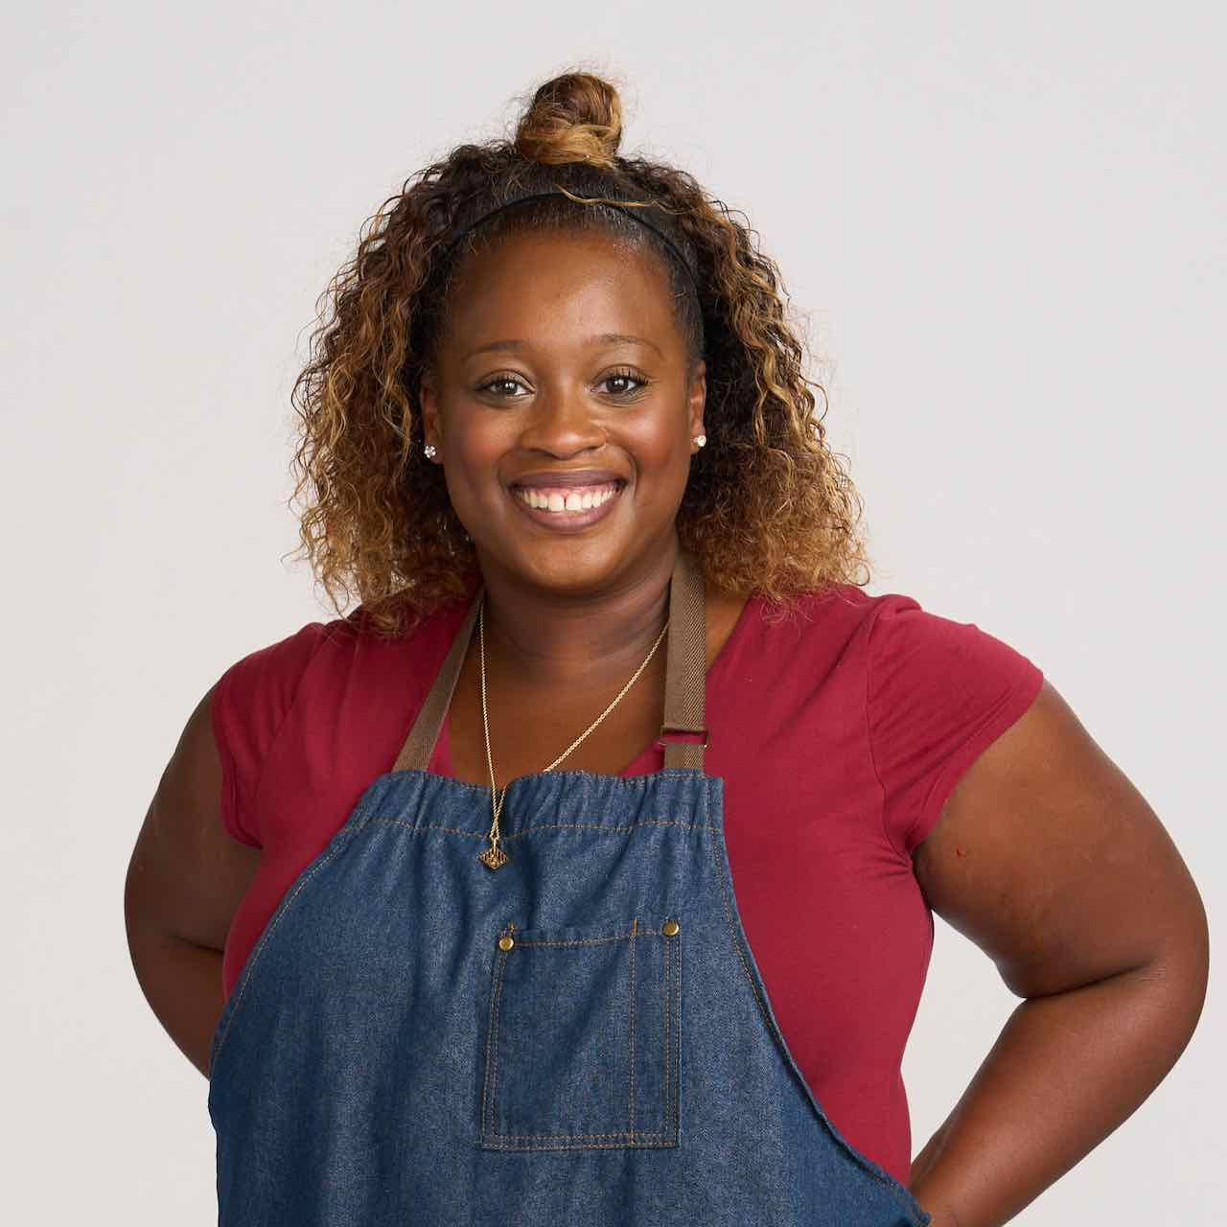
Leanna Pierre (Norcross, Georgia) is a wife, mother, attorney, food blogger and world traveler who loves to cook for her husband and son. A first-generation American, she is proud to be the daughter of Caribbean-born and raised parents. Leanna learned how to cook from her mother, Pat, and her paternal grandmother, Felis. Leanna’s specialty is traditional Caribbean cuisine with a twist of “Southern Comfort” from living in Atlanta for the past 15 years. In addition to being an attorney, Leanna has a food blog where she shares her recipes with the world. Her signature dish is Caribbean Stewed Chicken with allspice and fresh thyme. It’s Leanna’s dream to show that working mothers can be successful professionally and provide for their families while still embracing their personal passions, whatever those may be.

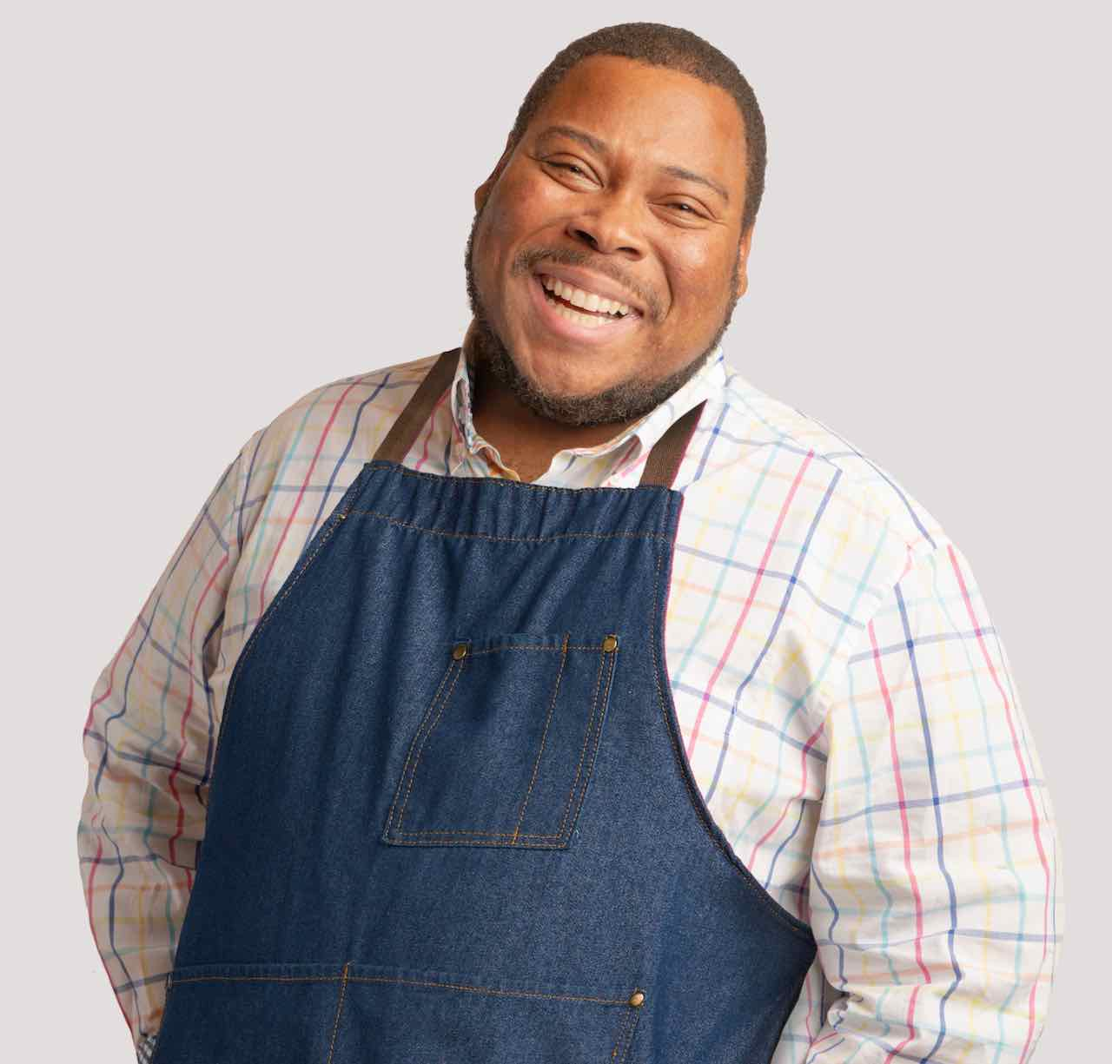
Mike Thomas (Cleveland, Ohio) is a special education teacher who wants his students to learn how to cook and be self-sufficient. Growing up, Mike spent most of his time with his mother and grandmother, and his connection to food comes from watching the women in his life cook favorite Southern recipes. While his family is from Mississippi, Mike now resides in the Midwest with his wife and three kids. As a father, he connects with his children in the kitchen and shares his love for cooking with family recipes. Mike also runs a small catering business, employing his fellow special education teachers to help with events. Mike cooks Southern homestyle cuisine. His flavors are rooted in rich, Southern ingredients with added hints of his Midwest style. His signature recipe is Shrimp and Grits with bacon, ham, green onions, and vegetables.

THE GREAT AMERICAN RECIPE blends food, family, and fun, highlighting the amazing variety of tastes and traditions found across the U.S., while capturing the roots of America’s diverse cuisine. From family favorites passed down through generations, to internationally influenced recipes that are quickly becoming mainstays of American cuisine, the series mixes camaraderie with competition, revealing rich personal stories and the inspiration behind the contestant’s favorite recipes. THE GREAT AMERICAN RECIPE will culminate in a finale that features the finalists preparing an entire meal for the judges to make their ultimate decision. One of the winner’s dishes will grace the cover of The Great American Recipe Cookbook, which will also feature recipes from all the contestants and the show’s host and judges.

Also premiering in June is an eight-episode digital companion series to THE GREAT AMERICAN RECIPE called PAN PALS. Created by noted food influencer, Beryl Shereshewsky, and co-produced by Austin PBS, PAN PALS will feature diverse cooks, influencers, and current and former participants from THE GREAT AMERICAN RECIPE becoming "culinary pen pals" and swapping a cherished recipe. Each episode will feature a dish, ingredient, or theme done through each of the "Pan Pals’" unique cultural and culinary lens in an effort to expand their own world view and food knowledge. PAN PALS will begin streaming on Wednesday, June 21, 2023 on PBS’s Food YouTube Channel, PBS.org, the PBS App and on PBS social media channels, with new episodes rolling out weekly.

THE GREAT AMERICAN RECIPE will be available to stream on all station-branded PBS platforms, including PBS.org and the PBS App, available on iOS, Android, Roku, Apple TV, Amazon Fire TV, Android TV, Samsung Smart TV, Chromecast and VIZIO.

THE GREAT AMERICAN RECIPE is co-produced for PBS by VPM and Objective Media Group America. Steve Humble is the Executive in Charge for VPM. Zara Frankel is the Executive in Charge for PBS. At Objective Media Group America, Megan Bidner is Showrunner, Layla Smith and Jilly Pearce are Executive Producers and Alyssa Hastrich is Senior Vice President of Current Series.

Funding for THE GREAT AMERICAN RECIPE is provided by VPM, the Corporation for Public Broadcasting (CPB) and Plow & Hearth.

About VPM
As Virginia’s home for public media, VPM connects nearly 2 million people across Central Virginia and the Shenandoah Valley to insightful programming in arts and culture, history, science, news, and education. VPM operates public television stations VPM PBS, VPM Plus, VPM PBS KIDS, lifestyle channel VPM Create and international program channel VPM WORLD, as well as Richmond NPR station VPM News (88.9 FM) and VPM Music (107.3 FM, 93.1 FM and 88.9-HD2). In the Northern Neck (89.1 FM) and Southside Virginia (90.1 FM), listeners receive a combination of news and music. Audiences can access VPM online at VPM.org and on Facebook, Twitter, Instagram and YouTube.

About OBJECTIVE MEDIA GROUP AMERICA
Objective Media Group America is the U.S. arm of Objective Media Group. An LA-based All3Media America company, OMG America is led by President Jilly Pearce in creating and producing original entertainment and reality formats, including “Lingo” (CBS), “The Cube” (returning for season 2 on TBS), “Phrogger: Hider in My House” (Lifetime), “12 Dates of Christmas” (HBO Max), “Worst Cooks in America” (The Food Network), “Spring Baking Championship: Easter” (The Food Network) and more. Objective Media Group is headquartered in London and headed up by CEO Layla Smith.

About CPB
The Corporation for Public Broadcasting, a private, nonprofit corporation authorized by Congress in 1967, is the steward of the federal government’s investment in public broadcasting. It helps support the operations of more than 1,500 locally managed and operated public television and radio stations nationwide. CPB is also the largest single source of funding for research, technology and program development for public radio, television, and related online services. For more information, visit cpb.org, follow us on Facebook and LinkedIn and subscribe for email updates.

About PBS
PBS, with more than 330 member stations, offers all Americans the opportunity to explore new ideas and new worlds through television and digital content. Each month, PBS reaches over 42 million adults on linear primetime television, more than 15 million users on PBS-owned streaming platforms, and 56 million people view PBS content on social media, inviting them to experience the worlds of science, history, nature, and public affairs; to hear diverse viewpoints; and to take front-row seats to world-class drama and performances. PBS’s broad array of programs has been consistently honored by the industry’s most coveted award competitions. Teachers of children from pre-K through 12th grade turn to PBS LearningMedia for digital content and services that help bring classroom lessons to life. As the number one educational media brand, PBS KIDS helps children 2-8 build critical skills, enabling them to find success in school and life. Delivered through member stations, PBS KIDS offers high-quality content on TV — including a PBS KIDS channel — and streaming free on pbskids.org and the PBS KIDS Video app, games on the PBS KIDS Games app, and in communities across America. More information about PBS is available at PBS.org, one of the leading dot-org websites on the internet, Facebook, Instagram, or through our apps for mobile and connected devices. Specific program information and updates for press are available at pbs.org/pressroom or by following PBS Communications on Twitter.

– PBS –

CONTACTS:
Atiya Frederick, PBS, anfrederick@pbs.org

Cara White / Mary Lugo, CaraMar, Inc.
cara.white@mac.com; lugo@negia.net

For images and additional up-to-date information on this and other PBS programs, visit PBS PressRoom at pbs.org/pressroom.

