THE GREAT AMERICAN RECIPE SOCIAL MEDIA INFORMATION

#RecipePBS

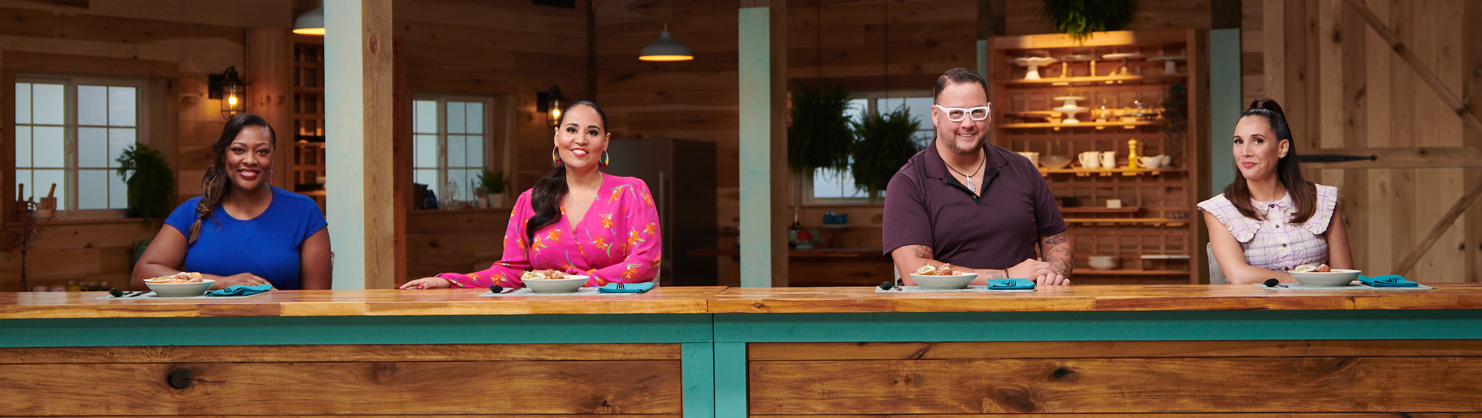
Left to right: Tiffany Derry, Alejandra Ramos, Graham Elliot and Leah Cohen. Credit: PBS/VPM

THE GREAT AMERICAN RECIPE is a new eight-part uplifting cooking competition that celebrates the multiculturalism that makes American food unique and iconic. Hosted by Alejandra Ramos, the series gives talented home cooks from different regions of the country the opportunity to showcase their beloved signature dishes and compete to win the national search for “The Great American Recipe.” Judges Leah Cohen, Tiffany Derry and Graham Elliot bring their professional insights and deep culinary knowledge to encourage and support the contestants along the way.

THE GREAT AMERICAN RECIPE premieres Fridays, June 24-August 12, 9:00-10:00 pm ET (check local listings) on PBS, PBS.org and the PBS Video app. THE GREAT AMERICAN RECIPE will also have a “Digital Premiere” on the PBS Food Facebook and PBS Food YouTube channel at the same time.

Where to find the digital premiere & streaming episode:
- PBS.ORG: https://www.pbs.org/show/great-american-recipe/
- PBS VIDEO APP: https://www.pbs.org/pbs-video-app/
- FACEBOOK: https://www.facebook.com/pbsfood
- YOUTUBE: https://www.youtube.com/pbsfood

In your social posts, please tag PBS Food social media handles:
- HASHTAG: #RecipePBS
- FACEBOOK: @PBSFood, @PBS
- TWITTER: @PBSFood, @PBS
- INSTAGRAM: @PBSFood, @PBS

Host and Judges social handles
- Alejandra Ramos: @alwaysalejandra
- Graham Elliot: @grahamelliot
- Tiffany Derry: @MasterChefTD, @rootssouthtable on Instagram and Twitter, Instagram-@rootschickenshak, Twitter - @rootschknshak, Facebook
- Leah Cohen: Instagram - @LeahSCohen @pigandkhao @piggybacknewyork

Official website: https://www.pbs.org/food/shows/the-great-american-recipe/
Subscribe to the PBS Food channel for more great content: https://www.youtube.com/c/pbszest
Enjoy full episodes of your favorite PBS shows at https://www.pbs.org/video/

FOLLOW PBS FOOD:
Website: https://www.pbs.org
Facebook: https://www.facebook.com/pbsfood
Twitter: https://www.twitter.com/pbsfood
Instagram: https://www.instagram.com/pbsfood

