Silvia Martinez Wins PBS’s First National Search for
THE GREAT AMERICAN RECIPE

PBS Announces Season 2 to Premiere Summer 2023, with Host Alejandra Ramos and Judges Leah Cohen, Tiffany Derry and Graham Elliot Set to Return

A Multiplatform Success on Broadcast and Digital,
Season 1 Attracted Younger, Diverse New Viewers for PBS
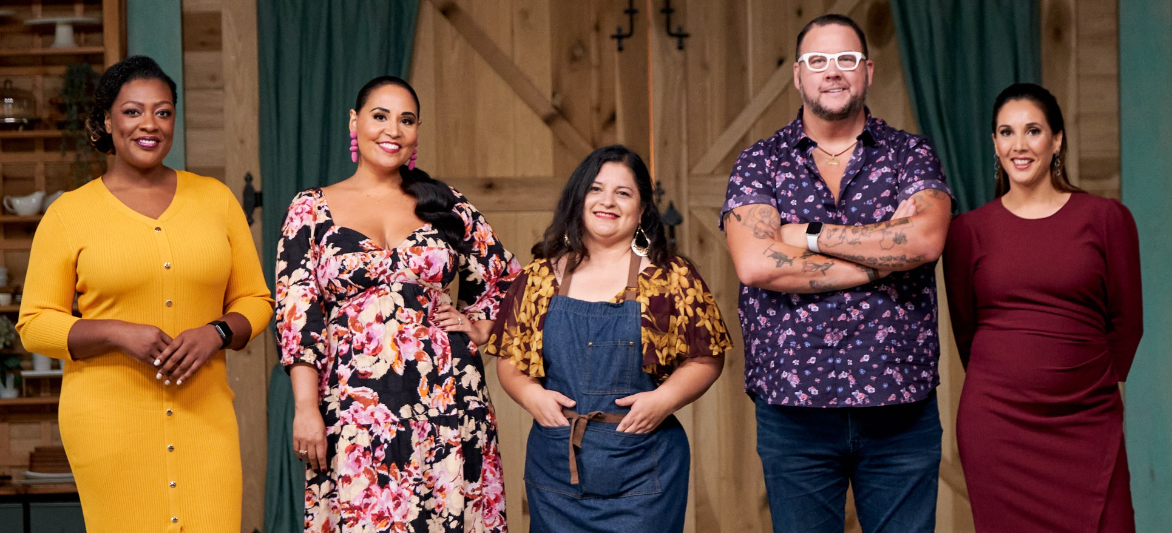
Left to right: Judge Tiffany Derry, host Alejandra Ramos, contestant Silvia Martinez,
judges Graham Elliot and Leah Cohen. Credit: PBS/VPM

ARLINGTON, VA; August 15, 2022 – Silvia Martinez, a California home cook who grew up making Mexican dishes she learned from her grandmother, aunts and mother, was revealed as the winner of THE GREAT AMERICAN RECIPE in the season finale, which premiered on Friday, August 12. Originally from Guanajuato in central Mexico, Silvia formerly had a successful career as a human resources executive and university instructor before transitioning to life in the U.S. after meeting and marrying her husband. Silvia’s heartwarming personal stories and delicious recipes, which combine the flavors of her home country with the bounty of California produce, repeatedly charmed host Alejandra Ramos and judges Leah Cohen, Tiffany Derry and Graham Elliot. All episodes of THE GREAT AMERICAN RECIPE are currently streaming on PBS.org and the PBS Video app.

Today PBS also announced Season 2 of the uplifting cooking competition series that celebrates the multiculturalism that makes American food unique and iconic. The second season, which will give home cooks from around the country another opportunity to showcase their beloved signature dishes, is set to premiere in Summer 2023. Ramos will once again host, and chefs Cohen, Derry and Elliot will return as judges. Production for Season 2 of the show, which is co-produced by VPM and Objective Media Group America (an All3Media America company), is scheduled to begin in Fall 2022.

“Congratulations to Silvia Martinez for being named the winner of the first season of THE GREAT AMERICAN RECIPE,” said Zara Frankel, Director of Programming and Development, General Audience Programming. “The first season was a multiplatform success, attracting younger and more diverse audiences for PBS as part of our ongoing commitment to showcasing a range of voices and perspectives. We are delighted that the show resonated with viewers and are thrilled to be bringing new episodes of this fan-favorite back to audiences across the country.”

“The recipe for success for this series was bringing 10 home cooks together to share cherished family recipes and personal stories of what those dishes mean to them,” said Steve Humble, Chief Content Officer at VPM. “As the series progressed, each episode drew viewers into deeper connections with the contestants. At a time when America is divided, this series about food and family brought people together around the table.”

“We’re excited to be bringing back this wonderfully warm show to PBS,” said Jilly Pearce, President, Objective Media Group America. “It’s a unique kind of cooking competition, a celebratory series where the judges offer professional advice and the contestants root for each other and bond through the shared stories of food and family.”

PBS seeks to provide a platform where audiences can see themselves and their stories reflected and to elevate diverse stories and perspectives both in front of and behind the camera. Season 1 of THE GREAT AMERICAN RECIPE ranked highly among Black and Hispanic adults 18+ and scored well overall among multicultural viewers 18+. In addition, two-thirds of young adults 18-34 were new viewers to PBS, as were nearly a third of persons aged 35-49. To date, THE GREAT AMERICAN RECIPE has accumulated over 1 million streams, with relatively consistent streaming performance week-over-week. In addition, the show was praised for the camaraderie between contestants, proving that “competition doesn’t have to be combative to be great.”*

THE GREAT AMERICAN RECIPE COOKBOOK, an official series companion book, features winner Silvia Martinez’s recipe for Chiles en Nogada (Stuffed Poblano Peppers in Walnut Sauce) on the cover. The cookbook includes more than 100 recipes from the cast, host and judges, along with personal stories, stills from the series and color photographs throughout. The cookbook is now available at Shop PBS, The VPM store and wherever books are sold.

THE GREAT AMERICAN RECIPE Season 1 will be available for catch-up streaming through the end of 2022 on all station-branded PBS platforms, including PBS.org and the PBS Video app, available on iOS, Android, Roku, Apple TV, Amazon Fire TV, Android TV, Samsung Smart TV, Chromecast and VIZIO. Beginning in January 2023, all episodes will be available via PBS Passport. For more information about PBS Passport, visit the PBS Passport FAQ website.

THE GREAT AMERICAN RECIPE is co-produced for PBS by VPM and Objective Media Group America. Steve Humble is the Executive in Charge for VPM. Zara Frankel is the Executive in Charge for PBS. At Objective Media Group America, Megan Bidner is Showrunner, Layla Smith and Jilly Pearce are Executive Producers and Alyssa Hastrich is Vice President of Current Series.
Funding for THE GREAT AMERICAN RECIPE is provided by VPM and the Corporation for Public Broadcasting (CPB).

About VPM
As Virginia’s home for public media, VPM connects nearly 2 million people across Central Virginia and the Shenandoah Valley to insightful programming in arts and culture, history, science, news and education. VPM operates public television stations VPM PBS, VPM Plus, VPM PBS KIDS, lifestyle channel VPM Create and international program channel VPM WORLD, as well as Richmond NPR station VPM News (88.9 FM) and VPM Music (107.3 FM, 93.1 FM and 88.9-HD2). In the Northern Neck (89.1 FM) and Southside Virginia (90.1 FM), listeners receive a combination of news and music. Audiences can access VPM online at VPM.org and on Facebook, Twitter, Instagram and YouTube.

About OBJECTIVE MEDIA GROUP AMERICA
Objective Media Group America is the US arm of Objective Media Group. An LA-based All3Media America company, OMG America is led by President, Jilly Pearce in creating and producing original entertainment and factual formats, including “12 Dates of Christmas” (HBO Max), “Worst Cooks in America” (The Food Network), “Spring Baking Championship: Easter” (The Food Network), “Great Balloon Bomb Invasion” (discovery+), as well as all new and upcoming series including “Phrogger: Hider in My House” (Lifetime), “Lingo” for CBS and more. OMG America also adapts formats created and produced by Objective Media Group in the UK, which is headquartered in London and headed up by CEO Layla Smith, including the U.S. version of popular gameshow “The Cube” on TBS, which is returning this year for a second season.

About CPB
The Corporation for Public Broadcasting, a private, nonprofit corporation authorized by Congress in 1967, is the steward of the federal government’s investment in public broadcasting. It helps support the operations of more than 1,500 locally managed and operated public television and radio stations nationwide. CPB is also the largest single source of funding for research, technology and program development for public radio, television, and related online services. For more information, visit cpb.org, follow us on Twitter @CPBmedia, Facebook and LinkedIn and subscribe for email updates.

About PBS
PBS, with more than 330 member stations, offers all Americans the opportunity to explore new ideas and new worlds through television and digital content. Each month, PBS reaches over 120 million people through television and 26 million people online, inviting them to experience the worlds of science, history, nature and public affairs; to hear diverse viewpoints; and to take front row seats to world-class drama and performances. PBS’ broad array of programs has been consistently honored by the industry’s most coveted award competitions. Teachers of children from pre-K through 12th grade turn to PBS for digital content and services that help bring classroom lessons to life. Decades of research confirms that PBS’ premier children’s media service, PBS KIDS, helps children build critical literacy, math and social-emotional skills, enabling them to find success in school and life. Delivered through member stations, PBS KIDS offers high-quality educational content on TV – including a 24/7 channel, online at pbskids.org, via an array of mobile apps and in communities across America. More information about PBS is available at www.pbs.org, one of the leading dot-org websites on the internet, or by following PBS on Twitter, Facebook or through our apps for mobile and connected devices. Specific program information and updates for press are available at pbs.org/pressroom or by following PBS Communications on Twitter.

– PBS –

CONTACTS:

Atiya Frederick, PBS, anfrederick@pbs.org

Cara White / Mary Lugo, CaraMar, Inc.
cara.white@mac.com; lugo@negia.net

For images and additional up-to-date information on this and other PBS programs, visit PBS PressRoom at pbs.org/pressroom.

*Foodsided, 6/25/22.

