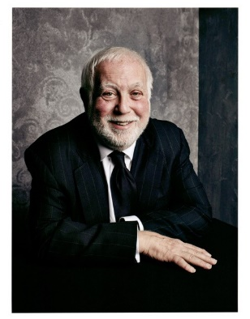
Ken Ehrlich

Among other things, Ken Ehrlich is the creator of both the VH1 DIVAS franchise and the MTV Movie Awards, directed numerous Las Vegas residencies, including those of Celine Dion, Mariah Carey, and John Fogerty, and produced more hours of network, cable PBS, home videos and other assorted live event and taped specials than nearly anyone else working in television today. He’s also produced 40 editions of “Music’s Biggest Night,” the annual Grammy Awards, as well as, two nights after the Grammys, eight spectacular two-hour Grammy tribute shows celebrating the careers of Elton John, Stevie Wonder, The Bee Gees, Motown, Aretha Franklin, Frank Sinatra, Prince, and The Beatles (which featured a historic television reunion of Paul McCartney and Ringo Starr).

His 45-year-plus career has taken him from Wembley Stadium (Mandela), Times Square (NFL Kickoff), Berlin’s Brandenburg Gate, Texas Motor Speedway (Blockbuster500) to world-famous arenas coast to coast (Madison Square Garden to Staples Center and SoFi Stadium), to intimate venues like Tipitina’s (New Orleans) and The Bottom Line (NYC) to Las Vegas showrooms like the Coliseum the Lido De Paris and everywhere in between. And though maybe not the largest venue, the 250-seat East Room of the White House where, during the Obama administration, Ehrlich did six “In Performance at the White House” shows, bringing everyone from Bob Dylan, Mick Jagger, Willie Nelson, Justin Timberlake, Ariana Grande, and Aretha Franklin to perform for President and Mrs. Obama and the PBS cameras.

In December 2021, after a four-year absence, he returned to the White House to produce his first Biden administration “In Performance at The White House,” a one-hour special, Sounds of the Season, in cooperation with PBS and WETA. For nine years, he has produced the annual Global Citizens Festival, a multi-hour event from New York’s Central Park, and telecast on multiple platforms.

Last March, he continued his nearly 50-year history with PBS (he created and produced the legendary SOUNDSTAGE music series for PBS beginning in 1975) by producing the 2023 Library of Congress Gershwin Prize for Popular Song that honored Joni Mitchell. The show was highly acclaimed, and its musical director Greg Philinganes, was awarded an Emmy in January 2024.

His unique abilities to both create and deliver incredible combinations and one-of-a-kind production ideas even gave a name to his signature moments, now called by many “Grammy moments,” whether they are on the Grammys or another of Ehrlich’s prodigious output of shows and live events. His shows have been nominated for more than 40 Emmy Awards (he has produced the Emmy show five times), has been awarded a Golden Globe Award, a star on the Hollywood Walk of Fame, and in 2009 was presented with the Visionary Award by the Producers Guild of America.

