EMBARGOED - TO PUBLISH THU., 12/12/24
FRONTLINE & AP Documentary 2000 METERS TO ANDRIIVKA To Make World Premiere at 2025 Sundance Film Festival
Directed by Oscar®-winning Ukrainian filmmaker Mstyslav Chernov, the film will world premiere in Sundance’s World Cinema Documentary Competition in January 2025
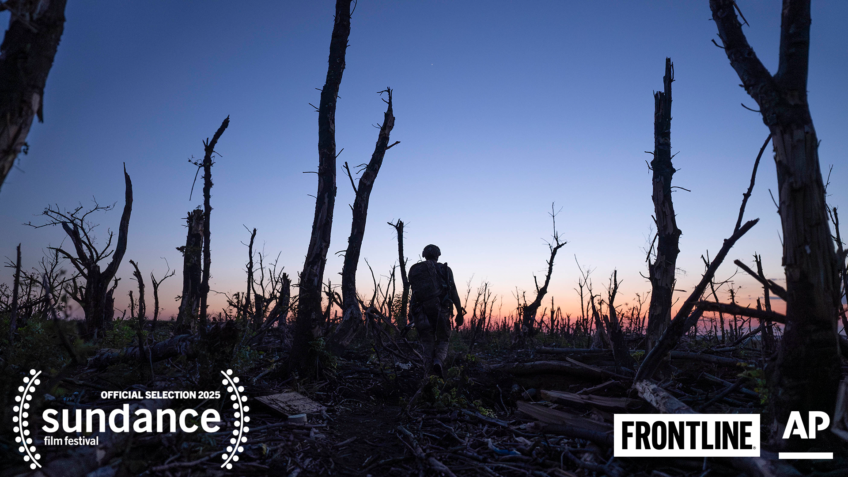
December 12, 2024 — Boston, MA — 2000 METERS TO ANDRIIVKA, a new feature film on the war in Ukraine from FRONTLINE, the award-winning PBS documentary series housed at GBH in Boston, and The Associated Press, will make its world premiere at the Sundance Film Festival this January in Park City, Utah.
2000 METERS TO ANDRIIVKA is the second feature film from the Oscar®-winning team behind 20 DAYS IN MARIUPOL — Ukrainian filmmaker and Pulitzer Prize-winning AP journalist Mstyslav Chernov, producer and editor Michelle Mizner and producer Raney Aronson-Rath. The film will be featured in the world-renowned festival's World Cinema Documentary Competition.
Chernov’s 2024 Academy Award®-winning documentary 20 DAYS IN MARIUPOL offered audiences a visceral view of the first days of Russia’s invasion of Ukraine and its civilian toll. Now, in 2000 METERS TO ANDRIIVKA, Chernov turns his lens towards Ukrainian soldiers — who they are, where they came from, and the impossible decisions they face in the trenches as they fight for every inch of land.
Amid a failing counteroffensive in 2023, Chernov and his AP colleague Alex Babenko follow a Ukrainian platoon traversing through one mile of a heavily fortified forest on their mission to liberate the small, Russian-occupied village of Andriivka. But as 2000 METERS TO ANDRIIVKA reveals with haunting intimacy, the farther the soldiers advance through their destroyed homeland, the more they realize that, for them, this war may never end.
Weaving together intensive Ukrainian Army bodycam footage and powerful moments of reflection, Chernov captures the war in his own country from a personal and devastating vantage point. 2000 METERS TO ANDRIIVKA documents a battle emblematic of the broader Russian-Ukraine war — the largest military operation in Europe since World War II — and presents a view of modern warfare reminiscent of battles fought nearly a century ago.
Kim Yutani, Sundance Film Festival’s director of programming, told AP she expects audiences will be deeply moved by 2000 METERS TO ANDRIIVKA, calling it “An incredible documentary,” and a “beautiful, horrifying portrait of the futility of war.”
“At a time when the destiny and future of Ukraine is being decided, it is important to me to show the perspective of soldiers who have lost their lives or are continuing to fight in this war,” says director Chernov. “The film is built to place the audience on the battlefield, to see and feel their experience and how it is to be there.”
“We are proud to work once again with The Associated Press and to offer both trustworthy reporting and a gripping, cinematic documentary. Just as we did with the feature film 20 DAYS IN MARIUPOL, we hope that 2000 METERS TO ANDRIIVKA offers audiences an on-the-ground look at the human cost of the Russia-Ukraine conflict,” says 2000 METERS TO ANDRIIVKA producer and FRONTLINE’s editor-in-chief and executive producer, Raney Aronson-Rath.
“As the war in Ukraine continues into its third year, The Associated Press has remained steadfast in delivering crucial eyewitness journalism that exposes the harsh realities on the ground,” said AP Senior Vice President and Executive Editor Julie Pace. “Through our continued collaboration with FRONTLINE, we have been able to offer audiences an unflinching view of the ongoing conflict.”
2000 METERS TO ANDRIIVKA is directed by filmmaker and AP journalist Mstyslav Chernov. It is produced by FRONTLINE’s senior editor and producer Michelle Mizner and FRONTLINE’s editor-in-chief and executive producer Raney Aronson-Rath. It is edited by Michelle Mizner. The film is co-produced and includes additional cinematography by AP journalist Alex Babenko. It is composed by two-time Grammy Award®-winning composer and music-producer Sam Slater (‘Chernobyl,’ ‘Joker’).
2000 METERS TO ANDRIIVKA is part of an ongoing editorial collaboration between FRONTLINE and AP examining Russia’s war in Ukraine.
2000 METERS TO ANDRIIVKA will be distributed by PBS Distribution in North America.
About FRONTLINE
FRONTLINE, U.S. television’s longest running investigative documentary series, explores the issues of our times through powerful storytelling. FRONTLINE has won an Academy Award® as well as every major journalism and broadcasting award, including 108 Emmy Awards and 34 Peabody Awards. Visit pbs.org/frontline and follow us on YouTube, Instagram, LinkedIn, X and Facebook to learn more. FRONTLINE is produced at GBH in Boston and is broadcast nationwide on PBS. Funding for FRONTLINE is provided through the support of PBS viewers and by the Corporation for Public Broadcasting. Additional support for FRONTLINE is provided by the Abrams Foundation, Park Foundation, the John D. and Catherine T. MacArthur Foundation, the Heising-Simons Foundation, and the FRONTLINE Journalism Fund, with major support from Jon and Jo Ann Hagler on behalf of the Jon L. Hagler Foundation, and from Koo and Patricia Yuen.
About AP
The Associated Press is an independent global news organization dedicated to factual reporting. Founded in 1846, AP today remains the most trusted source of fast, accurate, unbiased news in all formats and the essential provider of the technology and services vital to the news business. More than half the world’s population sees AP journalism every day. Online: www.ap.org
Press Contacts:
Festival Publicity:
Charlie Olsky, Cinetic Media
charlie@cineticmedia.com | 917-545-7260
FRONTLINE (PBS):
Anne Husted
anne_husted@wgbh.org | 617-300-5312
The Associated Press
Lauren Easton
leaston@ap.org | 212-621-7005
###

