EXPEDITION WITH STEVE BACKSHALL Returns to PBS This Summer as the Modern-Day Explorer Ventures Deeper into the Unknown

Season Two of the Exhilarating Documentary Series Premieres
Wednesday, July 6, 2022, 10:00–11:00 p.m. ET
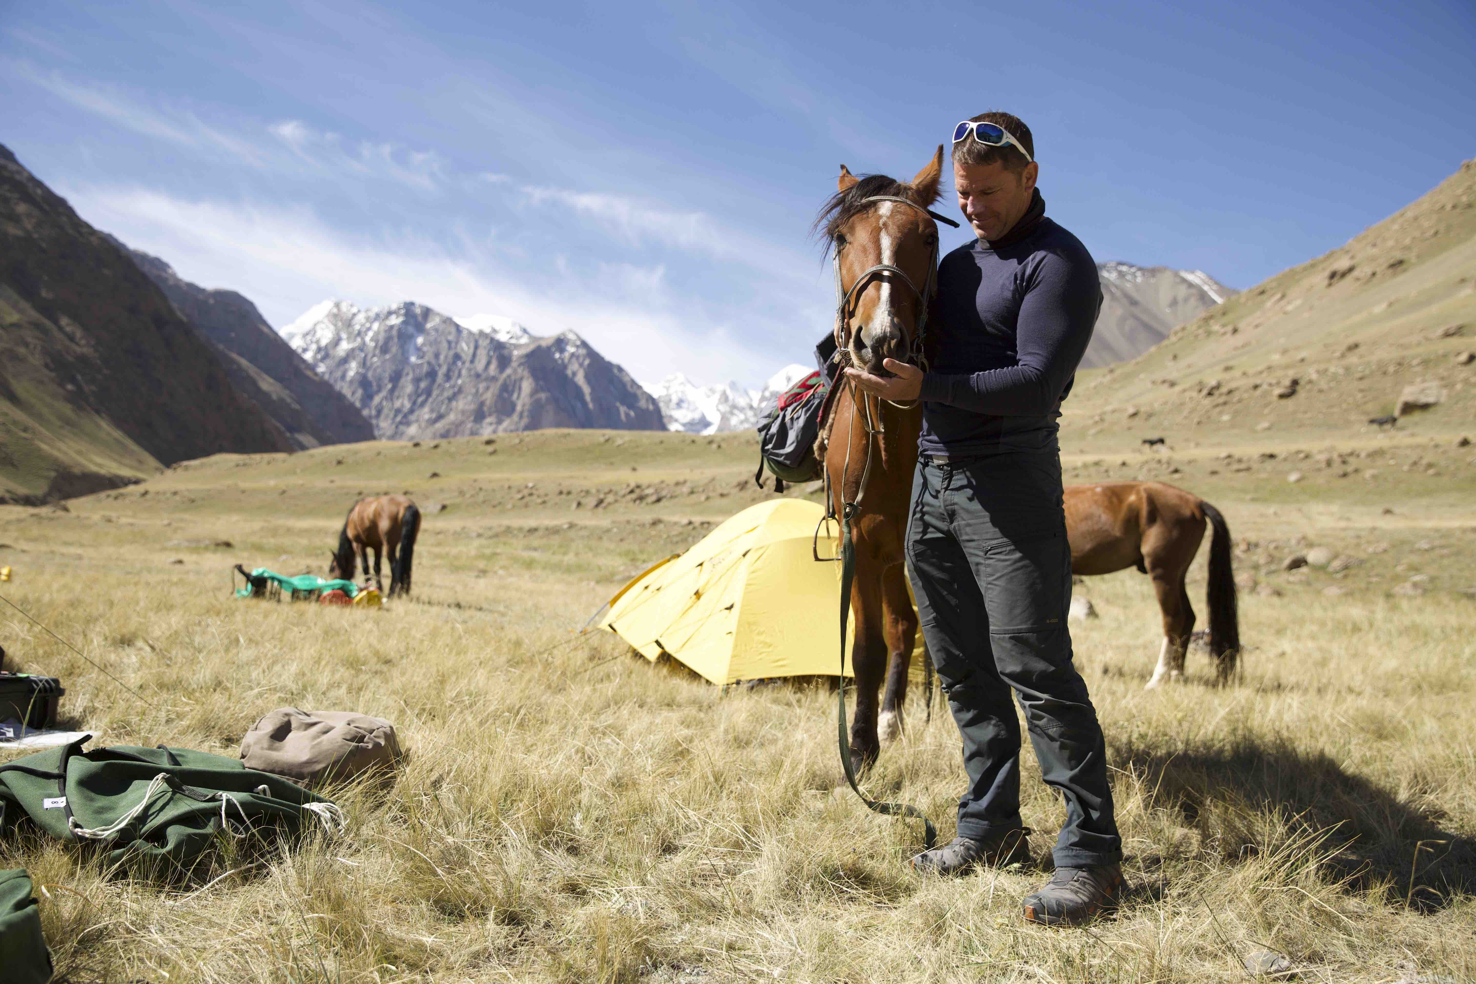
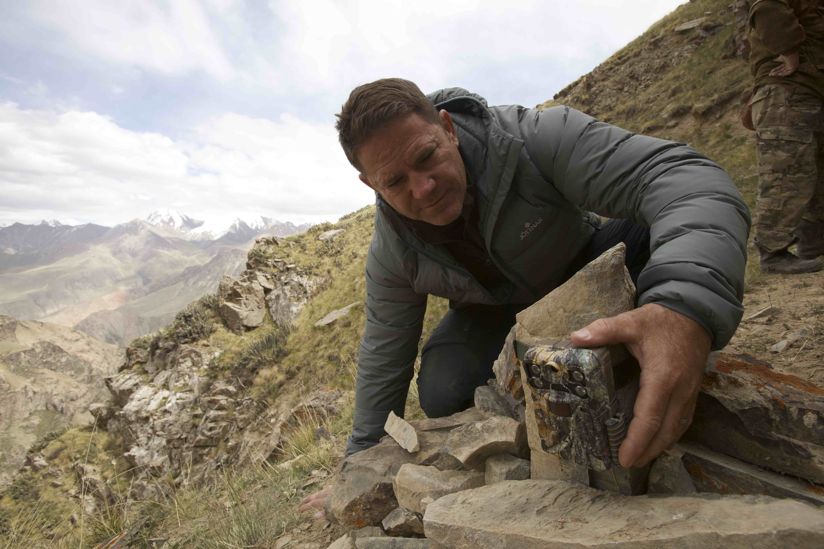
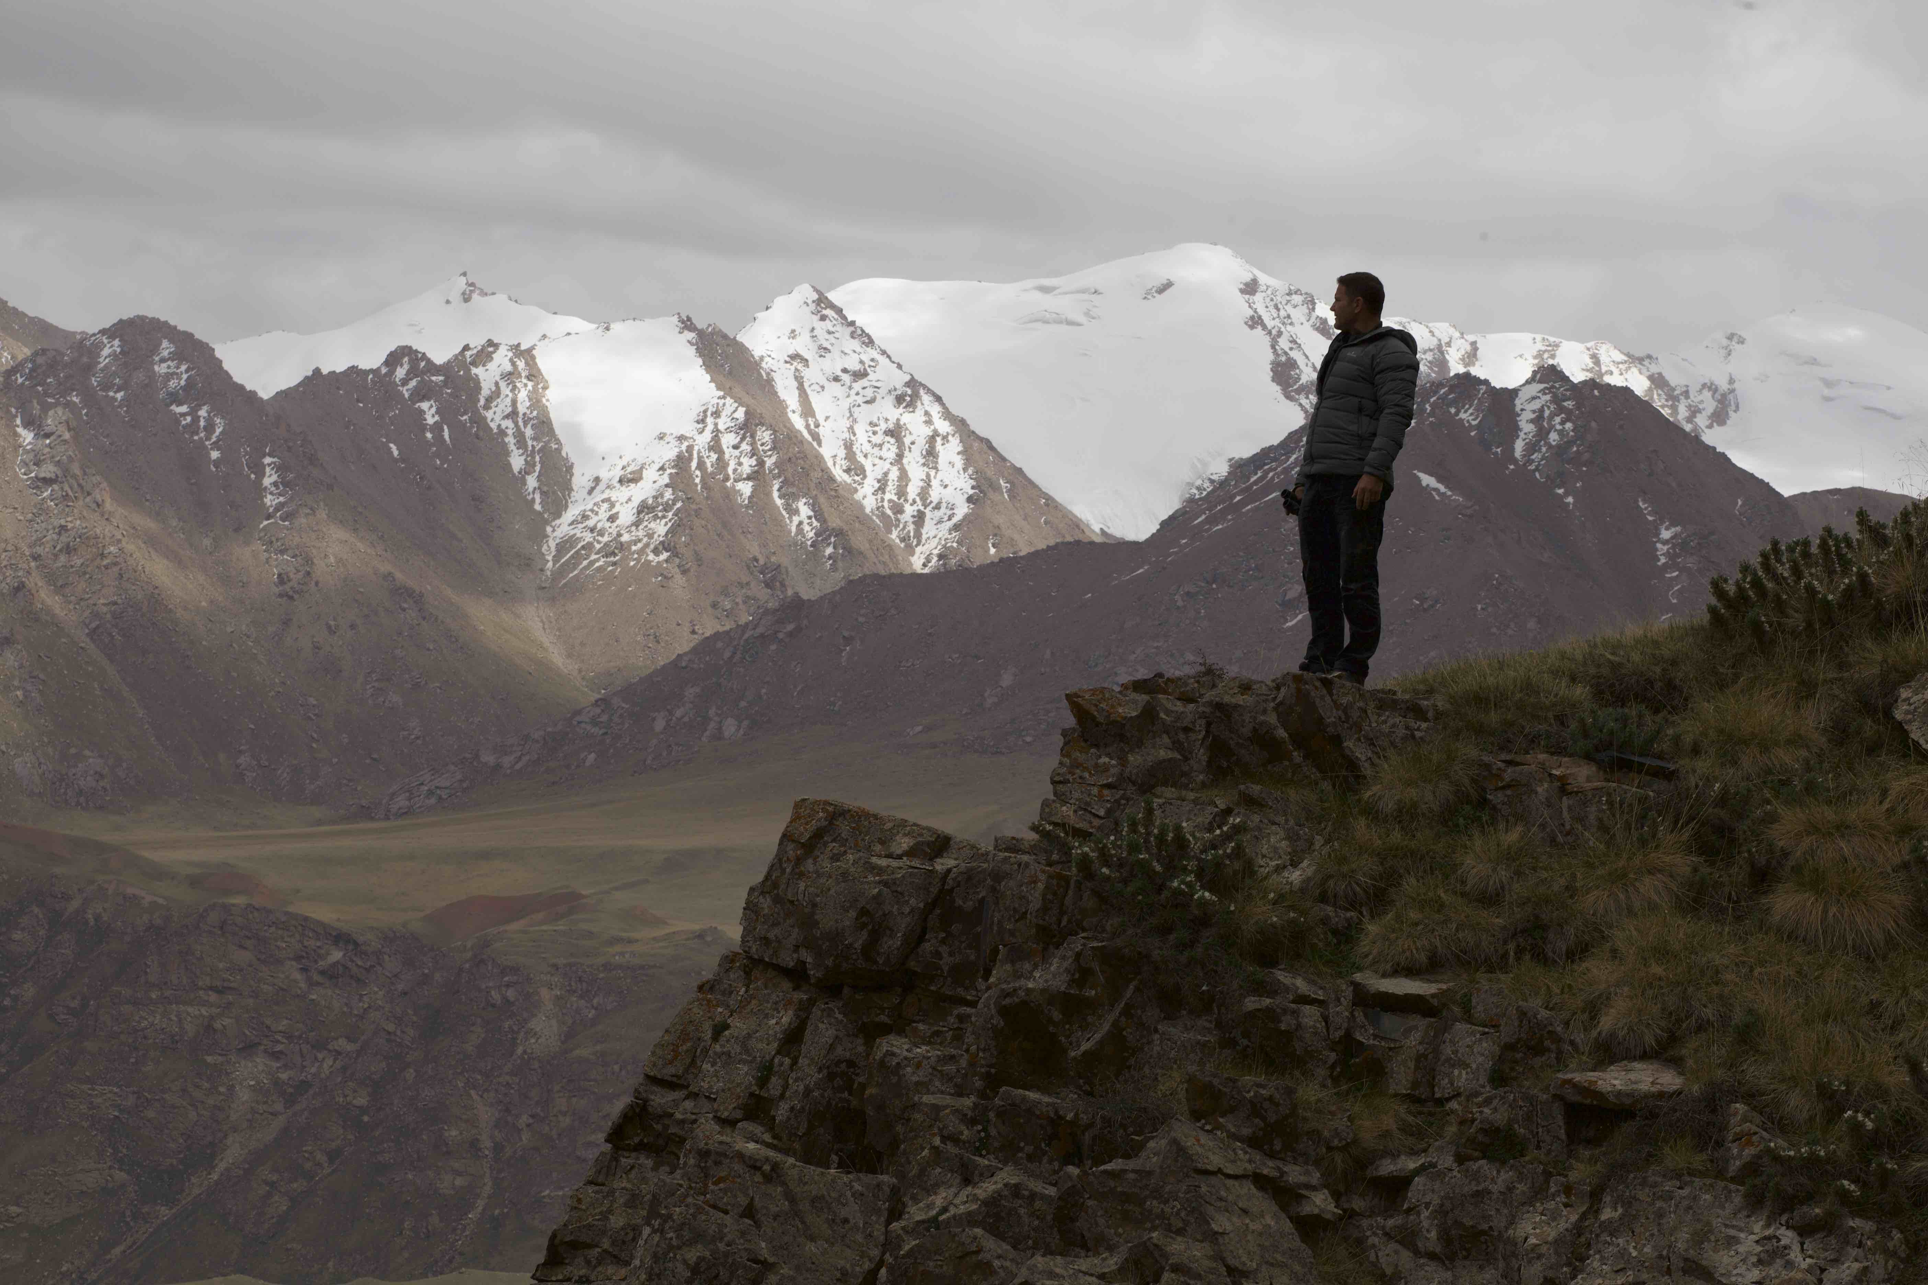
Photo credit: True to Nature Ltd.
ARLINGTON, VA (June 2, 2022) – PBS’s popular documentary series, EXPEDITION WITH STEVE BACKSHALL, returns with six episodes this summer and uncovers even more places around the globe never seen by human eyes. Naturalist Steve Backshall once again ventures deep into the unknown, shining a light on unexplored corners of the Earth. In each episode, Backshall pursues incredible journeys into uncharted landscapes, as only he can do. PBS continues to deliver enlightening and entertaining programming in this second season of EXPEDITION WITH STEVE BACKSHALL, which premieres on Wednesday, July 6 at 10:00 p.m. ET on PBS (check local listings), PBS.org and the PBS Video app.

In this global series, Backshall shares an up-close and personal look into heights, depths and the farthest perimeters of the Earth. On a mission to discover fresh insights that could help to secure a future for the world’s wildlife, he and his hand-picked team of experts dive with sharks in Mexico’s Eastern Pacific, search for apes in Africa’s unexplored jungles, paddle into the heart of brown bear territory in the Far East, explore the uncharted volcanic underworld of Saudi Arabia’s ancient deserts and climb the Djangart mountains of Kyrgyzstan in search of endangered snow leopards. Backshall has big ambitions, and on this rapidly changing planet, the stakes have never been higher.

“There are still unmapped, unknown corners of our planet where no human has ever been. A sense of curiosity has always driven scientists and explorers onward, propelling us to uncover new frontiers,” said Backshall. “Knowing that there are unclimbed mountains, unrun rivers and cave systems that have never seen light in millions of years is a powerful thing.”

A brief overview of EXPEDITION WITH STEVE BACKSHALL is outlined below:

Episode 1: “Kamchatka: Expedition Grizzly River”
Premieres Wednesday, July 6, 2022, 10:00–11:00 p.m. ET
Description: Steve and a team of world-class kayakers take on the first descent of an unexplored white-water river into the heart of brown bear country—on a mission to experience a connection with nature and wildlife that has not been impacted by human presence.

Episode 2: “Saudi Arabia: Expedition Volcanic Underworld”
Premieres Wednesday, July 13, 2022, 10:00–11:00 p.m. ET
Description: Steve and a team of geologists and ropes experts enter the Kingdom of Saudi Arabia as it opens up to the outside world—on a mission to head deep into unexplored volcanic deserts where secrets of our ancient past lie waiting to be discovered.

Episode 3: “Kyrgyzstan: Expedition Mountain Ghost”
Premieres Wednesday, July 20, 2022, 10:00–11:00 p.m. ET
Description: Steve and a team of snow leopard biologists and mountain experts explore a remote region of the Tien Shan mountains—on a mission to discover whether this could be home to an undiscovered population of snow leopards.

Episode 4: “Gabon: Expedition Jungle Paradise”
Premieres Wednesday, July 27, 2022, 10:00–11:00 p.m. ET
Description: Steve joins forces with primatologists, river experts and Gabonese guides to discover what lies beyond a mythical river canyon that local people believe disappears off the face of the earth—on a mission to explore a pristine jungle where no one has ever set foot to discover what wildlife might be living there.

Episode 5: “Socorro: Expedition Shark Island”
Premieres Wednesday, August 3, 2022, 10:00–11:00 p.m. ET
Description: Steve and a team of shark experts and marine biologists set out into the Eastern Pacific to dive unexplored waters—on a mission to discover the best-kept secret of our oceans: the place where sharks give birth.

Episode 6: “Expedition Unseen”
Premieres Wednesday, August 10, 2022, 10:00–11:00 p.m. ET
Description: With the planet under more pressure now than at any other time in history, exploration has never been more important. Steve takes on four entirely new adventures into the unknown to reveal nature at its rawest and leaves us with no doubt that this is the last chance to protect our planet.

For more information on EXPEDITION WITH STEVE BACKSHALL, visit www.pbs.org. Viewers are also encouraged to engage in online conversation about the series by tagging @PBS and using #ExpeditionPBS on Facebook, Twitter and Instagram.

Episodes of EXPEDITION WITH STEVE BACKSHALL will be available to stream concurrently with broadcast starting July 6, 2022, on all station-branded PBS platforms, including PBS.org and the PBS Video app, available on iOS, Android, Roku streaming devices, Apple TV, Amazon Fire TV, Samsung Smart TV, Chromecast and VIZIO. PBS station members can also view many series, documentaries and specials via PBS Passport. For more information about PBS Passport, visit the PBS Passport FAQ website.
EXPEDITION WITH STEVE BACKSHALL is a True to Nature Production distributed by FremantleMedia International for PBS. Bill Gardner is Executive in Charge for PBS. The series is executive produced by Wendy Darke. EXPEDITION WITH STEVE BACKSHALL was commissioned by BBC and UKTV, with funding for the PBS presentation provided by public television viewers.

About Steve Backshall
Steve Backshall, BAFTA-winning adventurer and wildlife expert, is an experienced and unparalleled natural history producer and presenter. He is hugely popular with young television audiences who are both terrified and delighted to watch his encounters with extraordinary and inspiring predators. Steve is an old-fashioned action hero whose leisure pursuits include mountaineering, kayaking, scuba diving, martial arts and endurance running, which together with his unsurpassed wildlife knowledge, make him a compelling and motivational speaker for a multitude of audiences. In 2011, Steve was recognized with a BAFTA for The Best Children’s Television Presenter for his work on Deadly 60, as well as the series itself being honored with a BAFTA for The Best Factual Series. Steve was also an on-air correspondent for the PBS and BBC co-production, BIG BLUE LIVE, which won the BAFTA for a Live Event in 2016. Steve is also a prolific author, having published 13 books, and is a proud ambassador for The Scouts and the Get Outside champion for Ordinance Survey.
About PBS
PBS, with more than 330 member stations, offers all Americans the opportunity to explore new ideas and new worlds through television and digital content. Each month, PBS reaches over 120 million people through television and 26 million people online, inviting them to experience the worlds of science, history, nature and public affairs; to hear diverse viewpoints; and to take front row seats to world-class drama and performances. PBS’ broad array of programs has been consistently honored by the industry’s most coveted award competitions. Teachers of children from pre-K through 12th grade turn to PBS for digital content and services that help bring classroom lessons to life. Decades of research confirms that PBS’ premier children’s media service, PBS KIDS, helps children build critical literacy, math and social-emotional skills, enabling them to find success in school and life. Delivered through member stations, PBS KIDS offers high-quality educational content on TV – including a 24/7 channel, online at pbskids.org, via an array of mobile apps and in communities across America. More information about PBS is available at www.pbs.org, one of the leading dot-org websites on the internet, or by following PBS on Twitter, Facebook or through our apps for mobile and connected devices. Specific program information and updates for press are available at pbs.org/pressroom or by following PBS Pressroom on Twitter.

– PBS –

MEDIA CONTACTS:

Heather Marohn, Bullseye Communications
908-268-3770; heather.marohn@bullseyecomm.com

Chelsie Pope, PBS
703-405-8280; cepope@pbs.org

Editorial Note: For images and additional up-to-date information on EXPEDITION WITH STEVE BACKSHALL and other PBS programs, visit PBS PressRoom at pbs.org/pressroom.

