New Musical Special DÍA DE LOS MUERTOS Honors the Traditional Mexican Celebration with Performances by
Los Lobos, Ozomatli and Flor de Toloache

Premieres Friday, October 28, 2022 on PBS and Streaming on PBS.org

ARLINGTON, VA – Día de los Muertos—Day of the Dead—has become a globally recognized Mexican tradition celebrated in Latino neighborhoods throughout the United States and by people of Mexican heritage everywhere. Traditionally observed on the first two days of November, Día de los Muertos sees families and friends paying their respects to deceased loved ones with colorful and festive gatherings filled with food, flowers and warm remembrances rather than funereal mourning. In honor of this year’s celebration, DÍA DE LOS MUERTOS premieres Friday, October 28, 2022, 9:00-10:00 p.m. ET (check local listings) on PBS, and streaming on PBS.org and the PBS Video app.
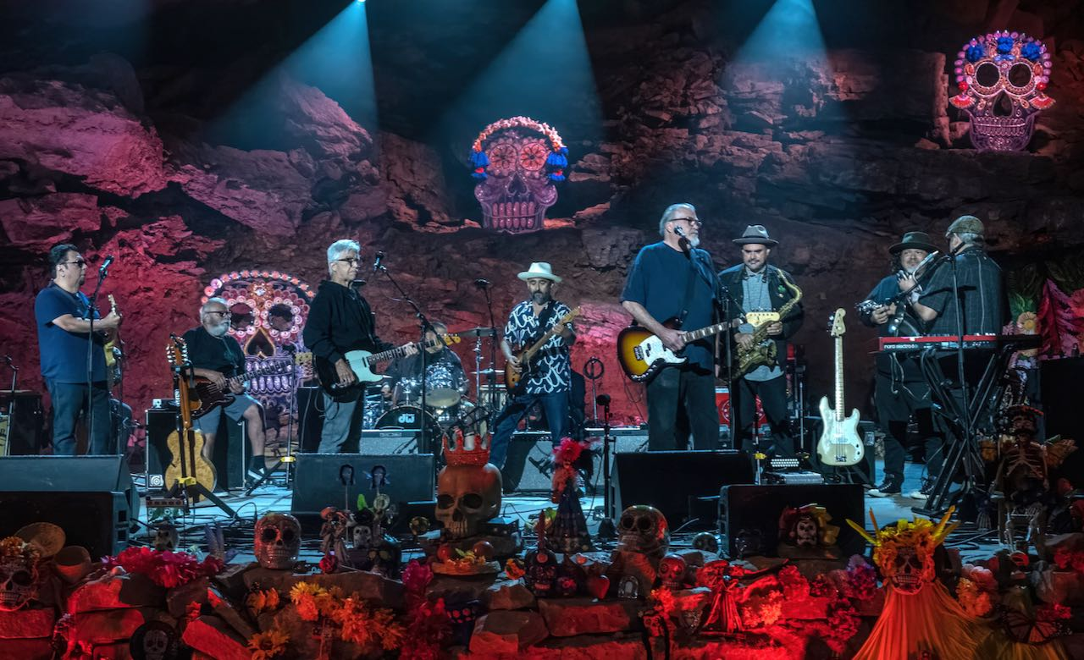
Los Lobos and members of Ozomatli in the finale.
Credit: John Partipilo

Taped before a live audience deep within the unique and beautiful “underworld” of The Caverns, a subterranean amphitheater in Middle Tennessee, the concert includes performances by the following artists:

LOS LOBOS – with their unique GRAMMY-winning amalgamation of rock and roll, Tex-Mex, country, zydeco, folk, R&B, blues and traditional music such as cumbia, boleros and norteños, the East L.A. band formed almost 50 years ago has sold millions of records, won prestigious awards and made fans around the world.

OZOMATLI – this longtime Los Angeles-based band brings the evening’s energy up with their lively mash-up of salsa, jazz, funk, reggae, rap and several types of Latin music: tropical genres like merengue and cumbia, Mexican styles like norteño and Jamaican ska and reggae, all mixed with a heavy dose of hip-hop and funk.

FLOR DE TOLOACHE – this Latin GRAMMY Award-winning, New York-based, all-female group combines old-style Mariachi with a modern edge. Featured on NPR and The Late Show with Stephen Colbert, Flor de Toloache’s distinctive sound is a fresh, genre-busting take on traditional Mexican music.

The audience is composed of Tennessee’s diverse Latino communities, many in skeleton makeup and traditional costumes, organized by the Tennessee Immigrant and Refugee Rights Coalition. The performances are intermixed with short vignettes produced by San Francisco filmmaker Jennifer Maytorena Taylor that illuminate the meaning of Día de los Muertos.

“This joyous new special is a great way to learn about and celebrate the rich Mexican observance of Día de los Muertos,” says Sandie Viquez Pedlow, executive director of Latino Public Broadcasting. “We’re delighted to partner with Todd Jarrell Productions to bring the amazing music of these exciting Latino artists to the PBS family.”

DÍA DE LOS MUERTOS will stream simultaneously with broadcast and be available on all station-branded PBS platforms, including PBS.org and the PBS Video app, available on iOS, Android, Roku, Apple TV, Amazon Fire TV, Android TV, Samsung Smart TV, Chromecast and VIZIO.

DÍA DE LOS MUERTOS is produced by Todd Jarrell Productions, LLC in association with PBS and Latino Public Broadcasting. The executive producer is Todd Jarrell. The executive producer for LPB is Sandie Viquez Pedlow.

About Latino Public Broadcasting
Latino Public Broadcasting (LPB) is the leader in the development, production, acquisition and distribution of film and digital cultural media that is representative of Latino people or addresses issues of particular interest to Latino Americans. These programs are produced for dissemination to public broadcasting stations and other public media entities. Providing a voice for the diverse Latino community throughout the United States, Latino Public Broadcasting is funded by the Corporation for Public Broadcasting. LPB also produces the acclaimed PBS documentary series VOCES, exploring the rich diversity of the Latino experience. VOCES presents new and established filmmakers and brings their powerful and illuminating stories to a national audience — on TV, online and on the PBS app.

Between 2009 and 2022, LPB programs won over 130 awards, including three prestigious George Foster Peabody Awards as well as Emmys, Imagen Awards and the Sundance Film Festival Award for Best Director, Documentary. LPB has been the recipient of the Norman Lear Legacy Award and the NCLR Alma Award for Special Achievement – Year in Documentaries. Sandie Viquez Pedlow is executive director of LPB; Edward James Olmos is co-founder and chairman.

About PBS
PBS, with more than 330 member stations, offers all Americans the opportunity to explore new ideas and new worlds through television and digital content. Each month, PBS reaches over 120 million people through television and 26 million people online, inviting them to experience the worlds of science, history, nature and public affairs; to hear diverse viewpoints; and to take front row seats to world-class drama and performances. PBS’ broad array of programs has been consistently honored by the industry’s most coveted award competitions. Teachers of children from pre-K through 12th grade turn to PBS for digital content and services that help bring classroom lessons to life. Decades of research confirms that PBS’ premier children’s media service, PBS KIDS, helps children build critical literacy, math and social-emotional skills, enabling them to find success in school and life. Delivered through member stations, PBS KIDS offers high-quality educational content on TV – including a 24/7 channel, online at pbskids.org, via an array of mobile apps and in communities across America. More information about PBS is available at www.pbs.org, one of the leading dot-org websites on the internet, or by following PBS on Twitter, Facebook or through our apps for mobile and connected devices. Specific program information and updates for press are available at pbs.org/pressroom or by following PBS Communications on Twitter.

– PBS –
CONTACTS:

Cara White / Mary Lugo, CaraMar, Inc.
cara.white@mac.com; lugo@negia.net

For images and additional up-to-date information on this and other PBS programs, visit PBS PressRoom at pbs.org/pressroom.

