Aaron Tang, Moderator
Aaron Tang is a law professor at the University of California, Davis and former law clerk to Supreme Court Justice Sonia Sotomayor. Tang writes frequently about the Supreme Court in popular media including the New York Times, Washington Post, Los Angeles Times, Slate, The Atlantic, USA Today, and elsewhere. He is the author of Supreme Hubris: How Overconfidence is Destroying the Court—and How We Can Fix It, published in August 2023 by Yale University Press.

Headshot:
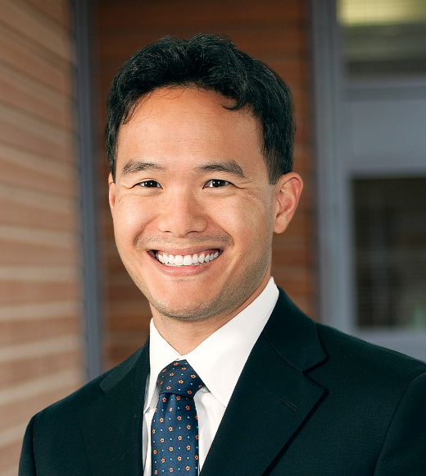

Andrew Lack, Executive Producer
Andrew Lack is Executive Chairman and Founder of Deep South Today and Mississippi Today, the non-profit digital news services supporting local journalism in Mississippi and Louisiana. Mississippi Today won the 2023 Pulitzer Prize for Local Reporting for “The Backchannel,” which uncovered a sprawling $77 million welfare scandal, the largest embezzlement of federal funds in the state’s history. From 2015 to 2020, Lack was the Chairman of NBC News and MSNBC, and was the CEO of Bloomberg Media Group from 2008 to 2014. He previously was Chairman and CEO of Sony Music Entertainment and President of NBC News. From 1977 to 1993, Andrew Lack was Producer at 60 Minutesand Executive Producer and creator of CBS’ West 57th newsmagazine. He was also Senior Executive Producer of the CBS Reports documentary unit with Bill Moyers, which was founded by Fred Friendly. Lack is the recipient of multiple Emmy, Alfred I. duPont – Columbia University and George Foster Peabody awards.

Headshot:
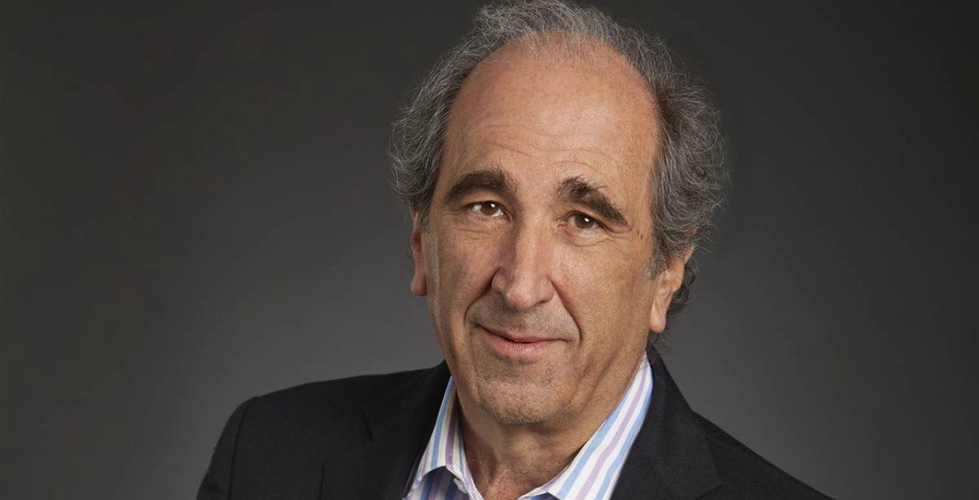

John Bredar, Executive Producer
John Bredar is Vice President of GBH National Programming, overseeing the public media platform’s many celebrated primetime series for PBS and related digital media, including FRONTLINE, NOVA, MASTERPIECE, AMERICAN EXPERIENCE, and ANTIQUES ROADSHOW. He oversees lifestyle content including Lidia Celebrates America with Lidia Bastianich, and Weekends with Yankee, in collaboration with Yankee Magazine, as well as limited series like Sea Change: Crisis in the Gulf of Maine. His prior work includes 26 years with National Geographic, where he was responsible for more than 150 programs as senior executive producer for National Geographic Specials. His work earned him the Best Director Emmy for his 2004 film, Field of Honor, and his co-production with NOVA, Ape Genius, was recognized with a George Foster Peabody Award.

Headshot:
