COLOMBIA – WILD AND FREE
Premieres Wednesdays, May 18 and 25, 2022 on PBS

From the Andes to the Amazon, Explore This Captivating Natural Paradise Filled with Jaguars, Anacondas, Exotic Birds, Humpback Whales and More

ARLINGTON, VA – COLOMBIA – WILD AND FREE, featuring spectacular photography of wildlife and magnificent landscapes, premieres Wednesdays, May 18 and 25, 10:00-11:00 p.m. ET (check local listings) on PBS, PBS.org and the PBS Video app. This two-part series visits Colombia, a land of breathtaking beauty and mysterious legends like El Dorado, a lost city of gold that adventurous explorers searched to find for centuries. Some of Colombia’s real treasures are the rainforests along the Amazon River, the vast plains in the East, the majestic mountains of the Andes and the wild coasts of the Pacific Ocean. For decades, many of Colombia’s wild places remained hidden as fighting between separatist militias and the national army made them unsafe to visit. Now safety has returned, and Colombia’s stunning array of natural wonders can be explored.
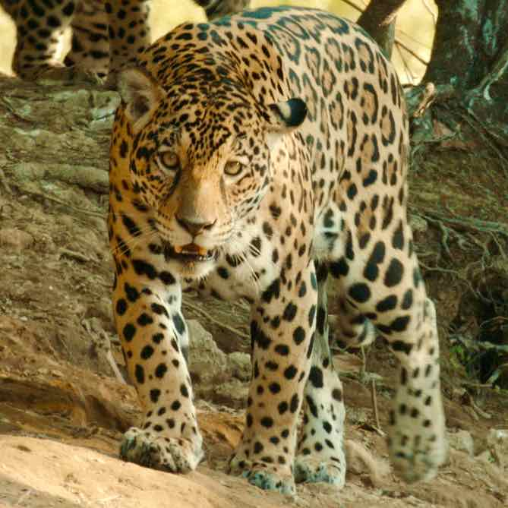
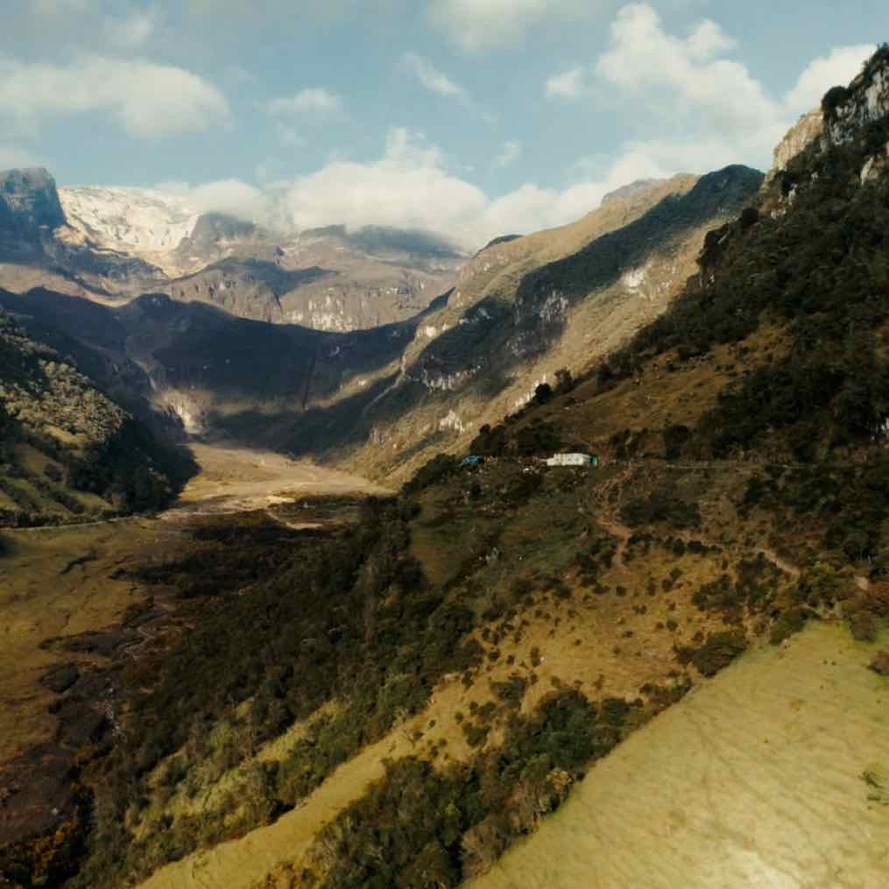
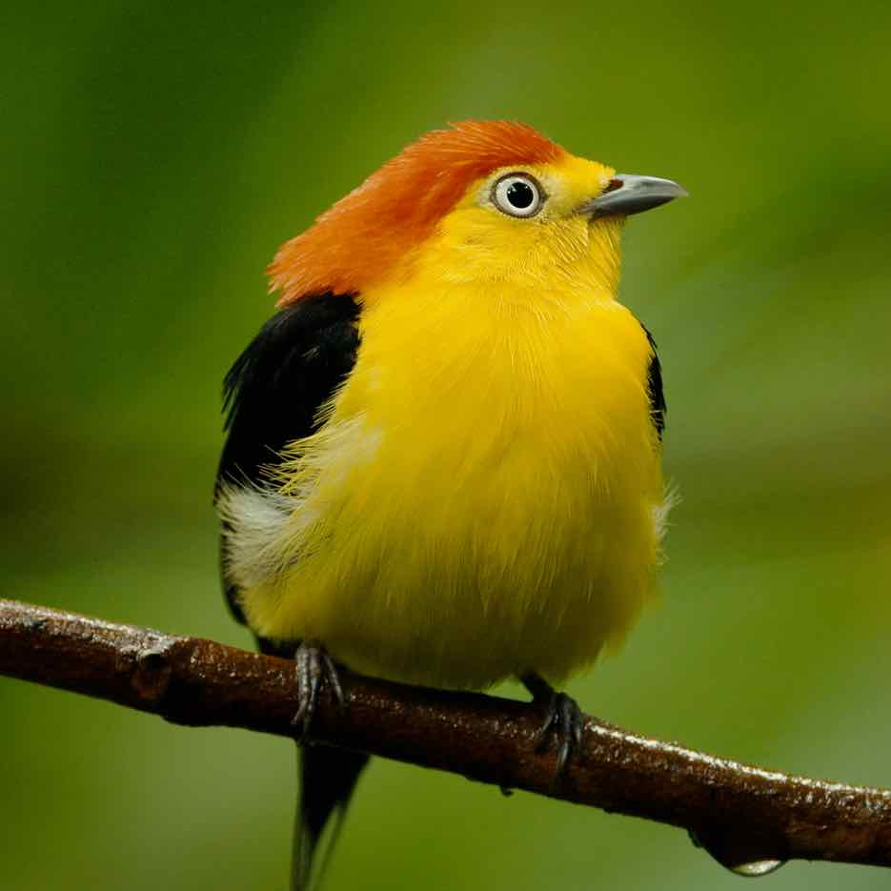
Photo credit: Cosmos Factory

Episode 1: “Two Rivers,” premiering Wednesday, May 18, explores Eastern Colombia, a region defined by two mighty rivers — the Amazon and the Orinoco. The Amazon River flows through lush, dense rainforests, while the Orinoco carves its way across a landscape of grassy plains, lakes and floodplain forests. A dizzying variety of birds live in Eastern Colombia, including roseate spoonbills, black skimmers, jabiru storks and scarlet ibises. A trio of burrowing owlets provides comic relief as they play with twigs and a male wire-tailed manakin shows off his elaborate courtship dancing skills. A female jaguar watches over her baby cub, only two months old but already a predator in training. And the forest canopy is populated by close-knit, multigenerational families of squirrel monkeys and tiny Pygmy marmosets, the world’s smallest monkeys.

Episode 2: “From the Pacific to the Andes,” on Wednesday, May 25, takes viewers to Western Colombia, from the largely uninhabited and wild coasts of the Pacific to the Andes, the longest continental mountain range in the world. Hidden natural wonders lie off the rugged shoreline, in the rocky inlets and mysterious depths of distant islands. Thousands of humpback whales gather to give birth in the summer, while fish hunt crabs in the roots of the mangrove trees, endangered poison dart frogs creep along the forest floor, and a mother and baby sloth hang out in the treetops. The ascent into the Andes is like a journey to a different planet. Snow-capped volcanoes known as the Los Nevados — two of which are still active — have delivered both deadly destruction and nutrient-rich volcanic ash soil for growing crops. The volcanos are surrounded by the Paramó, a magical and mysterious landscape of giant flowers. The mountain forests of the Andes begin just below 12,000-feet and are home to the legendary Andean condor, solitary spectacled bears and stunning hummingbirds.

COLOMBIA – WILD AND FREE will stream simultaneously with broadcast and be available on all station-branded PBS platforms, including PBS.org and the PBS Video app, available on iOS, Android, Roku, Apple TV, Amazon Fire TV, Android TV, Samsung Smart TV, Chromecast and VIZIO.

COLOMBIA – WILD AND FREE is written and directed by Harald Pokieser. The Directors of Photography are Ivo Nörenberg and Christian Stolz. Original Music is by David Mitcham. The Narrator is Natalia Reyes. Executive producers are Harald Pokieser and Manfred Christ. The commissioning editors for Arte G.E.I.E. are Jörg Krause and Sabine Joertz. Executive Producer for NDR/Naturfilm is Britta Kiesewetter. Executive in Charge for PBS is Bill Gardner and Assistant Director for PBS is Annie Curran. The Commissioning Editor for Orf is Gernot Lercher. A production of Cosmos Factory, Orf, PBS, ARTE GEIE, NDR/Naturfilm and DocLights.

ABOUT PBS
PBS, with more than 330 member stations, offers all Americans the opportunity to explore new ideas and new worlds through television and digital content. Each month, PBS reaches over 120 million people through television and 26 million people online, inviting them to experience the worlds of science, history, nature and public affairs; to hear diverse viewpoints; and to take front row seats to world-class drama and performances. PBS’ broad array of programs has been consistently honored by the industry’s most coveted award competitions. Teachers of children from pre-K through 12th grade turn to PBS for digital content and services that help bring classroom lessons to life. Decades of research confirms that PBS’ premier children’s media service, PBS KIDS, helps children build critical literacy, math and social-emotional skills, enabling them to find success in school and life. Delivered through member stations, PBS KIDS offers high-quality educational content on TV – including a 24/7 channel, online at pbskids.org, via an array of mobile apps and in communities across America. More information about PBS is available at www.pbs.org, one of the leading dot-org websites on the internet, or by following PBS on Twitter, Facebook or through our apps for mobile and connected devices. Specific program information and updates for press are available at pbs.org/pressroom or by following PBS Communications on Twitter.

– PBS –

CONTACTS:

Chelsie Pope, PBS, cepope@pbs.org

Cara White / Mary Lugo, CaraMar, Inc.
cara.white@mac.com; lugo@negia.net

For images and additional up-to-date information on this and other PBS programs, visit PBS PressRoom at pbs.org/pressroom.

