PBS Announces CIVICS MADE EASY with Bestselling Author Ben Sheehan

A New Twelve-Part Series on the Fundamentals of Civics and American Government Launches Today on PBS, PBS App and YouTube

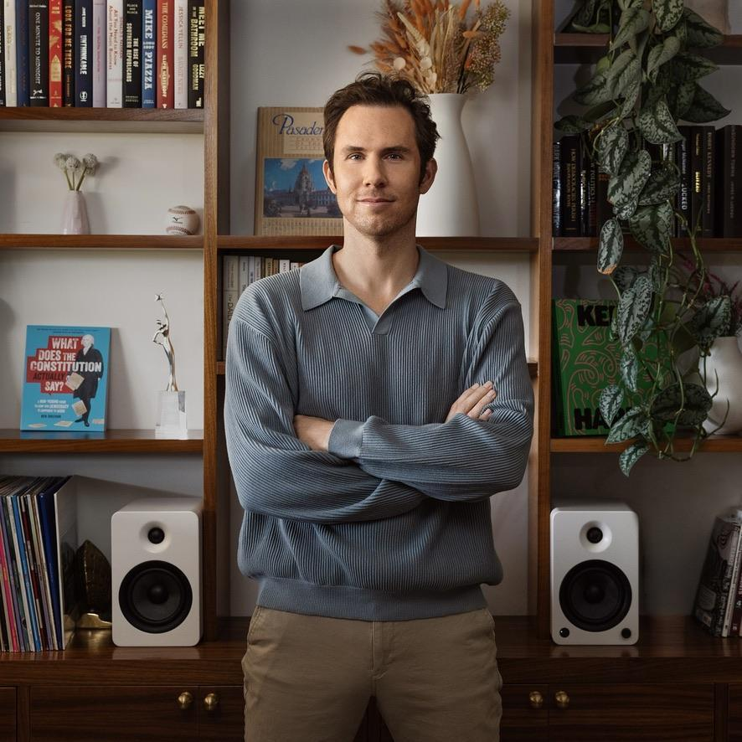
ARLINGTON, VA; June 26, 2025 – PBS announces CIVICS MADE EASY, a new twelve-part series with host and bestselling author Ben Sheehan, premiering Thursday, June 26 on the PBS app, PBS.org, and YouTube. Produced by Second Peninsula, the series aims to explore the fundamentals of American government for a national audience.
From exploring questions like, “What exactly is the Electoral College?" to uncovering the origins of Election Day, Sheehan makes understanding civics both accessible and engaging. In each episode, he breaks down complex topics into digestible lessons that empower, inform, and equip audiences of all ages with a deeper understanding of the fundamentals of U.S. government.

Sheehan, known for his #1 Amazon bestseller “What Does the Constitution Actually Say? A Non-Boring Guide to How Our Democracy Is Supposed to Work,” brings a rare mix of constitutional literacy and pop culture fluency to the project as executive producer, host and writer. He has amassed a devoted social media following among both Hollywood political circles and D.C. insiders for his ability to distill complex civic concepts and breaking political news into clear, compelling, and relatable language. His straightforward approach resonates especially in an era marked by heightened polarization and civic confusion. His work has been praised by educators, journalists, legal scholars, and elected officials. In addition to authoring a widely read Substack, Politics Made Easy, Sheehan has contributed to The Washington Post, The Hill, and The Daily Beast, and made frequent media appearances on Real Time with Bill Maher, PBS NewsHour, Good Morning America, CBS News, and Amanpour & Co.

“Instead of shaming people for not knowing how the U.S. government works, CIVICS MADE EASY is about getting caught up together,” said host Sheehan. “There’s a real hunger right now for clear, engaging, nonpartisan information about the basics.”
Steve Goldbloom, founder of Second Peninsula and creator of the short-form interview series “Brief But Spectacular” added, “Ben is a unique voice in the political arena. His blend of constitutional scholarship and humor will inspire viewers to feel more connected to the political process. There’s never been a more important moment to empower the public.”
CIVICS MADE EASY will be also published on PBS LearningMedia alongside curriculum-aligned support materials for middle and high school classrooms. These materials will feature full episodes from the program and teaching tips and activities that draw on the content of the video to build civic knowledge. Written by educators for educators, these learning materials allow grade 6-12 educators to easily use program content in their classrooms.

“As one of YouTube’s leading educational content providers, PBS delivers smart, accessible and engaging content for learners at every age,” said Margaret Ebrahim, Senior Director, Programming and Development at PBS. “Ben brings a fresh and entertaining lens to our civics and history programming, and we’re thrilled for audiences to dive into this timely and enlightening series as we look ahead to our nation’s Semiquincentennial.”

Episode descriptions for CIVICS MADE EASY are provided below.

Episode 1: “What is the Electoral College?”
Premieres Thursday, June 26, 2025
Ben Sheehan provides a comprehensive exploration of the Electoral College, covering its historical origins, how it operates today, its controversies, and possible reforms.

Episode 2: “Why Do Politicians Keep Asking for Money?”
Premieres Thursday, July 10, 2025
Ben Sheehan breaks down the origins of political fundraising and the ins and outs of campaign
texts, political donations, Super PACs, and dark money.

Episode 3: “Why Do We Have Two Main Political Parties?”
Premieres Thursday, July 24, 2025
Ben Sheehan explores America's two-party system, its history, and why third parties struggle to compete.

Episode 4: “Why Is Election Day a Tuesday in November?”
Premieres Thursday, August 7, 2025
Ben Sheehan reveals why we vote on Tuesdays, who runs our elections, and how voting varies by state.

Episode 5: “Do Americans Have the Right to Vote?”
Premieres Thursday, August 21, 2025
Ben Sheehan looks into where our voting rights come from and why they're more complex than
you think.

Episode 6: “Why Do We Know So Little About How Our Government Works?”
Premieres Thursday, September 4, 2025
Ben Sheehan explores why many Americans know so little about government and how to change that.

Episode 7: “What Is the Filibuster?
Premieres Thursday, September 18, 2025
Ben Sheehan explains the filibuster’s history, evolution, rules, and potential reforms.

Episode 8: “What Are U.S. Territories and Why Do We Have Them?
Premieres Thursday, October 2, 2025
Ben Sheehan covers U.S. territories and how they became a part of America.

Episode 9: “Where Do Our Tax Dollars Go?
Premieres Thursday, October 16, 2025
Ben Sheehan looks at how the U.S. government raises, and spends, your hard-
earned money.

Episode 10: “What Is a Constitutional Convention?
Premieres Thursday, October 30, 2025
Ben Sheehan explains what happened at the first one and if the U.S could have another.

Episode 11: “How to Amend the Constitution
Premieres Thursday, November 13, 2025
Ben Sheehan explains how, and how often, Americans have changed their Constitution.

Episode 12: “Do Our Founding Documents Still Matter?
Premieres Thursday, November 27, 2025
Ben Sheehan explores how these documents, and their lessons, still resonate today.

CIVICS MADE EASY will be available to stream starting Thursday, June 26 on all station-branded PBS platforms, including PBS.org and the PBS app, available on iOS, Android, Roku streaming devices, Apple TV, Android TV, Amazon Fire TV, Samsung Smart TV, Chromecast and VIZIO. The series will also be available on PBS’ flagship YouTube channel.

CIVICS MADE EASY is produced for PBS by Second Peninsula. Ben Sheehan is Executive Producer and Writer. Steve Goldbloom is the Creative Director and Executive Producer, along with Melissa Williams. Ana Dávila is Head of Post-Production. Katie Hodgman, Summer Mastin, and Mira Kittner are Producers. Benita Sills is Senior Editor and Fred Arelaro is Finishing Editor. Gabi Amerth is Social Media Manager. Executive in charge for PBS is Margaret Ebrahim and Estefanía De León is Assistant Director.

Funding for CIVICS MADE EASY is provided by the Corporation for Public Broadcasting.

CIVICS MADE EASY is part of a slate of new programming for PBS America @ 250, a multiyear celebration of U.S. history, culture, and children’s programming that pays homage to America’s Semiquincentennial in 2026. As part of the largest national and local engagement effort in its history, PBS member stations will activate events in more than 75 markets nationwide. In addition to tentpole programming like THE AMERICAN REVOLUTION from Florentine Films, PBS KIDS, PBS LearningMedia, PBS Digital Studios, and PBS member stations will explore these topics at a national and local level. Visit the PBS America @ 250 Explore Page at www.pbs.org/explore/pbs-america-at-250 for more program information and PBS LearningMedia resources related to this effort as they premiere.

ABOUT SECOND PENINSULA
Second Peninsula is an Emmy-nominated production company that specializes in authentic, human centered storytelling. The company’s signature style of short-form, first-person narratives offer viewers a glimpse into the lived experience of others. Second Peninsula’s flagship series, Brief But Spectacular, has released over 500 episodes and garnered more than 400 million views. The company produces original content for various partners including PBS, PBS NewsHour, and many non-profit and corporate clients.
ABOUT PBS
PBS, with more than 330 member stations, offers all Americans the opportunity to explore new ideas and new worlds through television and digital content. Each month, PBS reaches over 36 million adults on linear primetime television, more than 16 million users on PBS-owned streaming platforms, 53 million viewers on YouTube, and 60 million people view PBS content on social media, inviting them to experience the worlds of science, history, nature, and public affairs and to take front-row seats to world-class drama and performances. PBS’s broad array of programs has been consistently honored by the industry’s most coveted award competitions. Teachers of children from pre-K through 12th grade turn to PBS LearningMedia for digital content and services that help bring classroom lessons to life. As the number one educational media brand, PBS KIDS helps children 2-8 build critical skills, enabling them to find success in school and life. Delivered through member stations, PBS KIDS offers high-quality content on TV — including a PBS KIDS channel — and streaming free on pbskids.org and the PBS KIDS Video app, games on the PBS KIDS Games app, and in communities across America. More information about PBS is available at PBS.org, one of the leading dot-org websites on the internet, Facebook, Instagram, or through our apps for mobile and connected devices. Specific program information and updates for press are available at pbs.org/pressroom or by following PBS Communications on X.

– PBS –

MEDIA CONTACTS:

Atiya Frederick, PBS, anfrederick@pbs.org
Stephanie Kennard, PBS, skkennard@pbs.org

Lisa Dyer, Bullseye Communications, lisa.dyer@bullseyecomm.com
Heather Marohn, Bullseye Communications, heather.marohn@bullseyecomm.com

Melissa Williams, Second Peninsula, melissa@secondpeninsula.com

Editorial Note: For images and additional up-to-date information on CIVICS MADE EASY and other PBS programs, visit PBS PressRoom at pbs.org/pressroom.

