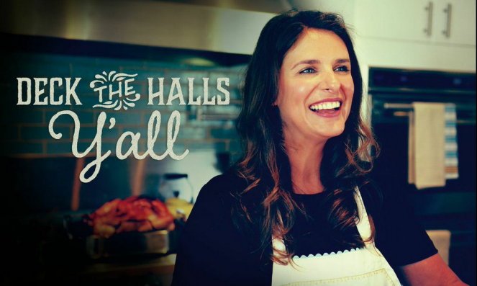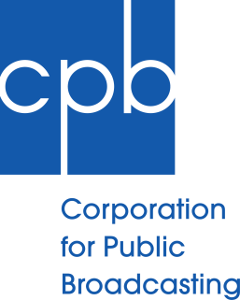

PEABODY AWARD-WINNING PBS SERIES INVITES VIEWERS HOME FOR THE HOLIDAYS WITH A CHEF’S LIFE HOLIDAY SPECIAL

– Acclaimed chef Vivian Howard celebrates food, family, and Southern traditions in one-hour documentary special –
KINSTON, NC, November 6, 2014 – This holiday season, the popular series A CHEF’S LIFE invites viewers on a journey to discover and rediscover holiday traditions with a one-hour documentary A CHEF’S LIFE HOLIDAY SPECIAL. Chef Vivian Howard hosts a holiday to remember at her home in Eastern North Carolina as she creates a Southern holiday feast steeped in her family’s Christmas and Chanukah traditions. A CHEF’S LIFE HOLIDAY SPECIAL airs on PBS Tuesday, December 16 at 10pm ET/PT (check local listings).

Having spent most of her adult life in the kitchens of highly-lauded restaurants, Vivian has rarely celebrated the holidays during busy Decembers. This year, she and her husband Ben Knight are determined to give their toddler twins a traditional holiday experience, cooking, laughing, and yes, crying their way through Southern traditions new and old. In A CHEF’S LIFE HOLIDAY SPECIAL, Vivian discovers that mistletoe is traditionally shot out of a pecan tree, experiences her first hog killing, and leads a “tacky Christmas sweater” night with the restaurant staff at Chef and the Farmer.

This is television you can virtually taste, complete with culinary expert friends and family stopping by to help Vivian with her feast. Chef Scott Barton (Voyage), Vivian’s mentor and an expert on Southern food, shows her how to prepare Hoppin’ John, and North Carolina’s Bill Smith (Crook’s Corner) shares his secrets for his world famous corned ham. Vivian recreates her childhood memories as she bakes red velvet cake with her sister and celebrates the first night of Chanukah with Ben’s family, making traditional foods and lighting the menorah.

“With A CHEF’S LIFE HOLIDAY SPECIAL, you truly get a sense of the emotion of the holidays, and PBS is pleased to feature the new special in primetime as families gather at home and around their own culinary traditions,” said Donald H. Thoms, Vice President, General Audience Programming, PBS. “PBS has a long-standing tradition of quality food and documentary programs, and A CHEF’S LIFE encapsulates the best of both worlds as an insightful and inspiring documentary food series.”

More than a cooking show, A CHEF’S LIFE is a character-driven documentary series that takes viewers inside the life and kitchen of Chef Vivian Howard. Howard originally made a name for herself in the competitive Manhattan restaurant world, before she and her husband Benjamin Knight moved back to her home of Eastern Northern Carolina to open their own restaurant. From a devastating fire to the opening of a second restaurant, A CHEF’S LIFE has followed Vivian and Ben as they raise a family, manage their business, and discover the food traditions that make the South such a special place. A CHEF’S LIFE was honored with a Peabody Award in 2014 and was also nominated for a James Beard Award.

A CHEF'S LIFE is produced by Markay Media in association with SCETV Presents. The series is directed and produced by Cynthia Hill with Rex Miller as co-producer and cinematographer. Derek Britt is the Executive Producer, and the series is edited by Tom Vickers. The opening title song, “Will You Return,” is written and performed by the Avett Brothers. Amy Shumaker is Executive-in-Charge for SCETV Presents.

A CHEF’S LIFE HOLIDAY SPECIAL is made possible, in part, by the Corporation for Public Broadcasting and by public television viewers.

About South Carolina ETV
South Carolina ETV has a strong history of bringing quality programming to national public television and radio. From critically-acclaimed series such as Firing Line and Piano Jazz with Marian McPartland to countless award-winning arts, performance, documentary and international specials, SCETV Presents is dedicated to producing and presenting fresh, innovative public media programming for national and international audiences. SCETV is the South Carolina public educational broadcasting network with 11 television and eight radio transmitters, and a multi-media educational system. By using television, radio and the web, SCETV's mission is to enrich lives by educating, informing and connecting citizens, celebrating our culture and environment and instilling the joy of learning. More information is available at scetv.org.

About PBS
PBS, with its more than 350 member stations, offers all Americans the opportunity to explore new ideas and new worlds through television and online content. Each month, PBS reaches nearly 120 million people through television and nearly 28 million people online, inviting them to experience the worlds of science, history, nature and public affairs; to hear diverse viewpoints; and to take front row seats to world-class drama and performances. PBS’ broad array of programs has been consistently honored by the industry’s most coveted award competitions. Teachers of children from pre-K through 12th grade turn to PBS for digital content and services that help bring classroom lessons to life. PBS’ premier children’s TV programming and its website, pbskids.org, are parents’ and teachers’ most trusted partners in inspiring and nurturing curiosity and love of learning in children. More information about PBS is available at www.pbs.org, one of the leading dot-org websites on the Internet, or by following PBS on Twitter, Facebook or through our apps for mobile devices. Specific program information and updates for press are available at pbs.org/pressroom or by following PBS Pressroom on Twitter.

About CPB
The Corporation for Public Broadcasting (CPB), a private, nonprofit corporation created by Congress in 1967, is the steward of the federal government’s investment in public broadcasting. It helps support the operations of more than 1,400 locally-owned and -operated public television and radio stations nationwide, and is the largest single source of funding for research, technology, and program development for public radio, television and related online services. More information about CPB is available at www.cpb.org.

For images and additional up-to-date information on this and other PBS programs, visit PBS Press Room at pbs.org/pressroom.

CONTACT:
Meredith Gandy, 360 Public Relations, 415.610.4067, mgandy@360pr.com

