CHANGING PLANET Returns to Explore the Amazing Global Innovations Being Implemented to Save Coral Reefs

Third Year of Seven-Year Project Premieres Wednesday,
April 24, 2024 on PBS and PBS.org

Global Conservation Scientist Dr. M. Sanjayan Travels to the Maldives and the Florida Keys to Investigate the Urgent Efforts to Help Coral
Fight Climate Change

ARLINGTON, VA; March 4, 2024 – In the third year of the seven-year CHANGING PLANET project, renowned conservationist Dr. M. Sanjayan travels to the Maldives and the Florida Keys for an in-depth look at coral reefs — a habitat under urgent threat from climate change — and the innovative techniques that could save them. Featuring spectacular underwater cinematography, the program explores how scientists from across disciplines are collaborating on projects that offer glimmers of hope for the future of coral reefs. CHANGING PLANET: CORAL SPECIAL premieres Wednesday, April 24, 2024, 8:00-9:00 p.m. ET (check local listings) on PBS, PBS.org and the PBS App.
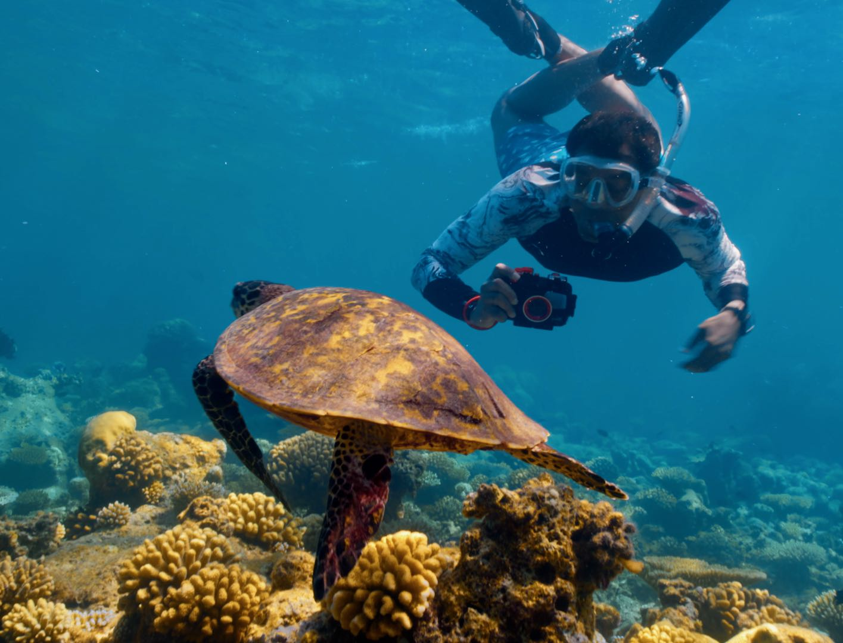
M. Sanjayan photographs a sea turtle in the Maldives. Credit: Mark Sharman

Globally, coral reefs are at a crisis point; warming seas have caused corals to bleach and die at an alarming rate. Five hundred million people worldwide rely on reefs for food and to protect coastlines from storms and rising sea levels. But without action, scientists predict that nearly all reefs could die off in the next few decades.

In CHANGING PLANET: CORAL SPECIAL, Sanjayan visits Laamu Atoll in the Maldives to take part in a first-time collaboration that could be the key to restoring reefs. Professor Peter Harrison from Southern Cross University in Australia has devised a fertility treatment to help corals reproduce more successfully: “coral IVF.”

Corals spawn on just a few nights a year, releasing billions of eggs and sperm into the ocean. The resulting larvae settle on a reef and grow to become baby coral. But in the wild, spawn is at the mercy of currents and predators; only one in a million may survive to adulthood. Peter’s technique involves collecting spawn and maximizing fertilization, then allowing the larvae to develop in the safety of a net before releasing them onto areas of the reef that need restoration, significantly increasing their chance of survival.

Peter is now working with a scientist who hopes to enhance this process further. Professor Steve Simpson from Bristol University in the UK discovered that coral larvae move towards the sound of a healthy reef — and it is fish vocalizations, in particular, which trigger them to sink to the bottom, settle and grow. The scientists’ audacious plan is to combine Peter’s fertility technique with Steve’s fish recordings to lure them to set up home on a damaged reef. This method has never been tried before, but if it works, it could be a global game changer for reef restoration.

In the U.S., Florida has the third largest barrier reef in the world, but it has lost an alarming 98% of its coral. Dr. Erinn Muller at Mote Marine Laboratory in Florida oversees a high-tech warehouse where thousands of coral fragments are carefully nurtured, a last-ditch attempt to prevent them from going extinct. As part of a $100 million reef restoration project, her team is breeding millions of coral to be planted back out on the reef, selecting ones that can best withstand warming oceans.

At the University of Miami, Professor Andrew Baker is creating a hybrid reef — a concrete structure seeded with coral larvae that will grow into a vibrant coral layer. These ready-made reefs could soon provide a home for wildlife and protect coastlines everywhere from extreme weather.

“The problems that coral reefs face can seem insurmountable, but around the globe, the scientific community is working together and working fast to come up with novel and surprising techniques to give coral a lifeline,” said Sanjayan. “These projects give me hope.”

CHANGING PLANET: CORAL SPECIAL will stream simultaneously with broadcast and be available on all station-branded PBS platforms, including PBS.org and the PBS App, available on iOS, Android, Roku, Apple TV, Amazon Fire TV, Android TV, Samsung Smart TV, Chromecast and VIZIO.

CHANGING PLANET: CORAL SPECIAL is a BBC Studios Natural History Unit production for PBS and BBC. Rosemary Edwards is executive producer. Caroline El-Marazki is senior producer and director. Series producers are Charlotte Jones and Joanne Steves. Diana El-Osta is Executive in Charge for PBS. BBC Studios is handling global distribution.
PBS is committed to offering audiences new thought-provoking programs, documentaries and specials designed to elevate the conversation around climate change and sustainability. This programming is part of a multiyear, multiplatform initiative from PBS that explores every aspect of the issues surrounding climate change and exploring its intersections with conservation, biodiversity, and the ecosystem. CHANGING PLANET: CORAL SPECIAL is included in PBS’s Earth Month programming slate, which is also comprised of A BRIEF HISTORY OF THE FUTURE (Wednesday, April 3, 9:00 p.m. ET), INDEPENDENT LENS’ “A Thousand Pines” (Monday, April 1, 9:00 p.m. ET), “One with the Whale” (Tuesday, April 23, 10 p.m. ET) and AMERICAN EXPERIENCE “Poisoned Ground: The Tragedy at Love Canal.” In addition, PBS DIGITAL STUDIOS is set to debut a new series STOP SAVING THE PLANET on the PBS Terra YouTube channel beginning March 28.
About Dr. M. Sanjayan
Dr. M. Sanjayan is a conservation scientist and chief executive officer of Conservation International, an organization working primarily in the Global South to secure nature for humanity. Born in Sri Lanka and raised in West Africa, Sanjayan brings a unique perspective to his work, which has attracted media coverage. Most recently, he was named to the inaugural TIME 100 list of climate leaders, which noted his ability to forge powerful partnerships for environmental protection and restoration. Additional media coverage and profiles include The New York Times, The Washington Post, CNN, and Outside Magazine.

He has hosted more than a dozen award-winning documentaries from PBS, BBC, National Geographic, Discovery, Showtime, and Vox Media and has appeared on The Today Show, The Late Show with David Letterman, CBS This Morning, and Fareed Zakaria GPS.

Sanjayan holds a master’s degree from the University of Oregon and a Ph.D. in conservation biology from the University of California, Santa Cruz. His peer-reviewed scientific work has appeared in Science, Nature, and Conservation Biology. He has been a visiting researcher at UCLA, distinguished professor of practice at Arizona State University, and a fellow at the Aspen Institute. Sanjayan also serves as a Trustee for The Earthshot Prize and a Climate Advisor for the Clinton Global Initiative. Sanjayan lives in Washington, D.C. with his wife and daughter. He enjoys spending time fly fishing in Montana, or birding, cycling and diving around the world.

ABOUT PBS
PBS, with more than 330 member stations, offers all Americans the opportunity to explore new ideas and new worlds through television and digital content. Each month, PBS reaches over 42 million adults on linear primetime television, more than 15 million users on PBS-owned streaming platforms, and 56 million people view PBS content on social media, inviting them to experience the worlds of science, history, nature, and public affairs; to hear diverse viewpoints; and to take front-row seats to world-class drama and performances. PBS’s broad array of programs has been consistently honored by the industry’s most coveted award competitions. Teachers of children from pre-K through 12th grade turn to PBS LearningMedia for digital content and services that help bring classroom lessons to life. As the number one educational media brand, PBS KIDS helps children 2-8 build critical skills, enabling them to find success in school and life. Delivered through member stations, PBS KIDS offers high-quality content on TV — including a PBS KIDS channel — and streaming free on pbskids.org and the PBS KIDS Video app, games on the PBS KIDS Games app, and in communities across America. More information about PBS is available at PBS.org, one of the leading dot-org websites on the internet, Facebook, Instagram, or through our apps for mobile and connected devices. Specific program information and updates for press are available at pbs.org/pressroom or by following PBS Communications on X (formerly Twitter).

– PBS –

CONTACTS:

Stephanie Kennard, PBS, skkennard@pbs.org

Cara White / Mary Lugo, CaraMar, Inc.
cara.white@mac.com; lugo@negia.net

For images and additional up-to-date information on this and other PBS programs, visit PBS PressRoom at pbs.org/pressroom.

