CELTIC WOMAN: POSTCARDS FROM IRELAND
Premieres on PBS Stations Beginning November 27

A Spectacular Musical Journey Around The Emerald Isle

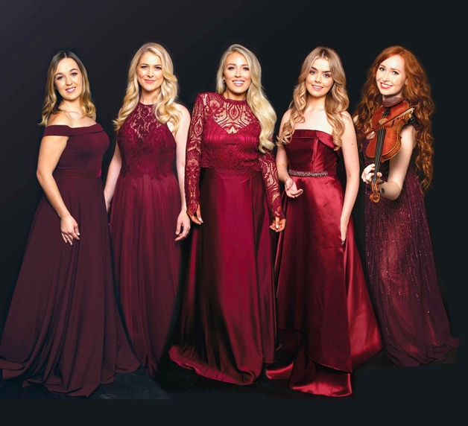
Credit: Kip Carroll
As the world looks forward to getting together again, Celtic Woman shares a message of love, hope and expectation with their fans around the world in the form of musical postcards, written with the songs from Celtic Woman’s latest album. Filmed in 14 different locations around the island, CELTIC WOMAN: POSTCARDS FROM IRELAND is part of special programming premiering on PBS stations beginning Saturday, November 27, 2021 (check local listings).

Breaking from the usual format of their TV specials, Celtic Woman brings an innovative, fresh and vibrant approach to their performances, taking viewers on a musical journey through some of the most stunning land and seascapes across Ireland.

Using the forests, lakes and beaches as their stage and the mountains and valleys as their backdrop, the soft light from dramatic skyscapes becomes their only source of illumination. Blending their performances into these sometimes wild, natural places, their costumes in lush palettes become the perfect visual match for these postcard settings.

CELTIC WOMAN: POSTCARDS FROM IRELAND introduces viewers to Sean, an American now living in Ireland as he writes a postcard to his family back home. “You were right about Ireland,” he writes. “There’s music everywhere here. It’s in the trees, it’s in the rivers, in the wind and rain. It rolls in on Atlantic waves.”

And so the musical and visual journey begins as we follow Celtic Woman with their musicians and dancers to many popular locations. The postcards appear throughout the program as signposts to keep the viewer informed of the location, and performers share associations they have with the location or the song they are about to perform.

The journey begins in Ireland’s Ancient East with a return visit to Johnstown Castle in County Wexford, where the group delivers a spine-tingling performance of the ever-popular “Amazing Grace.” Then on to the monastic site at Glendalough in County Wicklow for Megan’s performance of “Bonny Portmore.” Next up are the spectacular seascapes and cliffs in County Antrim where the group performs a brand new rendition of “The Dawning of the Day.” They then move on to a reconstructed early 20th-century Irish village in County Tyrone to perform “Beeswing,” a beautiful folk song. Then on to “The Wild Atlantic Way,” stopping off at Lissadell House in County Sligo, the holiday home of renowned Irish poet W.B. Yeats to hear Muirgen sing “Down By the Salley Gardens.” At Kylemore Abbey in Connemara, County Galway, Chloe delivers a stunning rendition of “Angel.” In County Kerry, Tara performs the magnificent Bach violin solo “Where Sheep May Safely Graze” in the medieval monastic ruins of Muckross Abbey. In the Chapel at Trinity College in Dublin, Susan offers a powerful rendition of “May It Be.”

PBS special programming invites viewers to experience the worlds of science, history, nature and public affairs; hear diverse viewpoints; and take front-row seats to world-class drama and performances. Viewer contributions are an important source of funding, making PBS programs possible. PBS and public television stations offer all Americans from every walk of life the opportunity to explore new ideas and new worlds through television and online content.

Underwriters: Public Television Viewers and PBS
Production Company: Celtic Woman, Limited

- PBS –

CONTACT: Cara White, CaraMar, Inc., cara.white@mac.com

For images and additional up-to-date information on this and other PBS programs, visit PBS PressRoom at pbs.org/pressroom.

