CELEBRATING PBS NEWSHOUR

Danny Glover, Host
Actor, producer and humanitarian Danny Glover has been a commanding presence on screen, stage and television for more than 30 years. As an actor, his film credits range from the blockbuster Lethal Weapon franchise to smaller independent features, some of which Glover also produced.
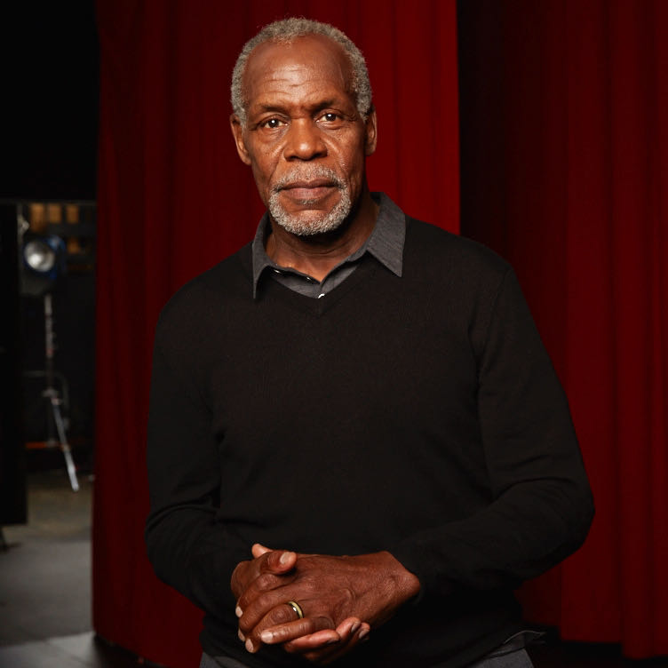
Credit: Courtesy of Inky Dinky Worldwide CT LLC.
In recent years he has starred in an array of motion pictures including the critically-acclaimed Dreamgirls, directed by Bill Condon, and in the futuristic 2012 for director Roland Emmerich. In addition to his film work, Glover is highly sought after as a public speaker, delivering inspirational addresses and moving performances in such diverse venues as college campuses, union rallies and business conventions.

Glover has gained respect for his wide-reaching community activism and philanthropic efforts, with a particular emphasis on advocacy for economic justice and access to health care and education programs in the United States and Africa. For these efforts Glover received a 2006 DGA Honor and was honored with a 2011 “Pioneer Award” from the National Civil Rights Museum. Internationally Glover has served as a Goodwill Ambassador for the United Nations Development Program from 1998-2004, focusing on issues of poverty, disease and economic development in Africa, Latin America and the Caribbean. Glover was presented in 2011 with the prestigious Medaille des Arts et des Letters from the French Ministry of Culture and was honored with a Tribute at the Deauville International Film Festival. In 2014 Glover received an Honorary Doctorate of Humane Letters from the University of San Francisco. Currently Glover serves as UNICEF Ambassador.

In 2005, Glover co-founded NY-based Louverture Films with writer/producer Joslyn Barnes and more recent partners Susan Rockefeller and the Bertha Foundation. The company is dedicated to the development and production of films of historical relevance, social purpose, commercial value and artistic integrity. Among the films Glover has executive- or co-produced at Louverture are the César-nominated Bamako; Sundance Grand Jury Prize and the Academy Award® and Emmy nominated film Trouble The Water ; the award-winning The Black Power Mixtape 1967-1975 and Concerning Violence; Sundance Grand Jury Prize winner The House I Live In; Cannes Palme d’Or winner Uncle Boonmee Who Can Recall His Past Lives; the Academy Award® nominated and Emmy-winning Strong Island, ZAMA by Lucrecia Martel; the Oscar® nominated documentary Hale County This Morning, This Evening by RaMell Ross; and Oscar® nominated Best Foreign Language Film Capernaum by Nadine Labaki. Forthcoming films in 2021 include President by Camilla Nielsson, Noche de Fuego by Tatiana Huezo and Memoria by Apichatpong Weerasethakul.

A native of San Francisco, Glover trained at the Black Actors’ Workshop of the American Conservatory Theatre. It was his Broadway debut in Fugard’s Master Harold…and the Boys that brought him to national recognition and led director Robert Benton to cast him in his first leading role in 1984’s Academy Award-nominated Best Picture, Places in the Heart. The following year Glover starred in two more Best Picture nominated films: Peter Weir’s Witness and Steven Spielberg’s The Color Purple. In 1987 Glover partnered with Mel Gibson in the first Lethal Weapon film and went on the star in three hugely successful Lethal Weapon sequels. Glover starred in The Royal Tenenbaums and To Sleep With Anger, which he executive produced and for which he won an Independent Spirit Award for Best Actor.

On the small screen, Glover won an Image Award, a Cable ACE Award and earned an Emmy nomination for his performance in the title role of the HBO Movie Mandela. He has also received Emmy nominations for his work in the acclaimed miniseries Lonesome Dove, the telefilm Freedom Song, and as a director he earned a Daytime Emmy nomination for Showtime’s Just a Dream. Glover also appeared in the HBO Original Movie Muhammad Ali’s Greatest Fight.

Glover starred in Mr. Pig, which had its debut at the 2016 Sundance Film Festival, and which now appears on Netflix. Co-starring Maya Rudolph, Mr. Pig was filmed entirely on location in Mexico and is a tour de force for him.

Glover starred in Almost Christmas for Universal Studios. He was also seen in Rage, co-starring Nicolas Cage, Beyond the Lights and the independent Complete Unknown.

He co-starred in the feature film The Old Man & The Gun opposite Robert Redford and in the films Proud Mary opposite Taraji P. Henson, Come Sunday with Chewitel Ejiofor, and appeared in Sorry to Bother You. Glover also had a pivotal role in the critically-acclaimed film Last Black Man In San Francisco.

Glover appeared in the Sony Pictures box office hit Jumanji: Welcome to The Jungle co-starring Dwayne Johnson and Jack Black and filmed the independent feature Press Play on location in Hawaii. He recently completed a Guest-Star appearance for ABC’s Black-ish and was featured in What The Funk for Netflix. In addition, Glover appeared opposite Susan Sarandon in the touching Dance video for artist Julia Stone.

