An Epic Tale of Hubris and Ambition,
THE BOLEYNS: A SCANDALOUS FAMILY,
Premieres Sundays, August 28-September 11, 2022
on PBS and Streaming on the PBS Video App

New Three-Part Series Follows The Rise and Fall of a Family Dynasty Whose Hunger for Power Proved to Be Their Undoing

ARLINGTON, VA – Beloved, betrayed and beheaded, Anne Boleyn is England’s most infamous queen. The second wife of Henry VIII, she was tried on his orders for crimes of adultery and treason, led from her rooms at the Tower of London to her death by an executioner’s sword. But to fully understand Anne’s rise and fall, it’s important to know more about her tight-knit, cunning and power-hungry family. Based on 16th-century sources, including rare original letters and documents, this new three-part series uses insights from leading Tudor scholars and dramatic re-enactments to bring this story to life from the family’s own perspective. Rising from obscurity to the apex of power, the Boleyns played a dangerous game and paid the ultimate price. But they changed the course of British history and left a remarkable legacy in the form of two magnificent monarchs: Queen Elizabeth I, daughter of Anne, and Queen Elizabeth II, a direct descendant of Mary Boleyn. A riveting story of love, sex, betrayal and obsession, THE BOLEYNS: A SCANDALOUS FAMILY premieres Sundays, August 28-September 11, 8:00-9:00 p.m. ET (check local listings) on PBS, and streaming on PBS.org and the PBS Video app.
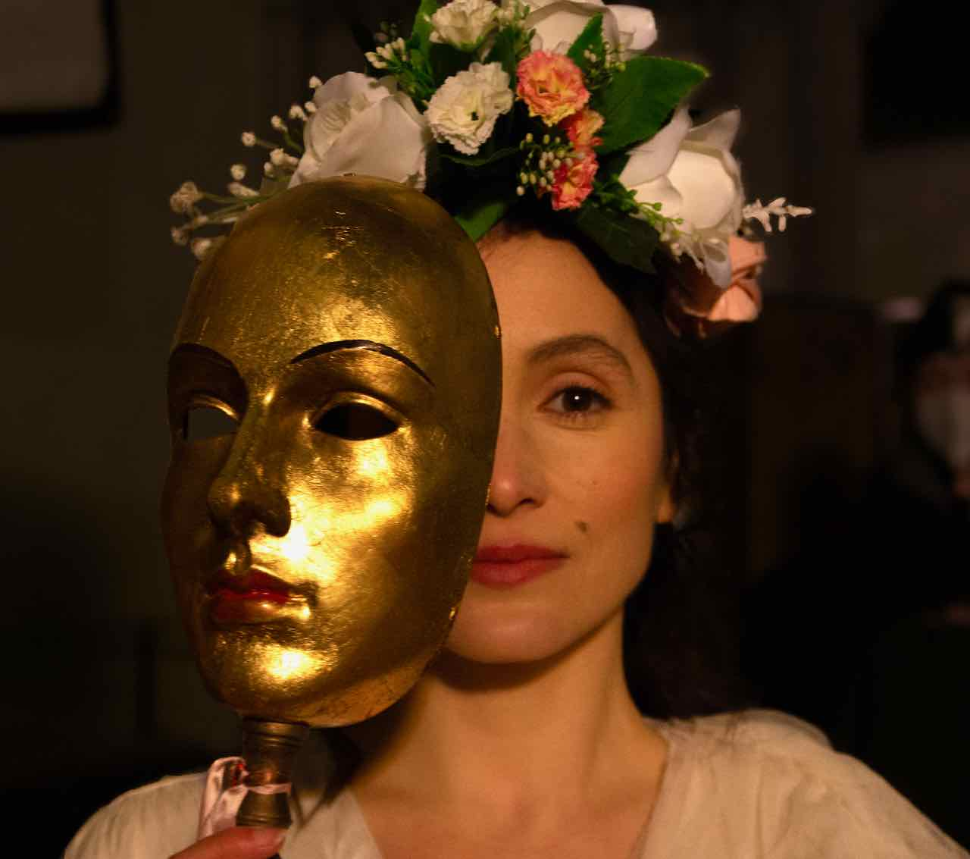
Anne Boleyn (Rafaelle Cohen).
Credit: Mackenzie Quicke/BBC Studios

Episode 1: “Ambition” – Sunday, August 28
Patriarch Thomas Boleyn is determined to elevate the family name. But it is his ambitions for his three children — Mary, George and Anne — that will take them to the heart of the Tudor court. Recognizing that Anne is extraordinary, he places her in the most influential courts in Europe from the age of 12. Along with other noble families, Thomas jostles for position in a court rife with gossip, backstabbing rivalries and intrigue. He realizes that the powerful Cardinal Wolsey is the gatekeeper to the king’s inner circle. Anne returns from France, having grown into a sophisticated beauty admired as exotic, stylish and fashionable. She sets her cap for a nobleman far above her station, but Cardinal Wolsey ends the match, something Anne will not forget. But it is Mary who attracts the king’s eye, and he demands that she become his mistress. Although married, Mary is powerless to resist the will of the king. After their affair begins, Henry promotes Thomas Boleyn to Viscount Rochford, accelerating his rise through the Tudor Court. But Anne’s ambition will soon outstrip even that of her father.

Episode 2: “Desire” – Sunday, September 4
Henry casts Mary Boleyn aside and turns his attention to her sister. A calculating courtier, Anne adeptly dazzles with her beauty, wit and seductive charm. Henry falls under her spell, and Anne does what all Boleyns do: makes good use of an opportunity. She positions herself as a woman of power and refuses to become his mistress, skillfully leveraging his desire for her to negotiate a marriage proposal. In succeeding, she turns the role of Tudor women and royal mistresses upside down. But one obstacle stands in the couple’s way: Katherine of Aragon, Henry’s first wife, who failed to deliver an heir to the throne. Anne directs Henry to enlist Cardinal Wolsey to obtain an annulment from the Pope. But Wolsey drags his feet, and the impatient Henry removes him from his position. The Boleyns are now the most powerful family in Henry’s court. Above them all is Anne herself, pushing the king to get on with the divorce. But holding the reins of power makes the family acutely vulnerable. Now that Wolsey is gone, there is no one standing between them and the unpredictable king.

Episode 3: “The Fall” – Sunday, September 11
In a high-stakes gamble, Anne makes her play for — and wins — the biggest prize in the kingdom. The Boleyns and their allies push Henry to break with the Catholic Church in Rome and claim his destiny as Supreme Head of the Church of England, overturning 1000 years of history. With the power to grant his own divorce, Henry makes Anne his queen. She does her best to please the king and provide him with a male heir. But when she fails — giving birth to first a daughter and then miscarrying — the knives are out. Henry’s roving eye has already turned to her replacement, the young Jane Seymour. Anne is arrested and tried on charges of treason, adultery and incest with her brother George. Both are executed. But the Boleyn legacy lives on through Anne’s daughter Elizabeth, the greatest Tudor Queen, and through Elizabeth II, a descendant of Mary Boleyn.

Narrated by Shelley Conn, the series features Elizabeth McCafferty as Mary Boleyn, Max Dowler as Thomas Boleyn, Philip Brodie as Thomas Howard, Rafaelle Cohen as Anne Boleyn, Roger Evans as Thomas Wolsey and Sam Retford as George Boleyn.

THE BOLEYNS: A SCANDALOUS FAMILY is a BBC Studios Production for PBS and BBC. The series is produced and directed by Richard Curson Smith. Episode 1 is produced and directed by Katie Greening and Emma Frank. Episodes 2 and 3 are produced and directed by Katie Greening. The executive producer is Maxine Watson. The BBC Commissioning Editor is Simon Young. The producer is Kathryn Ellinger. Executive in Charge for PBS is Bill Gardner. BBC Studios is handling global distribution.

About PBS
PBS, with more than 330 member stations, offers all Americans the opportunity to explore new ideas and new worlds through television and digital content. Each month, PBS reaches over 120 million people through television and 26 million people online, inviting them to experience the worlds of science, history, nature and public affairs; to hear diverse viewpoints; and to take front row seats to world-class drama and performances. PBS’ broad array of programs has been consistently honored by the industry’s most coveted award competitions. Teachers of children from pre-K through 12th grade turn to PBS for digital content and services that help bring classroom lessons to life. Decades of research confirms that PBS’ premier children’s media service, PBS KIDS, helps children build critical literacy, math and social-emotional skills, enabling them to find success in school and life. Delivered through member stations, PBS KIDS offers high-quality educational content on TV – including a 24/7 channel, online at pbskids.org, via an array of mobile apps and in communities across America. More information about PBS is available at www.pbs.org, one of the leading dot-org websites on the internet, or by following PBS on Twitter, Facebook or through our apps for mobile and connected devices. Specific program information and updates for press are available at pbs.org/pressroom or by following PBS Communications on Twitter.

– PBS –
CONTACTS:

Atiya Frederick, PBS, anfrederick@pbs.org

Cara White / Mary Lugo, CaraMar, Inc.
cara.white@mac.com; lugo@negia.net

For images and additional up-to-date information on this and other PBS programs, visit PBS PressRoom at pbs.org/pressroom.

