For Immediate Release
Media Contact
GBH
Emily Balk
emily_balk@wgbh.org
617-300-5317

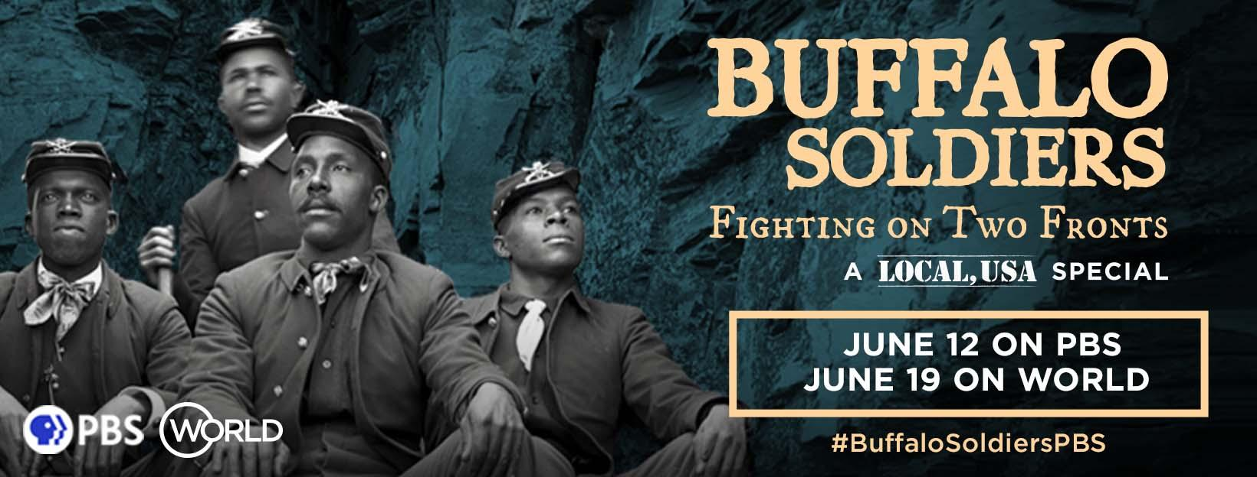

PBS and WORLD Channel to Explore the History of Black Soldiers in America with Buffalo Soldiers: Fighting on Two Fronts

PBS and WORLD Channel documentary examines the often-contradictory role played by the Black soldiers throughout American history

Premieres June 12 on PBS and June 19 on WORLD Channel’s Local, USA series

Boston, MA (April 20, 2023) – PBS and WORLD Channel announced today the presentation of Buffalo Soldiers: Fighting on Two Fronts, an award-winning documentary feature that explores the complex history of Black soldiers in the United States military. Director and producer Dru Holley weaves together the testimony of historians, experts and descendants of Buffalo Soldiers with archival photographs, reenactments and animation to tell the story of how newly free Black Americans enlisted in the U.S. Army, a reliable path to income and greater respect, and in the process helped to both fulfill America’s Manifest Destiny and disrupted the lives of Indigenous peoples. Buffalo Soldiers: Fighting on Two Fronts will premiere Monday, June 12 at 10pm ET on PBS and Monday, June 19 at 8pm ET on WORLD Channel’s Local, USA series. The film will be available to stream on the PBS app, WORLDChannel.org , YouTube and on the PBS Documentaries Prime Video Channel.

“The rise and role of Black Americans in the military is an important and overlooked part of American history, from conflicts abroad and on Indigenous lands at home,” said Chris Hastings, executive producer for WORLD Channel at GBH in Boston. “WORLD Channel is proud to bring Buffalo Soldiers to viewers on Juneteenth. With this film we hope to honor the contributions of brave Black soldiers and officers, and to acknowledge the painful legacy of westward expansion and colonial pursuits.”
Buffalo Soldiers: Fighting on Two Fronts, explores the often-contradictory role played by the Black soldiers throughout American history, with particular emphasis on the settling of the American West and colonialism abroad.
After the ratification of the 14th Amendment by Congress in 1868 granting full citizenship to Black men, many of them enlisted in the military. But they faced structural and social barriers to equal opportunity and fair treatment. Black soldiers helped lead the United States expansion westward; they helped build and guard transcontinental railroads and served as park rangers in places like Yosemite before the U.S. government established the National Park Service.
These Black soldiers fought bravely in the Indian Wars, the Spanish-American War, the Philippine-American War, the Mexican Punitive Expedition, World War I, World War II and the Korean War. However, the Buffalo Soldiers also participated in the subjugation of Indigenous peoples as the United States appropriated tribal land, the persecution of striking silver miners in Idaho, and against Filipinos fighting for independence during the Spanish-American War, resulting in a complicated legacy.

“The Buffalo Soldiers are key American figures whose tenacity to battle against overwhelming odds in service to the country has forever shaped history,” said Sylvia Bugg, Chief Programming Executive and General Manager of General Audience Programming at PBS. “PBS is proud to present this eye-opening and deeply moving story to audiences this summer, directed by one of the selected creators from our Open Call for Emerging Filmmakers.”

Buffalo Soldiers: Fighting on Two Fronts was produced and directed by Dru Holley, a filmmaker passionate about producing inspiring stories that empower viewers to re-think broken systems. Buffalo Soldiers: Fighting on Two Fronts is his feature directorial debut.
“The story of the Buffalo Soldiers involves historical complexities like race, class, power, colonialism and western expansion. It is particularly relevant today as our country is roiling with the agony of racial strife,” said Holley. “As a Black filmmaker, I feel a responsibility to tell our story, to provide an inspiring story about history often left out of school textbooks. We want young kids to know the accounts of people like them that stretch across the nation, to have more knowledge of their past than we did.”
Buffalo Soldiers: Fighting on Two Fronts is a film from PBS's Open Call for Emerging Filmmakers, which provides support for creators with unique ideas that will resonate, foster dialogue, and bring new engagement across the public media system. Whether in early concept stages or nearing completion, PBS will offer funding support for selected films that may be distributed across PBS platforms, including PBS.org and PBS Digital Studios. The films include a broad array of stories from a diversity of perspectives in genres ranging from arts & culture, personal history, social justice, health, immigration, economics, environment, democracy, and civics. Information about each film, creator and distribution partner will be announced on a rolling basis.
The film Buffalo Soldiers: Fighting on Two Fronts was an official selection at the Seattle International Film Festival, Portland Film Festival, Astoria Film Festival and Vashon Film Festival in 2022. It was the 2022 Audience Award Winner at the Tacoma Film Festival.
For more information, visit www.WORLDchannel.org or follow @worldchannel on Facebook, Twitter, Instagram, TikTok and YouTube. Join the conversation on social media with #BuffaloSoldiersPBS.

###

About PBS
PBS, with more than 330 member stations, offers all Americans the opportunity to explore new ideas and new worlds through television and digital content. Each month, PBS reaches over 120 million people through television and 26 million people online, inviting them to experience the worlds of science, history, nature, and public affairs; to hear diverse viewpoints; and to take front row seats to world-class drama and performances. PBS’s broad array of programs has been consistently honored by the industry’s most coveted award competitions. Teachers of children from pre-K through 12th grade turn to PBS for digital content and services that help bring classroom lessons to life. Decades of research confirms that PBS’s premier children’s media service, PBS KIDS, helps children build critical literacy, math, and social-emotional skills, enabling them to find success in school and life. Delivered through member stations, PBS KIDS offers high-quality educational content on TV — including a 24/7 channel — online at pbskids.org, via an array of mobile apps, and in communities across America. More information about PBS is available at PBS.org, one of the leading dot-org websites on the internet, Facebook , or through our apps for mobile and connected devices. Specific program information and updates for press are available at pbs.org/pressroom or by following PBS Communications on Twitter.

About WORLD Channel
WORLD shares the best of public media in news, documentaries and programming. WORLD’s original series examine the issues and amplify the voices of those often ignored by mainstream media. The multicast 24/7 channel helps audiences understand conflicts, movements and cultures from around the globe. Its original work has won a Peabody Award, an Alfred I. duPont-Columbia Award, an International Documentary Association Award, a National News and Documentary Emmy Award, two Webby Awards and many others honoring diversity of content and makers. WORLD is carried by 193 member stations in markets representing 75% of US TV households. Funding for WORLD Channel is provided by the Corporation for Public Broadcasting, the John D. and Catherine T. MacArthur Foundation, Wyncote Foundation and the National Endowment for the Arts and Artworks. WORLD is produced by GBH in partnership with WNET and is distributed by American Public Television (APT). Find out more at WORLDChannel.org.

