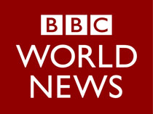

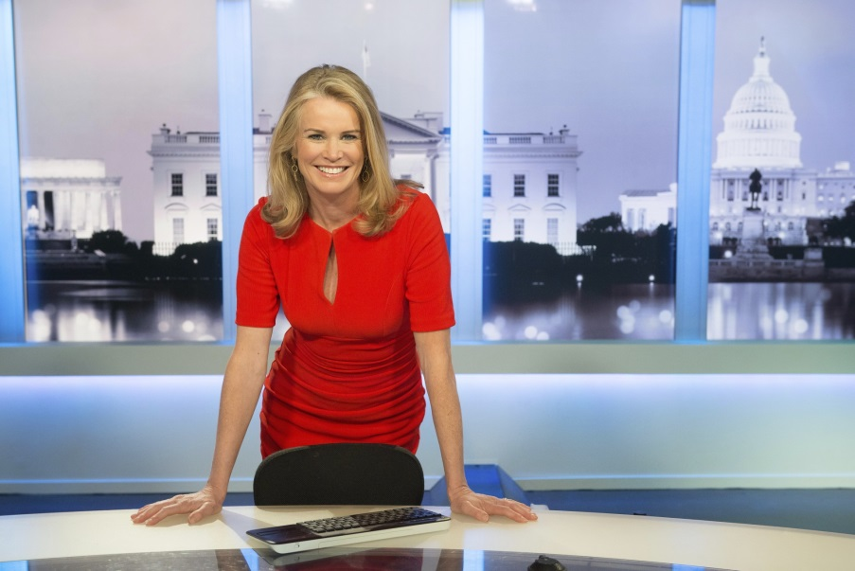

Katty Kay

Katty is the lead anchor of the corporation’s flagship U.S. newscast BBC World News America, and previously served as the BBC’s Washington correspondent.

As a correspondent and anchor, Katty’s work has taken her around the globe for the BBC spanning continents from the Americas, to the Middle East, Africa, Asia, and Europe. Drawing on this global expertise, Katty is based in Washington, where she covers the major U.S and global stories, connecting the dots between the national and international.

Katty’s childhood was spent in various countries across the Middle East, where her father was posted as a British diplomat. She studied modern languages at Oxford University in the UK and is a fluent French and Italian speaker.

Her career with the BBC began in Zimbabwe in 1990, where she worked for BBC World Service (radio) and covered the demise of apartheid in South Africa among many other stories from the continent. She has also worked as BBC correspondent in London, and later Tokyo. She moved to Washington in 1996 and has since covered four Presidential elections, the wars in Iraq and Afghanistan, the economic crash of 2008 and controversies surrounding the Clinton administration. She was at the Pentagon on September 11th 2001, reporting for the BBC in the immediate aftermath of the attack.

Katty was appointed lead anchor of BBC World News America in 2011. She has interviewed a range of international figures and newsmakers as well as anchoring the BBC’s coverage of 2012 Presidential Elections and State of the Union addresses. In 2014 Katty was in Rio, to cover the build up to the FIFA World Cup and also travelled to Italy in 2014 to cover President Obama’s meeting with Pope Francis.

Kay is a frequent guest commentator on NBC’s Meet the Press and MSNBC’s Morning Joe where she also frequently serves as guest co-host. She is also a regular guest host for Diane Rehm on NPR.

Katty is the co-author of two New York Times best-selling books: Womenomics and The Confidence Code: The Science and Art of Self-Assurance—What Women Should Know (2014).

BBC World News America airs globally on the BBC’s international 24-hour news network - BBC World News, bringing international audiences a unique insight on U.S. news and political events.

Audiences can follow Katty on twitter @kattykaybbc

