HARRIET TUBMAN: VISIONS OF FREEDOM
BECOMING FREDERICK DOUGLASS

TCA Panelists
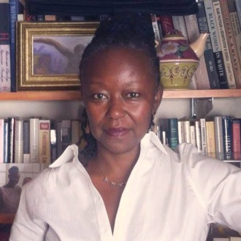
Dr. Farah Jasmine Griffin (Author, Scholar) is the William B. Ransford Professor of English and Comparative Literature at Columbia University, where she also served as the inaugural Chair of the African American and African Diaspora Studies Department. She is a 2021 Guggenheim Fellow and an Andrew Mellon Foundation Scholar in Residence.

Professor Griffin received her B.A. in History & Literature from Harvard and her Ph.D. in American Studies from Yale. She is the author or editor of eight books, including Who Set You Flowin?: The African American Migration Narrative (Oxford, 1995); If You Can’t Be Free, Be a Mystery: In Search of Billie Holiday (Free Press, 2001); and Harlem Nocturne: Women Artists and Progressive Politics During World War II (Basic Books, 2013). Griffin collaborated with composer and pianist Geri Allen and director and actor S. Epatha Merkerson on two theatrical projects for which she wrote the book. The first, Geri Allen and Friends Celebrate the Great Jazz Women of the Apollo, with Lizz Wright, Dianne Reeves, Teri Lyne Carrington and others, premiered on the main stage of the Apollo Theater in May 2013. The second, A Conversation with Mary Lou, featuring vocalist Carmen Lundy, premiered at Harlem Stage in March 2014 and was performed at The John F. Kennedy Center in May 2016. Her most recent book is Read Until You Understand: The Profound Wisdom of Black Life and Literature (W.W. Norton, 2021).

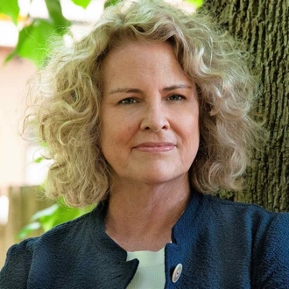
Dr. Kate Clifford Larson (Author, Scholar) is a best-selling author of acclaimed biographies, including Bound for the Promised Land: Harriet Tubman, Portrait of an American Hero; Rosemary: The Hidden Kennedy Daughter; The Assassin's Accomplice; and her latest work, Walk With Me: A Biography of Fannie Lou Hamer, which was named one of Kirkus Review’s best of 2021. A historical consultant, Larson has worked on feature film scripts—including Focus Features' Harriet starring award-winning actress Cynthia Erivo and Robert Redford's The Conspirator—numerous documentaries, museum exhibits, public history and heritage tourism products, and more. A leading authority on Harriet Tubman, her work has shaped Maryland’s Harriet Tubman Underground Railroad State and National Monument and Park, the Harriet Tubman Underground Railroad Byway and All-American Road, and the Harriet Tubman Home and National Historical Park in Auburn, New York. She is a Brandeis University Women’s Studies Research Center Scholar.

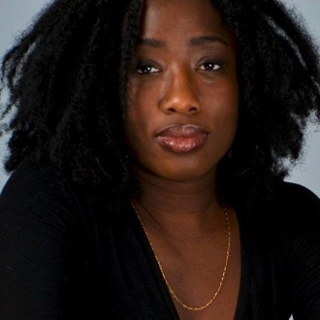
Nicole London (Director, Producer) is an Emmy Award-winning and GRAMMY-nominated producer and director who began her career as an associate producer at PBS's To The Contrary and local stations in Maryland and has gone on to work on many projects with the top directors in documentary film.

She was an associate producer for AMERICAN MASTERS “Marvin Gaye: What's Going On” and “Sammy Davis, Jr.: I've Gotta Be Me;” POV “American Promise;” and INDEPENDENT LENS “The Black Panthers: Vanguard of the Revolution,” which was nominated for a 2016 Emmy for Exceptional Merit In Documentary Filmmaking. She served as a producer on Life & Life and Netflix's Crack: Cocaine, Corruption & Conspiracy, directed by Stanley Nelson.

She was also the producer for Miles Davis: Birth of the Cool, for which she was nominated for a 2020 GRAMMY for Best Music Film, and which won the 2021 News & Documentary Emmy for Outstanding Arts and Culture Documentary. In 2021, she was honored as a Trailblazer at the 22nd Annual African American Women In Cinema Film Festival. She is currently directing a new project for AMERICAN MASTERS slated for 2023.

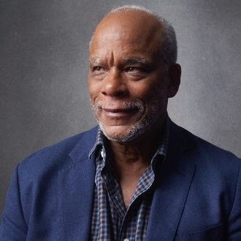
Stanley Nelson (Executive Producer, Director, Producer) is one of the foremost chroniclers of the African American experience working in nonfiction film today. His films, many of which have aired on PBS, combine compelling narratives with rich and deeply researched historical detail, shining new light on both familiar and under-explored aspects of the American past. Nelson’s film The Black Panthers: Vanguard of the Revolution (2016) is the first comprehensive feature length historical documentary portrait of that iconic organization, as well as an extremely timely look at an earlier phase of Black activism around police violence in African American communities. The film won the 2016 NAACP Image Award. Nelson’s two previous films, Freedom Riders (2010, three Primetime Emmy Awards) and Freedom Summer (2014, Peabody Award), took a fresh look at multiracial efforts to register Black voters and desegregate public transportation facilities in the Jim Crow South—critical events in the civil rights struggles of the 1960s. In 2020, Freedom Riders was added to the National Film Registry of the Library of Congress. Nelson’s 2003 film The Murder of Emmett Till, about the brutal killing of a 14-year-old African American boy in Mississippi in 1955—an event that had a galvanizing effect on the mid-century civil rights movement—uncovered new eyewitnesses to the crime and helped prompt the U.S. Department of Justice to reopen the case.

Nelson’s recent documentary Attica, for SHOWTIME Documentary Films, was nominated for Best Documentary Feature at the 94th Academy Awards and earned him the DGA Award for Outstanding Directorial Achievement in Documentary. In 2021, Nelson also directed the feature film Crack: Cocaine, Corruption & Conspiracy for Netflix, which was a 2022 duPont-Columbia Awards finalist, and Tulsa Burning: The 1921 Race Massacre, with co-director Marco Williams, for the HISTORY Channel, which was nominated for three Primetime Emmy Awards. Nelson also executive produced After Jackie, about the generation of Black baseball players who came after Jackie Robinson, for the HISTORY Channel in 2022.

Nelson’s feature for AMERICAN MASTERS, “Miles Davis: Birth of the Cool,” a definitive look at the life and career of the iconic Miles Davis, premiered at the Sundance Film Festival in 2019, marking his 10th premiere at the prestigious festival—the most premieres of any documentary filmmaker. The film also won two Emmy Awards at the 42nd Annual News and Documentary Emmy Awards and was nominated for Best Music Film at the 62nd GRAMMY Awards.

Other notable Nelson films include the Emmy-nominated The Black Press: Soldiers Without Swords (1999), a sweeping portrait of over a century of independent Black journalism; Two Dollars and a Dream (1989), a biography of Madame C.J. Walker, the first self-made African American female millionaire; Jonestown: The Life and Death of People’s Temple (2006, Tribeca Film Festival Special Jury Prize), a riveting account of how cult leader Jim Jones led more than 900 followers to commit mass suicide in a remote corner of northwestern Guyana in 1978; Marcus Garvey: Look for Me in the Whirlwind (2000, Sundance Premiere) a moving account of the life of the controversial early 20th century Black nationalist; and A Place of Our Own (2004, Sundance Premiere), a remarkable and revealing portrait of the upper middle class African American resort community of Oak Bluffs on Martha’s Vineyard, as well as a very personal portrait of Nelson’s sometimes difficult relationship with his father.

In 2000, Nelson, along with his wife, Marcia A. Smith, founded Firelight Media, a nonprofit production company dedicated to using historical film to advance contemporary social justice causes, and to mentoring, inspiring and training a new generation of diverse young filmmakers committed to advancing underrepresented stories. In the last seven years, 15 Firelight Media films have aired on national television.

Nelson, a MacArthur “Genius” Fellow, was awarded an individual Peabody for his body of work in May of 2016. He has received numerous honors over the course of his career, including the 2016 Lifetime Achievement Award from the National Academy of Television Arts & Sciences. In 2013, Nelson received the National Medal in the Humanities from President Barack Obama.

