BECOMING FREDERICK DOUGLASS
Premieres Tuesday, October 11, 2022 on PBS

Film Will also Stream on PBS.org and the PBS Video App

Acclaimed Actor Wendell Pierce Is the Voice of Frederick Douglass in New Documentary Directed by Oscar®-Nominated Filmmaker Stanley Nelson
and Nicole London

(ARLINGTON, VA) – BECOMING FREDERICK DOUGLASS explores the inspiring story of how a man born into slavery transformed himself into one of the most prominent statesmen and influential voices for democracy in American history. Using his writings, images and words to follow his rise to prominence against all odds, the film is rooted in the singular truth of Douglass’s life: his insistence on controlling his own narrative and his lifelong determined pursuit of the right to freedom and complete equality for African Americans.
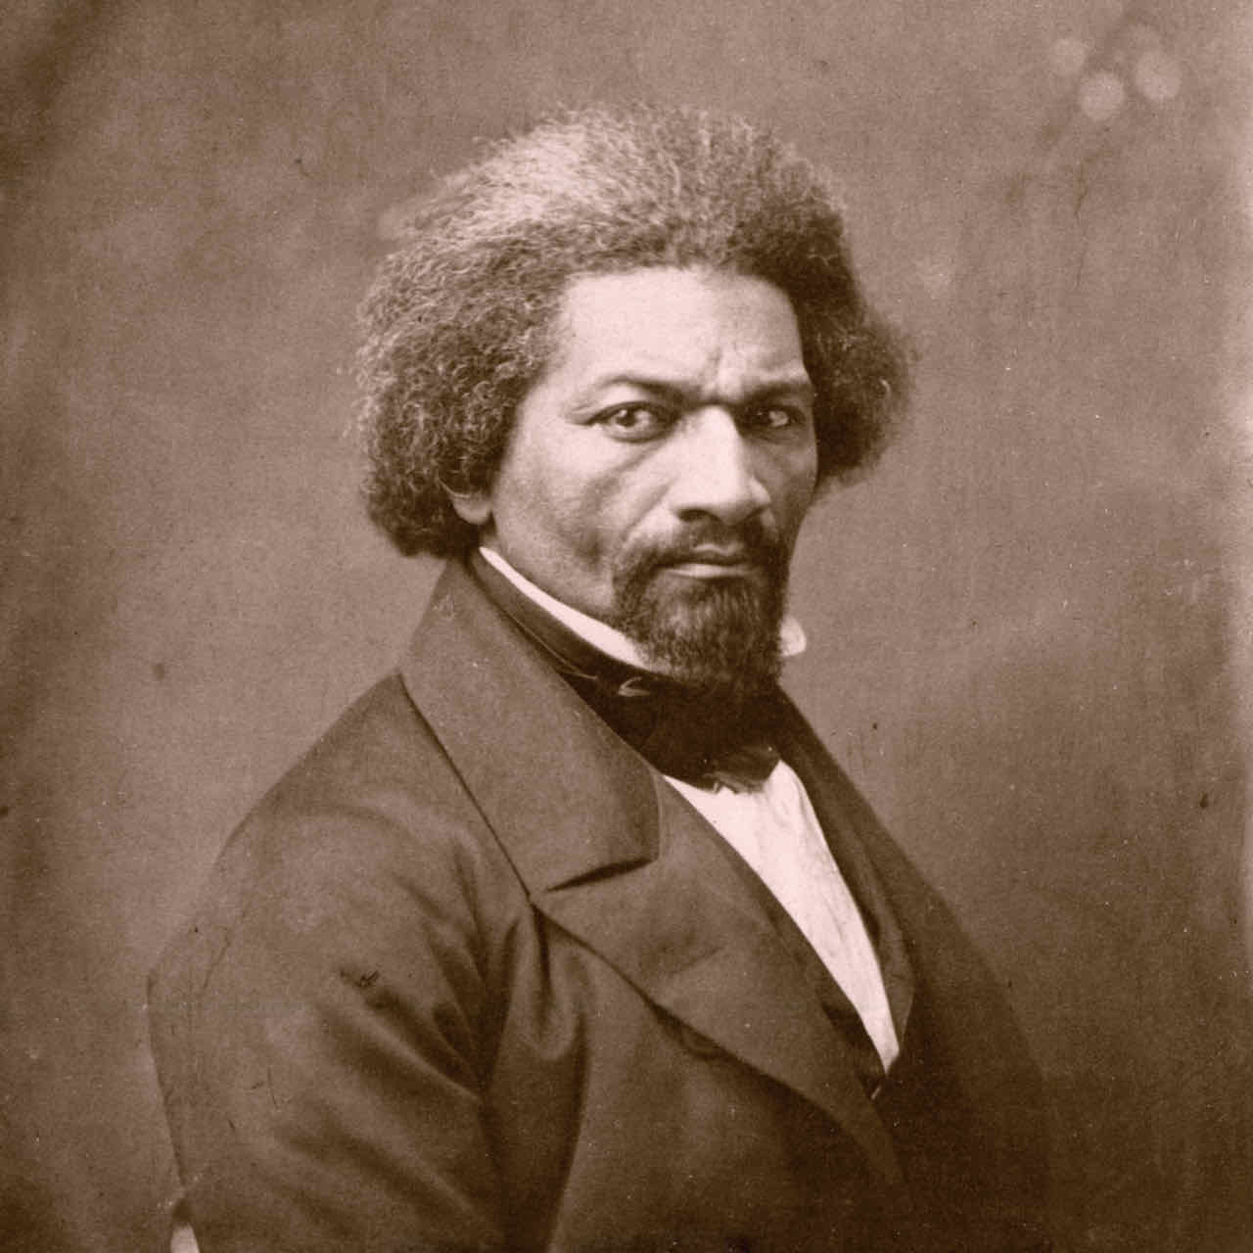
Credit: © New York Historical Society / Bridgeman Images

Featuring acclaimed actor Wendell Pierce as the voice of Frederick Douglass, BECOMING FREDERICK DOUGLASS premieres Tuesday, October 11, 2022, 10:00-11:00 p.m. ET (check local listings) on PBS, PBS.org and the PBS Video App.

A co-production of Firelight Films and Maryland Public Television (MPT), the film is executive produced by Stanley Nelson and Lynne Robinson and produced and directed by Nelson and Nicole London.

A companion film, HARRIET TUBMAN: VISIONS OF FREEDOM, premieres on Tuesday, October 4, 2022, 10:00-11:00 p.m. ET (check local listings) on PBS.
“Given that Frederick Douglass was one of the most prolific and powerful orators of his time, we were interested in exploring how he created and controlled his image, and ultimately how he used it to shift public opinion around abolition,” Nelson said. “It was such a gift to have the inimitable Wendell Pierce provide the voice of Douglass to bring his words to life. Wendell’s dynamic performance, coupled with the many stunning photographs taken throughout Douglass’s lifetime, show how Douglass evolved to become one of the most influential and enduring social justice activists in American history.”

Born in 1818 in Maryland, Frederick Douglass escaped from slavery in 1838 and went on to become many things: abolitionist, autobiographer, essayist, diplomat, orator, editor, philosopher, political theorist, newspaper publisher and social reformer. And considering his trajectory — from enslaved to elder statesman — he was arguably the most accomplished man of his time.

For decades, Douglass was the most famous Black person in the world. More Americans heard him speak than any other contemporary, with the possible exception of Mark Twain. His lectures and speeches were so eloquent and persuasive that some called him a fraud, finding it difficult to believe he had ever been enslaved. To prove his claims, Douglass wrote his first autobiography, Narrative of the Life of Frederick Douglass, An American Slave. Published in 1845, it made its author a celebrity. But fame brought with it the threat of capture, so Douglass embarked on a lecture tour throughout the United Kingdom in 1845. His devoted English supporters warmly welcomed him, ultimately negotiating and purchasing his freedom in 1846. Douglass was able to return to the United States a free man.

In addition to mastering oratory, Douglass understood the incredible power of the new medium of photography and how it could be used for political and social reform. The most photographed American man of the 19th century, Douglass was fully in command of his image, presenting himself as self-possessed, dignified and masterful, often gazing directly into the camera. “Douglass recognized the degree to which representation itself could be a powerful mechanism for ending slavery, for achieving universal freedom and equality,” said author John Stauffer.

Compared to his abolitionist peers, Douglass was an uncompromising and relentless campaigner for Black equality. Confined by white abolitionists to a narrow role of telling his story repeatedly to the public, Douglass broke away to express his own political ideas. He began publishing his antislavery newspaper, The North Star, in 1847. “To have a newspaper was to be the shaper of public opinion,” said historian Derrick Spires. “Founding the newspaper is sort of like Douglass’s declaration of intellectual and activist independence.”

He was an outspoken advocate—even a revolutionary—who insisted that ending slavery was necessary but was not enough to level the playing field. A fierce critic of President Abraham Lincoln for refusing to free enslaved people and allow them to enlist in the Union military, Douglass argued passionately that this action would end the war quickly. “Lincoln was a politician, so he was truly on the fence, and it would take somebody like Frederick Douglass, who I think Lincoln had great respect for, to say, ‘Mr. President, we can’t wait,’” said Kenneth B. Morris, Jr., co-founder and president of the Frederick Douglass Family Initiatives.

Finally, in 1863, after almost three years of war, the president issued the Emancipation Proclamation, authorizing the arming of Black men as soldiers. Douglass eagerly supported the effort and even recruited his two sons, who served in the first Northern Black regiment, the Massachusetts 54th.

Following the Civil War, Douglass was hopeful that the Union had been restored and a
lasting peace had been achieved. But he also knew that “if there is no struggle, there is
no progress.” He spent the rest of his life continuing to work for Black equality.

Despite the extensive written and photographic record of his life, there remains much to be discovered about Frederick Douglass, both the man and his legacy. “Douglass is one of the most complicated people in our history,” said Columbia University’s Farah Jasmine Griffin. “He’s one of the few Black Americans—or Americans of any race—who left so much for us to read and engage with that he’s still, in some ways, directing us as we try to learn more about him.”

“Frederick Douglass moved from being a mirror to hold up to the nation about its failures to becoming a lens for future generations to understand their own public service, to understand their own commitment to justice, to understand why bravery is so important,” said historian Marcia Chatelain. “Frederick Douglass challenges us to become the fullest expression of ourselves and our ideals.”

BECOMING FREDERICK DOUGLASS will stream simultaneously with broadcast and be available on all station-branded PBS platforms, including PBS.org and the PBS Video app, available on iOS, Android, Roku, Apple TV, Amazon Fire TV, Android TV, Samsung Smart TV, Chromecast and VIZIO.

Additional information and resources about the films are available at tubmandouglassfilms.com.

Executive producers for BECOMING FREDERICK DOUGLASS are Stanley Nelson and Lynne Robinson. The film is produced and directed by Stanley Nelson and Nicole London. Keith M. Brown and Michael English are the executives in charge of production. BECOMING FREDERICK DOUGLASS was written by Anne Seidlitz. Wendell Pierce is the voice of Frederick Douglass.

BECOMING FREDERICK DOUGLASS is a co-production of Firelight Films and Maryland Public Television with an appropriation from the State of Maryland. These programs are also made possible by Bowie State University, DIRECTV and Pfizer, Inc. Bowie State is the oldest Historically Black College and University (HBCU) in Maryland and the first HBCU to become a premier sponsor of a national PBS film.
About Maryland Public Television
Launched in 1969, Maryland Public Television (MPT) is a state-licensed public television network and member of the Public Broadcasting Service (PBS). MPT is among the leading producers and distributors of national public television programming in the United States. As a major content supplier to PBS stations, MPT boasts a five-decade legacy of groundbreaking and innovative contributions to public TV schedules nationwide. MPT is also one of the most prolific producers of regional programming in the public television system, serving a six-state area in the Mid-Atlantic region. MPT’s Emmy Award-winning content catalog includes news, public affairs, documentary, performance and lifestyle programming. For more information visit mpt.org.

About Firelight Films
Founded by award-winning filmmaker Stanley Nelson, Firelight Films produces documentaries by and about communities of color. Firelight Films productions have garnered multiple Primetime Emmy, Peabody, IDA, and Sundance awards. Among them, the feature films Attica, which was recently nominated for an Academy Award and premiered on Showtime; Tulsa Burning: The 1921 Race Massacre; Crack: Cocaine, Corruption & Conspiracy; Miles Davis: Birth of the Cool; The Black Panthers: Vanguard of the Revolution; Freedom Summer; Freedom Riders; The Murder of Emmett Till; and The Black Press: Soldiers Without Swords. Firelight Films has also produced notable short films, including “The Story of Access,” which was commissioned by Starbucks in 2017 for a mandatory anti-bias employee training program, and “Commemorate and Celebrate Freedom,” commissioned by the Smithsonian’s National Museum of African American History and Culture for its opening night in 2015. Upcoming Firelight Films productions include Creating the New World: The Transatlantic Slave Trade, a four-part documentary series for PBS.
About PBS
PBS, with more than 330 member stations, offers all Americans the opportunity to explore new ideas and new worlds through television and digital content. Each month, PBS reaches over 120 million people through television and 26 million people online, inviting them to experience the worlds of science, history, nature and public affairs; to hear diverse viewpoints; and to take front row seats to world-class drama and performances. PBS’ broad array of programs has been consistently honored by the industry’s most coveted award competitions. Teachers of children from pre-K through 12th grade turn to PBS for digital content and services that help bring classroom lessons to life. Decades of research confirms that PBS’ premier children’s media service, PBS KIDS, helps children build critical literacy, math and social-emotional skills, enabling them to find success in school and life. Delivered through member stations, PBS KIDS offers high-quality educational content on TV—including a 24/7 channel, online at pbskids.org, via an array of mobile apps and in communities across America. More information about PBS is available at www.pbs.org, one of the leading dot-org websites on the internet, or by following PBS on Twitter, Facebook or through our apps for mobile and connected devices. Specific program information and updates for press are available at pbs.org/pressroom or by following PBS Communications on Twitter.

– PBS –
CONTACTS:

MPT
Tom Williams, tomwilliams@mpt.org

Cara White / Mary Lugo, CaraMar, Inc.
cara.white@mac.com; lugo@negia.net

For images and additional up-to-date information on this and other PBS programs, visit PBS PressRoom at pbs.org/pressroom.

