American Experience
Woodstock: Three Days That Defined a Generation
Premieres Tuesday, August 6, 2019 on PBS

Award-winning Filmmaker Barak Goodman Revisits the 1969 Event
on 50th Anniversary

(BOSTON, MA) — In August 1969, half a million
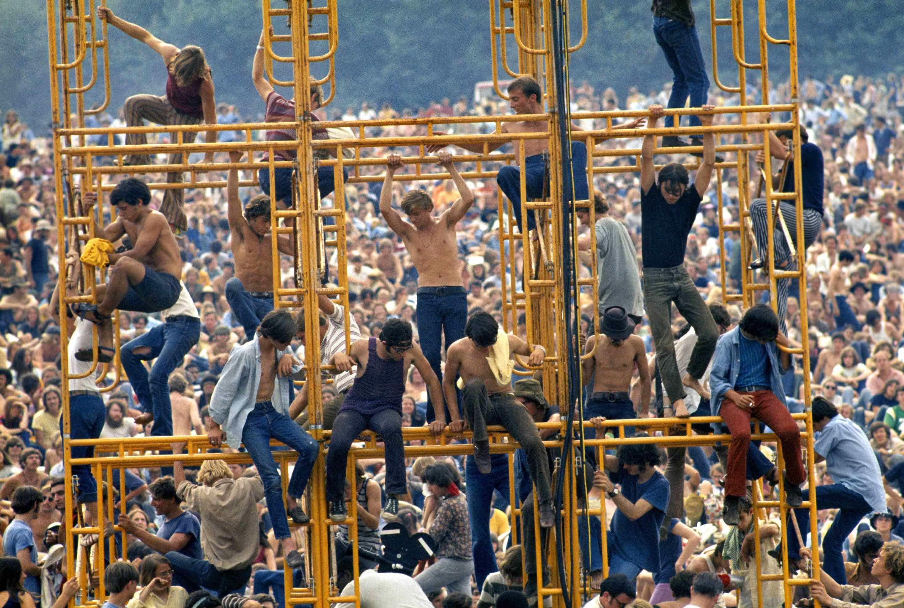
© Elliott Landy/The Image Works
young people from all walks of life journeyed from
every corner of the country to a dairy farm in upstate
New York for a concert unprecedented in scope and influence. Woodstock examines the tumultuous decade that led to those three historic days — years that saw the nation deeply divided by Vietnam and racial, generational and sexual politics — through the voices of those who were present for the event that would become the defining moment of the counterculture revolution. In conjunction with the 50th anniversary, Woodstock: Three Days That Defined a Generation, directed by Barak Goodman, written by Goodman and Don Kleszy, and produced by Goodman and Jamila Ephron, premieres Tuesday, August 6, 2019, 9:00-11:00 p.m. ET (check local listings) on PBS, pbs.org and the PBS Video App.

“For three days in August, 1969, the values of ‘peace and love,’ loudly championed by the counterculture movement, were actually put to the test in the miserable conditions at Woodstock,” said director Barak Goodman. “The more than 400,000 people who attended the festival proved that they were more than just words. For a surprising number of people, that brief encounter with sacrifice, cooperation and generosity changed their lives. I think Woodstock continues to inspire because the grace demonstrated there was real and enduring.”

“Unlike Michael Wadleigh’s classic 1970 documentary, our film turns the cameras around, into the audience,” said American Experience executive producer Mark Samels. “By focusing on individuals — from concert goers to security guards to performers to local residents — Woodstock expands our understanding of the event as not only an unparalleled musical milestone, but a once-in-a-century cultural phenomena that served as a coda to the sixties and a harbinger of the decades to come.”

Interviewees include festival producers and staff including Donald Goldmacher, Carol Green, Michael Lang, John Morris, John Roberts and Joel Rosenman; activist Wavy Gravy; festival attendees and others.

About the Filmmakers

Directed by | BARAK GOODMAN
Co-Director | JAMILA EPHRON
Written by | BARAK GOODMAN & DON KLESZY
Edited by  Produced by | DON KLESZY  JAMILA EPHRON  BARAK GOODMAN  MARK SAMELS

American Experience is a production of WGBH Boston
Senior Producer | SUSAN BELLOWS
Executive Producer | MARK SAMELS

Barak Goodman (Writer/Producer/Director) has become one of the most prolific and respected nonfiction
filmmakers in America. A co-founder of Ark Media, his films have been nominated for an Academy Award and won multiple Emmy and Writers Guild Awards, DuPont-Columbia, and Peabody Awards, the RFK Journalism Prize, and three times been official selections at the Sundance Film Festival. Among Barak’s 12 films for American Experience are the Peabody Award-winning Oklahoma City, about the worst domestic terrorist attack in American history and its roots in the rise of the radical right; My Lai, the Emmy and Peabody Award-winning film on America’s worst war crime; Scottsboro, the Academy Award-nominated film on the trial of black teenagers falsely accused of rape in Depression-era Alabama; and Clinton, a four-hour biography of our 42nd President. Barak was also the director, writer and producer of the six-hour PBS series Cancer: The Emperor of all Maladies, based on the Pulitzer Prize-winning book by Siddhartha Mukherjee. He wrote and directed Makers, the first complete history of the modern women's movement. He directed six films for the PBS series FRONTLINE, including the Peabody Award-winning Lost Children of Rockdale County and the Columbia Du-Pont winning series Failure to Protect. He has recently completed Slay the Dragon with Participant Media, a film about gerrymandering and voter suppression that premiered at the 2019 Tribeca Film Festival.

Jamila Ephron (Producer/Co-Director) is a documentary filmmaker with a background in historical nonfiction films. Most recently, Jamila produced and co-directed Far from the Tree, based on the bestselling book by Andrew Solomon, for Participant Media and Sundance Selects. Her work includes My Lai (winner of a Primetime Emmy and Peabody Award), The Assassination of Abraham Lincoln and Clinton, each for American Experience. She has also co-produced a three-hour documentary on second wave feminism, Makers: Women Who Make America and Cancer: The Emperor of All Maladies. A Seattle native and Sarah Lawrence College graduate, Jamila is based in Brooklyn, NY.

Don Kleszy (Editor/Writer) is the writer of Above & Beyond, a portrait of NASA directed by Rory Kennedy, and Oklahoma City, directed by Barak Goodman. Don received the 2014 IDA Award for Best Editor, honoring his work on American Experience’s Academy Award-nominated feature documentary Last Days in Vietnam, directed by Rory Kennedy. Don also received a 2016 Emmy nod, in Outstanding Editing– Documentary and Long Form, for his work on Last Days in Vietnam. In addition, many of the documentaries Don has edited have received Emmy nominations, including Makers: Women in War, directed by Rachel Grady; The Poisoner’s Handbook, directed by Rob Rapley; and Oswald’s Ghost and Guerrilla: The Taking of Patty Hearst, both directed by Robert Stone.

Mark Samels (Executive Producer) conceives, commissions and oversees all films for the PBS flagship history series American Experience. Samels has overseen more than 130 films, expanding both the breadth of subjects and the filmmaking style embraced by the series, allowing for more contemporary topics and witness-driven storytelling. Beginning his career as an independent documentary filmmaker, he held production executive positions at public television stations in West Virginia and Pennsylvania before joining WGBH. Samels is a founding member of the International Documentary Association and has served as a governor of the Academy of Television Arts & Sciences. A graduate of the University of Wisconsin, Samels holds honorary Doctor of Humane Letters degrees from Emerson College and Elizabethtown College.

Susan Bellows (Senior Producer) is an award-winning producer and writer with more than 20 years of experience producing national programs for public television. Bellows most recently served as the writer, director and producer for The Bombing of Wall Street, which premiered on American Experience in February 2018. She was also the producer and director on the four-hour JFK, which premiered in 2013. Since joining the series in 2003, she has provided editorial support and guidance to its broadcast and new media work. Previously, Bellows served as senior producer for the Peabody and Emmy-Award winning series Africans in America. Her other producing credits include films for The Great Depression, for which she received an Emmy nomination, and America’s War On Poverty, both productions of Blackside, Inc. Bellows also co-produced New Worlds, New Forms for the WNET-produced series Dancing, an eight-hour landmark series on dance forms around the world.

About American Experience
For 30 years, American Experience has been television’s most-watched history series. Hailed as “peerless” (The Wall Street Journal), “the most consistently enriching program on television” (Chicago Tribune), and “a beacon of intelligence and purpose” (Houston Chronicle), the series brings to life the incredible characters and epic stories that have shaped America’s past and present. American Experience documentaries have been honored with every major broadcast award, including 30 Emmy Awards, four duPont-Columbia Awards, and 17 George Foster Peabody Awards; the series received an Academy Award® nomination for Best Documentary Feature in 2015 for Last Days in Vietnam. American Experience also creates original digital content that uses new forms of storytelling to connect our collective past with the present. Visit pbs.org/americanexperience and follow us on Facebook, Twitter, Instagram and YouTube to learn more.

Major funding for American Experience provided by Liberty Mutual Insurance, Consumer Cellular and by the Alfred P. Sloan Foundation. Additional funding for American Experience provided by the Robert David Lion Gardiner Foundation, The Documentary Investment Group: The Estate of Gwenn Therrien, in memory of Gwenn Therrien and Michael Blake, the Corporation for Public Broadcasting and public television viewers. American Experience is produced for PBS by WGBH Boston.

###
CONTACTS:

CaraMar Publicity
Mary Lugo 770-623-8190 lugo@negia.net
Cara White 843-881-1480 cara.white@mac.com
Abbe Harris 908-244-5516 abbe.harris@caramar.net

For further information and photos visit http://www.pbs.org/pressroom.

