American Experience “Woodstock”

Premieres Tuesday, August 6, 2019 on PBS

TCA Panelists

Susan Bellows (Senior Producer) is an award-winning producer and writer with more than 20 years of experience producing national programs for public television. Bellows most recently served as the writer, director and producer for “The Bombing of Wall Street,” which premiered on American Experience in February 2018. She was also the producer and director on the four-hour JFK, which premiered in 2013. Since joining the series in 2003, she has provided editorial support and guidance to its broadcast and new media work. Previously, Bellows served as senior producer for the Peabody and Emmy Award-winning series Africans in America. Her other producing credits include The Great Depression, for which she received an Emmy nomination, and America’s War on Poverty, both productions of Blackside, Inc. Bellows also co-produced New Worlds, New Forms for the WNET-produced series Dancing, an eight-hour landmark series on dance forms around the world.
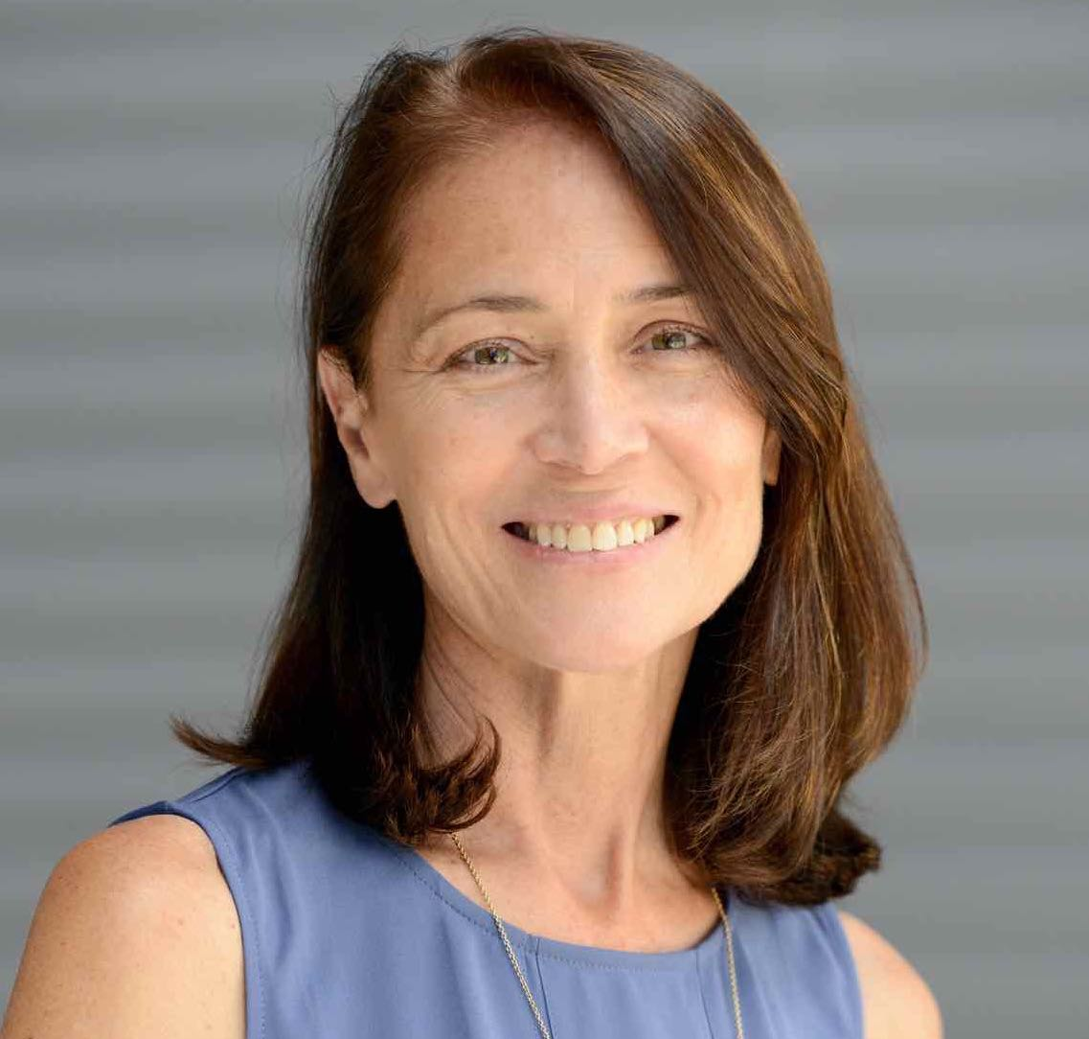

Barak Goodman (Writer/Producer/Director) has become one of the most prolific and respected nonfiction filmmakers in America. A co-founder of Ark Media, his films have been nominated for an Academy Award and won multiple Emmy and Writers Guild Awards, duPont-Columbia and Peabody Awards, the RFK Journalism Prize, and three times been official selections at the Sundance Film Festival.
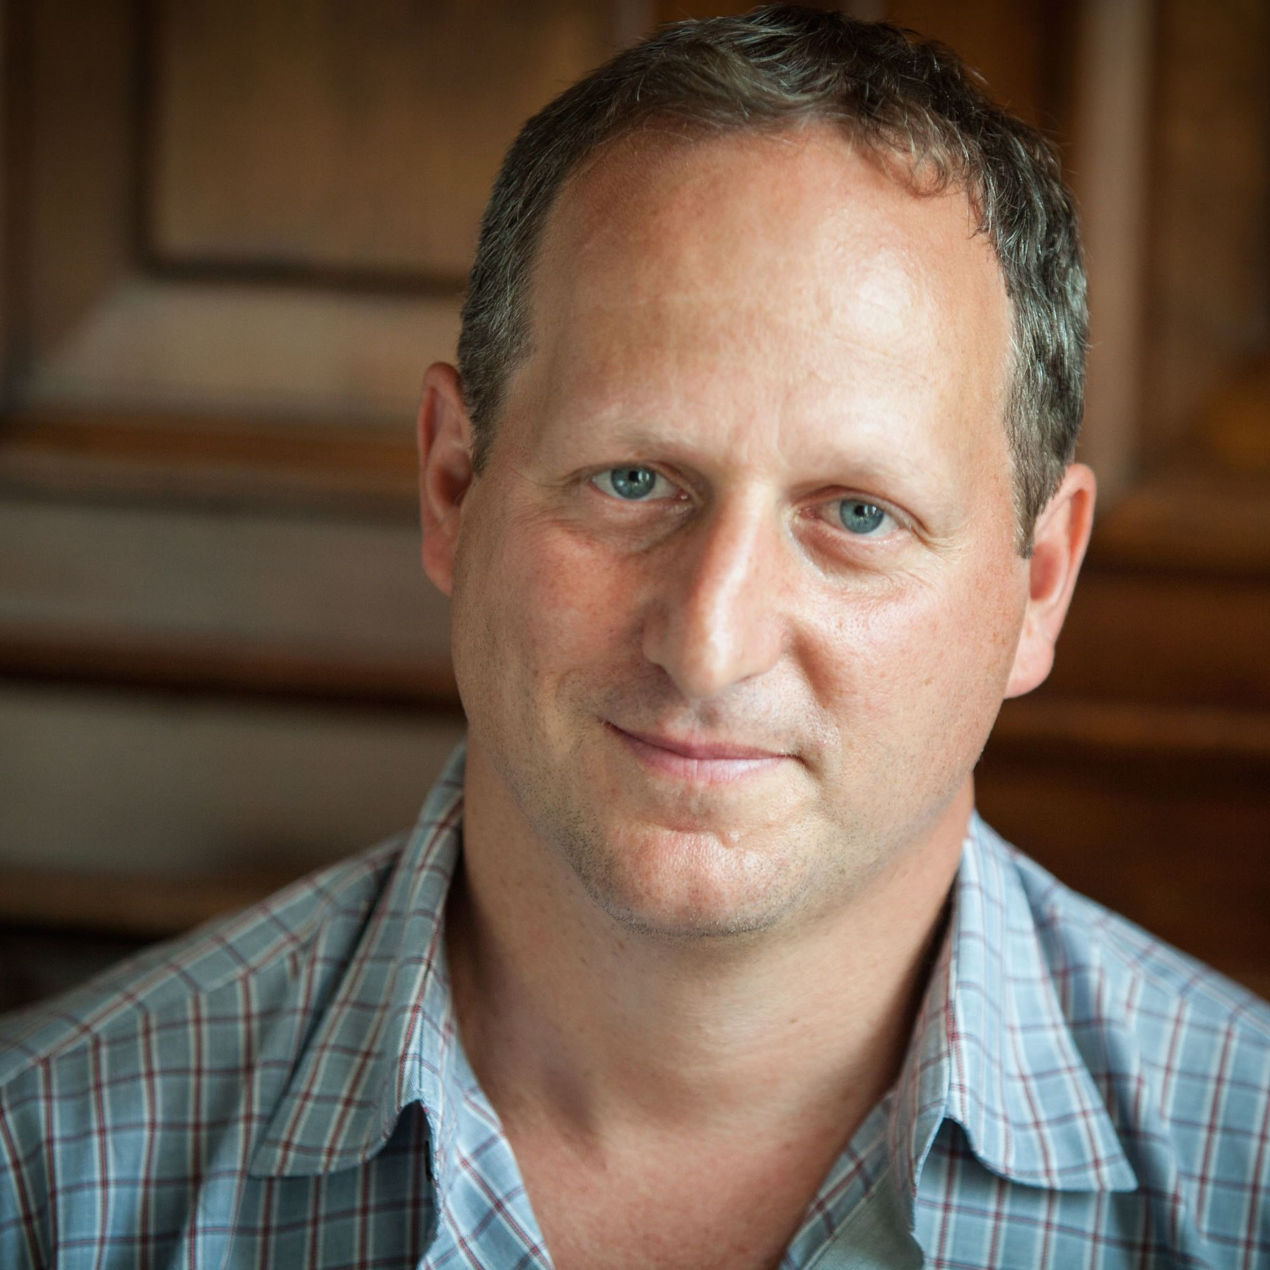

Among Goodman’s 12 films for American Experience are the Peabody Award-winning “Oklahoma City,” about the worst domestic terrorist attack in American history and its roots in the rise of the radical right; “My Lai,” the Emmy and Peabody Award-winning film on America’s worst war crime; “Scottsboro,” the Academy Award-nominated film on the trial of black teenagers falsely accused of rape in Depression-era Alabama; and “Clinton,” a four-hour biography of our 42nd President. Goodman was also the director, writer and producer of the six-hour PBS series Cancer: The Emperor of all Maladies, based on the Pulitzer Prize-winning book by Siddhartha Mukherjee. He wrote and directed Makers, the first complete history of the modern women's movement. He directed six films for the PBS series FRONTLINE, including the Peabody Award-winning “Lost Children of Rockdale County” and the duPont-Columbia-winning series “Failure to Protect.” He has recently completed Slay the Dragon with Participant Media, a film about gerrymandering and voter suppression that premiered at the 2019 Tribeca Film Festival.

Joel Makower (Participant) is the author of Woodstock: The Oral History (1989), which Rolling Stone called “the definitive study of the mega-concert.” The chairman and executive editor of GreenBiz Group, Inc., Makower is creator of GreenBiz.com along with research and events on sustainable business and clean technology. He hosts GreenBiz.com’s annual GreenBiz forums, as well as the VERGE and Circularity conferences produced by his company, and is principal author of the annual “State of Green Business” report.
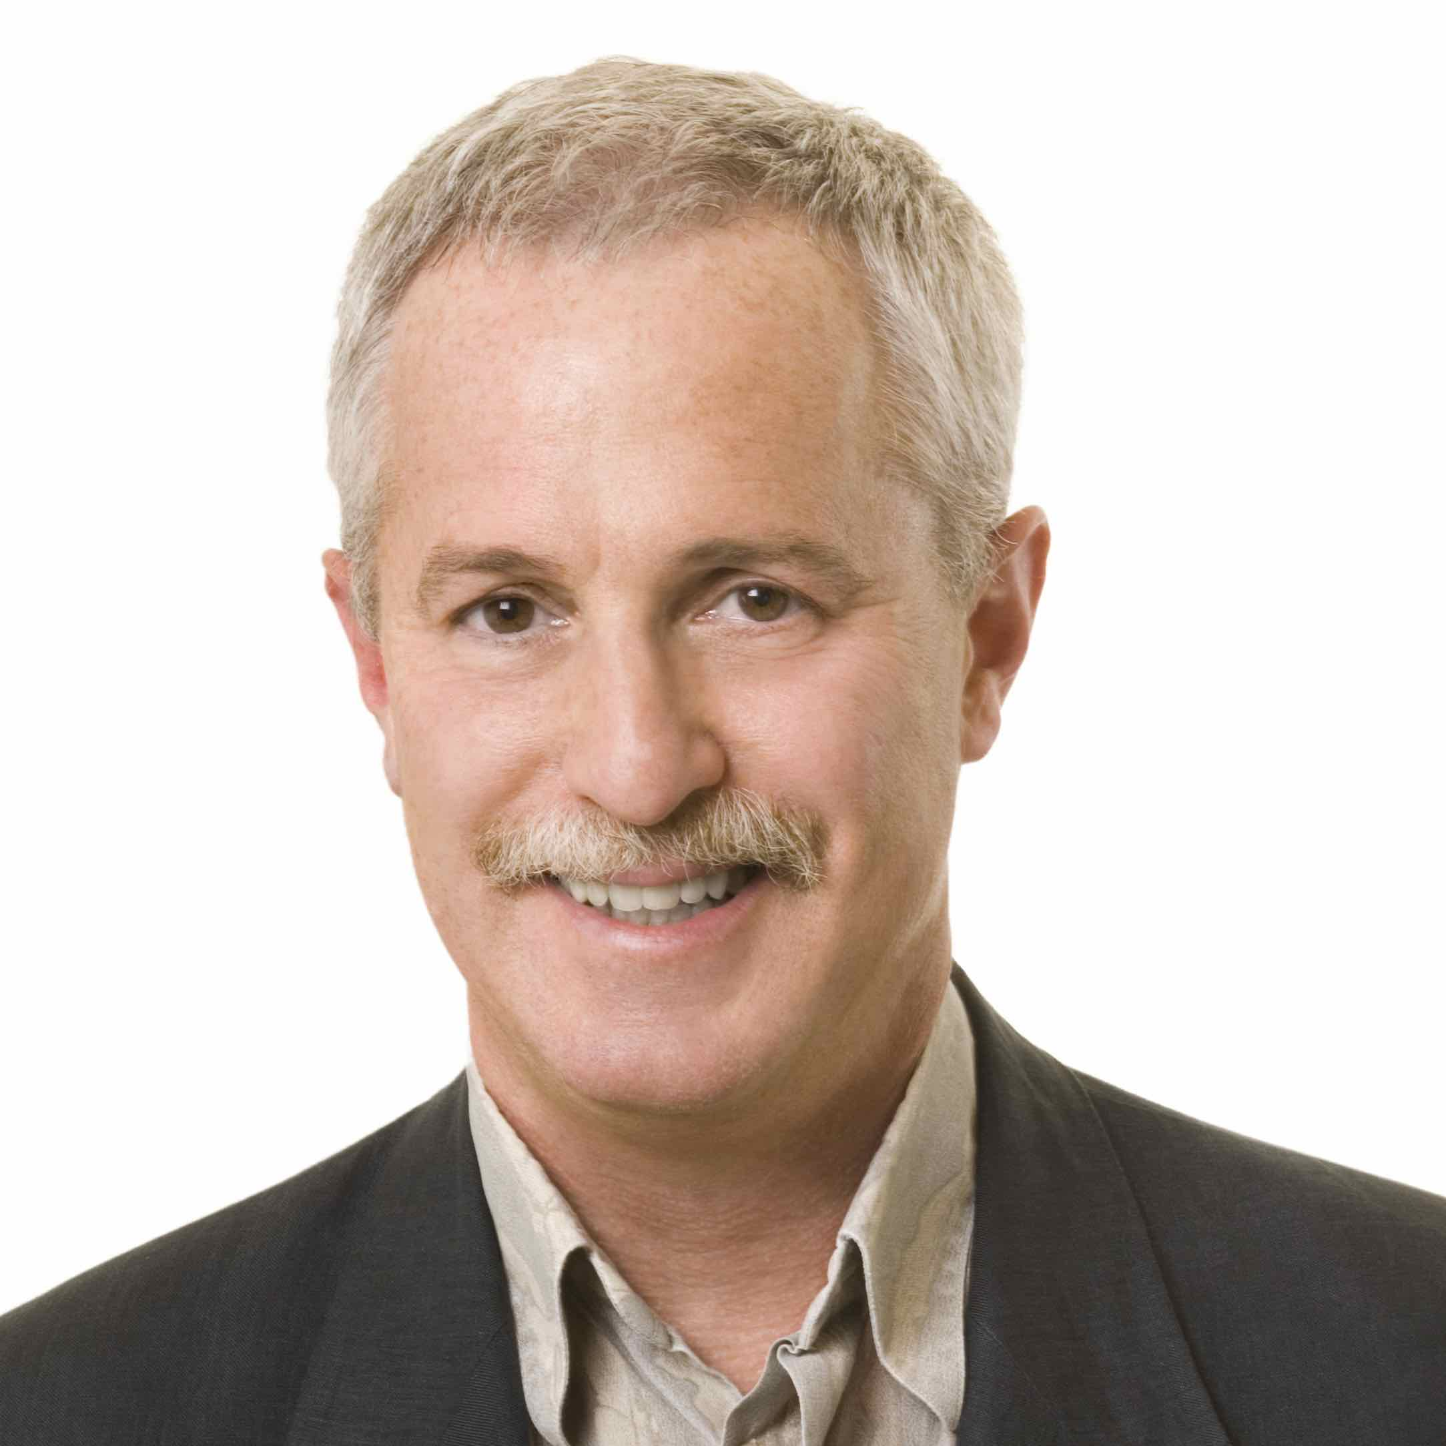

For 30 years, Makower has been a well-respected voice on business, sustainability and clean technology. A former nationally syndicated columnist, Makower is author or co-author of more than a dozen books, including The New Grand Strategy: Restoring America’s Prosperity, Security and Sustainability in the 21st Century (St. Martin’s Press, 2016), about a business plan for America, born at the Pentagon, that embeds sustainability as a strategic national imperative. Previous books include Strategies for the Green Economy (2008), Beyond the Bottom Line (1994) and The E-Factor (1992), two of the earliest framing books on corporate environmental responsibility and corporate social responsibility, respectively.

Called “the guru of green business practices” by the Associated Press, he was awarded the Hutchens Medal by the American Society for Quality in 2012. In 2014, he was inducted into the Hall of Fame of the International Institute of Sustainability Professionals.

Makower frequently keynotes corporate events, business associations, and regional business and economic development events, is a sought-after moderator and host of sustainability events, and is frequently quoted in major news media. He advises several startups and chairs the board of the nonprofit youth entrepreneurship organization United Roots.

Joel Rosenman (Participant) conceived and co-produced the 1969 Woodstock Festival. Prior to Woodstock, he built and ran Media Sound, the premier recording studio in New York. In the early 1970s, he co-wrote (with John Roberts) Making Woodstock, an amusing, unfiltered behind-the-scenes account of the festival. He is currently working with Marshall Brickman (writer of Annie Hall and Jersey Boys) on a script for the musical Woodstock.
