**American Experience** ***American Coup: Wilmington 1898***

**Premieres Tuesday, November 12, 2024 on PBS and Streaming on PBS.org**

**New Documentary Explores the Deadly Coup Waged By White Supremacists to Overthrow the Multi-Racial Government of Wilmington, North Carolina**

(Boston, MA) — ***American Coup: Wilmington 1898*** tells the little-known story of a deadly race massacre and carefully orchestrated insurrection in North Carolina’s largest city in 1898 — the only coup d’état in the history of the US. Stoking fears of “Negro Rule,” self-described white supremacists used intimidation and violence to destroy Black political and economic power and overthrow Wilmington’s democratically-elected, multi-racial government. Black residents were murdered and thousands were banished. The story of what happened in Wilmington was suppressed for decades until descendants and scholars began to investigate. Today, many of those descendants — Black and white — seek the truth about this intentionally buried history. Directed by award-winning filmmakers Brad Lichtenstein and Yoruba Richen in association with PBS North Carolina and executive produced by Cameo George and Rachel Raney, ***American Coup: Wilmington 1898****,*premieres Tuesday, November 12, 2024, 9:00-11:00 p.m. ET ([check local listings](https://r20.rs6.net/tn.jsp?f=001lswnKdgoPMzgPRrwVw-vyj3_5bjd7tOQsl3tGjb-IWipGusKrY3CZSgSpIlTd8ZNfk4e7Ak8ScIlTeg6-7XzMLQNctp9G92I6SJcXaMsBCQ8ODjOQpaSilvbPGXUlIoUDOCoL4BZpOQkn4BB0nGE46dYoeFMVwQP&c=cTqMsIBK_2RGunUpQSSKNc4lJsZ9neujUUK7Dt_3zZ_h47YqRnoXNA==&ch=2qYdCUxePWhlxKtPMFcWViHzlQnfxJnLApoQzZjon6rvM4_BpF5z9A==)) on **American Experience** on PBS, [PBS.org](https://r20.rs6.net/tn.jsp?f=001lswnKdgoPMzgPRrwVw-vyj3_5bjd7tOQsl3tGjb-IWipGusKrY3CZSgSpIlTd8ZNIyfbJ505IadPifVGf1KWbe9EGTG7MAmdp5D4qbjvnssOdGSaPelgWKbbeMisqMmavgn8TswC_xw=&c=cTqMsIBK_2RGunUpQSSKNc4lJsZ9neujUUK7Dt_3zZ_h47YqRnoXNA==&ch=2qYdCUxePWhlxKtPMFcWViHzlQnfxJnLApoQzZjon6rvM4_BpF5z9A==) and the [PBS app](https://r20.rs6.net/tn.jsp?f=001lswnKdgoPMzgPRrwVw-vyj3_5bjd7tOQsl3tGjb-IWipGusKrY3CZYj5rBpqQbtocXi7D16xql3iz6VV4DPys1I_5jBxmC4XHldjxzofrvTaniceJ8TjxGiuxzIlQDdCzn0O-nWN04StGCWgA4m2yqN-o5J-2yjY&c=cTqMsIBK_2RGunUpQSSKNc4lJsZ9neujUUK7Dt_3zZ_h47YqRnoXNA==&ch=2qYdCUxePWhlxKtPMFcWViHzlQnfxJnLApoQzZjon6rvM4_BpF5z9A==).

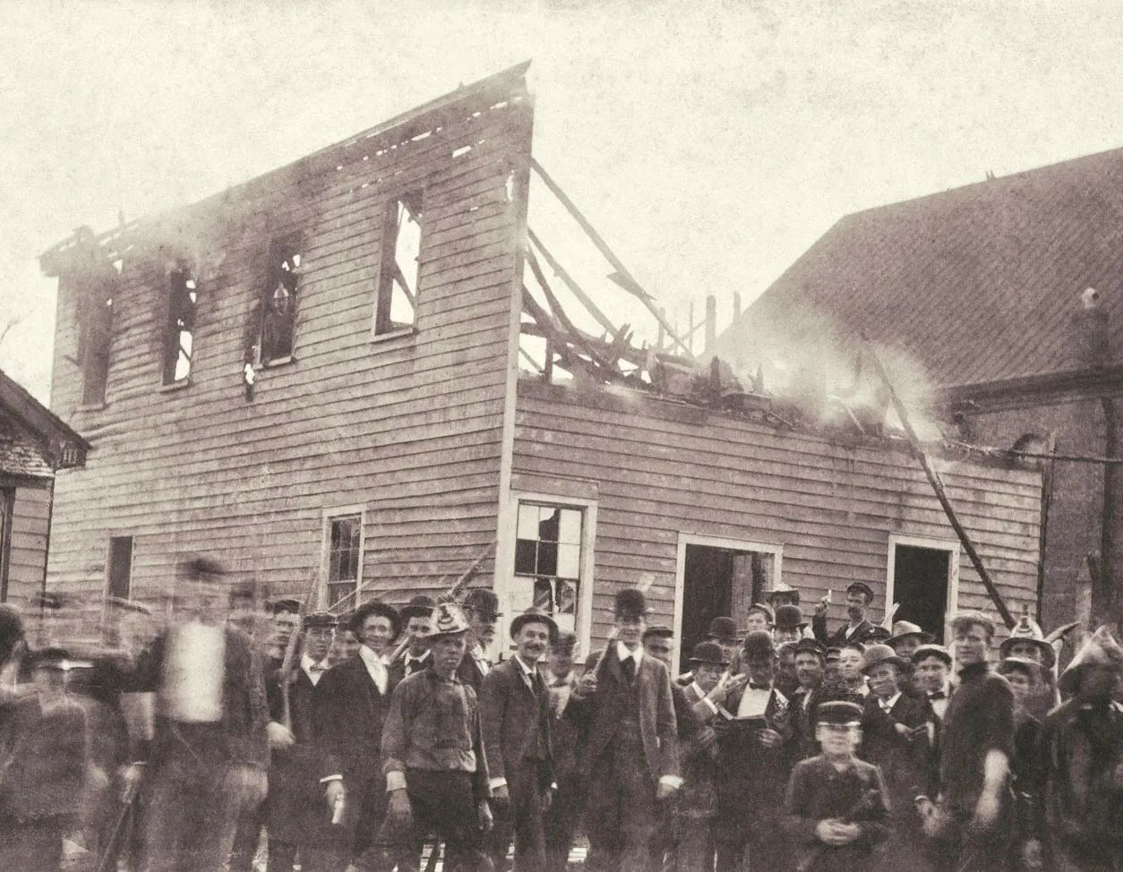

*A mob in front of* The Daily Record *newspaper office after it was set on fire in November 1898.*

*Credit: New Hanover County Public Library*

“We didn't know anything about this story when we started, and most of America has never heard about it,” said filmmakers Lichtenstein and Richen. “It’s important to tell the history of one of America's most egregious racist and violent moments and also bring to light the stories of the descendants, Black and white, who are actively seeking truth and accountability more than 125 years after the coup and massacre.”

“When we started researching the disturbing events that unfolded in Wilmington, we quickly discovered that many North Carolinians are not aware of this important history,” said PBS North Carolina executive producer Rachel Raney. “That’s partly because it happened so long ago, but also because it was intentionally buried. The more we learned, it became clear that all Americans need to understand what happened there. ***American Coup: Wilmington 1898***is a cautionary tale for our country, about a perilous breakdown of a cornerstone of our democracy: fair and free elections.”

To create the documentary, the filmmakers interviewed leading scholars of the coup and its historical context. On-screen commentators include professors Carol Anderson (Emory), Glenda Gilmore (Yale), Robin D.G. Kelley (UCLA), Crystal R. Sanders (Emory), and journalist David Zucchino, author of the Pulitzer Prize-winning *Wilmington’s Lie: The Murderous Coup of 1898 and the Rise of White Supremacy*, among others. The filmmakers also interviewed and followed the stories of descendants, both Black and white, who describe their ancestors' connection to the coup and its enduring legacy in their lives.

Grammy Award-winning musician, MacArthur “Genius” award recipient, and Pulitzer Prize-winner Rhiannon Giddens wrote an original song for the score and joins a cast of acclaimed actors, including Emmy-winner Keith David, in reading original accounts of the harrowing events of 1898. To bring the story to life, the film draws on hundreds of rarely-seen archival images and incorporates artwork in the form of black-paper silhouettes to illustrate additional scenes.

In the 1890s, Wilmington, North Carolina, was a thriving multi-racial community with a majority Black population. A prosperous port city, it offered plenty of opportunity for newly freed Black citizens, who competed with whites for skilled labor jobs as brick masons, blacksmiths and carpenters. There was a flourishing Black professional class of doctors, teachers and lawyers. Blacks owned property and businesses, invested in banks, served as police officers, and held public office in multiple levels of government, including the US House of Representatives.

But as the multi-racial government expanded and the social and economic status of Black citizens increased, so did the resentment of a group of white elites. They took measures to thwart the combined political power of Blacks and working class whites, who had united to form a “Fusion” government. Their strategy was to divide Blacks and whites by promoting fear, using racist propaganda, and running on a platform of white supremacy supported by the state’s largest newspaper.

One Black resident who rose to prominence was Alex Manly, editor and publisher of *The Daily Record*, Wilmington’s Black newspaper. On August 18, 1898, Manly published a rebuttal to a speech by a Georgia congressman’s wife, who argued that lynching was justified to protect white women from a falsely claimed “epidemic” of assaults by Black men. Manly’s editorial contended that relationships between Black men and white women were sometimes consensual, and that, for generations, white men had raped Black women with impunity. The editorial was widely reprinted and angered whites across the South. White businesses pulled ads, *The Daily Record* was evicted from its offices, and Manly received death threats.

Coup leaders promoted the falsehood that African Americans were arming themselves when, in fact, it was the white community that was preparing for war. Fearful that violence would erupt at any moment, a delegation of Black ministers went to Washington to ask President McKinley to intervene before tragedy struck, but worried about alienating white voters, he refused to send in federal troops.

On November 8, 1898, Election Day, armed white men were out in the Wilmington streets to prevent Black men from voting. Through intimidation, voter suppression, and outright fraud, the white supremacists took control of the state legislature in a landslide. Too impatient to wait for the following year’s municipal election, architects of the coup issued what came to be known as the “White Declaration of Independence,” declaring that they would never again “be ruled by men of African origin.” After being forced to resign their positions at gunpoint in a coup d’état, local government officials, along with prominent Black citizens, were told to get out of town and never return.

On November 10, vigilantes rode through Wilmington looking for Alex Manly to lynch him, but he had already escaped. A growing mob burned the offices of *The Daily Record*, then posed for a photo in front of the ruins. Several dozen Black men were shot and killed (an accurate number will never be known) and Black women and children were terrorized, running into a nearby swamp and cemetery for refuge.

Following the white supremacist insurrection, many newspapers throughout the country reported the incident as a “race riot” and suggested that Black citizens were the aggressors. More than 2000 African Americans fled the city. Wilmington, which had a Black majority of 56% in the 1890s, became a majority-white city. In 1899, North Carolinians passed a Constitutional amendment requiring voters to pay a poll tax and take a literacy test unless a father or grandfather had voted before 1867 — effectively disenfranchising the Black population. No Black citizen from Wilmington served in public office again until 1972, and no Black North Carolinian was elected to statewide office for nearly 100 years. No one was ever prosecuted or held responsible for the violence.

The history of what happened in Wilmington was buried until descendants and scholars began to investigate half a century later. Centennial remembrances in 1998 brought together white and Black descendants for public events, sparking a full re-examination of the coup and its aftermath.

“What happened in Wilmington had the effect of putting the final nail in the coffin of democracy in North Carolina,” said historian Robin D.G. Kelly. “1898 was the culmination of a process that had begun in many states throughout the South. That is the end of Black voting rights, Black civil rights until the 1960s.”

**American Experience*****American Coup: Wilmington 1898*** will stream for free simultaneously with broadcast on all station-branded PBS platforms, including [PBS.org](http://pbs.org/) and the [PBS App](https://www.pbs.org/pbs-video-app/), available on iOS, Android, Roku, Apple TV, Amazon Fire TV, Android TV, Samsung Smart TV, Chromecast and VIZIO. The film will also be available for streaming with closed captioning in English and Spanish.

**About the Filmmakers**

**American Experience *American Coup: Wilmington 1898***

|  |  |  |
| --- | --- | --- |
| Directed by  Edited by  Written by  Produced by | BRAD LICHTENSTEIN  YORUBA RICHEN  MICHELLE CHANG  BRAD LICHTENSTEIN  PETER MILLER  YORUBA RICHEN  ARTEMIS FANNIN  BRAD LICHTENSTEIN  YORUBA RICHEN | |
|  |  |

***American Coup: Wilmington 1898*** is a 371 Productions film in association with

PBS North Carolina for **American Experience**

|  |  |
| --- | --- |
| Executive Producer | RACHEL RANEY |

**American Experience** is a production of **GBH Boston**

|  |  |
| --- | --- |
| Executive Producer | CAMEO GEORGE |

**Brad Lichtenstein (Director, Writer, Producer)** is an award-winning filmmaker and founder of 371 Productions. He won a 2022 Primetime Emmy for *When Claude Got Shot*. He was nominated for a Sports Emmy for the VR film*Ashe ’68*, which premiered at Sundance in 2019, and a News and Documentary Emmy for the 2012 INDEPENDENT LENS/PBS film*As Goes Janesville*. He’s won two Dupont Awards: one for the 2016 Al Jazeera America series *Hard Earned* (with Kartemquin Films) and another for his 2001 film*Ghosts of Attica* (with Lumiere Productions). His 2022 film,*American Reckoning* (with producer/director Yoruba Richen) for the PBS series FRONTLINE, was nominated for a Peabody and a News & Documentary Emmy for Best Historical Documentary. With Emily Kuester, he directed *Messwood* for Participant, which premiered in 2021 at DocNYC. His radio series about gun violence,*Precious Lives*, was nominated for a Peabody. Since 2003, his company has been committed to nurturing the careers of emerging women and BIPOC storytellers.

**Yoruba Richen (Director, Writer, Producer)** is a Peabody Award-winning documentary filmmaker and founder of Promised Land Film. She was recently awarded the Trailblazer Award by Black Public Media, and her work has been featured on multiple outlets, including Netflix, MSNBC, Peacock and FX/Hulu. Her film, *The Rebellious Life of Mrs. Rosa Parks*,won a Gracie Award and was honored by the Television Academy. Other recent work includesthe Emmy-nominated films *American Reckoning*, *How It Feels to Be Free, The Sit In: Harry Belafonte Hosts the Tonight Show*, and *Green Book: Guide to Freedom*. Her film, *The Killing of Breonna Taylor*,won an NAACP Image Award. Her films *The New Black* and *Promised Land* won multiple festival awardsbeforeairing on PBS's INDEPENDENT LENS and POV. Richen’s other work includes directing an episode of the award-winning series *Black and Missing* for HBO and *High on the Hog* for Netflix. Richen is a recipient of the Chicken & Egg Breakthrough Filmmaker’s Award and a Guggenheim Fellowship. She is the Founding Director of the Documentary Program at the Craig Newmark Graduate School of Journalism at CUNY.

**Rachel Raney (Executive Producer, PBS North Carolina)** is a veteran nonfiction filmmaker and public TV/radio producer with deep experience producing content, as well as collaborating with and supporting independent producers. Determined to work on documentaries after college, she landed at the highly regarded Center for Investigative Reporting in San Francisco, working on programs for the PBSseries FRONTLINE. After producing multiple projects for CIR and other production companies, Raney’s directorial debut, the feature documentary *Livermore,*aired on PBS’ INDEPENDENT LENS. Raney went on to create and produce the award-winning documentary series *Truly CA* for KQED-TV which ran for 14 seasons. After returning to the American South, Raney worked at North Carolina Public Radio, producing for the nationally distributed program *The Story with Dick Gordon*. Raney served as the first Executive Director of the Southern Documentary Fund and later joined PBS North Carolina where she created the PBS documentary series *Reel South* and serves as Director of National Productions.

**Cameo George** (**Executive Producer,** **American Experience)** is an Emmy Award-winning producer, writer and journalist with more than 20 years of experience in documentary, broadcast television and digital content production. George has produced, developed and commissioned innovative programming at CNN, NBC News and ABC News. She was the senior producer of CNN’s groundbreaking series *Black in America* and *Latino in America* and executive producer of the eight-hour PBS documentary series 16 FOR '16: THE CONTENDERS, which was also broadcast on the BBC. George joined **American Experience** from ABC News, where she was head of development for long-form projects, responsible for creating a pipeline of docuseries and feature documentary films across Walt Disney Television platforms, including ABC News, Hulu, National Geographic and Disney+.

**About PBS North Carolina**

As North Carolina’s statewide PBS network serving the country’s third largest public media market, PBS North Carolina educates, informs, entertains and inspires its audience on air, online and in person. Through its unique partnership of public investment and private support, the network includes in-person engagement, digital-first social and online content delivery and four over-the-air channels: PBS NC, the North Carolina Channel, Rootle 24/7 PBS KIDS channel and the Explorer Channel. Its transformational events and content spark curiosity and wonder for all North Carolinians. Additionally, PBS North Carolina serves as the backbone for North Carolina’s state emergency services. To learn more about PBS North Carolina, visit [pbsnc.org](https://www.pbsnc.org/) or follow us on [Facebook](https://www.facebook.com/MyPBSNC/), [Instagram](https://www.instagram.com/mypbsNC/) and [LinkedIn](https://www.linkedin.com/company/mypbsnc).

**About American Experience**

For over 35 years, **American Experience** has been television’s most-watched history series, bringing to life the incredible characters and epic stories that have shaped America’s past and present. **American Experience** documentaries have been honored with every major broadcast award, including 30 Emmy Awards, five duPont-Columbia Awards and 19 George Foster Peabody Awards. PBS’s signature history series also creates original digital content that innovates new forms of storytelling to connect our collective past with the present. Cameo George is the series executive producer. **American Experience** is produced for PBS by GBH Boston. Visit [pbs.org/americanexperience](http://pbs.org/americanexperience) and follow us on [Facebook](https://www.facebook.com/AmericanExperiencePBS/), [Twitter](http://twitter.com/amexperiencepbs), [Instagram](https://www.instagram.com/americanexperiencepbs/) and [YouTube](http://youtube.com/americanexperience) to learn more.

Major funding for **American Experience** provided by Liberty Mutual Insurance, Carlisle Companies and by the Alfred P. Sloan Foundation. Funding for ***American Coup: Wilmington 1898*** provided by the National Endowment for the Humanities: Democracy demands wisdom, the Corporation for Public Broadcasting, Atlantic Packaging, Ford Foundation JustFilms, GBH Voices and Equity Fund, members of The Better Angels Society including The Fullerton Family Charitable Fund, Firelight Media and Black Public Media. Additional funding for **American Experience** provided by the Robert David Lion Gardiner Foundation, The American Experience Trust, and public television viewers.

**American Experience*****American Coup: Wilmington 1898*** is distributed internationally by [PBS International](https://urldefense.proofpoint.com/v2/url?u=https-3A__pbsinternational.org_&d=DwMGaQ&c=QX2OfGk7aRC3kh1nmtbeQQ&r=s91bx4LZAGaX9J4elQuHU0ONRGORfW085QJyKg3__AM&m=6vFCZytD660A_gL0T4utbPYnyQSvT_jKN3r9cxQQw5Gzweu_uNY_D-OJCbnBwPoj&s=SV_QJ4pEkKwoDNEiuyAW4jFWRtxAC_kEIv1E7IAbutk&e=).

* * *

**Contacts:** CaraMar Publicity

Mary Lugo 770-851-8190 [lugo@negia.net](mailto:lugo@negia.net)

Cara White 843-881-1480 [cara.white@mac.com](mailto:cara.white@mac.com)

Abbe Harris 908-244-5516 [abbe.harris@caramar.net](mailto:abbe.harris@caramar.net)

For further information and photos visit [PBS Pressroom.](https://pressroom.pbs.org/programs/american-experience/wilmington-1898)