American Experience The War on Disco Premieres Monday,
October 30, 2023 on PBS and Streaming on PBS.org

Explore the Rise of Disco and the
Backlash That Tried to Destroy It

(Boston, MA) — The War on Disco, a new documentary produced by Lisa Q. Wolfinger and Rushmore DeNooyer, explores the culture war that erupted over the spectacular rise of disco music. Originating in underground Black and gay clubs, disco had unseated rock as America’s most popular music by the late 1970s, fueled in part by the 1977 film Saturday Night Fever, starring John Travolta. But many diehard rock fans viewed disco as shallow and superficial. A story that’s about much more than music, The War On Disco explores how the powerful anti-disco backlash revealed a cultural divide that to some seemed to be driven by racism and homophobia. The hostility came to a head on July 12, 1979, when a riot broke out at “Disco Demolition Night” during a baseball game in Chicago. Executive produced by Cameo George, The War on Disco premieres on American Experience on Monday, October 30, 2023, 9:00-10:00 p.m. ET (check local listings) on PBS, PBS.org and the PBS App.
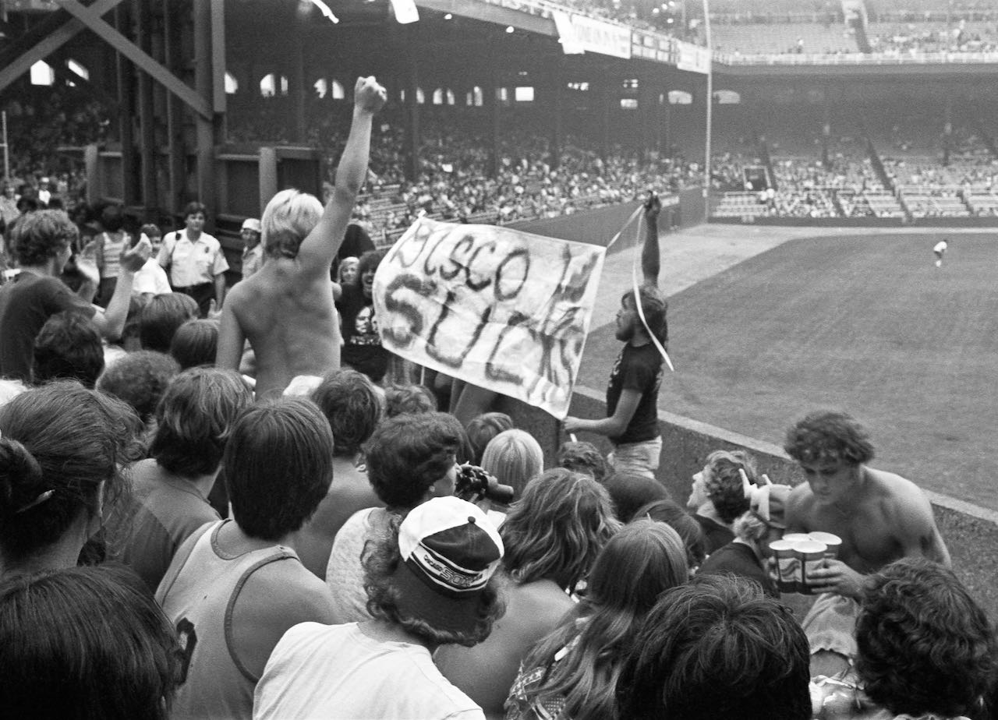
Disco Demolition Night at Comiskey Park, Chicago Illinois, July 12, 1979.
Credit: Diane Alexander White

In the 1970s, disco began to dominate American popular music, taking over clubs, radio stations, and record sales. Its roots lay in the urban subculture, and the artists who created it were predominantly African American and Latino. In the gay dance clubs where it first flourished, disco was much more than music — it was an expression of pride.
Chicago DJ Steve Dahl played the music of AC/DC, Aerosmith, the Rolling Stones and other rock groups at WDAI Radio. On Christmas Eve 1978, he was told that the station was changing formats to disco and he was out of a job. Dahl was snapped up by a new radio station, WLUP, but feeling bitter and betrayed by WDAI, his anti-disco diatribes began and proved popular with audiences.

“Disco was about electronic music; disco fans liked the clubs where if you didn’t look good enough, you couldn’t get in,” said Lee Abrams, inventor of the “Album Oriented Rock” (AOR) radio format. “Rockers loved big concerts, real drummers, real guitar players — rock was about jeans and a T-shirt. . . Rockers were just angry at disco because they felt sort of threatened by it.”

In 1979, Chicago’s White Sox were the second-worst team in baseball. Hoping to draw crowds to a doubleheader at Comiskey Park, White Sox promotion director Mike Veeck partnered with WLUP to host “Disco Demolition Night” on Thursday, July 12, 1979. The price of admission was ninety-eight cents — WLUP’s frequency — and one disco record to be blown up by DJ Dahl between games.

Event organizers expected to draw an extra 5,000 people. Fifty thousand showed up, with another 20,000 waiting outside to get in. After the large crate filled with records exploded and blew a large hole in the field, the crowd started running out of the stands, tearing up bases and destroying the batting cage; others threw albums from the stands, hitting and injuring people. Police were called to clear the field, and ultimately, the White Sox had to forfeit the second game to the Detroit Tigers.

While everyone recognized that the promotion had gone terribly wrong, some saw something more frightening in the hordes of rampaging — almost entirely white — youth on the field: homophobia and racism. “It felt racist,” said Darlene Jackson. “I don't think you could have a stadium full of, you know, Black and brown kids that would be allowed just to run uncontained, loose, damaging property.”

“What I would never want to do is villainize Steve Dahl for the ultimate outcome 100%,” said Ayana Contreras, host of “Reclaimed Soul” on WBEZ and contributor to Downbeat Magazine. “Yes, you had a perfect storm of disenfranchised youth and alcohol. But I don’t think he intended for a riot to happen. I think the ultimate point was it was ‘the other’ — that’s what they were rallying against — the people who were not like themselves.”

Some believed disco music was already on the wane and it declined sharply after the event. “The evening at Comiskey Park was the moment that set the fuse,” said Felipe Rose of the iconic disco group The Village People. “Suddenly, radio stations stopped playing disco music — not slowly, overnight.”
“All of American history is defined by culture wars,” said Jefferson Cowie, Vanderbilt University Professor of History and author of Stayin’ Alive: The 1970s and the Last Days of the Working Class. “But in the 1970s, an entire new front opened up in the battle over the culture. The Civil Rights movement, the women’s movement, the gay rights movement come along and say, ‘Hey, we want in too.’ And that’s why the 1970s are the foundation of our own time because we’re still battling over these same questions.”
American Experience The War on Disco will stream for free simultaneously with broadcast through November 29, 2023, on all station-branded PBS platforms, including PBS.org and the PBS App, available on iOS, Android, Roku, Apple TV, Amazon Fire TV, Android TV, Samsung Smart TV, Chromecast and VIZIO. The film will also be available for streaming with closed captioning in English and Spanish.

About the Participants

Lee Abrams is a radio industry consultant who pioneered audience research, developed the album-oriented rock radio format, and co-founded XM Satellite Radio. Known for anticipating trends, at different times he promoted both disco and anti-disco formats for different radio markets.

Daphne Brooks is a professor of African American studies, Gender studies, and Music at Yale University; she has written numerous articles about race, gender, performance, and popular music culture.

Linda Clifford, a former Miss New York State, is an actress and singer of jazz, R&B, and disco who had a number of popular records through the 1970s and 1980s.

Ayana Contreras is a cultural historian, radio host and producer at Chicago Public Radio, columnist and reviewer at DownBeat magazine, archivist collector with over 8,000 vintage vinyl records, and author of Energy Never Dies: Afro-Optimism and Creativity In Chicago.

Jefferson Cowie is a historian at Vanderbilt University whose work focuses on how class, race, and work shape American culture. His book Stayin’ Alive: The 1970s and the Last Days of the Working Class examines the intersection of politics, labor, and popular culture during the disco years.

Adam Green is a professor of African American history and cultural studies at the University of Chicago who has studied and written about Black culture and creativity in 20th-century Chicago.

Jim Hankes is a music lover and Chicago White Sox fan who listened to the Steve and Garry radio show on WLUP and attended Disco Demolition Night at Comiskey Park.

Dave Hoekstra is a Chicago-based author and journalist. A columnist and critic at the Chicago Sun-Times for nearly 30 years, he’s a contributor to many other newspapers and magazines and has written three books.

Darlene Jackson is a DJ, public radio host and producer with deep knowledge of the ethnomusicology of Chicago, especially dance music.

Nancy Faust Jenkins is a musician who played the organ at Chicago White Sox baseball games for 41 consecutive seasons, missing only five games when her son was born.

Rich King is a longtime Chicago sportscaster and journalist, a fixture in Chicago media for decades, and the author of three books.

Dave Logan is a longtime veteran of the radio business, a consultant and programmer who was promotion director at Chicago’s WLUP during the heyday of “The Steve and Garry Show” and the WLUP-Chicago White Sox promotion Disco Demolition Night.

Garry Meier is a radio DJ and podcaster who partnered with noted DJ Steve Dahl on “The Steve and Garry Show” at WLUP and other stations in Chicago from 1979 through 1992.

Paul Natkin, widely considered Chicago’s greatest music photographer, has spent four decades documenting over 10,000 concerts and most of the major music stars of the second half of the 20th century.

Felipe Rose is a singer, dancer, co-founding member (the Native American character) of The Village People, and host of the podcast “The Disco Chronicles.”

Joe Shanahan is a noted Chicago music promoter and club owner who has championed a broad spectrum of diverse musical artists and philanthropic causes.

Ray Smith grew up in Philadelphia and was a teenage dancer on American Bandstand. Moving to New York City in the 1960s, he joined the gay subculture, going to underground gay dance clubs at a time when being openly gay could mean losing your job or being arrested.

Diane Alexander White is a photographer who has chronicled scenes of life and culture in Chicago for over four decades, including Disco Demolition Night at Comiskey Park.

Wayne Williams is a music producer, DJ, record label executive, and pioneer of house music.

About the Filmmakers

American Experience The War on Disco

Written and Produced by  Produced by  Archival Producer  Edited by | RUSHMORE DENOOYER  LISA Q. WOLFINGER  MARY ANTINOZZI SOULE  JED RAUSCHER
American Experience is a production of GBH Boston
Executive Producer | CAMEO GEORGE

Lisa Q. Wolfinger (Producer), co-owner of Lone Wolf Media, has written, produced and directed a wide range of television programs and films, including episodic drama, high-end factual series, specials and feature documentaries. She is the co-creator and executive producer of the PBS drama Civil War series Mercy Street. In the non-fiction field, she is the executive producer and director of the Hulu true crime anthology series Wild Crime. Other notable work includes the Emmy-winning series America’s Hidden Stories for Smithsonian and Emmy-nominated docudramas for History: Desperate Crossing, the Untold Story of the Mayflower, Fire on the Mountain, Witch Hunt, and the mini-series Conquest of America.

Rushmore DeNooyer (Producer, Writer) has written, produced, and directed numerous documentaries for PBS, History, Discovery, National Geographic, Smithsonian, Turner and others. A former musician, he is passionate about American history as well as science and has made films about the space race, the Kennedy assassination, and the Titanic. His work has been honored with the George F. Peabody Award, the Writers Guild of America Award, the International Documentary Association’s Distinguished Achievement Award, the Edgar Dale Award for Excellence in Informational Screenwriting, and numerous Emmy nominations. His PBS special, Black Hole Apocalypse, was selected by the American Institute of Physics for its Science Communication Award in the Broadcast category for storytelling and communicating science to the public.

Cameo George (Executive Producer, American Experience) is an Emmy Award-winning producer, writer and journalist with more than 20 years of experience in documentary, broadcast television and digital content production. George has produced, developed and commissioned innovative programming at CNN, NBC News and ABC News. She was the senior producer of CNN’s groundbreaking series Black in America and Latino in America and executive producer of the eight-hour PBS documentary series 16 FOR '16: THE CONTENDERS, which was also broadcast on the BBC. George joined American Experience from ABC News, where she was head of development for long-form projects, responsible for creating a pipeline of docuseries and feature documentary films across Walt Disney Television platforms, including ABC News, Hulu, National Geographic and Disney+.

About American Experience

For 35 years, American Experience has been television’s most-watched history series, bringing to life the incredible characters and epic stories that have shaped America’s past and present. American Experience documentaries have been honored with every major broadcast award, including 30 Emmy Awards, five duPont-Columbia Awards and 19 George Foster Peabody Awards. PBS’s signature history series also creates original digital content that innovates new forms of storytelling to connect our collective past with the present. Cameo George is the series executive producer. American Experience is produced for PBS by GBH Boston. Visit pbs.org/americanexperience and follow us on Facebook, Twitter, Instagram and YouTube to learn more.

Major funding for American Experience provided by Liberty Mutual Insurance and by the Alfred P. Sloan Foundation. Funding for The War on Disco provided by members of The Better Angels Society including The Fullerton Family Charitable Fund and Bobby and Polly Stein. Additional funding for American Experience provided by the Robert David Lion Gardiner Foundation, The Documentary Investment Group, the Corporation for Public Broadcasting and public television viewers.

The War on Disco is distributed internationally by PBS International.

* * *
Contacts: CaraMar Publicity
Mary Lugo 770-851-8190 lugo@negia.net
Cara White 843-881-1480 cara.white@mac.com
Abbe Harris 908-244-5516 abbe.harris@caramar.net

For further information and photos visit http://www.pbs.org/pressroom

