American Experience The Sun Queen
Premieres Tuesday, April 4, 2023, on PBS and Streaming on PBS.org

New Film Explores the Fascinating Life of the Solar Energy Pioneer
Mária Telkes, Known as “The Sun Queen”

(BOSTON, MA) – For nearly 50 years, chemical engineer and inventor Mária Telkes applied her prodigious intellect to harnessing the power of the sun. She designed and built the world’s first successfully solar-heated modern residence and identified a promising new chemical that, for the first time, could store solar heat like a battery. And yet, along the way, she was undercut and thwarted by her boss and colleagues — all men — at MIT. Despite these obstacles, Telkes persevered and, upon her death in 1995, held more than 20 patents. She is now recognized as a visionary pioneer in the field of sustainable energy. An unexpected and largely forgotten heroine, Telkes was remarkable in her vision and tenacity — a scientist and a woman in every way ahead of her time. Her research and innovations from the 1930s through the ‘70s continue to shape how we power our lives today. Produced and directed by Amanda Pollak, produced and written by Gene Tempest, and executive produced by Cameo George, The Sun Queen premieres Tuesday, April 4, 2023, 9:00-10:00 p.m. ET (check local listings) on PBS, PBS.org and the PBS App.
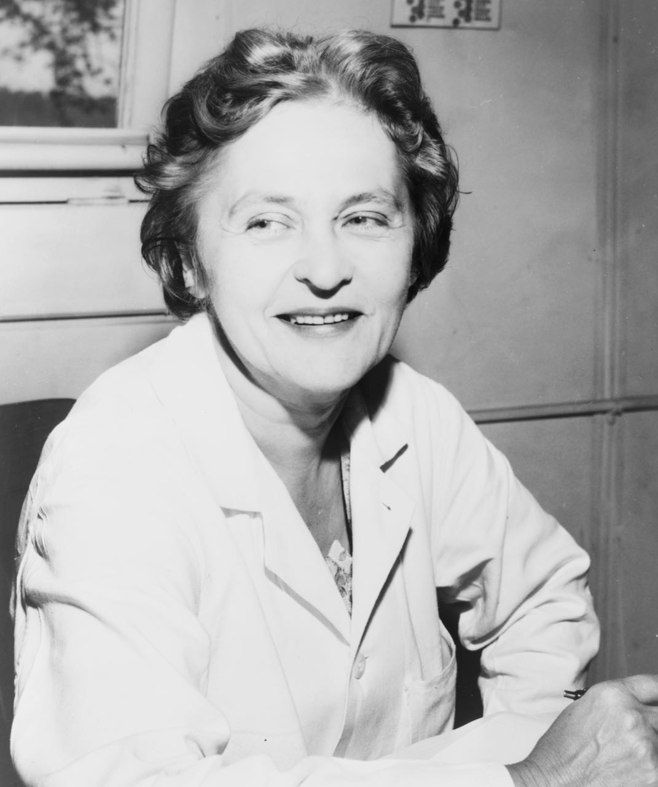
Mária Telkes
Credit: Library of Congress

“It is the things supposed to be impossible that interest me,” Telkes once explained. “I like to do things they say cannot be done.” Her driving ambition was to design practical inventions that would use the sun to benefit humanity writ large. Born in Hungary in 1900, she earned a doctorate in physical chemistry at age 24 and emigrated to the U.S. in 1932, to be a part of the burgeoning field of solar energy. When MIT launched its Solar Energy Fund in 1938, aimed at bringing together the best minds in the field, Telkes immediately wrote to the university president, asking to join the team. She got the job.

The timing was precipitous. Soon, with the country entering World War II, resources were tightly rationed and the idea of creating housing that could run without coal or oil was more urgent than ever. Telkes threw herself into the war effort along with the head of the solar project, a fuel engineer named Hoyt Hottel. Their task: to develop a solar desalinator for downed pilots in the Pacific theater.

When the war ended, America faced a new challenge: creating affordable housing for the millions of returning G.I.s who were starting families. With energy still scarce, it seemed like the time for solar had arrived. Telkes devoted her energies to developing a prototype house that could be heated entirely by the sun. There had been other attempts at solar housing, but no matter how well they worked on sunny days, they could not hold heat overnight. “The problem of solar energy,” explained Telkes, “is storage.” Her solution was a chemical compound that could store solar-generated energy. Hottel allowed Telkes to use the process in their next experimental house. When the system failed, she was removed from the project.

Telkes was undeterred. If she couldn’t find support for her work in the male-dominated halls of MIT, she would find new backers who shared her passion and vision. Amelia Peabody was a wealthy Boston philanthropist; Eleanor Raymond was a pioneering architect. Together with Telkes, they formed an all-woman dream team and built what became known as the Dover Sun House, in Dover, Massachusetts.

Completed in 1948, the Dover Sun House was, unlike earlier prototypes, designed to be lived in by a family; that Christmas, the Nemethys, a Hungarian émigré family, moved in. It was soon one of the most famous houses in the country, and Telkes became a media celebrity. The “Sun Queen,” as she was known in the press, fast became the nation’s most visible face of the solar future. That fame, which Telkes leveraged to further the solar cause, came at a cost. The boys’ club at MIT was unimpressed by her latest project and, in 1953, she was fired.

Still, Telkes persisted. She created a solar-powered oven that is still in use and continued to push her vision of solar housing for the masses. But by the mid-50s, the Dover Sun House began to fall into disrepair. Materials corroded and systems failed. Undeterred, she refused to see the experiment as a failure and continued to work on refinements.

But the quest for solar solutions was sidelined by the much-publicized failure of the Dover Sun House and an American economy fueled by cheap and abundant petroleum. The age of fossil fuels had arrived. As scholar Olivia Meikle says, “What really is the tragedy here is what she could have accomplished. We won't ever be able to know what she could have done. Maybe she could have made these huge leaps. Maybe we could have been a decade or two ahead on solar power from where we are now.”
Cameo George, executive producer of American Experience, says: “We could be living in a very different world today if we had followed up on her inventions. I think there are a lot of viewers — not just women, not just girls — who will be inspired by her story, but also wonder why they haven’t heard of her until now.”

American Experience The Sun Queen will stream simultaneously with broadcast on all station-branded PBS platforms, including PBS.org and the PBS App, available on iOS, Android, Roku, Apple TV, Amazon Fire TV, Android TV, Samsung Smart TV, Chromecast and VIZIO. All titles will be available for streaming with closed captioning in English and Spanish.

About the Participants

Michelle Addington is dean of the School of Architecture and the former Gerald Hines Chair in Sustainable Architectural Design at Yale University School of Architecture.

Daniel A. Barber is an architectural historian and author of A House in the Sun: Modern Architecture and Solar Energy in the Cold War.

A. L. Hu is an architect, organizer and facilitator. A.L. was a 2019-2021 Enterprise Rose Architectural Fellow, and is currently the Design Initiatives Manager at Ascendant Neighborhood (AND), a nonprofit affordable housing developer in East Harlem.

Olivia Meikle teaches Women’s & Gender Studies at Naropa University in Boulder, Colorado, and is the host of the women’s history podcast What’sHerName.

Andrew Nemethy grew up in the Dover Sun House in Massachusetts designed by Maria Telkes, living there from 1948 to 1963. He is an award-winning journalist and editor.

Joy Olgyay is the goddaughter of Maria Telkes and the daughter of her closest collaborator, the Hungarian immigrant architect Aladar Olgyay.

Ivan Penn is a Los Angeles-based New York Times reporter covering alternative energy. He previously covered utility and energy issues at The Tampa Bay Times and The Los Angeles Times.

Adam Rome is a professor of environment and sustainability at the University at Buffalo.

Sara Shreve-Price is the author of Futures So Bright: Solar Homes in Mid-Twentieth Century America.

About the Filmmakers

American Experience The Sun Queen

Produced and Directed by  Written and Produced by  Narrated by  Music by  Edited by | AMANDA POLLAK  GENE TEMPEST  ANDIA WINSLOW  EDUARDO ARAM  JOSH MELROD  JAI LI
American Experience is a production of GBH Boston
Executive Producer | CAMEO GEORGE

Amanda Pollak (Producer and Director) has been directing and producing highly acclaimed documentaries for over two decades, including over a dozen films for American Experience. She produced and co-directed The Great War, an epic six-hour series on America’s role in World War 1, which was seen by more than 10 million people nationwide. She produced Into the Grand Canyon, an environmental adventure story that premiered on National Geographic and is now streaming worldwide on Disney+, and executive produced Ailey, an immersive portrait of the renowned choreographer, which premiered at Sundance, was released theatrically by NEON and broadcast on PBS’s American Masters. Pollak was part of the founding team for Retro Report, an online series of investigative pieces featured on the front page of The New York Times digital edition. Her work has been recognized with three Emmy Awards, a Cine Golden Eagle Award and the George Foster Peabody Award.

Gene Tempest (Writer and Producer) is an award-winning filmmaker and historian. Her work has appeared in The Boston Globe and The New York Times, and her screenwriting has been recognized by the Writers Guild of America. A coeditor of Une Histoire De La Guerre (2018) and a former contributor to the French magazine L'histoire, her projects include the PBS documentaries The Great War (coproducer; 2017), American Veteran (cowriter; 2021) and Citizen Hearst (writer, producer; 2021). She received her BA from the University of California at Berkeley, and her PhD from Yale University, where she won the Hans Gatzke Prize for her work in military history. She has taught at SUNY Cortland and Boston University, and from 2016-2017 served as the first ever Historian in Residence for American Experience, where she helped fund and develop new history programming for public television.

Cameo George (Executive Producer, American Experience) is an Emmy Award-winning producer, writer and journalist with more than 20 years of experience in documentary, broadcast television and digital content production. George has produced, developed and commissioned innovative programming at CNN, NBC News and ABC News. She was the senior producer of CNN’s groundbreaking series Black in America and Latino in America and executive producer of the eight-hour PBS documentary series 16 FOR '16: THE CONTENDERS, which was also broadcast on the BBC. George joined American Experience from ABC News, where she was head of development for long-form projects, responsible for creating a pipeline of docuseries and feature documentary films across Walt Disney Television platforms, including ABC News, Hulu, National Geographic and Disney+.

About American Experience

For 35 years, American Experience has been television’s most-watched history series, bringing to life the incredible characters and epic stories that have shaped America’s past and present. American Experience documentaries have been honored with every major broadcast award, including 30 Emmy Awards, five duPont-Columbia Awards and 19 George Foster Peabody Awards. PBS’s signature history series also creates original digital content that innovates new forms of storytelling to connect our collective past with the present. Cameo George is the series executive producer. American Experience is produced for PBS by GBH Boston. Visit pbs.org/americanexperience and follow us on Facebook, Twitter, Instagram and YouTube to learn more.

Major funding for American Experience provided by Liberty Mutual Insurance, the Corporation for Public Broadcasting, and the Alfred P. Sloan Foundation. Major funding for The Sun Queen provided by GBH Planet Future Fund, members of The Better Angels Society including The Fullerton Family Charitable Fund and Bobby and Polly Stein. Additional series funding for American Experience provided by the Robert David Lion Gardiner Foundation, the Documentary Investment Group, and public television viewers.

The Sun Queen is distributed internationally by PBS International.

* * *
Contacts:
CaraMar Publicity
Mary Lugo 770-851-8190 lugo@negia.net
Cara White 843-881-1480 cara.white@mac.com
Abbe Harris 908-244-5516 abbe.harris@caramar.net

For further information and photos visit http://www.pbs.org/pressroom

