American Experience The Cancer Detectives
Premieres Tuesday, March 26, 2024 on PBS and Streaming on PBS.org

New Documentary Tells the Story of the Remarkable Team Responsible
for the Life-Saving Cervical Cancer Test

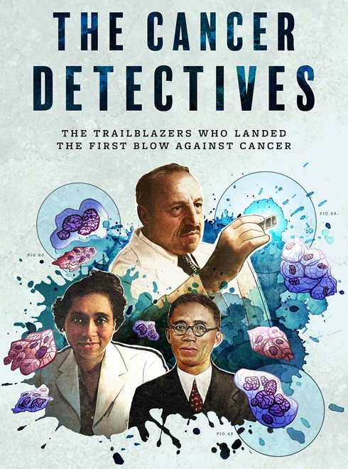
(Boston, MA) — The story of how the life-saving cervical cancer test became an ordinary part of women’s lives is as unusual and remarkable as the coalition of people who ultimately made it possible: a Greek immigrant, Dr. George Papanicolaou; his intrepid wife, Mary; Japanese-born artist Hashime Murayama; Dr. Helen Dickens, an African American OBGYN in Philadelphia; and an entirely new class of female scientists known as cyto-screeners. But the test was just the beginning. Once the test proved effective, the campaign to make pap smears available to millions of women required nothing short of a total national mobilization. The Cancer Detectives tells the untold story of the first-ever war on cancer and the people who fought tirelessly to save women from what was once the number one cancer killer of women. Directed by Amanda Pollak and Gene Tempest, and executive produced by Cameo George, The Cancer Detectives premieres on American Experience on Tuesday, March 26, 2024, 9:00-10:00 p.m. ET (check local listings) on PBS, PBS.org and the PBS App.

In the 1920s, cervical cancer was deeply feared, little discussed, and responsible for some 40,000 deaths of American women a year. There was little doctors could do once the cancer was detected. As historian Barron Lerner, MD, explains, “The notion of trying to find cervical cancer early wasn’t on anyone’s radar screen, because nobody had thought of it before, and nobody thought there was a way to do that.”

Enter Dr. George Papanicolaou — known as “Dr. Pap” — and his wife, Mary, who worked as his technician and lab manager. While studying the cellular changes that happen during the reproductive cycle of guinea pigs at Cornell Medical College, Dr. Pap discovered that by examining cervical swabs under the microscope, he could see changes in cancerous cells. When he needed to see if these changes would be similarly detectable in human females, Mary volunteered for the first Pap tests.

When Dr. Pap presented his findings in 1928, the medical community ignored the new test’s potential, and for more than a decade, the pap smear languished. Then, beyond the world of white coats and lab microscopes, attitudes towards cancer began to shift.

By the late 1930s, a new generation of activists — most of them women — were fighting to make cancer a part of the national conversation. Members of the Women’s Field Army, an offshoot of the recently founded American Society for the Control of Cancer (ASCC), mobilized to bring the gospel of cancer detection directly to American families. Soon, the Cornell Medical College urged Dr. Pap to return to his work on the pap smear.

Dr. Pap brought on the gifted scientific illustrator Hashime Murayama to depict the evolution of cancer across cervical cells, a vital step for explaining and teaching the technique of evaluating the tests on a mass scale. After the outbreak of WWII, Murayama was arrested and interned as a Japanese “alien,” and the fate of the project seemed once again in jeopardy until the Attorney General of the United States, Francis Biddle, stepped in to free Murayama. As the war ended, the ASCC became the American Cancer Society, fully rebranded and ready for a new fight. Their dream was to launch the pap smear across the country. Still, getting the smear out of the lab and into the real world required an unprecedented health campaign and a new kind of medical activist.

Dr. Helen Dickens, a trailblazing African American OBGYN in Philadelphia who’d fought the odds to become a doctor in the 1930s, now made it her mission to make sure that Black women had access to the life-saving test. Her tireless campaign — from workshops across the city to free Pap smears at churches to teaching hundreds of other Black doctors how to perform the test — shows how many hurdles had to be overcome before the pap smear could become an accepted part of American women’s lives.

By the late 1950s, the Pap test was triumphant. It had taken more than three decades, but the Pap smear became a routinely accepted part of women’s healthcare. And by some estimates, the test has saved more than one million lives.

American Experience The Cancer Detectives will stream for free simultaneously with broadcast on all station-branded PBS platforms, including PBS.org and the PBS App, available on iOS, Android, Roku, Apple TV, Amazon Fire TV, Android TV, Samsung Smart TV, Chromecast and VIZIO. The film will also be available for streaming with closed captioning in English and Spanish.

About the Participants

Dr. Jayne Henderson Brown is an internal medicine specialist in Philadelphia, Pennsylvania, and the daughter of Dr. Helen Dickens.

Deirdre Cooper Owens is an associate professor of history at the University of Connecticut and author of Medical Bondage: Race, Gender, and The Origins of American Gynecology.

Kirsten Gardner is an associate professor at the University of Texas at San Antonio, teaching in the Department of History and serving as affiliated faculty in Women’s Studies and Medical Humanities.

Rachel Gross is an award-winning science journalist and the author of Vagina Obscura: An Anatomical Voyage.

Leah Hazard is a midwife, activist, mother and author of Womb: The Inside Story of Where We All Began.

Sam Kean is an award-winning science journalist and author.

Dr. Barron Lerner is a professor of medicine and population health at NYU Langone Health. He is a bioethicist, speaker, historian, author and regular contributor to The New York Times, The Washington Post and Slate.

Ameenah Shakir is a 20th-century U.S. historian of race and medicine at the University of Houston. She is currently working on a book titled Birthing Liberation, a biography of Dr. Helen Dickens.

About the Filmmakers

American Experience The Cancer Detectives

Directed by  Written by  Produced by | AMANDA POLLAK and GENE TEMPEST  GENE TEMPEST  AMANDA POLLAK
American Experience is a production of GBH Boston
Executive Producer | CAMEO GEORGE

Amanda Pollak (Producer/Director) has been directing and producing highly acclaimed documentaries for over two decades, including over a dozen films for American Experience, most recently The Sun Queen. She produced and co-directed The Great War, an epic six-hour series on America’s role in World War 1, which was seen by more than 10 million people nationwide. She produced Into the Grand Canyon, an environmental adventure story that premiered on National Geographic and is now streaming worldwide on Disney+, and executive produced Ailey, an immersive portrait of the renowned choreographer, which premiered at Sundance, was released theatrically by NEON and broadcast on PBS’s American Masters. Pollak was part of the founding team for Retro Report, an online series of investigative pieces featured on the front page of The New York Times digital edition. Her work has been recognized with three Emmy Awards, a Cine Golden Eagle Award and the George Foster Peabody Award.

Gene Tempest (Director/Writer) is an award-winning filmmaker and historian. Her work has appeared in The Boston Globe and The New York Times, and her screenwriting has been recognized by the Writers Guild of America. A coeditor of Une Histoire De La Guerre (2018) and a former contributor to the French magazine L'histoire, her projects include the PBS documentaries The Great War (co-producer, 2017), The Sun Queen (writer/producer, 2022), American Veteran (co-writer, 2021) and Citizen Hearst (writer, producer, 2021). She received her BA from the University of California at Berkeley, and her PhD from Yale University, where she won the Hans Gatzke Prize for her work in military history. She has taught at SUNY Cortland and Boston University, and from 2016-2017 served as the first-ever Historian in Residence for American Experience, where she helped fund and develop new history programming for public television.

Cameo George (Executive Producer, American Experience) is an Emmy Award-winning producer, writer and journalist with more than 20 years of experience in documentary, broadcast television and digital content production. George has produced, developed and commissioned innovative programming at CNN, NBC News and ABC News. She was the senior producer of CNN’s groundbreaking series Black in America and Latino in America and executive producer of the eight-hour PBS documentary series 16 FOR '16: THE CONTENDERS, which was also broadcast on the BBC. George joined American Experience from ABC News, where she was head of development for long-form projects, responsible for creating a pipeline of docuseries and feature documentary films across Walt Disney Television platforms, including ABC News, Hulu, National Geographic and Disney+.

About American Experience

For over 35 years, American Experience has been television’s most-watched history series, bringing to life the incredible characters and epic stories that have shaped America’s past and present. American Experience documentaries have been honored with every major broadcast award, including 30 Emmy Awards, five duPont-Columbia Awards and 19 George Foster Peabody Awards. PBS’s signature history series also creates original digital content that innovates new forms of storytelling to connect our collective past with the present. Cameo George is the series executive producer. American Experience is produced for PBS by GBH Boston. Visit pbs.org/americanexperience and follow us on Facebook, Twitter, Instagram and YouTube to learn more.

Major funding for American Experience provided by Liberty Mutual Insurance, Carlisle Companies and by the Alfred P. Sloan Foundation. Funding for The Cancer Detectives provided by GBH Voices and Equity Fund and members of The Better Angels Society, including The Fullerton Family Charitable Fund. Additional funding for American Experience provided by the Robert David Lion Gardiner Foundation, The American Experience Trust, the Corporation for Public Broadcasting and public television viewers.

The Cancer Detectives is distributed internationally by PBS International.

* * *
Contacts: CaraMar Publicity
Mary Lugo 770-851-8190 lugo@negia.net
Cara White 843-881-1480 cara.white@mac.com
Abbe Harris 908-244-5516 abbe.harris@caramar.net

For further information and photos visit http://www.pbs.org/pressroom

