American Experience The Busing Battleground Premieres Monday, September 11, 2023 on PBS and Streaming on PBS.org

Film Tells the Story of the Bitter Struggle to Integrate Boston’s Schools

(Boston, MA) —On September 12, 1974, police were stationed outside schools across Boston as Black and white students were bused for the first time between neighborhoods to comply with a federal court desegregation order. The cross-town busing met with shocking violence, much of it directed at children: angry white protestors threw rocks at school buses carrying Black children and hurled racial epithets at the students as they walked into their new schools. The chaos and racial unrest would escalate and continue for years. Using eyewitness accounts, oral histories and news footage that hasn’t been seen in decades, The Busing Battleground pulls back the curtain on the volatile effort to end school segregation, detailing the decades-long struggle for educational equity that preceded the crisis. It illustrates how civil rights battles had to be fought across the North as well as the South and reckons with the class dimensions of the desegregation saga, exploring how the neighborhoods most impacted by the court’s order were the poorest in the city. Directed by Sharon Grimberg (American Experience Joseph McCarthy, The Abolitionists) and Cyndee Readdean (Reconstruction: America After the Civil War) and executive produced by Cameo George, The Busing Battleground premieres on AMERICAN EXPERIENCE on Monday, September 11, 2023, 9:00-11:00 p.m. ET (check local listings) on PBS, PBS.org and the PBS App. The film, part of a special two-night event exploring the legacy of school integration, will be followed by The Harvest, premiering September 12.
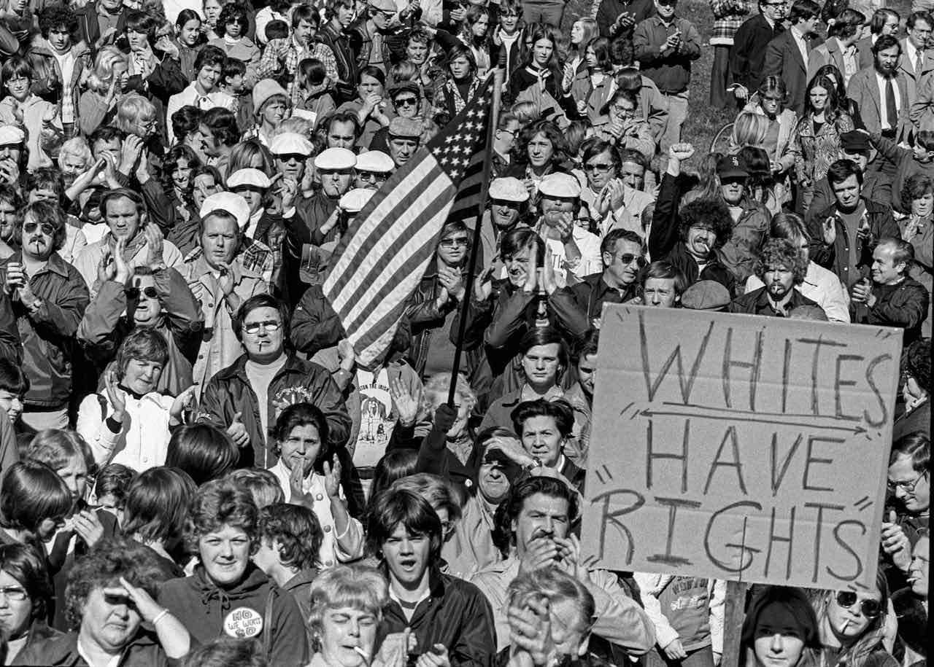
Opponents of court-ordered school desegregation at Thomas Park in South Boston. Credit: Spencer Grant.

The fight for educational equity in Boston began in the early 1950s, years before the landmark Brown v. Board of Education ruling. Local activists, including Ruth Batson, a mother and head of the local NAACP’s education committee, began documenting the differences between majority Black and white schools. They reported that Black children were taught in the oldest school buildings, the most overcrowded classrooms, and by the most inexperienced teachers. On June 11, 1963—the day President John Kennedy gave a historic Civil Rights speech on national television saying civil rights was a “moral issue”—Batson presented her findings to the all-white Boston School Committee and demanded its members acknowledge de facto segregation in Boston’s public schools. The committee, headed by South Boston lawyer Louise Day Hicks, refused to do so. That meeting was a turning point. In the words of activist Hubie Jones, “It ignited a movement.”

Over the next several years, Black activists led a series of demonstrations and protests, including “Stay Out for Freedom” actions, during which students boycotted their regular classrooms for the day to attend Freedom Schools, where they learned that the struggle for civil rights wasn’t unique to the South. The events only caused the school committee members to dig in their heels. They understood that opposing the Black community’s demands translated into support—and votes—from white Bostonians.

In 1965, in response to the inaction of the school committee and chastened by a visit to Boston by Martin Luther King, Jr., the Massachusetts legislature passed the Racial Imbalance Act. The law required school districts to ensure their schools were racially balanced. Yet, year after year, the Boston School Committee refused to comply. In 1972, the NAACP filed a lawsuit on behalf of 14 Black parents and their children, charging the committee with deliberately segregating the public schools. Judge Garrity ruled in favor of the plaintiffs, putting into motion a plan to bus children between Black and white neighborhoods.

The decision put the city on edge. Though some Black parents applauded the judge’s ruling, others would have preferred improved schools in their communities. Many white parents took to the streets in protest. They often came from lower-income neighborhoods and were furious that some of their children would no longer attend nearby schools; they complained that the wealthy white suburbs that supported integration would not be affected by the plan and argued that their children had nothing to gain from being sent to Black neighborhoods where the schools were reportedly even worse than their own.

When school opened in September 1974, thousands of white parents kept their children out. Protesters gathered outside South Boston High, and as the buses arrived, many shouted racist epithets and, later that day, threw rocks, terrorizing the Black children on board. Racist violence continued throughout the year and tensions outside the schools and fights inside made learning impossible. Attendance was spotty as many white families and some Black families refused to send their children to school. By the end of the year, 10,000 children had left the school system permanently.

The following year, Garrity imposed a revised plan that broadened the scope of the integration efforts and increased the number of children to be bused. Though the violent opposition continued, the majority of the city’s 164 schools were eventually peacefully integrated. Some white parents complied with the court’s orders because they felt obliged to obey the law; others thought it was the right thing to do. But as the disruptions continued, more and more white parents pulled their children out of the public school system.

Boston finally ended policies that required schools to bus students for desegregation in 1999, by which time more than 70 percent of the city’s students were children of color. Looking back, Black activist Bryant Rollins rues the fact that during the heightened tensions of the time, white and Black communities couldn’t listen to each other. “A lot of the conflict that arose during the ’60s and ’70s was avoidable,” he says. “People were in a state of violent agreement. What we agreed about was the inefficacy of busing. We did not slow down, take a deep breath, take a step back and ask ourselves what’s possible together. That’s a tragedy. Everybody has lost.”

American Experience The Busing Battleground will stream for free simultaneously with broadcast through October 10 on all station-branded PBS platforms, including PBS.org and the PBS App, available on iOS, Android, Roku, Apple TV, Amazon Fire TV, Android TV, Samsung Smart TV, Chromecast and VIZIO. The films will also be available for streaming with closed captioning in English and Spanish.

About the Participants

Henry Allen was a Boston schoolteacher and activist.

Garry Armstrong was a longtime Boston television journalist for more than three decades.

Tomiko Brown-Nagin is dean of Harvard Radcliffe Institute, one of the world’s leading centers for interdisciplinary research across the humanities, sciences, social sciences, arts, and professions. She is also the Daniel P.S. Paul Professor of Constitutional Law at Harvard Law School and a professor of history at Harvard University.

Joe Burnieika grew up in the Boston neighborhood of Dorchester. In the 1970s, he worked for the Department of Implementation, which oversaw Garrity’s orders to desegregate the Boston Public Schools.

Edward Crowder was a student activist who grew up in the predominantly Black neighborhood of Roxbury, attending Boston public schools.

Matthew Delmont is the Frank J. Guarini Associate Dean of International Studies and Interdisciplinary Programs and the Sherman Fairchild Distinguished Professor of History at Dartmouth University. He is the author of Why Busing Failed: Race, Media and the National Resistance to School Desegregation.

Connie Egan was a teacher at a majority-Black Boston public school.

Phyllis Ellison-Feaster was one of the first Black students bused from Roxbury to South Boston High School.

Sandie Fenton was a teacher at a majority-Black Boston public school.

Moe Gillen is a lifelong resident of Charlestown. He was selected by Garrity as a member of the Citywide Coordinating Council, which was set up to help implement court-ordered desegregation.

Charles Glenn was appointed head of the Bureau of Educational Opportunity in 1971. His primary responsibility was to promote compliance with Massachusetts’ Racial Imbalance Act.

Albert Holland is a longtime educator, administrator and consultant with the Boston Public Schools.

Ira Jackson was chief of staff for Boston Mayor Kevin White during the 1970s.

Carl Johnson was a teacher at South Boston High School.

Hubie Jones has been a social and educational activist in Boston for over 50 years and is dean emeritus of Boston University School of Social Work (BUSSW).

Fr. William Joy was a parish priest in Charlestown during the early 1970s.

Ted Landsmark is a Northeastern University professor; he was attacked by white protestors on the plaza of Boston City Hall in 1976.

Michael Patrick McDonald grew up in South Boston. He is a leading activist, organizer, writer and author of The New York Times bestselling memoir, All Souls: A Family Story from Southie.

Lisa McGoff-Collins is a lifelong resident of Charlestown. She attended Charlestown High during the first few years of desegregation.

Ione Malloy taught English at South Boston High School during the first years of school desegregation. She is the author of Southie Won't Go: A Teacher's Diary of the Desegregation of South Boston High School.

Zebulon Miletsky is an associate professor of Africana studies at SUNY Stonybrook and author of Before Busing: A History of Boston’s Long Black Freedom Struggle.

Bob Monahan is a lifelong resident of South Boston.

Lyda Peters worked closely with Ruth Batson at METCO, a voluntary metropolitan busing program. She was an educator and school desegregation activist.

Leon Rock grew up in Roxbury. He was a student and community activist.

Bryant Rollins (deceased) was a writer for The Boston Globe during the early 1960s, where he was nominated for a Pulitzer Prize. He left to found The Bay State Banner, a Black newspaper that allowed him to both write about and participate in the Civil Rights Movement.

Alan Rose was Judge Arthur Garrity’s law clerk from 1972-73.

Farah Stockman won a Pulitzer Prize for her coverage in The Boston Globe on the legacy of busing. She is currently a member of the editorial board of The New York Times.

Eric Van Loon was an attorney for the plaintiffs in Morgan v. Hennigan, the 1972 NAACP desegregation lawsuit.

Jim Vrabel is a longtime Boston community activist and historian. He is the author of A People’s History of the New Boston.

About the Filmmakers

American Experience The Busing Battleground

Produced and Directed by  Written by  Edited by | SHARON GRIMBERG  CYNDEE READDEAN  SHARON GRIMBERG  JON NEUBURGER
American Experience is a production of GBH Boston
Executive Producer | CAMEO GEORGE

Sharon Grimberg (Writer, Producer, Director) is an award-winning filmmaker with 25 years of experience working for public television. Her most recent film for American Experience was the critically acclaimed McCarthy (2020), about the infamous Wisconsin senator. Her previous project, a mini-series on the history of the circus, garnered a Writers Guild nomination and was on The Wall Street Journal’s list of the best television of 2018. Grimberg was the executive producer of The Abolitionists, which was nominated for a Primetime Emmy and of the multi-platform mini-series We Shall Remain, which retold US history from a Native perspective. From 2003-2015, Grimberg was the senior producer of American Experience, where she played a key role in the origination, development, acquisition, and editorial oversight of more than 130 films.

Cyndee Readdean (Producer and Director) is an award-winning director, producer, and writer. Her films have appeared on PBS, ABC, MSNBC and EPIX. Readdean directed and produced episode two of the Alfred I. duPont-Columbia University award-winning series Reconstruction: America after the Civil War and the Emmy-nominated film The FBI & the Panther. She served as the series producer on the four-hour series By Whatever Means Necessary: The Times of Godfather of Harlem. Her producer credits include Freedom Summer, the 2014 American Experience film that premiered at the Sundance Film Festival and won the George Foster Peabody Award; the Emmy-nominated Tell Them We Are Rising: The Story of Black Colleges and Universities, which also premiered at the Sundance Film Festival; and the two-hour premiere episode of the OBAMA series. Readdean is a member of DGA, PGA and WGA.

Cameo George (Executive Producer, American Experience) is an Emmy Award-winning producer, writer and journalist with more than 20 years of experience in documentary, broadcast television and digital content production. George has produced, developed and commissioned innovative programming at CNN, NBC News and ABC News. She was the senior producer of CNN’s groundbreaking series Black in America and Latino in America and executive producer of the eight-hour PBS documentary series 16 FOR '16: THE CONTENDERS, which was also broadcast on the BBC. George joined American Experience from ABC News, where she was head of development for long-form projects, responsible for creating a pipeline of docuseries and feature documentary films across Walt Disney Television platforms, including ABC News, Hulu, National Geographic and Disney+.

About American Experience

For 35 years, American Experience has been television’s most-watched history series, bringing to life the incredible characters and epic stories that have shaped America’s past and present. American Experience documentaries have been honored with every major broadcast award, including 30 Emmy Awards, five duPont-Columbia Awards and 19 George Foster Peabody Awards. PBS’s signature history series also creates original digital content that innovates new forms of storytelling to connect our collective past with the present. Cameo George is the series executive producer. American Experience is produced for PBS by GBH Boston. Visit pbs.org/americanexperience and follow us on Facebook, Twitter, Instagram and YouTube to learn more.

Major funding for American Experience provided by the Corporation for Public Broadcasting, Liberty Mutual Insurance, and the Alfred P. Sloan Foundation. Major funding for The Busing Battleground provided by Chasing the Dream, a public media initiative from The WNET Group, reporting on poverty, justice, and economic opportunity in America, GBH Voices and Equity Fund, and members of The Better Angels Society including The Fullerton Family Charitable Fund and Bobby and Polly Stein. Additional series funding for American Experience provided by the Robert David Lion Gardiner Foundation, the Documentary Investment Group, and public television viewers.

The Busing Battleground is distributed internationally by PBS International.

* * *
Contacts: CaraMar Publicity
Mary Lugo 770-851-8190 lugo@negia.net
Cara White 843-881-1480 cara.white@mac.com
Abbe Harris 908-244-5516 abbe.harris@caramar.net

For further information and photos visit http://www.pbs.org/pressroom

