American Experience “Taken Hostage”
TCA Panelists

Participants

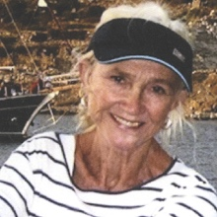
Hilary Brown was the first female foreign correspondent for ABC News. For more than 35 years, beginning in 1973, she reported from trouble spots around the world. She was one of the last journalists to be lifted by helicopter from the roof of the American Embassy in Saigon in 1975. During the 1980s, she was an anchor for the Canadian Broadcasting Corporation in Toronto, an experience she describes as “death by hairspray.” She was married for more than 30 years to the late British biographer John Bierman. Their long life together began in Tehran in 1972, where Bierman was assigned as the first BBC correspondent to Iran. Brown returned to Iran in 1975 to interview the Shah for ABC, and again in 1979 to cover the hostage crisis. Brown continued to work at what she calls “the best job in the world” until 2009, when she finally hung up her flak jacket. She recently published a memoir, War Tourist.

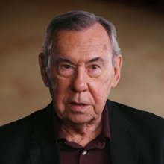
Gary Sick served on the National Security Council under Presidents Ford, Carter, and Reagan. He was the principal White House aide for Iran during the Iranian Revolution and the hostage crisis. Sick is a captain (ret.) in the U.S. Navy, with service in the Persian Gulf, North Africa, and the Mediterranean. From 1982 to 1987, Sick served as deputy director for international affairs at the Ford Foundation, where he was responsible for programs relating to U.S. foreign policy. He is a member (emeritus) of the board of Human Rights Watch in New York and founding chair of its advisory committee on the Middle East and North Africa.

Sick has a Ph.D. in political science from Columbia University, where he taught for 30 years in the School of International and Public Affairs as Adjunct Senior Research Scholar and served as director of the Middle East Institute (2000-2003). He is the author of All Fall Down: America's Tragic Encounter With Iran (Random House, 1985) and October Surprise: America's Hostages in Iran and the Election of Ronald Reagan (Random House, 1991).

Filmmakers

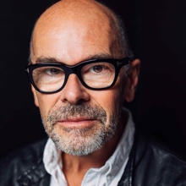
Robert Stone (Writer, Producer, Director) is an Oscar nominee for best feature documentary, a three-time Emmy nominee for exceptional merit in documentary filmmaking and the recipient of many other awards and accolades for his work over three decades. He gained considerable recognition for his first film, Radio Bikini (1987), which premiered at the Sundance Film Festival and was nominated for an Academy Award. His best-known work includes Guerrilla: The Taking of Patty Hearst (2004), which premiered at Sundance and became one of the most highly acclaimed theatrical documentaries of the year. Oswald’s Ghost (2007) earned Stone his second Emmy nomination for outstanding achievement in non-fiction filmmaking. Earth Days (2009) premiered as the closing night film at the 2009 Sundance Film Festival and was released theatrically to wide critical acclaim. Pandora’s Promise (2013), an audience favorite at Sundance, gained worldwide acclaim and prompted considerable controversy within the environmental movement for its advocacy in favor of nuclear energy to fight climate change. Stone’s most recent work, Chasing the Moon (2019), is an epic political and social history of the race to the moon, broadcast on American Experience on PBS as a three-part six-hour miniseries to celebrate the 50th anniversary of the first lunar landing. Broadcast in 13 countries on four continents, the film won the duPont-Columbia Award for broadcast journalism and earned Stone his third Emmy nomination for exceptional merit in documentary filmmaking. Stone also co-wrote, with Alan Andres, the companion book, Chasing the Moon, published by Random House. “Taken Hostage” is his ninth film for American Experience.

Cameo George (American Experience Executive Producer) is an Emmy Award-winning producer, writer and journalist with more than 20 years of experience in documentary, broadcast television and digital content production. George has produced, developed and commissioned innovative programming at CNN, NBC News, ABC News and more. She was the senior producer of CNN’s groundbreaking series Black in America and Latino in America and the executive producer of the eight-hour PBS documentary series 16 for '16: The Contenders, which was also broadcast on the BBC. George joined American Experience from ABC News, where she was Head of Development for Longform projects, responsible for creating a pipeline of docuseries and feature documentary films across Walt Disney Television platforms, including ABC News, Hulu, National Geographic and Disney+.

