American Experience
Poisoned Ground: The Tragedy at Love Canal
Premieres Monday, April 22 on PBS and
Streaming on PBS.org

Documentary Tells the Story of One of the Nation’s Most Notorious Environmental Disasters and the Women Who Fought the Chemical Industry and the Government – and Won

(Boston, MA) — Poisoned Ground: The Tragedy at Love Canal tells the dramatic and inspiring story of the ordinary women who fought against overwhelming odds for the health and safety of their families. In the late 1970s, residents of Love Canal, a working-class neighborhood in Niagara Falls, New York, discovered that their homes, schools and playgrounds were built on top of a former chemical waste dump, which was now leaking toxic substances and wreaking havoc on their health. Through interviews with many of the extraordinary housewives turned activists, the film shows how they effectively challenged those in power, forced America to reckon with the human cost of unregulated industry, and created a grassroots movement that galvanized the landmark Superfund Bill. Written, produced and directed by Jamila Ephron and executive produced by Cameo George, Poisoned Ground: The Tragedy at Love Canal premieres Monday, April 22, 2024, 9:00–11:00 p.m. ET (check local listings) on American Experience on PBS, PBS.org and the PBS App.
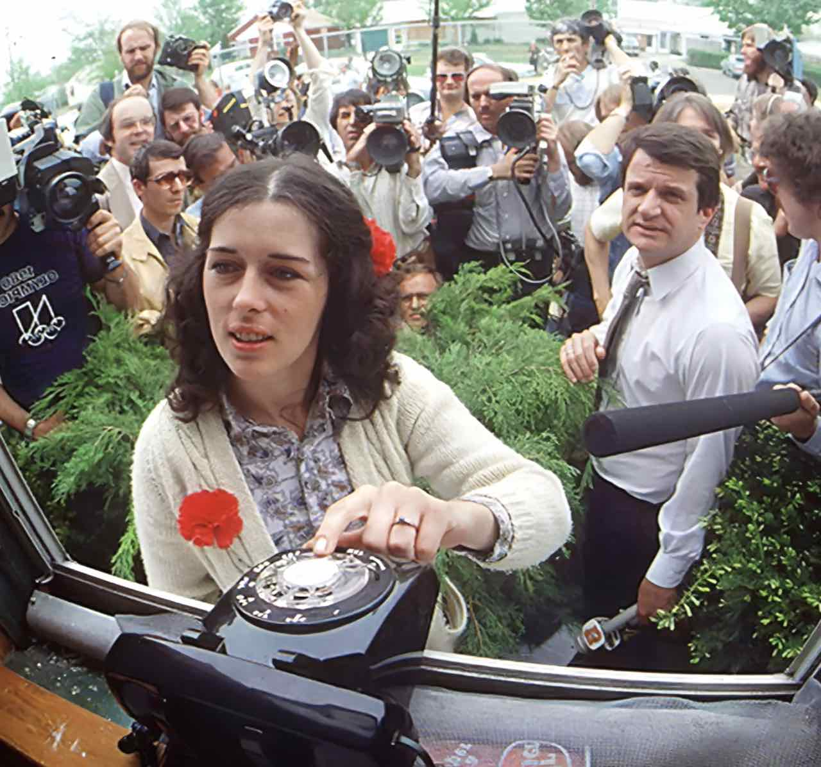
Lois Gibbs, surrounded by media, waits for a phone call from the White House. May 1980.
Credit: Mickey H. Osterreicher

The story of Love Canal began in the late 19th century, when William T. Love, hoping to harness the power of Niagara Falls, began to dig, but later abandoned, an enormous canal. Decades later, in the late 1940s, local company Hooker Chemical decided that Love’s Canal was the perfect site for a waste dump. For nearly a decade, Hooker dumped roughly 22,000 tons of dangerous chemical waste into the defunct waterway, a common disposal practice and one largely unregulated by the local government.

During the post-war baby boom, young families seeking job opportunities in the chemical industry flocked to the area, creating a demand for land for new homes and schools. Hooker Chemical sold its waste dump land to the Board of Education for $1, with a clause exempting them from all future liability. Over the next few decades, a suburban community blossomed around the Love Canal site, with an elementary school and hundreds of homes built on top of the former canal.

By the late 1970s, the persistent smell of chemicals filled the air, and residents noticed sludge seeping into basements, corroded sump pumps, and oily backyard puddles. Children playing in the schoolyard reported chemical burns and rocks that would catch fire when skipped on the water. Most alarming, residents noted troubling health maladies ranging from skin rashes and seizures to miscarriages and birth defects.

After air and soil tests revealed the presence of dozens of chemicals, panic spread as federal and state agencies scrambled for solutions. The newly-minted Environmental Protection Agency had never dealt with a catastrophe of this scale, and President Jimmy Carter declared a federal state of emergency — the first ever for a man-made disaster. Residents closest to the dumpsite were evacuated, but those farther removed were stuck, with renters unable to afford to leave and homeowners unable to sell their homes.
Those left behind were also suffering terrible health effects from the chemicals and banded together. Led by a 27-year-old homemaker named Lois Gibbs, the women advocated for government-funded relocation and medical testing. By the summer of 1978, Love Canal became a full-blown media sensation.

The Love Canal mothers educated themselves on chemical contamination and how to conduct health investigations. Their investigation, which found clusters of illness along old streambeds that intersected the canal, pushed health officials to recognize that the chemicals may have spread further than previously thought.

Finally, politicians began taking note of the risk that unregulated industrial practices posed to communities nationwide. Momentum built in Congress for legislation that would force companies dealing in toxic waste to help shoulder the burden of remediating impacted sites.

In May 1980, after two years of fighting, the Love Canal saga reached a breaking point when the results of an EPA pilot study indicating widespread chromosome damage were released to the community. Lois Gibbs and the Love Canal mothers held two EPA representatives hostage for several hours, a media spectacle that forced a response from Washington. Days later, President Carter declared a second federal emergency, which made the relocation of 700 remaining families possible. Months later, the Superfund Bill, which gained bipartisan support in Congress with the help of Love Canal, was finally passed into law. Love Canal was the first Superfund site identified for cleanup.

“Beyond saving themselves and their families, the Love Canal mothers forced America to reckon with how to balance the needs of the environment and industry,” said filmmaker Jamila Ephron. “Sadly, the larger story of the Love Canal neighborhood is still unfolding, and communities marginalized by class or race often bear the brunt of toxic waste contamination.”

American Experience films stream simultaneously with broadcast and are available on all station-branded PBS platforms, including PBS.org and the PBS Video app, available on iOS, Android, Roku, Apple TV, Amazon Fire TV, Android TV, Samsung Smart TV, Chromecast and VIZIO. All titles will also be available with closed captioning in English and Spanish.

Participants Featured in the Film:

Barbara Blum served as Deputy Administrator of the Environmental Protection Agency (EPA) from 1977 to 1981.

Michael Brown was a Niagara Gazette reporter who covered the Love Canal story. He is the author of Laying Waste: The Poisoning of America by Toxic Chemicals.

Bonnie Casper was a Congressional Aide to Congressman John LaFalce, who represented New York’s 36th Congressional District.

Debbie Cerrillo Curry was vice president of the Love Canal Homeowner’s Association.

Jannie Freeney was a resident of Griffon Manor, a housing project in Love Canal, who fought for the rights of renters to relocate.

Lois Gibbs was president of the Love Canal Homeowners Association, leading the successful effort to have government-funded relocation and health testing for outer community residents. She founded and is the former executive director of the Center for Health, Environment and Justice.

Amy Hay is an associate professor of history at the University of Texas Rio Grande Valley and has written extensively about environmental contamination, including the Love Canal disaster.

Luella Kenny was a Love Canal resident and activist. Her seven-year-old son became ill with an immune response disease and died in October 1978.

John LaFalce was a member of the US House of Representatives from 1975 to 2003. His district included the Love Canal neighborhood.

Stephen Lester was hired by the New York State Department of Health in 1978 to serve as a technical adviser to Love Canal homeowners. He is the Science Director of the Center for Health, Environment and Justice.

Richard Newman is a history professor at the Rochester Institute of Technology and author of Love Canal: A Toxic History from Colonial Times to the Present.

Keith O’Brien is a New York Times bestselling author and award-winning journalist. His books include Paradise Falls: The True Story of an Environmental Catastrophe.

Barbara Quimby (deceased) was a Love Canal resident and activist. Her daughter was born with congenital disabilities.

Marie Rice was a reporter at WIVB-TV in Buffalo, New York, for 27 years and covered the Love Canal disaster extensively.

Jennifer Thomson is the National Endowment for the Humanities Chair in the Humanities and associate professor of history at Bucknell University. She has written several articles about the Love Canal disaster and is the author of The Wild and the Toxic: Health and American Environmental Politics.

Charles Warren is a former regional administrator for the EPA. Currently, he is the chairman of the Environmental Group at the law firm of Kramer Levin Naftalis & Frankel.

Additional residents of Love Canal featured in the film include Ernie and Patti Grenzy, Carol Jones, Grace McCoulf, and Michael Tolli.

About the Filmmakers

American Experience Poisoned Ground: The Tragedy at Love Canal

Written, Produced and Directed by  Editor  Associate Producer  Archival Producer | JAMILA EPHRON  BRIAN FUNCK  EMILY DOYLE  ZOË KASE
American Experience is a production of GBH Boston
Executive Producer | CAMEO GEORGE

Jamila Ephron (Writer, Producer, Director) has been producing and directing documentary films for nearly 20 years. Her most recent film was The Blinding of Isaac Woodard, which premiered on American Experience in 2022. Her previous works for the series include Woodstock: Three Days That Defined a Generation, which was released theatrically, and George W. Bush. Ephron also produced and co-directed Far from the Tree, based on the bestselling book by Andrew Solomon for Participant Media and Sundance Selects. Additional work for American Experience includes My Lai (winner of the Primetime Emmy and Peabody Award), The Assassination of Abraham Lincoln and Clinton. She co-produced Makers: Women Who Make America, a three-hour documentary on second wave feminism, and Cancer: The Emperor of All Maladies, based on the Pulitzer Prize-winning book by Siddhartha Mukherjee.

Cameo George (Executive Producer, American Experience) is an Emmy Award-winning producer, writer and journalist with more than 20 years of experience in documentary, broadcast television and digital content production. George has produced, developed and commissioned innovative programming at CNN, NBC News, ABC News and more. She was the senior producer of CNN’s groundbreaking series Black in America and Latino in America and the executive producer of the eight-hour PBS documentary series 16 for '16: The Contenders, which was also broadcast on the BBC. George joined American Experience from ABC News, where she was Head of Development for Longform projects, responsible for creating a pipeline of docuseries and feature documentary films across Walt Disney Television platforms including ABC News, Hulu, National Geographic and Disney+.

About American Experience
For more than 35 years, American Experience has been television’s most-watched history series, bringing to life the incredible characters and epic stories that have shaped America’s past and present. American Experience documentaries have been honored with every major broadcast award, including 30 Emmy Awards, five duPont-Columbia Awards and 19 George Foster Peabody Awards. PBS’s signature history series also creates original digital content that innovates new forms of storytelling to connect our collective past with the present. Cameo George is the series executive producer. American Experience is produced for PBS by GBH Boston. Visit pbs.org/americanexperience and follow us on Facebook, Twitter, Instagram and YouTube to learn more.

Major funding for American Experience provided by Liberty Mutual Insurance, Carlisle Companies and by the Alfred P. Sloan Foundation. Funding for Poisoned Ground: The Tragedy at Love Canal provided by GBH Planet Future Fund and members of The Better Angels Society including The Fullerton Family Charitable Fund. Additional funding for American Experience provided by the Robert David Lion Gardiner Foundation, The American Experience Trust, the Corporation for Public Broadcasting and public television viewers.

Poisoned Ground: The Tragedy at Love Canal is distributed internationally by PBS International.

* * *
Contacts: CaraMar Publicity
Mary Lugo 770-851-8190 lugo@negia.net
Cara White 843-881-1480 cara.white@mac.com
Abbe Harris 908-244-5516 abbe.harris@caramar.net

For further information and photos visit https://pressroom.pbs.org/programs/american-experience.

