American Experience Nazi Town, USA
Premieres Tuesday, January 23, 2024 on PBS and Streaming on PBS.org

New Documentary Chronicles the Rise and Fall of the Pro-Nazi
German American Bund

(Boston, MA) — In February 1939, more than 20,000 Americans filled Madison Square Garden for an event billed as a “Pro-American Rally.” Images of George Washington hung next to swastikas and speakers railed against the “Jewish controlled media” and called for a return to a racially “pure” America. The keynote speaker was Fritz Kuhn, head of the German American Bund. Nazi Town, USA tells the largely unknown story of the Bund, which had scores of chapters in suburbs and big cities across the country and represented what many believe was a real threat of fascist subversion in the United States. The Bund held joint rallies with the Ku Klux Klan and ran dozens of summer camps for children centered around Nazi ideology and imagery. Its melding of patriotic values with virulent anti-Semitism raises thorny issues that we continue to wrestle with today. Produced, directed and written by Peter Yost, produced by Edna Alburquerque, and executive produced by Cameo George, Nazi Town, USA premieres on American Experience on Tuesday, January 23, 2024, 9:00-10:00 p.m. ET (check local listings) on PBS, PBS.org and the PBS App.
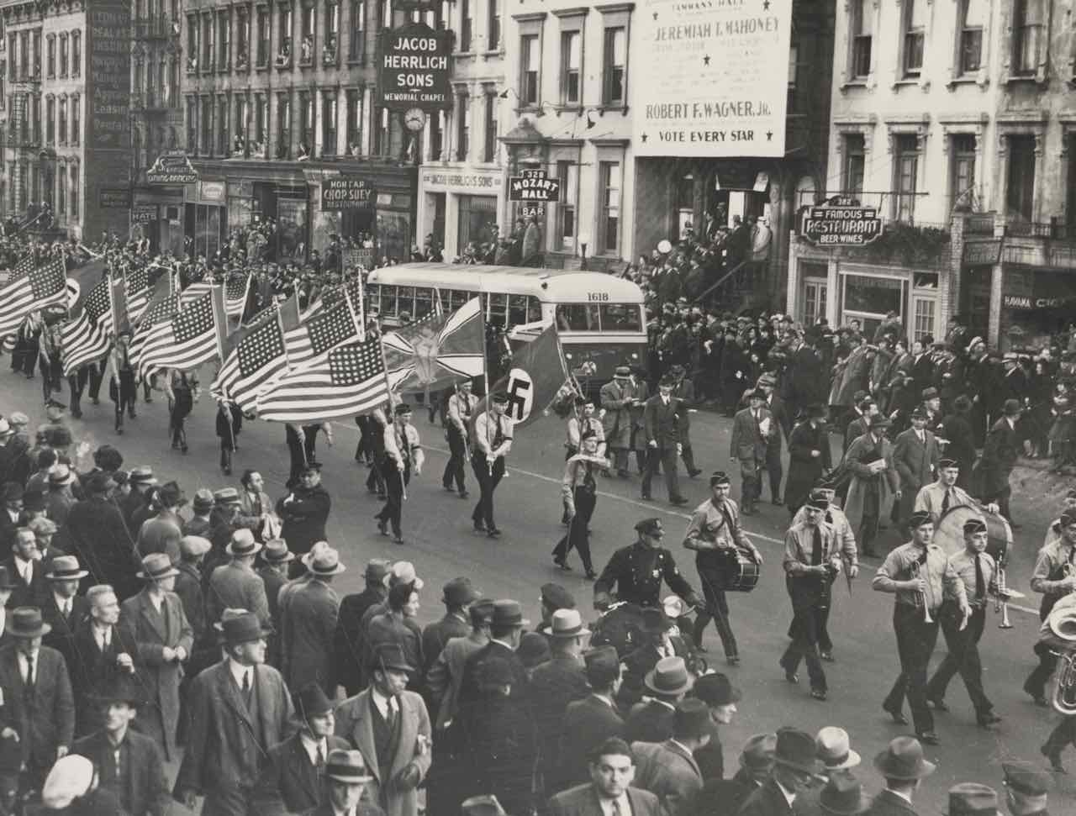
German American Bund parade in New York City on East 86th Street. Oct. 30, 1937.
Credit: Library of Congress

The German American Bund emerged in the 1930s, a period that tested the fabric of American democracy. The economic hardships of the Great Depression left many Americans fearing that the whole social order might collapse and extremist groups on both the right and the left found willing converts. Many, like the Bund, saw European fascism and Nazism as models that could and should be emulated in the United States.

1930s America was also a place of deep anti-Semitism, anti-immigrant sentiment, and racial segregation. Millions of Americans belonged to the KKK, including dozens of members of Congress. The popular right-wing radio priest Charles Coughlin told listeners that Jews were destroying their country, and industrialist Henry Ford devoted his time and money to the widespread dissemination of anti-Semitic conspiracies. All of this led members of the Bund to believe that America offered fertile ground for their ideas.

Headquartered in the Yorkville neighborhood on Manhattan’s Upper East Side, the Bund was organized into over 50 districts across the country and made great efforts to appeal to families and children, running summer camps nationwide. Some of the largest — including Camp Siegfried in Long Island and Camp Nordland in New Jersey — essentially functioned as indoctrination centers for young and old alike. The Bund also created a network of storm-troopers that marched openly in cities across America and a front organization called the German American Settlement League to establish planned communities for German-American families. In Yaphank, Long Island, they built a community called German Gardens, with streets named after prominent Nazis including Adolf Hitler.

The isolationist sentiments of the Bund’s leader, Fritz Kuhn, known as “The American Fuhrer,” aligned with the ideas of “America Firsters,” including Charles Lindbergh, who pushed to keep the United States out of the war in Europe by fanning nativist sentiment. Ultimately, the Bund opposed democracy and believed government was best when organized hierarchically, with a powerful dictator at the top. Kuhn imagined that America would be a kind of star in a constellation of pro-Nazi governments around the world, and his leadership climaxed with the massive 1939 rally in Madison Square Garden when some 20,000 Bund supporters gathered — only to be opposed by tens of thousands of counter-protesters outside.

By then, grassroots resistance to the Bund was gaining steam, including actions organized by Jewish mobsters and investigations by intrepid journalists who infiltrated the Bund to expose its inner workings and call out American fascism. Soon after the Madison Square Garden rally, Fritz Kuhn was jailed on embezzlement charges and ultimately deported as an unregistered foreign agent. Many Americans, however, continued to support right wing organizations like the Bund and isolationist groups like Lindbergh's “America First” right up to the United States’ entry in World War II, when the Bund finally collapsed. Its ugly history was largely forgotten and few ever reckoned with the appeal that fascist ideas had held to many Americans during the tumultuous 1930’s.

Says director Peter Yost, "Nazi Town, USA traces the rise and fall of the German American Bund and the threat posed by domestic fascism in the 1930’s. There’s a resonance in the film with today’s fractured times and I hope the story can serve as a reminder of both the fragility – and resilience – of American democracy.”

American Experience Nazi Town, USA will stream for free simultaneously with broadcast through February 22, 2024, on all station-branded PBS platforms, including PBS.org and the PBS App, available on iOS, Android, Roku, Apple TV, Amazon Fire TV, Android TV, Samsung Smart TV, Chromecast and VIZIO. The film will also be available for streaming with closed captioning in English and Spanish.

About the Participants

Arnie Bernstein is the author of Swastika Nation: Fritz Kuhn and the Rise and Fall of the German-American Bund.

Sarah Churchwell is a professor at the University of London and the author of Behold, America: The Entangled History of “America First” and “the American Dream.”

Beverly Gage is a professor of history at Yale University and the author of G-Man: J. Edgar Hoover and the Making of the American Century, winner of the 2023 Pulitzer Prize for Biography.

Bradley W. Hart is the author of Hitler’s American Friends: The Third Reich’s Supporters in the United States.

William Hitchcock is a professor of history at the University of Virginia. He is currently writing FDR and the Dictators: Fascism, Democracy and the Awakening of America, which explores reactions in the United States to the rise of fascism in Europe from the 1920s to 1941.

Leah Wright Rigueur is a professor of history at Johns Hopkins.

Steven J. Ross is a professor of history at the University of Southern California and author of Hitler in Los Angeles: How Jews Foiled Nazi Plots Against Hollywood and America.

About the Filmmakers

American Experience Nazi Town, USA

Written, Directed and Produced by  Produced by  Edited by | PETER YOST  EDNA ALBURQUERQUE  DON KLESZY
American Experience is a production of GBH Boston
Executive Producer | CAMEO GEORGE

Peter Yost (Director, Producer, Writer) is a multiple Emmy-nominated documentary filmmaker and the founder of Brooklyn-based Pangloss Films. He recently co-directed (with Michael Rohatyn) the upcoming feature-length documentary Drop Dead City: New York on the Brink in 1975, which won the 2023 Library of Congress Lavine/Ken Burns Prize, a national award for history documentary filmmaking. Yost has created seven films for the PBS science series NOVA on subjects ranging from the Hubble Space Telescope to the Dead Sea Scrolls, from drones to the microbiome. His most recent NOVA project was Crypto Decoded, which The Wall Street Journal said, “should be the last word in explaining the alternative money.” Yost has also made a dozen films for National Geographic’s Specials Unit, traveling the world to cover topics ranging from hippos to the International Gold Trade.

In 2021, Yost directed and produced the landmark, four-part PBS series Mysteries of Mental Illness, an exploration of the history of psychiatry and the dramatic attempts across generations to unravel the mysteries of mental illness. Among Yost’s other celebrated films are Inside North Korea, which was nominated for an Emmy for Best Long Form Documentary; The Color of Oil, an Emmy-nominated environmental film produced in conjunction with The New York Times which investigated the “greening” of Big Oil; and Solitary Confinement, which helped lead to the reform of incarceration policies in Colorado and elsewhere.
Edna Alburquerque (Producer) has worked on award-winning documentary films for over 15 years, including over a decade with Pangloss Films. Among numerous other films, she’s worked on projects for NOVA and National Geographic, ranging from an investigation of the international gold trade to an assessment of the use of solitary confinement in U.S. prisons to an exploration of the human microbiome.
She recently produced Mysteries of Mental Illness, a landmark, four-part PBS series exploring the complex history of mental illness in science and society and giving voice to contemporary Americans across a broad spectrum of experiences. With cross-cultural roots in Mexico and the Middle East, she has long been interested in telling stories that explore the complexity and diversity of the human experience.
Cameo George (Executive Producer, American Experience) is an Emmy Award-winning producer, writer and journalist with more than 20 years of experience in documentary, broadcast television and digital content production. George has produced, developed and commissioned innovative programming at CNN, NBC News and ABC News. She was the senior producer of CNN’s groundbreaking series Black in America and Latino in America and executive producer of the eight-hour PBS documentary series 16 FOR '16: THE CONTENDERS, which was also broadcast on the BBC. George joined American Experience from ABC News, where she was head of development for long-form projects, responsible for creating a pipeline of docuseries and feature documentary films across Walt Disney Television platforms, including ABC News, Hulu, National Geographic and Disney+.

About American Experience

For more than 35 years, American Experience has been television’s most-watched history series, bringing to life the incredible characters and epic stories that have shaped America’s past and present. American Experience documentaries have been honored with every major broadcast award, including 30 Emmy Awards, five duPont-Columbia Awards and 19 George Foster Peabody Awards. PBS’s signature history series also creates original digital content that innovates new forms of storytelling to connect our collective past with the present. Cameo George is the series executive producer. American Experience is produced for PBS by GBH Boston. Visit pbs.org/americanexperience and follow us on Facebook, Twitter, Instagram and YouTube to learn more.

Major funding for American Experience provided by Liberty Mutual Insurance and by the Alfred P. Sloan Foundation. Funding for Nazi Town, USA provided by members of The Better Angels Society including The Fullerton Family Charitable Fund. Additional funding for American Experience provided by The American Experience Trust, the Corporation for Public Broadcasting and public television viewers.

Nazi Town, USA is distributed internationally by PBS International.

* * *
Contacts: CaraMar Publicity
Mary Lugo 770-851-8190 lugo@negia.net
Cara White 843-881-1480 cara.white@mac.com
Abbe Harris 908-244-5516 abbe.harris@caramar.net

For further information and photos visit http://www.pbs.org/pressroom

