American Experience “George W. Bush”
Premieres Monday and Tuesday, May 4-5, 2020

TCA Panelists

Participants

Andrew H. Card, Jr. served as Chief of Staff in the presidential administration of George W. Bush from November 26, 2000 to April 14, 2006, making him the second longest-serving White House chief of staff.
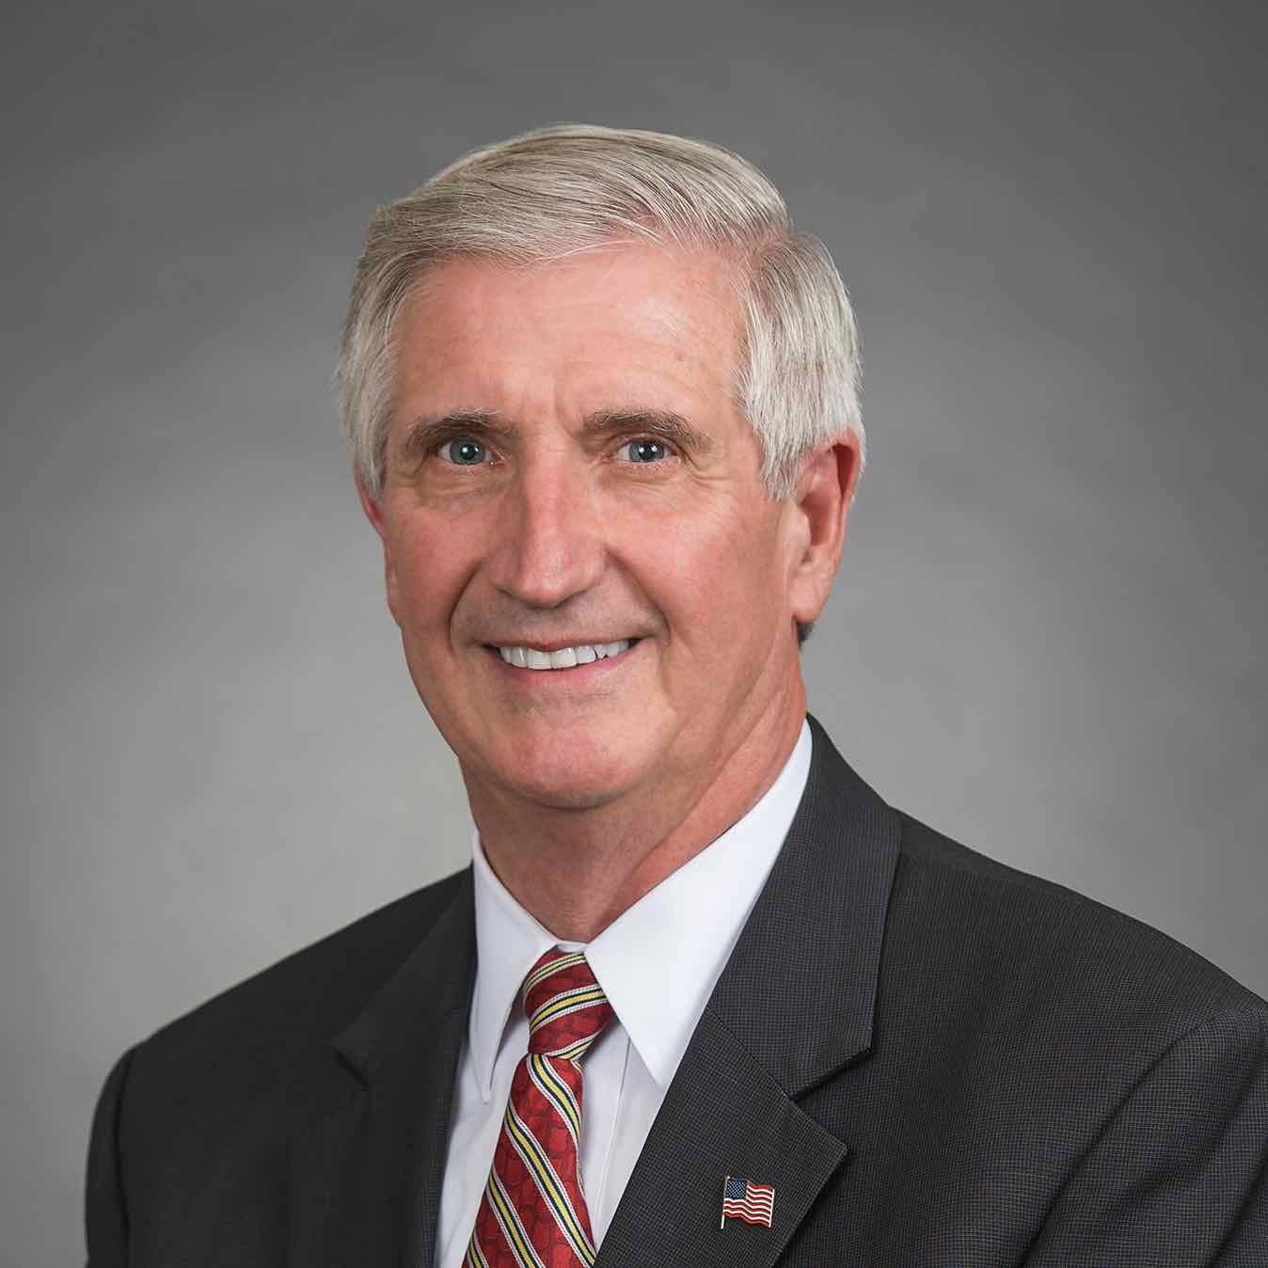

From 1992 until 1993, Mr. Card served as the 11th U.S. Secretary of Transportation under President George H. W. Bush. In August 1992, at the request of President Bush, Secretary Card coordinated the administration’s disaster relief efforts in the wake of Hurricane Andrew. From 1988 to 1992, Mr. Card served in President Bush’s administration as Assistant to the President and Deputy Chief of Staff. He served in President Reagan's administration as Special Assistant to the President for Intergovernmental Affairs and subsequently as Deputy Assistant to the President and Director of Intergovernmental Affairs, where he was liaison to governors, statewide elected officials, state legislators, mayors and other elected officials.

Prior to being named Chief of Staff for the presidential administration of George W. Bush, Mr. Card was General Motors’ Vice President of Government Relations. From 1993 to 1998, Mr. Card was President and Chief Executive Officer of the American Automobile Manufacturers Association (AAMA), the trade association whose members were Chrysler Corporation, Ford Motor Company and General Motors Corporation.

Mr. Card served in the Massachusetts House of Representatives from 1975-1983. In 1982, he was named Legislator of the Year by the National Republican Legislators Association and received the Distinguished Legislator Award from the Massachusetts Municipal Association.

Mr. Card graduated from the University of South Carolina with a Bachelor of Science degree in engineering. He attended the United States Merchant Marine Academy and the John F. Kennedy School of Government at Harvard University and has received numerous honorary degrees and awards. A native of Holbrook, Massachusetts, Andy and his wife, Kathleene, have three children and four grandchildren.

Ari Fleischer, former White House press secretary, was the primary spokesperson for President George W. Bush and delivered the daily White House briefings from 2001 to 2003. He previously served as the spokesperson for the Bush-Cheney presidential campaign. In his almost four years working for President Bush, he served as spokesperson during the historic presidential recount, September 11th, two wars and the anthrax attack. His best-selling book, Taking Heat, details his years in the White House and reached #7 on The New York Times Best Sellers list.
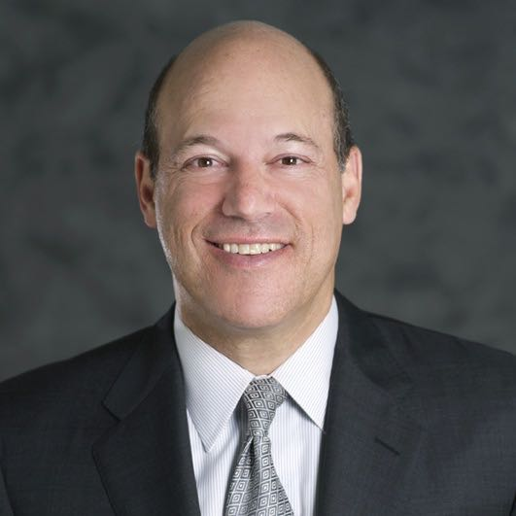

Prior to joining the Bush campaign, Fleischer was the national spokesperson and communications director for Elizabeth Dole's presidential campaign. He has also worked on Capitol Hill as a press secretary to three Congressmen and one U.S. Senator.

Fleischer is a native of Pound Ridge, New York, and a 1982 graduate of Vermont’s Middlebury College. Now president of his own firm, Ari Fleischer Communications Inc., he offers advice to clients in the corporate and sports worlds on how to handle the press. He is also a Fox News contributor.

He resides in Westchester County, New York, with his wife, Becki, and their two children.

Filmmakers

Susan Bellows (Senior Producer of American Experience) is an award-winning producer and writer with more than 20 years of experience producing national programs for public television. Bellows was the producer and director of the Emmy Award-winning JFK, which premiered on American Experience in 2013, and writer, director and producer for The Bombing of Wall Street, which premiered on the series in 2018. Since joining the series in 2003, she has provided editorial support and guidance to its broadcast and new media work. Previously, Bellows served as senior producer for the Peabody and Emmy Award-winning series Africans in America. Her other producing credits include films for The Great Depression, for which she received an Emmy nomination, and America’s War on Poverty, both productions of Blackside, Inc. Bellows also co-produced New Worlds, New Forms for the WNET-produced series Dancing, an eight-hour landmark series on dance forms around the world.


Barak Goodman (Writer; Senior Producer for Ark Media) has become one of the most prolific and respected nonfiction filmmakers in America. A co-founder of Ark Media, his films have been nominated for an Academy Award and won multiple Emmy and Writers Guild Awards, duPont-Columbia and Peabody Awards, the RFK Journalism Prize, and three times been official selections at the Sundance Film Festival. Among his many films for American Experience are Oklahoma City, about the worst domestic terrorist attack in American history and its roots in the rise of the radical right; My Lai, the Emmy and Peabody Award-winning film on America’s worst war crime; Scottsboro, the Academy Award-nominated film on the trial of black teenagers falsely accused of rape in Depression-era Alabama; Clinton, a four-hour biography of the 42nd president; and Woodstock: Three Days that Defined a Generation. Goodman was also the director, writer and producer of the six-hour PBS series Cancer: The Emperor of all Maladies, based on the Pulitzer Prize-winning book by Siddhartha Mukherjee. He wrote and directed Makers, the first complete history of the modern women's movement, and directed six films for the PBS series FRONTLINE, including the Peabody Award-winning Lost Children of Rockdale County and the duPont-Columbia-winning series Failure to Protect. Slay the Dragon, a film about gerrymandering and voter suppression, premiered at the 2019 Tribeca Film Festival.
