American Experience “George W. Bush”
Premieres Monday and Tuesday, May 4-5, 2020

New Documentary Explores His Life and Presidency

BOSTON, MA — American Experience explores the fascinating life and tumultuous presidency of George W. Bush in a new two-part biography of the 43rd U.S. president. The documentary features insights from historians, journalists and members of the president’s inner circle, including chiefs of staff Andy Card and Joshua Bolten, speechwriter David Frum, press secretary Ari Fleischer, senior advisor Karl Rove and others. The latest addition to the American Experience award-winning series of presidential biographies, “George W. Bush” premieres Monday and Tuesday, May 4-5, 2020, 9:00-11:00 p.m. ET on American Experience on PBS, PBS.org and the PBS Video App.
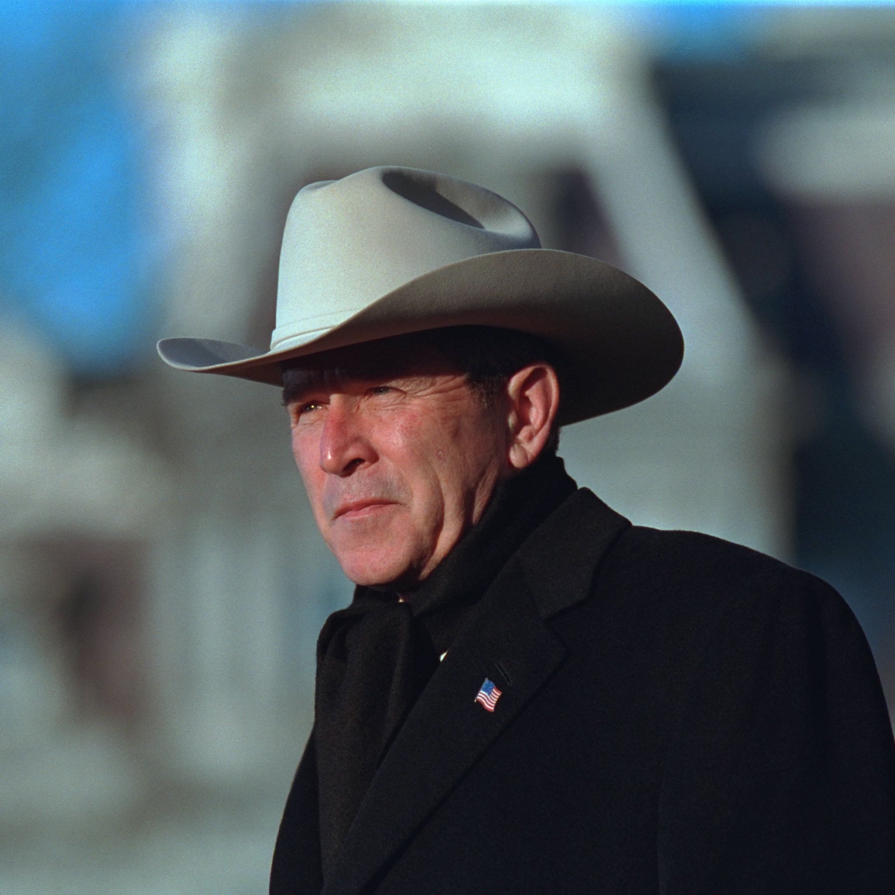
Credit: Courtesy George W. Bush Presidential Library and Museum

Part One chronicles Bush’s unorthodox road to the White House. The once wild son of a political dynasty, few expected Bush to ascend to the presidency. Yet 36 days after the November 2000 election, Bush emerged the victor of the most hotly contested race in the nation’s history. Little in the new president’s past could have prepared him for the events that unfolded on September 11, 2001. Bush’s response to the deadly terrorist attacks would come to define a new era in American foreign policy. Part Two opens with the ensuing war in Iraq and continues through Bush’s second term, as the President confronts the devastating impact of Hurricane Katrina and the most serious financial crisis since the Great Depression.

“George W. Bush took office less than 10 months before 9/11 ushered in a new era of fear, anger and uncertainty, as news of threat levels and anthrax scares became a daily occurrence,” said Susan Bellows, American Experience senior producer. “Twenty years after the dramatic Bush-Gore election of 2000 that introduced the term ‘hanging chad’ to our lexicon, this new film explores the evolution of George W. Bush’s character and how it shaped his presidency.”

“What makes George W. Bush such a fascinating subject is that he was one of the least prepared presidents in our history, yet faced some of the greatest challenges,” said filmmaker Barak Goodman. “Not since Lincoln has such an inexperienced leader been called upon in a moment of genuine existential crisis. How Bush evolved in office under these pressures — at first struggling mightily, but later finding his feet — illuminates not only his character, but the evolving nature of power and the presidency in an increasingly dangerous world.”

“George W. Bush” is written by Barak Goodman and Chris Durrance, and produced by Durrance and Jamila Ephron. The film is senior produced by Barak Goodman and executive produced by Mark Samels and Susan Bellows.

About the Filmmakers

Barak Goodman (Writer; Senior Producer for Ark Media) has become one of the most prolific and respected nonfiction filmmakers in America. A co-founder of Ark Media, his films have been nominated for an Academy Award and won multiple Emmy and Writers Guild Awards, duPont-Columbia and Peabody Awards, the RFK Journalism Prize, and three times been official selections at the Sundance Film Festival. Among his many films for American Experience are Oklahoma City, about the worst domestic terrorist attack in American history and its roots in the rise of the radical right; My Lai, the Emmy and Peabody Award-winning film on America’s worst war crime; Scottsboro, the Academy Award-nominated film on the trial of black teenagers falsely accused of rape in Depression-era Alabama; Clinton, a four-hour biography of the 42nd president; and Woodstock: Three Days that Defined a Generation. Goodman was also the director, writer and producer of the six-hour PBS series Cancer: The Emperor of All Maladies, based on the Pulitzer Prize-winning book by Siddhartha Mukherjee. He wrote and directed Makers, the first complete history of the modern women's movement, and directed six films for the PBS series FRONTLINE, including the Peabody Award-winning Lost Children of Rockdale County and the duPont-Columbia-winning series Failure to Protect. Slay the Dragon, a film about gerrymandering and voter suppression, premiered at the 2019 Tribeca Film Festival.

Mark Samels (Executive Producer) conceives, commissions and oversees all films for the PBS flagship history series American Experience. Samels has overseen more than 130 films, expanding both the breadth of subjects and the filmmaking style embraced by the series, allowing for more contemporary topics and witness-driven storytelling. Beginning his career as an independent documentary filmmaker, he held production executive positions at public television stations in West Virginia and Pennsylvania before joining WGBH. Samels is a founding member of the International Documentary Association and has served as a governor of the Academy of Television Arts & Sciences.
A graduate of the University of Wisconsin, Samels holds honorary Doctor of Humane Letters degrees from Emerson College and Elizabethtown College.

Susan Bellows (Senior Producer, American Experience) is an award-winning producer and writer with more than 20 years of experience producing national programs for public television. Bellows was the producer and director of the Emmy Award-winning JFK, which premiered on American Experience in 2013, and writer, director and producer for The Bombing of Wall Street, which premiered on the series in 2018. Since joining the series in 2003, she has provided editorial support and guidance to its broadcast and new media work. Previously, Bellows served as senior producer for the Peabody and Emmy Award-winning series Africans in America. Her other producing credits include films for The Great Depression, for which she received an Emmy nomination, and America’s War on Poverty, both productions of Blackside, Inc. Bellows also co-produced New Worlds, New Forms for the WNET-produced series Dancing, an eight-hour landmark series on dance forms around the world.

About American Experience
For over 30 years, American Experience has been television’s most-watched history series. Hailed as “peerless” (The Wall Street Journal), “the most consistently enriching program on television” (Chicago Tribune) and “a beacon of intelligence and purpose” (Houston Chronicle), the series brings to life the incredible characters and epic stories that have shaped America’s past and present. American Experience documentaries have been honored with every major broadcast award, including 30 Emmy Awards, four duPont-Columbia Awards and 17 George Foster Peabody Awards; the series received an Academy Award nomination for Best Documentary Feature in 2015 for Last Days in Vietnam. American Experience also creates original digital content that uses new forms of storytelling to connect our collective past with the present. Visit pbs.org/americanexperience and follow us on Facebook, Twitter, Instagram and YouTube to learn more.

Major funding for American Experience provided by Liberty Mutual Insurance, Consumer Cellular and by the Alfred P. Sloan Foundation. Additional funding provided by the Robert David Lion Gardiner Foundation, The Documentary Investment Group, the Corporation for Public Broadcasting and public television viewers. American Experience is produced for PBS by WGBH Boston.

###
CONTACTS:
CaraMar Publicity
Mary Lugo 770-623-8190 lugo@negia.net
Cara White 843-881-1480 cara.white@mac.com
Abbe Harris 908-244-5516 abbe.harris@caramar.net

For further information and photos visit http://www.pbs.org/pressroom

