American Experience Announces Winter-Spring Season
Premiering Tuesday, January 23, 2024, on PBS and
Streaming on PBS.org and the PBS Video App

New Documentaries Explore Untold Stories of 20th Century America

(Boston, MA) — American Experience returns for its 36th season in January 2024 with new documentaries that explore pivotal moments and movements of the 20th century.
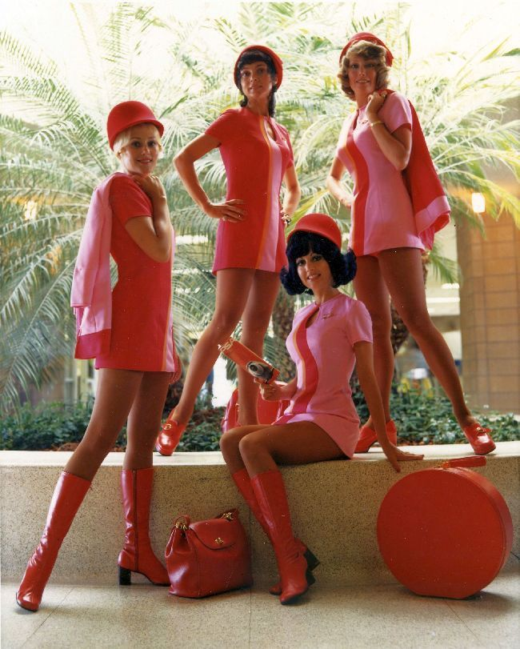
Photo from Fly With Me. Circa 1970. Credit: San Diego Air & Space Museum.

“This season’s documentaries illuminate fascinating — and in some cases forgotten — stories from America’s recent past,” said Cameo George, Executive Producer of American Experience. “They feature witnesses on the frontiers of change, from the pioneering flight attendants at the forefront of the women’s movement in Fly With Me to the last surviving member of LBJ’s Kerner Commission, who saw the Commission’s findings on race in America go unheeded, to the mothers turned citizen activists in Love Canal, New York, whose toxic waste awareness campaign was instrumental in getting residents relocated and holding the government accountable. Nazi Town, USA tells the story of the German American Bund, the virulently anti-Semitic organization that posed a subversive threat to democracy in the late 1930s and early 1940s, and The Life Savers honors the unlikely team that pioneered the Pap Test, saving hundreds of thousands of women from cervical cancer. Each film offers important insights into our shared American experience and issues we still wrestle with today and highlights the ways in which ordinary people can have extraordinary impact on society.”

In addition to its broadcast and streaming premieres, American Experience will continue its series of monthly online events, Past Forward: Conversations with American Experience, in 2024. These events feature discussions with historians, authors and journalists and explore film-inspired themes and issues each month through the lens of the present.

Below is more information on the 2024 Winter-Spring schedule. Fall titles will be announced at a later date.

Nazi Town, USA – Tuesday, January 23, 9 p.m. ET
In February 1939, more than 20,000 Americans filled Madison Square Garden for an event billed as a “Pro-American Rally.” Images of George Washington hung next to swastikas and speakers railed against the “Jewish controlled media” and called for a return to a racially “pure” America. The keynote speaker, Fritz Kuhn, was head of the German American Bund. Nazi Town, USA tells the largely unknown story of this organization that had chapters across the country and represented what experts believe was a “real threat of fascist subversion in the United States.” The Bund held joint rallies with the Ku Klux Klan and ran dozens of summer camps for children centered around Nazi ideology and imagery. Its embrace of “Americanism” raises thorny issues — from questions of free speech to declarations of “America First” — that we continue to wrestle with today. From filmmakers Peter Yost and Edna Alburquerque.

Fly With Me – Tuesday, February 20, 9 p.m. ET
At a time when single women were unable to order a drink or eat alone in a restaurant, forbidden to own a credit card or get a prescription for birth control, becoming a stewardess offered unheard-of opportunity and adventure. Maligned as feminist sellouts, “stewardesses,” as they were called, knew different: they were on the frontlines of a battle to assert gender equality and transform the workplace. Fly With Me is a story about new frontiers for working women and the constraints of traditional notions of femininity. It’s about exploitation and activism and pitched battles within the courtrooms of the United States. Featuring firsthand accounts, personal stories and a rich archive, the film tells a lively, fun and important but neglected history of the women who changed the world while flying it. Directed by Sarah Colt.

The Life Savers (w.t.) – Monday, March 26, 9 p.m. ET
In the 1950’s, survival rates from cancer of any kind were low, and cervical cancer, which was often asymptomatic until it was well advanced, was often a death sentence. From filmmakers Amanda Pollak and Gene Tempest, the dramatic story of the fight against cervical cancer is told through the lives of three fascinating characters: Dr. George Papanicolaou, a Greek immigrant whose single-minded pursuit of the development of a diagnostic test saved hundreds of thousands of women; Hashime Murayama, the Japanese-American illustrator who was interned in a WWII camp, then released to work on the project; and Dr. Helen Dickens, a groundbreaking Black surgeon who overcame deep distrust between the Black community and the medical establishment to save the lives of thousands.

Tragedy At Love Canal (w.t.) – Monday, April 22, 9 p.m. ET
The Love Canal disaster was one of the largest, most notorious, and most impactful public health and environmental crises in American history. Unfolding like a mystery, the film begins in 1977, when residents in a small neighborhood on the east side of Niagara Falls first noticed pungent odors in their homes. Soon, dozens of families began to suffer abnormally high rates of cancer, asthma, kidney disease, miscarriage, birth defects, migraines and more. The battle for justice was led mostly by women, including housewife-turned-activist Lois Gibbs and biologist and cancer researcher Beverly Paigen, whose toxic waste studies were instrumental in getting homeowners resettled even though their work was initially dismissed as “useless housewife data.” This “useless” work of citizen scientists informed the policies of the Federal Superfund program that today oversees the remediation of more than 1300 dangerous hazardous waste sites. Directed by Jamila Ephron.

The Riot Report – Tuesday, May 21, 9 p.m. ET
When Black neighborhoods in scores of American cities erupted in violence during the summer of 1967, President Lyndon Johnson appointed the National Advisory Commission on Civil Disorders –– informally known as the Kerner Commission –– to answer three questions: What happened? Why did it happen? And what could be done to prevent it from happening again? The commission’s final report, issued in March of 1968, would offer a shockingly unvarnished assessment of American race relations –– a verdict so politically explosive that Johnson refused to acknowledge it publicly or even thank the commissioners for their service. Featuring interviews with commission staffers and the last surviving Commission member, Senator Fred Harris, The Riot Report explores a pivotal moment in our nation’s history and the fraught social dynamics that simultaneously spurred the commission’s investigation and doomed its findings to political oblivion. Directed by Michelle Ferrari and written by Ferrari and New Yorker journalist Jelani Cobb.

American Experience films will stream simultaneously with broadcast and are available on all station-branded PBS platforms, including PBS.org and the PBS Video app, available on iOS, Android, Roku, Apple TV, Amazon Fire TV, Android TV, Samsung Smart TV, Chromecast and VIZIO. All titles will also be available with closed captioning in English and Spanish.

About American Experience Executive Producer, Cameo George
Cameo George is an Emmy Award-winning producer, writer and journalist with more than 20 years of experience in documentary, broadcast television and digital content production. George has produced, developed and commissioned innovative programming at CNN, NBC News, ABC News and more. She was the senior producer of CNN’s groundbreaking series Black in America and Latino in America and the executive producer of the eight-hour PBS documentary series 16 for '16: The Contenders, which was also broadcast on the BBC. George joined American Experience from ABC News, where she was Head of Development for Longform projects, responsible for creating a pipeline of docuseries and feature documentary films across Walt Disney Television platforms including ABC News, Hulu, National Geographic and Disney+.

About American Experience
For 35 years, American Experience has been television’s most-watched history series, bringing to life the incredible characters and epic stories that have shaped America’s past and present. American Experience documentaries have been honored with every major broadcast award, including 30 Emmy Awards, five duPont-Columbia Awards and 19 George Foster Peabody Awards. PBS’s signature history series also creates original digital content that innovates new forms of storytelling to connect our collective past with the present. Cameo George is the series executive producer. American Experience is produced for PBS by GBH Boston. Visit pbs.org/americanexperience and follow us on Facebook, Twitter, Instagram and YouTube to learn more.

Major funding for American Experience provided by Liberty Mutual Insurance and by the Alfred P. Sloan Foundation. Additional funding for American Experience provided by the Robert David Lion Gardiner Foundation, The Documentary Investment Group, the Corporation for Public Broadcasting and public television viewers.

All titles distributed internationally by PBS International.

* * *
Press Contacts:
CaraMar Publicity
Mary Lugo 770-851-8190 lugo@negia.net
Cara White 843-881-1480 cara.white@mac.com

For further information and photos visit https://pressroom.pbs.org/programs/american-experience

