American Experience Ruthless: Monopoly’s Secret History
Premieres Monday, February 20, 2023, on PBS and Streaming on PBS.org

The Real Story Behind America’s Most Popular Board Game

(BOSTON, MA) – For generations, Monopoly has been America’s favorite board game, a love letter to unbridled capitalism and — for better or worse — the impulses that make our free-market society tick. But behind the myth of the game’s creation is an untold tale of theft, obsession and corporate double-dealing. Part detective story, part sharp social commentary and part pop-culture celebration, Ruthless: Monopoly’s Secret History presents the fascinating true story behind America’s favorite game. Written and Directed by Stephen Ives and Executive Produced by Cameo George, Ruthless: Monopoly’s Secret History premieres Monday, February 20, 2023, 9:00-10:00 p.m. ET (check local listings) on PBS, PBS.org and the PBS App.
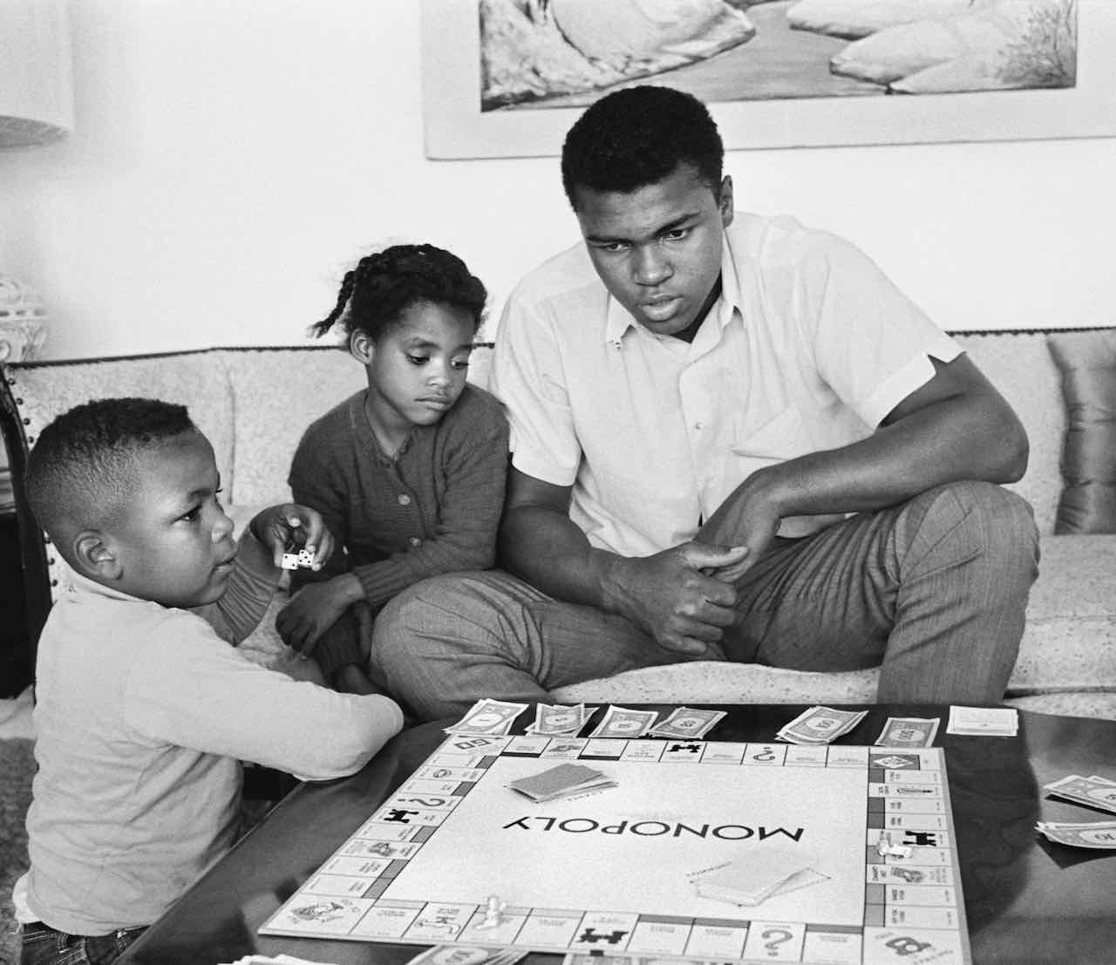
Muhammad Ali and children playing Monopoly at home. Credit: Steve Schapiro/Corbis via Getty Images

Few rituals are as all-American as a game of Monopoly. Its iconic board and game pieces — from the diminutive robber baron Rich Uncle Pennybags to the Get Out of Jail Free card to the tiny thimble and top hat — are instantly recognizable. It is an exhilarating game of no-holds-barred competition and brutal domination of your opponents, a celebration of greed and accumulation of wealth with only one player standing at the end. It may be only a game, but the popularity of Monopoly speaks volumes about who we are and what we value.

Contrary to the folksy legend spread by Parker Brothers, Monopoly’s secret history is a surprising saga that features a radical feminist, a community of Quakers in Atlantic City, America’s greatest game company, and an unemployed Depression-era engineer. According to the official origin story, during the Great Depression, an amateur inventor named Charles Darrow sketched out the now-famous Monopoly board on a piece of oilcloth on his kitchen table. His game became a best-seller, Darrow became a wealthy man, and Parker Brothers was saved from bankruptcy. It was a classic American success story. But it wasn’t true. The real story behind the creation of the game might never have come to light if it weren’t for the determination of an economics professor and impassioned anti-monopolist named Ralph Anspach.

Fed up with the OPEC oil cartels and gas shortages in the 1970s, Anspach created “Anti-Monopoly,” which retained the fun of the original game but made it clear that the monopolists were the bad guys. General Mills, which now owned Parker Brothers, was not amused and sued Anspach, ordering that he cease and desist selling his game. As part of his defense strategy, Ralph sought to prove that the Monopoly trademark was dubious and investigated the game’s early history before it was acquired by Parker Brothers. The ensuing investigation and David vs. Goliath legal battle would consume Ralph’s life for over a decade.

Anspach discovered that the game was invented in 1904 by Lizzie Magie, a feminist, actor, poet, engineer, and follower of the radical economic theories of the influential writer and public speaker Henry George. George believed that a single tax on land would reduce inequality and promote a more just society. Magie hoped to promote George’s ideas through the power of game, and she invented “The Landlord’s Game,” which was designed to illustrate the evils of landlords and monopolistic practices. Magie’s creation spread first on college campuses, with players across the country making their own boards. The game found its way to a community of Quakers in Atlantic City who added local street names — like Oriental Avenue, Marvin Gardens and, of course, Park Place and Boardwalk — to their boards. Decades later, when a Quaker couple invited their friends Charles Darrow and his wife to play the game, the unemployed Darrow saw a way out of his Depression-era woes. He asked his host to make him a replica of the board and type up the rules, then he began producing and marketing it himself. In 1935, Darrow sold his “invention” to the struggling Parker Brothers.

As Monopoly’s popularity exploded, Parker Brothers embarked on a frantic effort to cover up the fact that their best-selling game was, in fact, in the public domain. For some reason, the U.S. Patent Office granted Darrow a patent on his version of the game, even though the Landlord’s Game was clearly its progenitor. Parker Brothers then sought to buy off Lizzie Magie by promising to publish two of her other games. The company then set out to monopolize Monopoly – acquiring and destroying old folk versions of the game. Parker Brothers managed to keep their secret for decades, racking up hundreds of millions of dollars in profits. Ralph Anspach’s lonely crusade would take him to the brink of bankruptcy and all the way to the U.S. Supreme Court, where he would finally be vindicated. The fascinating origin story of America’s favorite game was brought to light. Ruthless: Monopoly’s Secret History celebrates America’s complicated relationship with its favorite board game, and gives credit to Lizzie Magie, one of the most creative and outspoken women of the early twentieth century.

American Experience Ruthless: Monopoly’s Secret History will stream simultaneously with broadcast on all station-branded PBS platforms, including PBS.org and the PBS App, available on iOS, Android, Roku, Apple TV, Amazon Fire TV, Android TV, Samsung Smart TV, Chromecast and VIZIO. All titles will also be available for streaming with closed captioning in English and Spanish.

American Experience Ruthless: Monopoly’s Secret History

Written & Directed by  Produced by  Music by  Edited by | STEPHEN IVES  AMANDA POLLAK and STEPHEN IVES  DeAndre JAMES ALLEN-TOOLE  JOSH MELROD

American Experience is a production of GBH Boston
Executive Producer | CAMEO GEORGE

About the Participants

Tristan Donovan is a British journalist and renowned games expert and the author of It’s All a Game – the History of Board Games from Monopoly to Settlers of Catan.

Christopher England is a historian and lecturer at Stanford University.

Tom Forsyth is a game aficionado and expert on the history of Monopoly.

Lindsay Grace is Knight Chair in Interactive Media and an associate professor at the University of Miami School of Communication.

Patrick Jagoda is a professor at the University of Chicago specializing in media theory, game studies and design, science studies, and 20th and 21st century American literature and culture. He is also the co-founder of the Game Changer Chicago Design Lab Labe and the Transmedia Story Lab.

Philip Orbanes is a game designer, author and founding partner of Winning Moves Games. He served as senior vice president for Parker Brothers and as chief judge at national and world Monopoly tournaments between 1979 and 1992. He has written books about Monopoly, the history of Parker Brothers, the card game Rook, and articles for The Games Journal.

Mary Pilon is a journalist focused primarily on the worlds of sports and business. She is the author of the bestselling book The Monopolists. Her work regularly appears in The New Yorker, Esquire, Bloomberg BusinessWeek, Vice, New York and The New York Times, among others.

Kate Raworth is an English economist and author of Doughnut Economics: Seven Ways to Think Thing Like a 21st Century Economist.

Bryant Simon is a professor of history at Temple University and author of Boardwalk of Dreams: Atlantic City and the Fate of Urban America.

Ashlyn Sparrow is a game designer, Assistant Director of the Weston Game Lab at the University of Chicago and Creative Director at Sunflake Studios.

Eric Zimmerman designs video games, tabletop games and large-scale game installations. He teaches at the NYU Game Center and frequently writes about game design.

About the Filmmakers

Stephen Ives (Writer, Director and Producer) is an Emmy Award-winning writer and director who has established himself as one of the nation’s leading documentary filmmakers. His landmark series The West was one of the most-watched PBS programs of all time. In 1987, Ives began a decade-long collaboration with Ken Burns as a co-producer of a history of the United States Congress and a consulting producer on the groundbreaking series The Civil War and Baseball.

After the premiere of The West, Ives produced a profile of the Cornerstone Theater Company, which aired on HBO in the fall of 1999, and Amato: A Love Affair with Opera, which aired on PBS in 2001 and earned him a nomination from the Directors Guild of America for Outstanding Directorial Achievement. His profile of 1930s thoroughbred Seabiscuit (American Experience, 2003) won multiple Emmy Awards and his PBS series, Reporting America At War, was described by the Los Angeles Times as “television that matters…a visual document of power and clarity.” His other films for American Experience include Lindbergh, Las Vegas, New Orleans, Kit Carson, Roads to Memphis, Panama Canal, Custer’s Last Stand, Grand Coulee Dam, 1964, Sealab, The Big Burn, The Great War, for which he received a Writers Guild Award, and Citizen Hearst. Most recently he served as a director, with Leah Williams, and writer, with Gene Tempest, of the multipart PBS series American Veteran.

Amanda Pollak (Producer) has been directing and producing highly acclaimed documentaries for over two decades, including over a dozen films for American Experience. She produced and co-directed The Great War, an epic six-hour series on America’s role in World War 1, which was seen by more than 10 million people nationwide. She produced Into the Grand Canyon, an environmental adventure story that premiered on National Geographic and is now streaming worldwide on Disney+, and executive produced Ailey, an immersive portrait of the renowned choreographer, which premiered at Sundance, was released theatrically by NEON, and broadcast on PBS’s American Masters. Pollak was part of the founding team for Retro Report, an online series of investigative pieces featured on the front page of The New York Times digital edition. Her work has been recognized with three Emmy Awards, a Cine Golden Eagle Award, and the George Foster Peabody Award.

Cameo George (Executive Producer, American Experience) is an Emmy Award-winning producer, writer and journalist with more than 20 years of experience in documentary, broadcast television and digital content production. George has produced, developed and commissioned innovative programming at CNN, NBC News and ABC News. She was the senior producer of CNN’s groundbreaking series Black in America and Latino in America and executive producer of the eight-hour PBS documentary series 16 FOR '16: THE CONTENDERS, which was also broadcast on the BBC. George joined American Experience from ABC News, where she was head of development for long-form projects, responsible for creating a pipeline of docuseries and feature documentary films across Walt Disney Television platforms, including ABC News, Hulu, National Geographic and Disney+.

About American Experience

For 35 years, American Experience has been television’s most-watched history series, bringing to life the incredible characters and epic stories that have shaped America’s past and present. American Experience documentaries have been honored with every major broadcast award, including 30 Emmy Awards, five duPont-Columbia Awards and 19 George Foster Peabody Awards. PBS’s signature history series also creates original digital content that innovates new forms of storytelling to connect our collective past with the present. Cameo George is the series executive producer. American Experience is produced for PBS by GBH Boston. Visit pbs.org/americanexperience and follow us on Facebook, Twitter, Instagram and YouTube to learn more.

Major funding for American Experience provided by Liberty Mutual Insurance and by the Alfred P. Sloan Foundation. Funding for Ruthless: Monopoly’s Secret History provided by members of The Better Angels Society including Philip I. Kent through the Philip I. Kent Charitable Fund. Additional funding for American Experience provided by the Robert David Lion Gardiner Foundation, The Documentary Investment Group, the Corporation for Public Broadcasting and public television viewers. American Experience is produced for PBS by GBH Boston.

Ruthless: Monopoly’s Secret History distributed internationally by PBS International.

* * *
Contacts:
CaraMar Publicity
Mary Lugo 770-851-8190 lugo@negia.net
Cara White 843-881-1480 cara.white@mac.com
Abbe Harris 908-244-5516 abbe.harris@caramar.net

For further information and photos visit http://www.pbs.org/pressroom

