American Experience The Lie Detector
Premieres Tuesday, January 3, 2023, on PBS and Streaming on PBS.org

The Story of the Polygraph, the Uniquely American Device Whose Bright Promise Proved Tragically Prone to Abuse

(BOSTON, MA) – In the first decades of the 20th century, when life was being transformed by scientific innovations, researchers made a thrilling new claim: they could tell whether someone was lying by using a machine. Popularly known as the “lie detector,” the device transformed police work, seized headlines and was extolled in movies, TV and comics as an infallible crime-fighting tool. Husbands and wives tested each other’s fidelity. Corporations routinely tested employees’ honesty and government workers were tested for loyalty and “morals.” But the promise of the polygraph turned dark, and the lie detector too often became an apparatus of fear and intimidation. Written and directed by Rob Rapley and executive produced by Cameo George, The Lie Detector is a tale of good intentions, twisted morals and unintended consequences. The film premieres on American Experience on Tuesday, January 3, 9:00-10:00 p.m. ET (check local listings) on PBS, PBS.org and the PBS Video app.
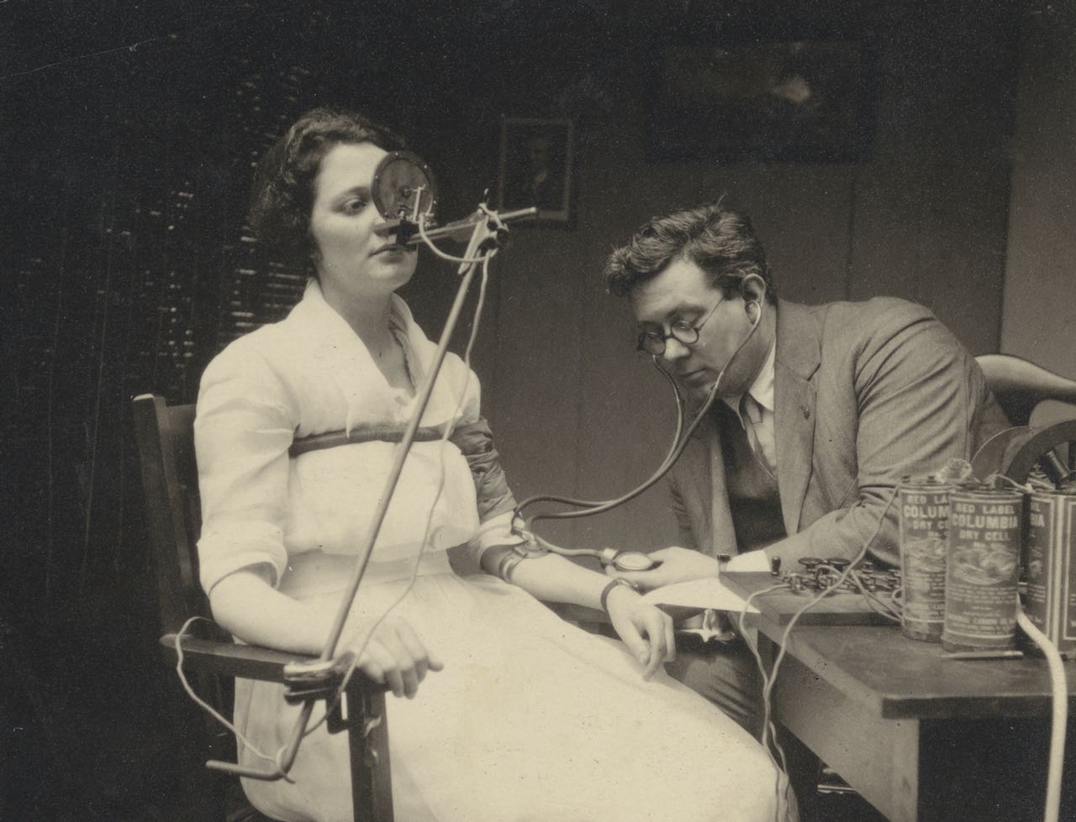
William Marston administers a lie detector test to the secretary of his law firm.
Credit: Schlesinger Library

Today, the lie detector is little more than a curiosity to the general public. But for decades, the device was an inescapable feature of American life, used by police, the government, the CIA and the FBI, and more than half the retail businesses in the country. Designed to ferret out Communists, cheats, criminals and homosexuals, it was used on millions of ordinary people, changing tens of thousands of lives forever. Yet in most of these circumstances, the results were little better than guesswork. Never fully accepted in any other country, the lie detector remains a uniquely American phenomenon.

In the first decades of the 20th century, three men — police officer John Larson, psychologist William Marston and Larson’s assistant Leonarde Keeler — claimed the polygraph could detect a lie by monitoring the physiological responses of their subjects.

In 1921, Larson — a rookie cop in Berkeley, California, and the only police officer in the country with a PhD — pursued a vision of scientific, clean policing. Determined to find a more humane alternative to the “third degree,” Larson created a device that took continuous blood pressure and respiration readings. When he solved a series of thefts with the device, reporters celebrated his machine as the way of the future. But Larson later realized his suspect had only confessed to the crime to avoid having her deepest secret — a history of sexual abuse — revealed. Disillusioned, Larson left Berkeley and quit the police.

The lie detector had other champions, including William Marston, inventor of the “Marston Deception Test.” Although this was simply a blood pressure cuff and useless as a lie detector, Marston promoted it as almost infallible. But in a sensational murder case in 1923, an appeals court declared the lie detector inadmissible. With few exceptions, that has been the case ever since.

Marston persevered and within a few years was using his lie detector to compare the emotional responses of blondes vs. brunettes and redheads. Marston’s hair color tests were a joke in the scientific community, but they caught the eye of Carl Laemmle, head of Universal Studios. By 1929, Marston was in Hollywood, tracking the emotional response of test audiences to upcoming releases. Over the years, Marston would use his lie detector for everything from advertising to marriage therapy — always one step ahead of his creditors, and sometimes the law. He finally hit it big when he created Wonder Woman, who fought evil with what became known as “The Lasso of Truth.” He died in 1946 a rich and famous man widely hailed as the inventor of the lie detector.

But it was Leonarde Keeler, an assistant to John Larson, who made the device a common feature of American life. While Larson envisioned the lie detector as a humane interrogation technique, in Keeler’s hands it became a psychological extension of the brutal third degree and the polygraph spread to police departments across the country.

During the Cold War, Keeler was summoned to the government’s vast A-bomb plant in Oak Ridge, Tennessee, where he was charged with ferreting out leaks and spies. Soon the national security sector, the military and businesses were using the device to screen out perceived threats. The intimidation factor of the machine was, and remains, a key to the lie detector’s power. Richard Nixon later summed up its usefulness: “I don’t know anything about polygraphs, but I know they’ll scare the hell out of people.”

The lie detector’s spread went unchecked until 1988. When President Reagan ordered a dramatic expansion of government testing. Congress responded with the Polygraph Protection Act, which effectively banned the lie detector from the business world. Overnight, use plummeted by 90 percent. Still used today in police investigations, plea bargaining and throughout the national security sector, the lie detector remains as controversial as ever.

American Experience The Lie Detector will stream simultaneously with broadcast on all station-branded PBS platforms, including PBS.org and the PBS Video app, available on iOS, Android, Roku, Apple TV, Amazon Fire TV, Android TV, Samsung Smart TV, Chromecast and VIZIO. The Lie Detector will also be available for streaming with closed captioning in English and Spanish.

American Experience The Lie Detector

Written and Directed by  Produced by  Narrated by  Edited by | ROB RAPLEY  EMILY HARROLD  ANDRE BRAUGHER  OMRY MAOZ
American Experience is a production of GBH Boston
Executive Producer | CAMEO GEORGE

About the Participants

Ken Alder is a professor of history and the Milton H. Wilson Professor in the Humanities at Northwestern University. He is the author of The Lie Detectors: The History of an American Obsession.

Frankie Bailey is a professor in the School of Criminal Justice, University at Albany (SUNY). She is the author of five mysteries featuring amateur sleuth Lizzie Stuart and two police procedural novels featuring Albany police detective Hannah McCabe.

Geoffrey C. Bunn is a senior lecturer in psychology at Manchester Metropolitan University and author of The Truth Machine: A Social History of the Lie Detector.

Douglas Flowe is an associate professor of history at Washington University in St. Louis. He is the author of Uncontrollable Blackness: African American Men and Criminality in Jim Crow New York, winner of the 2021 Littleton-Griswold Book Prize.

Matthew Barry Johnson is associate professor at John Jay College of Criminal Justice. His scholarship and research have focused on interrogation and confession and wrongful conviction, including a 2009 paper on two recent false confessions obtained with a polygraph.

Lisa A. Kort-Butler is a professor of sociology at the University of Nebraska-Lincoln. Her focus is on the role of the media in shaping public opinion and attitudes, crime, justice and related issues.

J. Patrick O’Burke is the school co-director and primary instructor at the Polygraph Institute in San Antonio, Texas. He has taught polygraph examiner courses in Iraq for the Department of Defense and instructed at the Texas Department of Public Safety Polygraph School and the Sturm School of Polygraph. He is a past president of the Board for the American Polygraph Association.

Ken Quattro is a comic historian and author of Invisible Men: The Trailblazing Black Artists of Comic Books. He has studied William Marston and served as historical consultant on the 2017 film Professor Marston and the Wonder Women.

About the Filmmakers

Rob Rapley (Writer, Director) has written, produced and directed a number of films for American Experience, including, most recently, Flood in the Desert (2022), Voice of Freedom (2021), and The Man Who Tried to Feed the World (2020). Other films for the series include The Secret of Tuxedo Park, episode three of The Great War and Murder of a President. Three previous films for the series — The Poisoner’s Handbook, The Abolitionists and Wyatt Earp — received two Emmy nominations, a Writers Guild Award, a Writers Guild Award nomination, a Western Heritage Award and a Western Writers of America Award. Rapley also produced the first episode of Henry Louis Gates’ Reconstruction, The Greely Expedition, Buffalo Bill, Trail of Tears and two episodes of the acclaimed PBS series on the Supreme Court. He was previously nominated for Emmy Awards for his work on Bill Moyers’ Becoming American: The Chinese Experience and Loosely Mozart: The New Innovators of Classical Music.

Cameo George (Executive Producer, American Experience) is an Emmy Award-winning producer, writer and journalist with more than 20 years of experience in documentary, broadcast television and digital content production. George has produced, developed and commissioned innovative programming at CNN, NBC News and ABC News. She was the senior producer of CNN’s groundbreaking series Black in America and Latino in America and executive producer of the eight-hour PBS documentary series 16 FOR '16: THE CONTENDERS, which was also broadcast on the BBC. George joined American Experience from ABC News, where she was head of development for long-form projects, responsible for creating a pipeline of docuseries and feature documentary films across Walt Disney Television platforms, including ABC News, Hulu, National Geographic and Disney+.

About American Experience

For 35 years, American Experience has been television’s most-watched history series, bringing to life the incredible characters and epic stories that have shaped America’s past and present. American Experience documentaries have been honored with every major broadcast award, including 30 Emmy Awards, five duPont-Columbia Awards and 19 George Foster Peabody Awards. PBS’s signature history series also creates original digital content that innovates new forms of storytelling to connect our collective past with the present. Cameo George is the series executive producer. American Experience is produced for PBS by GBH Boston. Visit pbs.org/americanexperience and follow us on Facebook, Twitter, Instagram and YouTube to learn more.
Major funding for American Experience provided by Liberty Mutual Insurance and by the Alfred P. Sloan Foundation. Funding for The Lie Detector provided by members of The Better Angels Society. Additional funding for American Experience provided by the Robert David Lion Gardiner Foundation, The Documentary Investment Group, the Corporation for Public Broadcasting and public television viewers.

The Lie Detector is distributed internationally by PBS International.

* * *
Contacts:
CaraMar Publicity
Mary Lugo 770-851-8190 lugo@negia.net
Cara White 843-881-1480 cara.white@mac.com

For further information and photos visit https://pressroom.pbs.org/pressroom

