**American Experience *Reagan***

**To Have Encore Broadcast**

**Tuesdays, August 4 and 11, 2020**

**The Life of the President Told By Those Who Knew Him Best, Including Nancy Reagan and Three of His Children**

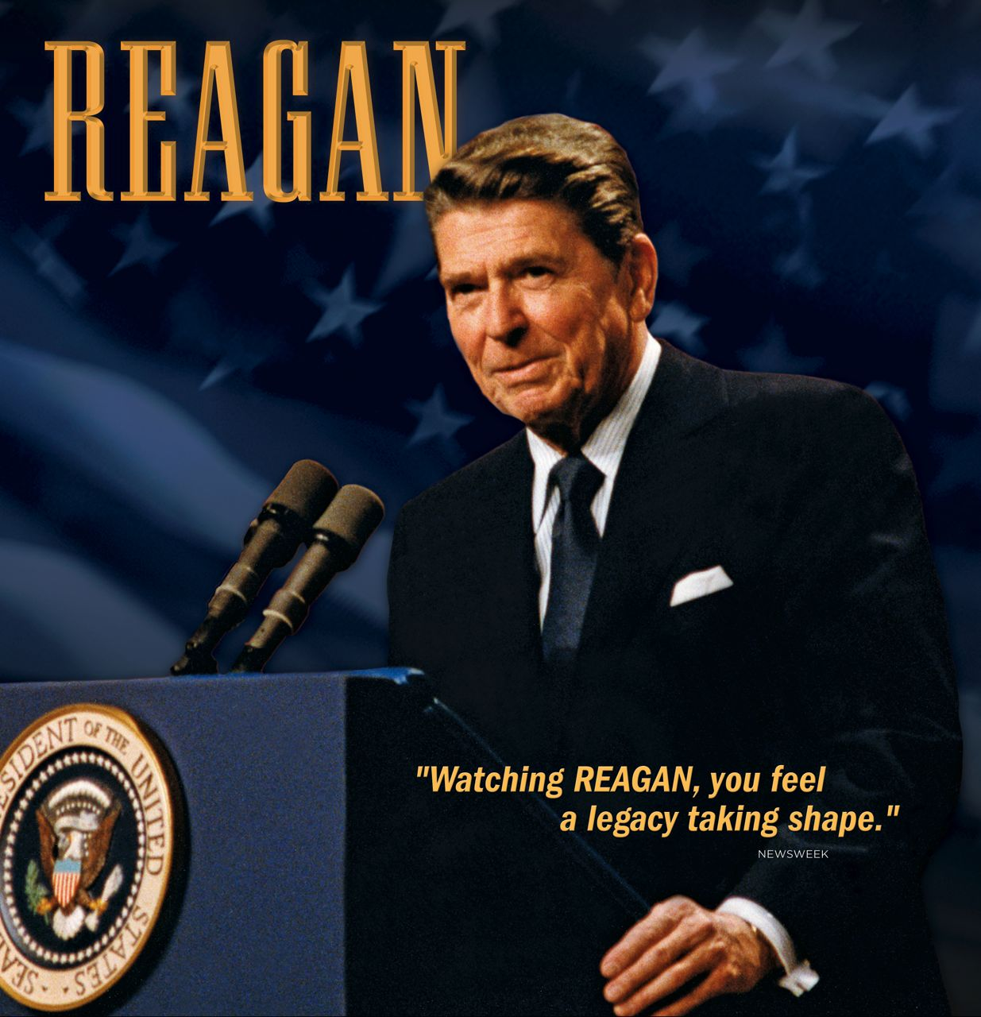(BOSTON, MA) — ***Reagan***, a four-hour, two-part biography of the president who saw America as “a shining city on a hill” will have an encore broadcast Tuesdays, August 4 and 11, 2020, 8:00-10:00 p.m. ET ([check local listings](http://www.pbs.org/tv_schedules/)) on PBS, PBS.org and the PBS Video App. Part of the Peabody Award-winning American Experience collection *The Presidents,* the documentary examines Reagan’s life through the testimony of family — including Nancy Reagan and three of his children — along with friends, historians, biographers and other witnesses to Reagan’s private life and public career.

Ronald Reagan was America’s most ideological president in his rhetoric, yet pragmatic in his actions. He believed in balanced budgets, but never submitted one; hated nuclear weapons, but built them by the thousands; preached family values, but presided over a dysfunctional family. His vision of America divided the nation, yet no matter what people thought of him politically, Reagan always won them over personally. “People don’t reckon with the power of charm,” says son Ron Reagan. “When my father turns the high beams on, even somebody like Gorbachev tends to melt.” A seemingly simple man, Ronald Reagan was consistently underestimated by his opponents; one by one, he overcame them all.

***Reagan*** was produced with unprecedented access to the Reagan family. Nancy Reagan agreed to be interviewed on camera for the first time since leaving the White House, as did three of Reagan’s four children, and the family also provided home movies. Also for the first time, Edmund Morris reveals insights gleaned from his 12 years spent working on Reagan’s official biography. Among the 42 people interviewed are members of Reagan’s inner political circle: his “California Cabinet” and his counterparts on the world stage, including former British Prime Minister Margaret Thatcher and Soviet leader Mikhail Gorbachev, who negotiated historic arms agreements with Reagan.

**Part One** follows Reagan from his youth in the American heartland to the triumph of his “revolution” in 1981. The program traces the origins of Reagan’s difficulty forming attachments due to his itinerant childhood and a painful episode with his drunken father, which led the young boy to turn to his mother and the teachings of her fundamentalist church, The Disciples of Christ, which gave him a belief in predestination and a strong sense of good and evil. After the family settled in Dixon, Illinois, Reagan spent his summers working as a lifeguard on the Rock River and was credited with saving 77 people from drowning.

Reagan’s anti-communism began in Hollywood where he faced down “communist agitators” in the Screen Actors Guild. After his movie career dried up in the 1950s, he became a corporate spokesman for General Electric and began speaking out against high taxes and big government. His political philosophy set, Ronald Reagan burst on the national scene in 1964 as a spokesman for conservative politics.

His marriage to actress Jane Wyman ended in divorce, but Reagan found the perfect companion in his second wife, actress Nancy Davis, “the other half of the circle,” says daughter Patti Davis. According to political adviser Stuart Spencer, Nancy would serve as Reagan’s “personnel director” during his political career.

After barely losing the 1976 Republican primary, Reagan triumphed over Jimmy Carter in 1980. He projected optimism and confidence, believing his mission was to restore America’s trust in itself. An assassination attempt only 70 days into his presidency elevated him to near-mythic status, but in 1983, near the end of his first term, Reagan’s conservative revolution was threatened by economic recession and a popular revolt against his defense buildup.

**Part Two** focuses on Reagan’s battle with the Soviet Union and his resolve to end the Cold War, which the program sees as his principal legacy. Morris calls Reagan’s hatred of Soviet communism “the only negative emotion he had in his life,” and says Reagan believed that, with the pressure of a defense buildup, he could “bring this hostile totalitarian system to its knees.” The program identifies two turning points in the Cold War: Reagan’s bold deployment of intermediate-range missiles in Europe, and a hastily called summit with rival Mikhail Gorbachev in Reykjavik, Iceland, in 1986, considered a failure at the time.

If the superpower summitry of his second term was the high point in Reagan’s presidency, the Iran-Contra affair was its lowest moment. The public perception that Reagan had traded arms for hostages with terrorists in Iran caused his credibility to plummet. “I went to the White House to buck him up,” recalls Ron Reagan. “It was the first time I ever saw him with the wind completely out of his sails.”

Five years after leaving the White House, when Reagan celebrated his 83rd birthday at a gala in Washington, many people noticed what close family and friends had been seeing more and more: Reagan was faltering. “We met beforehand to do all the photographs, and he was very quiet and not very communicative at all,” recalls Margaret Thatcher. “Nancy had to lead him to the platform holding him by the hand. And when she put up her hand to wave, immediately she said to Ron, ‘Wave.’”

Tests soon confirmed what many had suspected: Reagan had Alzheimer’s disease. On November 5, 1994, Ronald Reagan bid a public farewell to the American people in a poignant letter: “I now begin the journey that will lead me into the sunset of my life.

I know that for America there will always be a bright dawn ahead.”

***Reagan*** is executive produced by Austin Hoyt. The series editor is Adriana Bosch. Writers and producers: Adriana Bosch, Austin Hoyt. Editors: Betty Ciccarelli, Bill Lattanzi. Associate Producer: John Clark. Camera: Terry Hopkins. Music: Michael Bacon. Narrator: David Ogden Stiers. American Experience is a production of WGBH Boston. Susan Bellows and Mark Samels are executive producers.

American Experience [*The Presidents*](http://www.pbs.org/wgbh/americanexperience/presidents/) website showcases assets from the Peabody Award-winning collection of films about our nation’s most important leaders. The portal allows viewers to screen video clips, delve deeper with experts and living witnesses, and examine primary source documents. Video galleries on *The Presidents* site explore how different presidents faced issues including the economy, war, dealing with a crisis, and abuses of power.

**About American Experience**

For over 30 years, American Experience has been television’s most-watched history series. Hailed as “peerless” (*The Wall Street Journal*), “the most consistently enriching program on television” (*Chicago Tribune*) and “a beacon of intelligence and purpose” (*Houston Chronicle*), the series brings to life the incredible characters and epic stories that have shaped America’s past and present. American Experience documentaries have been honored with every major broadcast award, including 30 Emmy Awards, four duPont-Columbia Awards and 17 George Foster Peabody Awards; the series received an Academy Award® nomination for Best Documentary Feature in 2015 for *Last Days in Vietnam*. American Experience also creates original digital content that uses new forms of storytelling to connect our collective past with the present. Visit [pbs.org/americanexperience](http://pbs.org/americanexperience) and follow us on [Facebook](https://www.facebook.com/AmericanExperiencePBS/) [Twitter](http://twitter.com/amexperiencepbs), [Instagram](http://instagram.com/americanexperiencepbs) and [YouTube](http://youtube.com/americanexperience) to learn more.

Major funding for American Experience provided by Liberty Mutual Insurance, Consumer Cellular and by the Alfred P. Sloan Foundation. Additional funding provided by the Robert David Lion Gardiner Foundation, The Documentary Investment Group, the Corporation for Public Broadcasting and public television viewers. American Experience is produced for PBS by WGBH Boston.

**Press Contacts:**

CaraMar, Inc.

Mary Lugo 770-623-8190 lugo@negia.net

Cara White 843-881-1480 cara.white@mac.com

Abbe Harris 908-244-5516 abbe.harris@caramar.net

For further information and photos visit <http://www.pbs.org/pressroom>

Signature Image Credit: © WGBH Educational Foundation. Image of Ronald Reagan courtesy of the Ronald Reagan Presidential Library.