VOCES “American Historia: The Untold History of Latinos”
Session Bios

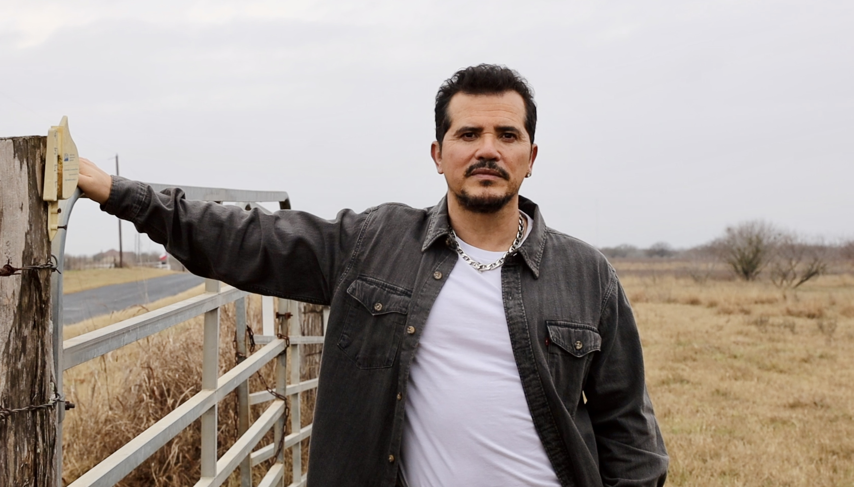
John Leguizamo
Co-creator, host, and executive producer
X: @JohnLeguizamo
Emmy Award winner John Leguizamo has appeared in over 100 films and countless television shows while establishing a career that defies categorization. With boundless and visceral creativity, his work in film, theatre, television, and literature covers a variety of genres, continually threatening to create a few of his own.
Leguizamo is the host and executive producer of MSNBC’s hit travel show, Leguizamo Does America. The series brings viewers inside America’s thriving Latino communities across the country, celebrating the history, culture, food and other contributions of Latinx people shaping America. The show was Peacock’s most-viewed MSNBC original in over two years and is currently in production for the second season, shooting in Philadelphia, Raleigh, New Orleans, San Antonio, Phoenix and Denver.

Leguizamo will star in Apple Studio’s upcoming drama series, Firebug, alongside Taron Egerton and Jurnee Smollett. Inspired by actual events, the series follows a troubled detective and an enigmatic arson investigator as they pursue the trails of two serial arsonists. Leguizamo will play ‘Esposito,’ a former policeman with bad habits and good instincts. Dennis Lehane created the series, which will begin shooting this summer.

Leguizamo stars as federal agent Gordon Rogers in the sci-fi-political mini-series The Green Veil which he produced alongside director Aram Rappaport. Highlighting oppression in 1950’s America, the eight-part series follows Gordon Rogers, a federal agent who must complete a top-secret mission while navigating the struggles of his picture-perfect family. The series first premiered at the 2022 Tribeca Film Festival and will be available on Rappaport’s new streaming platform, The Network, starting April 30, 2024.

Leguizamo stars in the upcoming independent film Bob Trevino Likes It opposite Barbie Ferreira. Written and directed by Tracie Laymon, the film is about a people-pleasing young woman searching for her estranged father online when she unexpectedly forms a close bond with a grieving, childless man with the same name as her father on Facebook. Inspired by a true story, the comedic drama recently premiered at SXSW, winning the SXSW Grand Jury Award and the Audience Award in the Narrative Feature category.

Leguizamo hosts the upcoming PBS documentary series American Historia: The Untold History of Latinos, a project he co-created with director Ben DeJesus. Produced by his Latino-focused NGL Collective, the three-part series follows Leguizamo as he travels throughout Mexico and The United States to shed light on both the known and lesser-known stories of Latino history. Inspired by Leguizamo’s multi-faceted style, each episode combines cultural travel segments and entertaining interstitials, unveiling passionate revelations about his favorite Latino figures.

Leguizamo will be seen in the upcoming thriller film Tin Soldier opposite Robert Di Niro, Jamie Foxx, and Rita Ora. Directed by Brad Furman, the film follows ‘The Bokushi,’ a leader who offers a program for US combat veterans seeking protection, purpose and a path forward. The government is concerned with the rapid rise of well-armed, highly trained, and devoted followers in the cult-like program.

He recently starred in the Amazon series The Power, based on the New York Times best-seller, alongside Toni Collette. He also starred in Showtime’s five-part drama series Waco: The Aftermath, and in Mark Mylod’s horror comedy The Menu, opposite Anya Taylor-Joy, Ralph Fiennes, and Nicholas Hoult.

Leguizamo garnered a Golden Globe nomination for Best Supporting Actor for his performance as a sensitive drag queen in To Wong Foo Thanks for Everything, Julie Newmar, was the recipient of the 2002 ALMA Special Achievement Award for Entertainer of the Year, and picked up ALMA Award nominations for his roles in Moulin Rouge (Best Supporting Actor) and King of the Jungle (Best Lead Actor).

Other film credits for him include The Crash; 11:55; Porzingod; Stealing Cars; Sisters; Meadowland; Experimenter; American Ultra; Cymbeline; Fugly; John Wick; Chef; the Ice Age franchise; Ride Along; Underdogs; Walking with Dinosaurs 3D; The Counsellor; Kick-Ass-2; Fish N Chips: The Movie; Inocente; The Trip 2; The Hollow Point; The Infiltrator; One for the Money; The Lincoln Lawyer; Vanishing on 7th Street; Big Balls; Repo Men; The Ministers; Rage; Gamer; Nothing Like the Holidays; Miracle at St. Anna; Righteous Kill; The Happening; The Babysitters; The Take; Ice Age: The Meltdown; Land of the Dead; The Honeymooners; Zig Zag; Doctor Dolittle; Romeo + Juliet; The Fan; A Pyromaniac’s Love Story; Super Mario Bros.; Night Owl; Poison; Die Hard 2; and Casualties of War.

Leguizamo’s TV work also includes Bloodline; The Kill Point; ER; My Name is Ear; The Brothers Garcia; House of Buggin’; and Miami Vice.

Leguizamo garnered a Tony Award for his 2022 performance in Latin History for Morons, his one-man show where he delivers his take on 500 years of Latin History spanning the Aztec and Incan Empires, to World War II. Latin History for Morons was co-produced by Berkeley Rep and New York’s Public Theatre.

In 1991, Leguizamo created his first off-Broadway sensation as the writer and performer of his one-man show Mambo Mouth, in which he portrayed seven different characters. He received Obie, Outer Critics Circle and Vanguardia awards for this specific performance. Leguizamo went on to create his second off-Broadway one-man show Spic-O-Rama, which garnered a Dramatists’ Guild Hull-Warriner Award for Best American Play, the Lucille Lortel Outstanding Achievement Award for Best Broadway Performance, the Theatre World Award for Outstanding New Talent, and the Drama Desk Award for Best Solo Performance.

Leguizamo’s debut to Broadway was his one-man show, Freak, for which he received a Tony Award nomination for Best Play and Best Performance by a Leading Actor in a Play. Additional theater credits include, Sexaholix… A Love Story, which received a Tony nomination for Best Special Theatrical Performance; A Midsummer Night’s Dream, La Puta Vida Trilogy; and American Buffalo. Leguizamo went on to film special presentations for HBO for his one-man shows including Mambo Mouth; Spic-O-Rama; Freak, for which he won a Emmy Award for Outstanding Performance in a Variety or Music Program; Sexaholix… A Love Story; and Ghetto Klown.

Leguizamo lengthened his lists of credits with his first literary project in 2006 with his memoir, Pimps, Hos, Playa Hatas and All the Rest of My Hollywood Friends: My Life. He also released Ghetto Klown, the graphic novel adaptation of his 2011 Drama Desk award winning one-man Broadway show in 2015.

Leguizamo currently resides in New York City with his wife and two children.

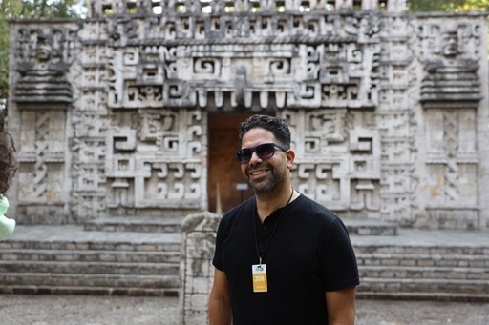
Ben DeJesus
Co-creator, director, and executive producer
IG: Ben DeJesus is an Emmy® and Tony®-nominated director, producer, writer and co-founder of NGL Studios with his partner, award winning actor and social activist John Leguizamo. With over a decade of experience in the U.S. multicultural, Latinx and youth markets, DeJesus has created over 200 hours of award-winning content including non-fiction, episodic, music videos and branded content.
Ben DeJesus is an Emmy® and Tony®-nominated director, producer, writer and co-founder of NGL Studios with his partner, award winning actor and social activist John Leguizamo. With over a decade of experience in the U.S. multicultural, Latinx and youth markets, DeJesus has created over 200 hours of award-winning content including non-fiction, episodic, music videos and branded content.

Ben got his start as stage actor before landing at MTV, where he became one of the original writer/producers for several seasons of MTV CRIBS. He then went on to produce and write for MTV News, VH1, mun2, Nick @ Nite, and many of the on-air VJ’s.

Television credits include (PBS) American Masters’ Lights, Camera, Acción; (CBS) Essential Heroes: Momento Latino, exec-produced and hosted by Eva Longoria; (Peacock) The Latino Presidential Inauguration Special and multiple episodes of (Disney) BUNK’D, the hit multi-cam sitcom. Currently, Ben is directing and exec-producing Leguizamo Does America a 12-episode series for MSNBC hosted by John Leguizamo.

Film credits include Raul Julia: The World’s a Stage which received an Emmy® nomination in the Non-Fiction Series category in 2020, along with his second Imagen Award and Best Latinx Film Award by the National Association of Independent Latino Producers (NALIP). Ben also directed Great Performances: John Leguizamo’s Road to Broadway where he won his first Imagen Award for Best Documentary. His previous feature doc (PBS) Tales from a Ghetto Klown was also produced by DeJesus and Academy Award- Winner® Fisher Stevens (The Cove) and premiered nationwide.

Theater credits include John Leguizamo’s Latin History for Morons, the hit Broadway show where he received a Tony nomination. This was followed by a national tour that broke attendance records at the Ahmanson Theatre in Los Angeles.

At NGL/mitu Studios, Ben directs and produces a growing slate of original television, documentary, non-fiction and digital projects. His passion for pop culture, music and theater continues to fuel his work.

DeJesus is represented by 3 Arts Entertainment, Kaplan-Stahler Agency and by Espada PR & Entertainment.

Stephen Segaller
Vice President of Programming, The WNET Group
Stephen Segaller oversees all national programming from The WNET Group’s producing subsidiaries – THIRTEEN, WLIW21 and Creative News Group. Among these ongoing productions are: Nature, Great Performances, American Masters, Secrets of the Dead, Amanpour and Company, Firing Line with Margaret Hoover, GZERO World with Ian Bremmer, Cyberchase, Camp TV, and Let’s Learn.
His output has won multiple industry awards, including Emmys and Peabodys for many of these series, and for single documentaries such as Srebrenica – A Cry From The Grave by Leslie Woodhead; Walter Cronkite’s last two documentary films City At War: London Calling and Legacy of War; films by Roger Weisberg including the Academy Award-nominated Sound and Fury; the Jazz Ambassadors by Hugo Berkeley – and dozens more.

