

**THIS OLD HOUSE® ANNOUNCES PARTNERSHIP & COLLABORATION WITH YOUTHBUILD USA**

**Two Apprentices Participate in Season 42 Projects in the Greater Boston Area for the Emmy® Award-Winning PBS Series *This Old House***

**CONCORD, MA., April 6, 2021 –** As part of its Generation Next program to encourage and empower young people to join the skilled trades, **This Old House is pleased to announce a partnership and collaboration with YouthBuild USA,** a nonprofit organization that champions opportunity youth who aspire to improve their lives and communities but lack the knowledge, skills, and resources to reach their full potential. Through hundreds of YouthBuild programs in the United States and around the globe, these young adults between the ages of 16 and 24 who are neither in school nor employed pursue their education, prepare for future careers, and grow into community leaders – building brighter futures for themselves, and their neighborhoods.

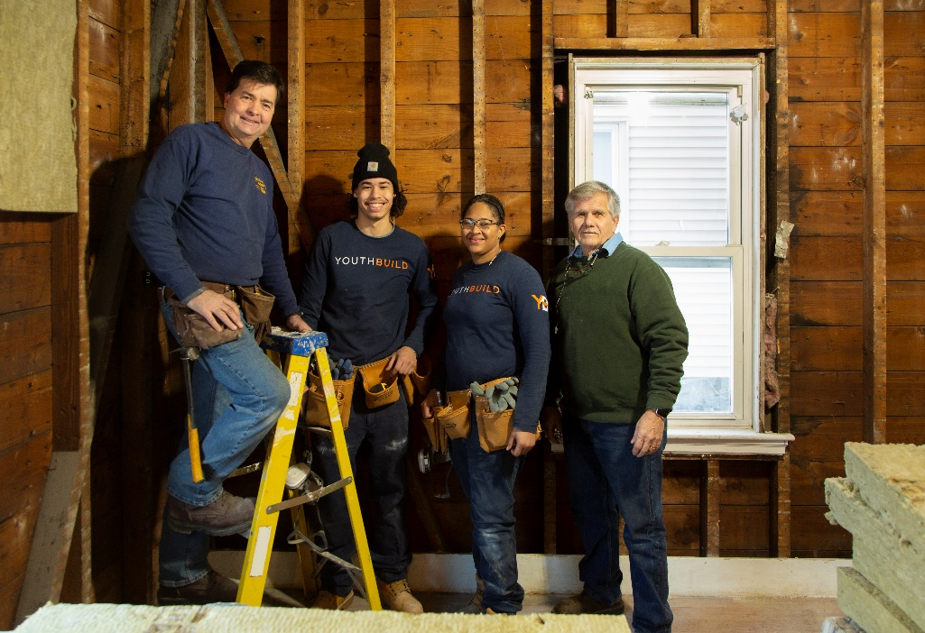

From Left: Charlie Silva, Yeren Rivera Cruz, Bobbi Jones & Tom Silva, Press Credit: Anthony Tieuli for This Old House

Two apprentices – Bobbi Jones of Roxbury and Yeren Rivera Cruz (nickname “Jay”) of Jamaica Plain, both 2020 graduates of the local YouthBuild Boston program – were chosen from an impressive lineup of applicants to join Charlie Silva and the *This Old House* team in Dorchester and the Greater Boston area for a six-week assignment during the 42nd season of *This Old House*. Let’s meet our apprentices:

Bobbi Jones: 26-year-old Bobbi found a spark with YouthBuild after she worked in an unfulfilling role as a security guard. After joining YouthBuild Boston, she gained exposure to carpentry, framing, and flooring. It immediately changed her perspective. “YouthBuild made me feel like I can do anything I put my mind to – that my dreams can come true.” She counts her son as her motivation to keep going and urges other women contemplating the trades to just “go for it. Don’t second-guess yourself. These industries want us to be here. Slow and steady wins the race.” Bobbi hopes to gain more knowledge in carpentry and HVAC systems during her apprenticeship with *This Old House*.

Yeren Rivera Cruz: At the age of 10, Yeren moved from Puerto Rico to Boston. While in high school, he struggled to find his path and didn’t know what to do with his life. But after a high school teacher told him about YouthBuild Boston, he found another family and soon learned professional skills and values. Now, at 18 years old, he sees YouthBuild and carpentry as “the ladder you build to climb up in life.” He counts his mother and her work ethic as inspiration for a better future, one that includes two major goals: joining the carpenters’ union and starting his own business. Yeren hopes to learn all about carpentry and construction from experts during his apprenticeship with *This Old House*.

While helping on the Dorchester Project, the apprentices will shadow the *This Old House* pros, and have the opportunity to attend the [GAF Roofing Academy](https://www.gaf.com/en-us/roofing-academy) in Parsippany, New Jersey. GAF, North America’s largest roofing and waterproofing manufacturer, will provide Yeren and Bobbi with a hands-on experience to learn the roofing trade as they explore career paths. They will also be putting their roofing skills into practice by helping the pros with a roof installation in the Boston-area later this year.

“We launched this partnership with YouthBuild USA to help continue our GenNext mission to encourage and empower young people to join the skilled trades, and to more directly provide opportunity for those in need in communities across the United States,” said Dan Suratt, CEO, This Old House Ventures.

“Opportunity youth are strong and resilient – and they are our greatest source of untapped potential,” said John Valverde, president and CEO of YouthBuild USA. “We are incredibly grateful and honored to partner with *This Old House* as they provide Bobbi and Yeren with crucial hands-on skills training at a job site in their own backyard. Apprenticeships unlock doors to long-term personal and professional success, and this is a remarkable opportunity to learn from some of the most trusted experts in the industry.”

YouthBuild USA is the nonprofit support center for nearly 300 YouthBuild programs around the world. Responding to the urgent need for knowledge, training and opportunity, YouthBuild primarily serves young people who lack a high school diploma and financial resources.

Roku announced on March 19, 2021, that it had acquired TOH Intermediate Holdings, LLC, which owns the This Old House business including the “This Old House” and “Ask This Old House” TV programs.

**About This Old House Ventures, LLC**

This Old House Ventures, LLC is the number one multi-platform home enthusiast brand, serving over 20 million house-proud consumers each month with trusted information and expert advice through its Emmy award-winning television shows *This Old House*and *Ask This Old House*, its highly regarded *This Old House* magazine and its inspiration and information-driven digital properties, including ThisOldHouse.com, streaming app, FAST channels, podcasts (Clearstory and Ask This Old House), social platforms, popular YouTube channel, and Insider subscription club. *This Old House* and *Ask This Old House* are produced by This Old House Ventures, LLC, and are presented on PBS by WETA Washington, DC. National underwriting for *This Old House* is provided by The Home Depot, GMC, Gorilla Glue, Marvin, HomeAdvisor, Kubota, Wagner SprayTech, and PODS Moving & Storage.

**About Roku, Inc.**

Roku pioneered streaming to the TV. We connect users to the streaming content they love, enable content publishers to build and monetize large audiences, and provide advertisers with unique capabilities to engage consumers. Roku streaming players and TV-related audio devices are available in the U.S. and in select countries through direct retail sales and licensing arrangements with service operators. Roku TV™ models are available in the U.S. and in select countries through licensing arrangements with TV brands. Roku is headquartered in San Jose, Calif. U.S.A.

**About YouthBuild**

With love and respect, YouthBuild partners with opportunity youth to build the skillsets and mindsets that lead to lifelong learning, livelihood, and leadership. At nearly 300 YouthBuild programs across the United States and around the world, students reclaim their education, gain job skills, and become leaders in their communities. To date, YouthBuild has partnered with more than 180,000 young people to dedicate over 50 million hours of service benefitting urban, rural, and tribal communities. YouthBuild strives to create a world where all young people are seen for their potential, and power to transform themselves and their communities. YouthBuild USA – the support center for the YouthBuild movement – strengthens YouthBuild programs through technical assistance, leadership development, innovative program enhancements, and advocacy. YouthBuild programs located outside of the United States are supported by YouthBuild USA’s international division, YouthBuild International. For more information about the YouthBuild movement, YouthBuild USA, and YouthBuild International, visit [YouthBuild.org](http://www.youthbuild.org/).

# # #

**Press Contact for This Old House:**

Tory Holmes

310-990-0040

[tory@bladepr.com](mailto:tory@bladepr.com)

**Press Contact for YouthBuild USA:**

Sarina Tracy

(413) 464-4970

[sarina@northwindstrategies.com](mailto:sarina@northwindstrategies.com)