TRANS-SIBERIAN ORCHESTRA:

THE GHOSTS OF CHRISTMAS EVE
Scheduled for Encore Broadcast on PBS Stations
Beginning September 9th

Celebrate the Magic of the Season With the Acclaimed Orchestra

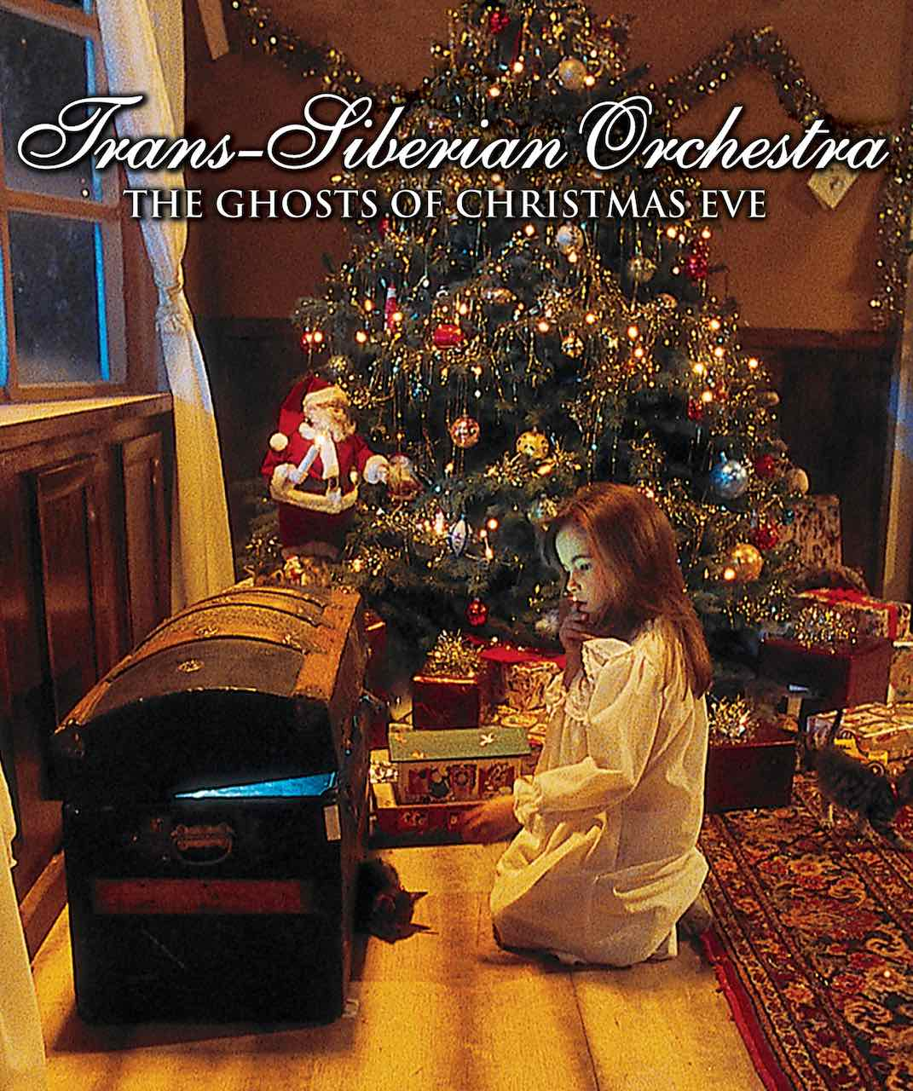
Along with such reliable Christmas traditions as It's a Wonderful Life, A Christmas Carol and The Nutcracker Suite, consider the annual return of TRANS-SIBERIAN ORCHESTRA: THE GHOSTS OF CHRISTMAS EVE, a luminous blend of a heartwarming Christmas allegory and stirring concert performances by the acclaimed Trans-Siberian Orchestra. The program will have an encore broadcast as part of special programming on PBS stations beginning Friday, September 9, 2022 (check local listings).

THE GHOSTS OF CHRISTMAS EVE tells the tale of a runaway girl who seeks shelter in a long-abandoned theater, where an old caretaker (Ossie Davis) brings the theater to life one last time. Jewel, Michael Crawford and the Trans-Siberian Orchestra bring the magic of Christmas to both the girl and viewers everywhere and help turn her life around on a snow-filled Christmas Eve.

TSO's rock operas — combining the dynamics of a symphonic orchestra with the power of a hard rock band — are the creation of O'Neill, who along with long-time collaborators Jon Oliva, Al Pitrelli and Bob Kinkel created a modern format for classic Christmas music.

Said O'Neill, "Christmas has always evoked the most powerful emotions in people. Those emotions draw people together, and it's this sort of music that serves as a conduit for the magic and spirit of the holidays. Trans-Siberian Orchestra is an all-star team of talent, gathered from the worlds of rock, classical, blues and Broadway music. This cross-pollination of talent is responsible for bringing our fans TSO's brand of creative and imaginatively staged rock opera.”

Trans-Siberian Orchestra was established in 1996 by producer/writer/guitarist Paul O'Neill. The epic "Christmas Eve/Sarajevo 12/24" was inspired by the true story of a cellist who refused to be intimidated by the gunfire in his native city of Sarajevo.
His playing outdoors amidst the shelling all around him represented the defiance of the violence that tore the city to pieces only a few years after it hosted the Olympics. This song became the centerpiece of "Christmas Eve & Other Stories," which is now a seasonal classic. Their second single "Christmas Canon," became another radio crossover hit.

PBS special programming invites viewers to experience the worlds of science, history, nature and public affairs; hear diverse viewpoints; and take front-row seats to world-class drama and performances. Viewer contributions are an important source of funding, making PBS programs possible. PBS and public television stations offer all Americans from every walk of life the opportunity to explore new ideas and new worlds through television and online content.

- PBS –

CONTACT: Cara White, CaraMar, Inc., cara.white@mac.com

For images and additional up-to-date information on this and other PBS programs, visit PBS PressRoom at pbs.org/pressroom.

